The brokerage role of a digital platform organisation in waste exchange network for a circular economy

Quynh Do (q.do1@lancaster.ac.uk)
Management Science Department, Lancaster University

Mark Stevenson
Management Science Department, Lancaster University

Abstract
The digital platform is recognised as a key enabler in facilitating information and resource flows for circular strategies such as recycling. Although the literature has attributed this to the brokerage functions of the digital platform in the recycling network, less is known about how digital platforms leverage their structural positions to facilitate these works. This paper sets out to explore how digital platform takes on brokerage roles to enable waste exchange networks for circularity. Drawing data from in-depth interviews with sixteen actors in a digital platform ecosystem, the findings indicate how a digital platform that pursues the tertius iungens strategy benefits from different structural positions to take on five roles, i.e., liaison, coordinator, consultant, gatekeeper and representative in facilitating waste exchange network for the circular economy. This provides empirical evidence for an integrative conceptualisation of brokerage structure and process in the circular network context.

Keywords: digital platform, structural hole theory, circular economy

Introduction
The rising tide of impending legislative crackdowns, spearheaded by the European Union's Strategy for Sustainable and Circular Textiles (European Commission, 2022), accelerates the adoption of closed-loop textile recycling within the fashion sector. Specifically, brands are in favour of sourcing recycled materials to comply with the minimum recycled content specified in the Ecodesign for Sustainable Product Regulations (ESPR) and to lower fees paid under the Extended Producer Responsibility (EPR) schemes based on the eco-modularisation principle. Meanwhile, EPR helps to finance the collection and recycling infrastructure, which allows for lowering the prices of recycled materials over the long run. Overall, legislations create a strong market and economic incentive in the recycling market, exemplified by a series of innovative recyclers (e.g., WornAgain, Infinited Fibre, Circ), who are looking to ramp up their commercial production in the upcoming years (Fashion for Good, 2020). It is expected that once matured and scaled, these recyclers could generate €1.5-2.2 billion in profits, create 15,000 new jobs and lower 4 million tons of carbon dioxide emissions by 2030 (Hedrich et al., 2022).
However, it remains a challenge for these recyclers to directly source textile waste material from the point of generation e.g., households for post-consumer wastes, retailers for pre-consumer wastes, or manufacturers for post-production wastes (Marques and Manzanares, 2022). This disconnection between supply- and demand-side actors of waste is conceptualised as a “structural hole” in social network literature (Burt, 1992), and its presence has been attributed to the logistical challenges associated with the fragmented flow of waste, and the non-standardised nature of waste resources (Franco, 2017; Sandvik and Stubbs, 2019). Due to the presence of structural holes, recyclers rely on the intermediaries, acting as brokers, to bridge connection with the supply source of wastes via a series of brokerage activities e.g., collecting, sorting, handling other added services (Marques and Manzanares, 2022). These brokers can be logistics providers, charity or waste management companies in developed countries where waste is highly regulated (Zanjirani Farahani et al., 2021), or waste handlers in developing countries where waste is less regulated (da Silva et al., 2019). The brokers have been in operation for many years, but their brokerage works might not lead to the best recycling use case for wastes, which hampers the circular transition in the textile sector (Fashion For Good, 2022).
In recent years, digital platforms have emerged as a new type of broker, enabled by the digitalisation wave and equipped with circular knowledge, which holds the potential to facilitate the information flow for waste exchange in the circular transition (Parker et al., 2016). Recent literature has accorded attention to various brokerage roles that digital platforms can undertake in different waste exchange settings, e.g., the food sector (Ciulli, 2019) and the construction sector (Wijewickrama et al., 2021). However, these studies have yet to answer how and why these platforms are different from the existing ‘offline’ brokers, and whether digital platforms can facilitate the operations of these offline brokers in facilitating waste exchange network for the circular economy. We argue that the structural advantages of spanning a diverse set of structural holes in the recyclers’ waste exchange network allow the digital platform to undertake a variety of brokerage roles that cannot be undertaken by offline brokers. Drawing on the structural hole theory, this study sets out to unpack the brokerage role of the digital platform in facilitating recyclers’ waste exchange network. Specifically, we aim to answer this question: How do the bridging roles of the digital platform facilitate the waste exchange of recyclers for circularity?
This study draws on a single case study of a digital platform that enables textile waste exchange in a network of recyclers, handlers and manufacturers (who are waste suppliers). The study contributes to the extant literature in three significant ways. First, it provides empirical evidence for the integrative view of the brokerage structure and process in the structural hole theory (Halevy et al., 2019). It shows how brokers can benefit their network outcomes by the ability to take on five brokerage roles (liaison, coordinator, consultant, gatekeeper and representative) via structural embeddedness. Second, it contributes to the supply chain literature by exposing the role of digital platforms in facilitating sustainable, circular supply chains. Third, it adds to the social network theory by elucidating its relevance in the growing body of circular economy research that remains lacking theoretical angles (Marques and Manzanares, 2022).

Theoretical background and Literature review

The circular waste exchange and the role of digital platform
Given the current trend of fashion brands adopting circular strategies, the recent literature has explored how closed-loop textile recycling can be implemented in the fashion sector and the key challenges in the implementation process (Denizel and Schumm, 2023; Colucci and Vecchi, 2021; Brydges, 2021). These studies indicated that closed-loop recycling in the fashion sector is still in the early stage (Denizel and Schumm, 2023), and its success relies on two significant factors: innovations and flow management of textile wastes (Jia et al., 2020). This is consistent with the widely advocated aspect of the circular economy that underlines systemic change to embrace innovation (Kirchherr et al., 2017; Suchek et al., 2021). Innovations aim at textile upcycling such as via chemical recycling (Sandvik and Stubbs, 2019) so that textile wastes are converted into high-quality fibres to be used in virtuously perpetual circular loops. Flow management of textile waste refers to the fluid movement between its supply and demand so that textile wastes can be appropriately collected, sorted and assigned to the most appropriate routes to retain the highest possible value (Denizel and Schumm, 2023). While innovation can be brought about by innovative recyclers, flow management entails systemic change at the network level where recyclers, waste collectors, manufacturers, and brands work together (Zanjirani Farahani et al., 2022; Brydges, 2021, Saha et al., 2021).
In the wave of digital technology, digital platform emerges as a novel actor that can allow for a constant symbiotic exchange of resources such as textile waste (Garud et al., 2022; Li and Schoenherr, 2023). A digital platform is defined as “a new business model that uses technology to connect people, organizations, and resources in an interactive ecosystem in which amazing amounts of value can be created and exchanged” (Parker et al., 2016 p.10). The current research has emphasised numerous challenges faced by digital platforms such as strong public backlash, lack of regulations (Li and Schoenherr, 2023), and resistance of existing players (Weber et al., 2019) in their proliferation. Hence, institutional theory, such as institutional voids or institutional entrepreneurs, has been widely used to explain the process by which these digital platforms cope with these institutional challenges to succeed (Li and Schoenherr, 2023; Garud et al., 2022; Mair and Reischauer, 2017). Despite its popularity, the institutional lens, however, only looks at the agency-structure interaction that is between the digital platform and its institutional environment. It fails to capture the interactions between the platform itself and its multiple users to facilitate circular flows of products or materials. A network theory is therefore advocated to overcome the limitations of institutional theory (Marques and Manzanares, 2023). Several attempts were made to apply the network perspective, such as network theory in circular economy research in general (Tate et al., 2019) or structural hole theory in digital platforms in particular (see Ciulli et al., 2019; Wijewickrama et al., 2021). However, none has looked at how digital platforms benefit from their unique structural advantages that span a variety of structural holes in waste exchange networks to deliver circular outcomes for such networks. This study sets out to fill in this void.

Structural hole theory and its relevance in the role of digital platforms for the circular waste exchange
Structural hole theory refers to the absence of ties between two non-redundant contacts (alters) who could otherwise benefit from having a connection (Burt, 1992, 2002, 2004). This absence of ties, or the presence of a structural hole, creates the brokerage opportunity for the third to build the bridges between two alters (Burt, 2005). The disconnection between two alters may arise from a “lack of access or trust” (Marsden, 1982, p.202), from geographical or cultural boundaries, or simply from the lack of awareness or interest in those working on the other side (Long et al., 2013). In the waste exchange network, literature has acknowledged the absence of ties between supply- and demand-side actors of waste and underlined the need for brokerage studies (Ciulli, 2020).
Literature employing structural hole theory often approaches the brokerage concept in two ways: as a structure and as a process (Obstfeld, 2014; Halevy, 2018). The first approach accentuates structural advantages that afford benefits to the third (Burt, 2005). Group affiliation in different network configurations allows brokers to take on different roles that can be grouped into five types: coordinator (all the actors belong to one group), liaison (all the actors belong to distinct groups), consultant (the broker does not belong to the group of two alters), gatekeeper and representative (the broker and the alter in one side of structural hole belong to the same group) (Table 1). Occupying these positions grants the brokers information and control benefits over the two disconnected actors (Fernandez and Gould, 1989; Burt, 1992). Information benefits come in three forms: access (i.e. possessing valuable information not accessible to other actors), timing (i.e. receiving information before other actors) and referrals (i.e. receiving more opportunities). Control benefits arise from the brokers’ exclusive ability to connect (or choose not to connect) the two alters (Zaheer et al., 2010; Burt, 1992). Prior studies (Saunders et al., 2019; Ghinoi et al., 2020) have used this brokerage structure approach to identify how different actors can take on these five brokerage roles to facilitate sustainable and circular initiatives.

Table 1 – Five types of brokers
Groups | Types | Definitions | Visualisation
Within-group | Coordinator | Brokers who facilitate exchange between otherwise disconnected actors. | 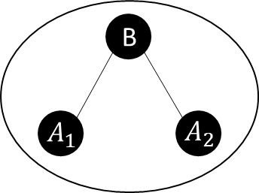
Within-group | Consultant | Brokers who possess specialized knowledge and offer expertise to network members. | 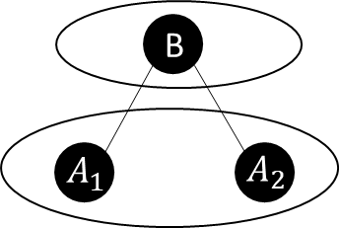
Between-group | Gatekeeper | Brokers who control the flow of information and resources within the network. | 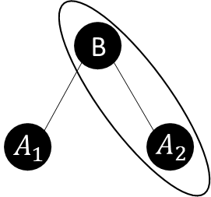
Between-group | Representative eper | Brokers who advocate for the interests of specific actors or subgroups | 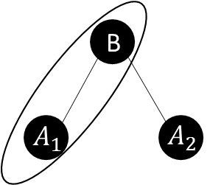
Between-group | Liaison | Brokers who connect two or more unconnected subgroups within the network, often without having prior allegiance. | 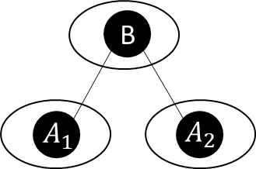

The brokerage process, on the other hand, highlights the active process brokers engage in to leverage their network position. Examples of these actions include: facilitating transactions, mediating conflicts and passing accurate, ambiguous or distorted information. These actions are often divided into two strategic orientations: tertius gaudens which strategically exploits the structural holes for brokers’ benefits, and tertius iungens which facilitates connections for a collective network benefit (Obstfeld, 2005). While tertius iungens often seek to create bridges and facilitate transactions, the tertius gaudens might pursue actions to maintain separation between two actors on the other side of the structural hole. Sustainability literature (Ciulli et al., 2019; Stadtler & Probst 2012; Manning & Roessler, 2014) have employed this approach to identify different brokerage behaviours (e.g., mobilising, enacting, reframing, educating, whistleblowing) and mostly associated these actions with tertius iungens strategy.
A recent study (Halevy et al., 2019) emphasised the need for an integrative structure-process approach. To our knowledge, none of the extant studies has followed an integrative approach. This study that focuses on the strategic actions of a digital platform as a broker purposively spans different structural holes to facilitate the waste exchange network for circularity offers empirical insight for an integrative approach.

Research method
This study focuses on the bridging role of the digital platform organisation in the waste exchange for the circular economy, which is less understood (Ciulli et al., 2020). Hence, a qualitative single case study is chosen for its ability to conduct a thorough examination of complex, process-oriented phenomena within their real-world context as it focuses on thick descriptions from multiple sources of data (Eisenhardt and Graebner, 2007). It also allows us to focus on the uniqueness of the case to generate theoretical insights and ensures the depth of the case analysis with thick descriptions (Yin, 2019).
We identified a digital platform organisation in a textile waste exchange network and pseudonymized as PlatformCo. PlatformCo serves as a critical setting for this study (Barratt, Choi, & Li, 2011), because PlatformCo purposively identifies and bridges structural holes within the recyclers’ waste exchange networks, facilitating more efficient material flows. Waste exchange in the textile sector provides an ideal context to study digital platform’s bridging actions for three reasons. First, textiles are a priority sector in the EU’s transition towards a circular economy, with a strong emphasis on textile recycling (European Commission, 2020). Second, recyclers are planning to expand their commercial operations within the next five years, creating a demand for an efficient waste exchange network (Fashion For Good, 2020). Finally, waste in the textile sector features low-value retention, which is different from those in other sectors such as electronics where recycling has matured (Denizel and Schumm, 2022). Hence, brokerage activities of platform organisations in the textile sector can potentially be generalised to other similar settings e.g., in plastics, construction or agriculture.

Data collection and analysis
Data were collected over a six-month period from October, 2023 to April 2024. Data were triangulated from three main sources: semi-structured interviews, project meetings and secondary data. Firstly, we conducted 16 interviews with four recyclers, four handlers and four manufacturers in the PlatformCo ecosystem, and four interviews with PlatformCo’s personnel. Interviewees were asked about their textile waste exchange network pre- and after-participation in PlatformCo and their perspectives on the roles of the PlatformCo. The interviews were conducted face-to-face and lasted between 45 minutes and an hour. The interviews were audio recorded and then transcribed verbatim. To ensure confidentiality, all names and positions were anonymised and a typed transcript was sent to interviewees for review and amendment. Secondly, one research team member observed the fieldwork of PlatformCo at the manufacturers’ sites. Finally, objectively verified using PlatformCo’s secondary data, including internal and publically available documents such as platform interface, waste data, white papers or blog posts. Industry reports of the projects with PlatformCo’s participation were also used to triangulate the data.
A simple coding scheme was created and used to analyse the data using a thematic analytic technique (Braun & Clarke, 2006) to analyse the interview, field notes, and secondary documents with a focus on behaviours, network affiliations and associated bridging roles. Data collection and analysis were conducted iteratively until the researchers arrived at the final coding structure that provided a robust explanation of the case (Eisenhardt & Graebner, 2007).

Findings and discussions
The findings reveal the five roles that PlatformCo takes on once strategically spans the recyclers’ structural holes to facilitate the flow of waste exchanges. This section will elaborate on each role and also discuss these roles in relation to prior studies and highlight novel contributions to the extant research.

PlatformCo as a liaison
PlatformCo is a distinct type of organisation, which allows them to be treated independently from all other sets of actors in the waste exchange network. Illustrated in Figure 1, the waste network consists of four major sets of actors: recyclers (R) who acquire waste, waste handlers (WH) who collect and handle waste, manufacturers (M) who produce wastes, brands (B) who shape the circular transition and influences the network exchange. PlatformCo as a data provider represents its own group and hence takes on the liaison role to identify potential synergy and connect sets of actors that would otherwise isolated (Obstfeld, 2005). Hence, they can keep a neutral stance in liaising activities between different groups in a non-partisan way once convening conversations across groups. In the pre-platform context, recyclers find difficulties in speaking directly with waste handlers and manufacturers who supply wastes due to a lack of understanding, structural complexity and effective communication channels. Consequently, wastes flowing in recyclers are contaminated and at high prices. Recognising this difficulty, the platform acts as a neutral ground for all these groups of actors to come in and communicate to seek a common understanding and a shared vision of a streamlined, high-quality waste material flow.
This function is particularly important in the emergent context of new recycling technologies. These recyclers have a range of requirements for specific waste inputs and rely on PlatformCo’s brokering role to build common understanding, communicate needs and standards, and forge trust with waste handlers and manufacturers. Despite not being affiliated with any set of actors, PlatformCo’s identity and mission that are associated with streaming waste flows allow them to act as a forum to convene conversations among actors and enact changes. These actors might be users or non-users of the platform.

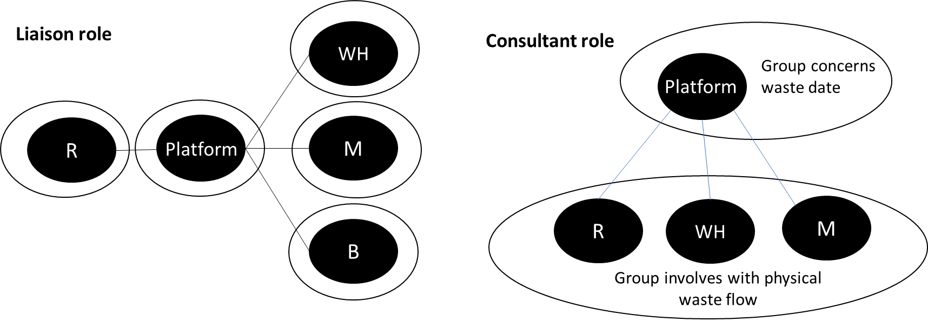
Figure 1: PlatformCo takes on liaison and consultant roles

PlatformCo as a consultant
Its uniqueness also allows PlatformCo to undertake the consultant role in the recyclers’ network (Figure 1). Their extensive data and knowledge of waste flow across different geographies allow PlatformCo to consult recyclers in decisions at the strategic and operational levels. At the strategic levels, PlatformCo can assist with network configuration decisions such as locations to build a new recycling plant or capacity decisions of such plant. At the operational level, PlatformCo can assist with the quarterly, monthly or even daily planning, which assures smooth sourcing of the waste resources coming into the recycling factory. This consultant role had not been previously undertaken by any actors in the recycling network due to the nonexistence of waste data. Thanks to its data hub function, PlatformCo acts as a data-driven consultant to give valuable insights to the recyclers and is associated with the knowledge broker feature to act as a source of information and knowledge translator (McEvily & Zaheer, 1999).

PlatformCo as a coordinator
PlatformCo acts as a coordinator for the activities of four sets of users (R, WH, M and B) in their platform environment (Figure 2). Once subscribing to PlatformCo’s system, these actors are affiliated in the same group with PlatformCo with a common goal of bringing a traceable, streamlined, and premium quality waste flow. As such, PlatformCo can matchmake wastes to its best possible recycling destination and orchestrate logistical and transactional activities in the best way.
In this digital environment, the digital platform coordinates activities to create a sense of order, reduce friction, and enable closer collaboration and forge trust (Soda et al., 2004). This coordination work is essential for brokerage works in the circular transition (Ghinoi et al., 2020; de Abreu & Ceglia, 2018), and the platform environment that acts as an interface among multiple actors (McIntyre et al., 2021) allows to reap the wider impact.

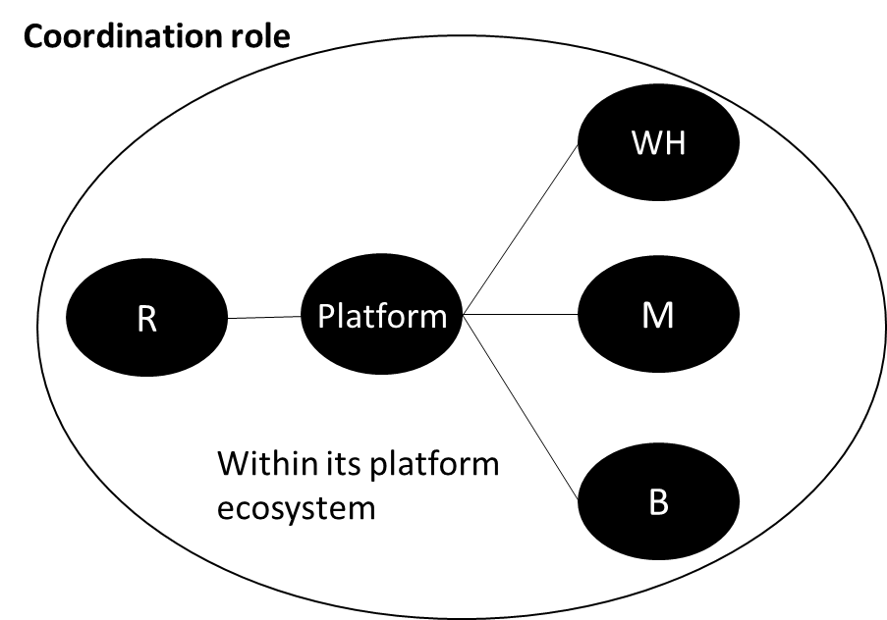
Figure 2: PlatformCo takes on coordination roles

PlatformCo as a gatekeeper
PlatformCo possesses a network of socially compliant waste handlers and manufacturers who can supply segregated wastes at lower prices. This allows them to take on the gatekeeper role of critical information, including waste supply network as well as waste composition and availability (Figure 3). These data are crucial to the recyclers in their sourcing decisions, particularly in foreign countries where geography and culture are significant barriers.
It is noted that waste handlers (offline brokers) also take on the gatekeeping role (Mayanti and Helo, 2024; Hezen et al., 2020), but are mostly constrained to resource accessibility. They lack of waste data e.g., composition, colour and volumes, which are critical in recyclers’ sourcing. In this line, PlatformCo which gatekeeps waste data can complement the gatekeeping function of waste handlers to benefit recyclers. In addition, PlatformCo’s network features socially compliant waste handlers that provide a decent working environment that somewhat complies with the recyclers’ social requirements. This not only benefits recyclers in building a traceable and compliant supply chain but also acts as a conduit to expand their complaint handlers’ reach to a wider network of recyclers. This benefits handlers once the recyclers ramp up their production in the near future. The power to selectively grant or deny access to data and resources of a gatekeeper has been particularly highlighted in the structural hole literature (Burt, 1992).

PlatformCo as a representative
Though not a recycler, PlatformCo can represent recyclers in dealing with other actors with whom recyclers find it hard to establish direct contact (Figure 3). For instance, Recycler 1 recently established in the EU has used PlatformCo to source from far East locations. In this instance, PlatformCo works on behalf of Recycler 1 to negotiate and arrange operations with manufacturers and recyclers. Had not been for PlatformCo, Recycler 1 would face geographical and cultural boundary challenges, hindering its sourcing. In this sense, we found PlatformCo acts as an intermediary to negotiate on behalf of recyclers and influence their decision-making (Brass, 1984).

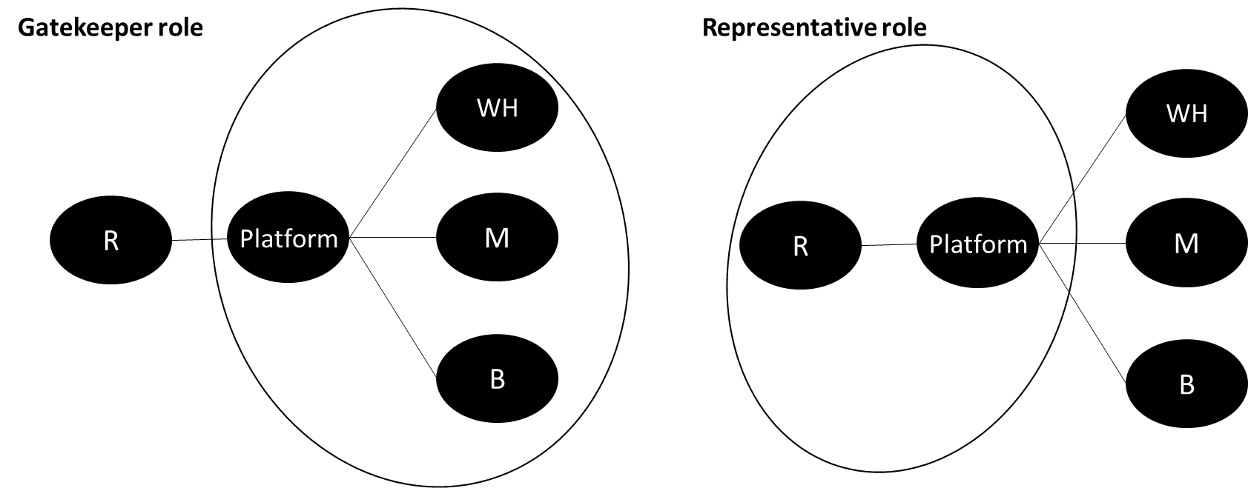
Figure 3: PlatformCo takes on gatekeeper and representative roles

PlatformCo pursues the tertius iungens orientations
Overall, PlatformCo’s brokerage behaviours bear the tertius iungens behaviours. We found evidence that PlatformCo not only introduces the previously unconnected actors e.g., global recyclers with local waste handlers but also facilitates interactions and forges ties among these actors, which is in line with the “union” strategy of tertius iungens (Obstfeld, 2005). Although PlatformCo’s union work does gain information and control benefits from occupying the structural hole (Burt, 1992), their motivations and intentions are “self-interested”, “egocentric”, “exploitative” or “manipulative” as tertius gaudens. Instead, they take on a “non-partisan” role to produce “the concord of two colliding parties” and function as an arbiter who balances the colliding parties and eliminates the “incompatibility” between them (Simmel, 1950, p. 146).
The findings highlight the need for all five types of brokers (coordinator, consultant, gatekeeper, liaison, representative) in waste exchange networks for circularity, and the potential for a single organisation, a platform organisation, to embody all five roles. This adds to prior studies that focus on separate stakeholders for each role (Ghinoi et al., 2020; Saunders et al., 2019). In addition, the findings challenge the prior findings (e.g., Saunders et al., 2019), which suggest that certain brokerage roles such as gatekeeper or liaison are less effective or even inhibitive to sustainability initiatives due to a lack of strategic alignments among actors belonging to the different groups.

Conclusions and Limitations
These roles underscore the multifaceted nature of brokerage, demonstrating how a digital platform follows the tertius iungens strategy to leverage their network positions to undertake multiple roles to facilitate waste resource and data exchange for the circular network. In doing so, the digital platform allows recyclers to access a more efficient, traceable and socially compliant network of waste handlers and waste suppliers who are manufacturers, in this particular instance.
The study is not conducted without limitations, which opens the opportunity for future research. First, sampling in this study was limited to a digital platform’s ecosystem in a post-production textile waste exchange network. This may limit the generalisation of the results to post-consumer wastes and waste exchange networks in other sectors. Future studies should investigate these brokerage roles and their effectiveness in the digital platforms of post-consumer wastes in other sectors. Second, while five roles are valuable in early network formation, their significance might shift as their network becomes more mature. This opens avenues for future research to explore how network context shapes the evolution of these brokerage roles over time.

References
Barratt, M., Choi, T.Y., & Li, M. (2011), "Qualitative case studies in operations management: Trends, research outcomes, and future research implications", Journal of Operations Management, Vol.29 No.4, pp. 329-342. doi:https://doi.org/10.1016/j.jom.2010.06.002.
Brass, D. J. (1984). Being in the right place: A structural analysis of individual influence in an organization. Administrative science quarterly, 518-539.
Braun, V., & Clarke, V. (2006). Using thematic analysis in psychology. Qualitative research in psychology, 3(2), 77-101.
Brydges, T. (2021). Closing the loop on take, make, waste: Investigating circular economy practices in the Swedish fashion industry. Journal of Cleaner Production, 293, 126245.
Burt R. S. (1992), Structural holes: The social structure of competition. Cambridge, MA: Harvard University Press.
Burt R. S. (2004), “Structural holes and good ideas”. American Journal of Sociology, 110: 349-399.
Burt R. S. (2005). Brokerage and closure: An introduction to social capital. Oxford, England: Oxford University Press.
Collins-Dogrul J. 2012. Tertius iungens brokerage and transnational intersectoral ooperation. Organization Studies, 33: 989-1014.
Colucci, M., & Vecchi, A. (2021). Close the loop: Evidence on the implementation of the circular economy from the Italian fashion industry. Business Strategy and the Environment, 30(2), 856-873.
da Silva, C. L., Weins, N., & Potinkara, M. (2019). Formalizing the informal? A perspective on informal waste management in the BRICS through the lens of institutional economics. Waste Management, 99, 79-89.
Denizel, M., & Schumm, C. Z. (2024). Closed loop supply chains in apparel: Current state and future directions. Journal of Operations Management, 70(2), 190-223.
Eisenhardt, K. M., & Graebner, M. E. (2007), “Theory building from cases: Opportunities and challenges”, Academy of management journal, 50(1), 25-32.
European Commission. (2020). A new Circular Economy Action Plan for a cleaner and more competitive Europe. Communication from the Commission to the European Parliament, the Council, the European Economic and Social Committee and the Committee of the Regions, COM (2020) 98 final
European Commission. (2022). EU strategy for sustainable and circular textiles. Communication from the Commission to the European Parliament, the Council, the European Economic and Social Committee and the Committee of the Regions, COM (2022) 141 final.
Fashion For Good. (2002). Creating a Circular System to Accelerate Textile Recycling. https://fashionforgood.com/our_news/creating-a-circular-system-to-accelerate-textile-recycling/
Fashion For Good. (2023). The great unlock closing the innovation commercialisation gap through project finance solutions. https://reports.fashionforgood.com/wp-content/uploads/2023/10/REPORT_THE-GREAT-UNLOCK_FASHION-FOR-GOOD-SPRING-LANE-CAPITAL.pdf
Fernandez, R. M., & Gould, R. V. (1989). A dilemma of state power: Brokerage and influence in the national health policy domain. American Journal of Sociology, 94(6), 1455-1491.
Franco, M. A. (2017). Circular economy at the micro level: A dynamic view of incumbents’ struggles and challenges in the textile industry. Journal of cleaner production, 168, 833-845.
Gargiulo, M., & Benassi, M. (2000). Trapped in your own net? Network cohesion, structural holes, and the adaptation of social capital. Organization science, 11(2), 183-196.
Garud, R., Kumaraswamy, A., Roberts, A., & Xu, L. (2022). Liminal movement by digital platform‐based sharing economy ventures: The case of Uber Technologies. Strategic Management Journal, 43(3), 447-475.
Ghinoi, S., Silvestri, F., & Steiner, B. (2020). The role of local stakeholders in disseminating knowledge for supporting the circular economy: a network analysis approach. Ecological Economics, 169, 106446.
Halevy, N., Halali, E., & Zlatev, J. (2019). Brokerage and brokering: An integrative review and organizing framework for third-party influence. Academy of Management Annals, 13(1), 215-239.
Hedrich, S., Janmark, J., Langguth, N., Magnus, K. H., & Strand, M. (2022). Scaling Textile Recycling in Europe-Turning Waste into Value. McKinsey Co, 76.
Jia, F., Yin, S., Chen, L. & Chen, X. 2020, “The circular economy in the textile and apparel industry: A systematic literature review”, Journal of Cleaner Production, 259, 120728.
Kirchherr, J., Reike, D., & Hekkert, M. (2017). Conceptualizing the circular economy: An analysis of 114 definitions. Resources, conservation and recycling, 127, 221-232.
Li, D., & Schoenherr, T. (2023). The institutionalization of sharing economy platforms in China. Journal of Operations Management, 69(5), 764-793.
Long, J. C., Cunningham, F. C., & Braithwaite, J. (2013). Bridges, brokers and boundary spanners in collaborative networks: a systematic review. BMC health services research, 13, 1-13.
Mair, J., & Reischauer, G. (2017). Capturing the dynamics of the sharing economy: Institutional research on the plural forms and practices of sharing economy organizations. Technological Forecasting and Social Change, 125, 11-20.
Manning, S., & Roessler, D. (2014). The formation of cross-sector development partnerships: How bridging agents shape project agendas and longer-term alliances. Journal of Business Ethics, 123, 527-547.
Marques, L., & Manzanares, M. D. (2022), “Towards social network metrics for supply network circularity”, International Journal of Operations & Production Management, 43(4), 595-618.
Marsden, R. (1982). Industrial Relations: A Critique of Empiricism. Sociology, 16(2), 232-250.
McEvily, B., & Zaheer, A. (1999). Bridging ties: A source of firm heterogeneity in competitive capabilities. Strategic management journal, 20(12), 1133-1156.
McIntyre, D., Srinivasan, A., Afuah, A., Gawer, A., & Kretschmer, T. (2021). Multisided platforms as new organizational forms. Academy of Management Perspectives, 35(4), 566-583.
Obstfeld D. (2005). “Social networks, the tertius iungens orientation, and involvement in innovation”. Administrative Science Quarterly, 50: 100-130.
Obstfeld D., Borgatti S. P., Davis J. (2014). “Brokerage as a process: Decoupling third party action from social network structure”. In Borgatti S. P., Mehra A., Labianca G. J., Brass D. J. (Eds.), Contemporary perspectives on organizational social networks. Research in the sociology of organizations: 135-159. Bingley, England: Emerald Group.
Parker, G. G., Van Alstyne, M. W., & Choudary, S. P. (2016). Platform revolution: How networked markets are transforming the economy and how to make them work for you. WW Norton & Company.
Saha, K., Dey, P. K., & Papagiannaki, E. (2022). Implementing circular economy in the textile and clothing industry. In Supply Chain Sustainability in Small and Medium Sized Enterprises (pp. 239-276). Routledge.
Sandvik, I. M., & Stubbs, W. (2019). Circular fashion supply chain through textile-to-textile recycling. Journal of Fashion Marketing and Management: An International Journal, 23(3), 366-381.
Saunders, L. W., Tate, W. L., Zsidisin, G. A., & Miemczyk, J. (2019). The influence of network exchange brokers on sustainable initiatives in organizational networks. Journal of Business Ethics, 154, 849-868.
Soda, G., Usai, A., & Zaheer, A. (2004). Network memory: The influence of past and current networks on performance. Academy of Management Journal, 47(6), 893-906.
Stadtler, L., & Probst, G. (2012). How broker organizations can facilitate public-private partnerships for development. European Management Journal, 30(1), 32-46.
Suchek, N., Fernandes, C. I., Kraus, S., Filser, M., & Sjögrén, H. (2021). Innovation and the circular economy: A systematic literature review. Business Strategy and the Environment, 30(8), 3686-3702.
Sutherland, W., & Jarrahi, M. H. (2018). The sharing economy and digital platforms: A review and research agenda. International Journal of Information Management, 43, 328-341.
Tate, W. L., Bals, L., Bals, C., & Foerstl, K. (2019). Seeing the forest and not the trees: Learning from nature’s circular economy. Resources, Conservation and Recycling, 149, 115-129.
Wijewickrama, M. K. C. S., Rameezdeen, R., & Chileshe, N. (2021). Information brokerage for circular economy in the construction industry: A systematic literature review. Journal of Cleaner Production, 313, 127938.Yin, R. K. (2019). Case study research and applications (6). Thousand Oaks, CA: Sage.
Zaheer, A., Gözübüyük, R., & Milanov, H. (2010). It's the connections: The network perspective in interorganizational research. Academy of management perspectives, 24(1), 62-77.
Zanjirani Farahani, R., Asgari, N., & Van Wassenhove, L. N. (2022). Fast fashion, charities, and the circular economy: challenges for operations management. Production and Operations Management, 31(3), 1089-1114.

