Type of the Paper (Article, Review, Communication, etc.)
Generation of pearl/Calcium phosphate composite particles and their integration into porous chitosan scaffolds for bone regeneration
Zhiyi Li ¹, Ihtesham ur Rehman ^{1,2} , Rebecca Shepherd ³ and Timothy E.L. Douglas ^{1,}*
Citation: To be added by editorial staff during production.
Academic Editor: Firstname Lastname
Received: date
Revised: date
Accepted: date
Published: date

Copyright: © 2023 by the authors. Submitted for possible open access publication under the terms and conditions of the Creative Commons Attribution (CC BY) license (https://creativecommons.org/licenses/by/4.0/).
¹ School of Engineering, Lancaster University, United Kingdom; z.li44@lancaster.ac.uk, t.douglas@lancaster.ac.uk
² School of Medicine and Dentistry, University of Central Lancashire, Preston, United Kingdom; iurehman@uclan.ac.uk
³ School of Anatomy, Faculty of Health and Life Sciences, University of Bristol, United Kingdom; rebecca.shepherd@bristol.ac.uk

* Correspondence: t.douglas@lancaster.ac.uk
Abstract: Bone tissue engineering using osteoconductive scaffolds holds promise for regeneration, with pearl powder gaining interest for its bioactive qualities. This study used freeze-drying to create chitosan (CS) scaffolds with pearl/calcium phosphate (p/CaP) powders, mimicking bone tissue structurally and compositionally. Characterization included scanning electron microscopy (SEM) and mechanical testing. X-ray diffraction (XRD) Fourier-transformed infrared-photoacoustic photo-acoustic sampling (FTIR-PAS), and FTIR- attenuated total reflectance (FTIR-ATR) were used to characterize p/CaP. In-vitro tests covered degradation, cell activity, and SEM analysis. The scaffolds showed notable compressive strength and modulus enhancements with increasing p/CaP content. Porosity, ranging from 60% to 90%, decreased significantly at higher pearl:CaP ratios. Optimal cell proliferation and differentiation were observed with scaffolds containing up to 30 wt.% p/CaP, with 30 wt.% pearl powder and 30 wt.% p/CaP yielding the best results. In conclusion, pearl/calcium phosphate chitosan (p/CaP_CS) composite scaffolds emerged as promising biomaterials for bone tissue engineering, combining structural mimicry and favourable biological responses.
Keywords: Pearl powder; Calcium phosphate; Chitosan; Bone regeneration; Porous scaffold

1. Introduction
Bone is an intricate and highly specialized variant of connective tissue which provides a sturdy framework that supports the human body and maintains its shape, while also providing attachment points for muscles and tendons [1, 2].
Bone disorders can occur through physical damage, or as part of the ageing process. Treatments for bone defects include autografts, allografts and xenografts[3]. However, the limitations of these methods , include their limited availability, an increased risk of causing additional pain, nerve injury, cosmetic defects, infection, immune rejection response and secondary fractures [4, 5]. In addition, with an increasing aging population worldwide, more people are suffering from the chronic degeneration of bone tissues, which is also associated with disorders of other connective tissues, cartilage and tendon [6, 7]. These limitations have led to bone tissue engineering [4]. A strategy in bone tissue engineering is biomimicry of natural materials, with the aim of controlling the synthesis of inorganic solids with an organic matrix. Carbonate minerals, which are components of sediments and sedimentary rocks, also play a role. These include calcium carbonate (CaCO₃), one of the most abundant minerals on earth. CaCO₃ potentially has important implications in biomineralization despite its relatively poor mechanical strength [8]. Over the history of the Earth, the primary source of marine carbonate minerals has shifted from abiotic precipitation to biogenic sources, and the simplest and most representative biominerals are pearls and shells [9].
The shell of bivalve molluscs, such as pearl oyster and freshwater pearl mussel, is a complex composite of calcium carbonate and organic (polymer) materials, essentially comprising two layers: an outer layer of prismatic calcite that often resembles chalk, and an inner, pearly layer of nacre [10]. This inner layer is predominantly composed of aragonite, but frequently contains mixed crystals of calcite. Nacre, also known as mother-of pearl, is a composite material, produced by some species of mollusc, that forms the inner structure of shells, and of pearls. This substance possesses a remarkable structure that is exceptionally tough [11].
Nacreous pearls are thought to form when a microscopic ‘irritant’ enters the mollusc shell and causes an increase in production of nacre. The mantle edge of the mollusc shell secretes the organic framework, and controls several aspects of the formation of the calcium carbonate crystals: their nucleation, growth, polymorphic structure, and even the positioning and elongation of crystal polygons within the concentric layers, and in the surface region which defines pearl quality [10]. Ancient Chinese people did not only value pearls as gemstones; they managed to apply pearl powders as a medicinal ingredients in traditional Chinese medicines for thousands of years [12]. Moreover, the in vitro study of nacre with human osteoblast cells in 1992 represented the first utilization of nacre and pearl in bioengineering as biomaterials [13]. Recently, a number of studies have focused on the osteogenesis of pearl in polymeric scaffolds and hydrogels [14-16], the antioxidant, anti-inflammatory and immune-modulating properties make the application of pearl in wound healing and bone tissue engineering attractive.
Hydroxyapatite (HA) has been widely studied as one of the most representative bioceramics since 1950s [17, 18]. It has very close association with the bony apatite structure and has been widely used as artificial bone substitutes because of many positive biological properties, including biocompatibility, bioactivity, osteoconduction, osteoinduction, and osteointegration [17, 18]. However, the common commercial highly crystalized structure of HA has a lower biodegradation rate compare to some ion substituted, amorphous CaP, or poorly crystalline HA in both nano-scale and micro-scale, because of relatively low osteoblast adhesion and ions releasing rate [19]. Furthermore, the direct use of HA has presented drawbacks compared to ion-substituted or modified HA based composite in different studies [20, 21]. As a biomineralization precursor of the bone apatite generation process, amorphous calcium phosphate (ACP) has attracted considerable attention from researchers for the design of bone regeneration materials. In previous research, thermal gravimetric analysis (TGA), X-ray diffraction (XRD), scanning electron microscopy (SEM), and vibrational spectroscopy, including the Fourier transformed infrared spectroscopy (FTIR) and Raman spectroscopy were considered as valuable techniques in studying ACP particles [22-24]
The hypothesis of this study was that the incorporation of pearl into bone scaffolds would improve the mechanical properties and cytocompatibility of bone scaffolds. This hypothesis was tested by incorporating pearl and CaP via a novel precipitation method. Subsequently, the porous CS composite scaffolds were fabricated in order to improve the properties of scaffolds, including mechanical strength and biological activity. Characterization of the physiochemical and osteogenic properties of particles and scaffolds was performed.

2. Materials and Methods

2.1 Materials
Fresh water pearl powder (particle diameter in the micrometre range) was donated by gN Pearl Group (Jingrun Zhenzhu, Hainan, China). For composite particle preparation, the following reagents were used for pearl/CaP synthesis: calcium nitrate tetrahydrate (Ca(NO₃)₂·4H₂O, Acros Organics, Belgium); di-ammonium hydrogen phosphate ((NH₄)₂HPO₄, VWR-Prolabo Chemicals, Germany); ammonia solution (NH₃·H₂O, 35%, Thermo Fisher Scientific, UK); and ethanol (EtOH, ≥99.8%, AnalaR NORMAPUR®, VWR-Prolabo Chemicals, France; 99.8%, ThermoScientific™, UK). Commercial non-sintered HA particles (Plasma Biotal, CAPTAL®, Buxton, UK) were used for comparison analysis. All solutions were dissolved and diluted in Milli-Q water (Milli-Q® Direct Water Purification System, Merck Millipore, Germany). The medium molecular weight chitosan powders (100 kDa to 300 kDa, Acros Organics, Germany) were purchased from the Merck KGaA Group. The Dulbecco’s Modified Eagle Medium (DMEM, Gibco®, ThermoFisher™, Loughborough, UK), penicillin/streptomycin (P/S, 10,000 U/mL, Gibco®, ThermoFisherTM, Loughborough, UK), fetal calf serum (FCS, Sigma-Aldrich®, Dorset, UK), and the phosphate buffer saline (PBS, Sigma-Aldrich®, Dorset, UK) tablets were purchased from the Merck KgaA Group.

2.2 Fabrication of composite particles
The p/CaP composite particles were prepared by a precipitation method. In brief, Ca(NO₃)₂·4H₂O with pearl solution and (NH₄)₂HPO₄ solution were prepared as the source of Ca²⁺, pearl and PO₄³⁻, respectively. NH₃·H₂O was added dropwise to adjust the pH of the reaction solution. The reactant solutions were prepared at a stoichiometric ratio of 0.1 M Ca²⁺ and 0.06 M PO₄³⁻ ions (equal to 1.67). For this, 0.1 M Ca²⁺ solution was prepared by dissolving the respective amount of Ca(NO₃)₂·H₂O plus pearl powders in 200 mL of Milli-Q water; meanwhile, 0.06 M NH₄⁺ solution was prepared in 200 mL Milli-Q water, respectively.
The pH of both solutions was adjust”d to’10.5 by NH₃·H₂O prior to starting the reaction. Afterwards, the alkaline (NH₄)₂HPO₄ (40 mL) solution was added into the Ca(NO₃)₂ plus pearl (200 mL) solution dropwise at 5 ml/min under constant stirring. After addition of (NH₄)₂HPO₄ solution, the pH was adjusted to 10 before adding another round of NH₄⁺ reagent solution (5 rounds, 200 mL in total). The pH adjustment process was repeated every hour to ensure the pH of the reaction solution remained at 10 ± 0.3. The stirring was stopped after 4 hours; the reaction solution was incubated in a silicone bath at 80 ℃ overnight to achieve an ageing effect. After the overnight ageing process, the solution was filtrated by using a vacuum filtration system with a 250 mm Ø filtration paper (Whatman™, Buckinghamshire, UK), a Büchner funnel, and a vacuum pump (Fisherbrand™, Leicestershire, UK).
During the filtration, HA precipitates were washed with Milli-Q water; this was repeated several (4-5) times until the final pH of the filtrated water reached a value below 8.0. Then, the neutralized precipitates were collected with the filtration paper inside a glass dish, dried at 80 ℃ for 48 h and crushed and ground in a mortar to obtain the fine HA powders.

2.3 Fabrication of scaffolds
The chitosan solution was prepared by dissolving medium molecular weight chitosan powders (100 kDa to 300 kDa, Acros Organics, Germany) in 0.2 M acetic acid and heating and stirring at 50℃ for 1 h, followed by cooling to room temperature for over 6 hours. Then, the ceramic components were added gradually to the solution and stirred overnight. The slurries were then poured into transparent plastic petri dishes (Ø = 75 mm) and degassed at room temperature for 2 hours to remove small bubbles. The samples were frozen in the freeze dryer from 0 ℃ to -20 ℃ (the gradient is -4 ℃/h) for 24 h and then sublimated under a pressure of 0.7 mbar for over 24 h. Afterwards, the obtained scaffolds were processed a neutralization step that transferred the scaffolds from the original petri dishes by pressing the edges to larger petri dishes. The 3M ethanol/NaOH (EtOH/NaOH) sol. (90-95%) was applied for the neutralisation process; all scaffolds were immersed in the alkaline sol. for another 12 h. Later, a series of wash and rinse steps were performed including, (1) 15 min in Milli-Q water, (2) 5 min in PBS sol., (3) 15 min in 80% EtOH sol., and (4) 15 min in 100 EtOH sol. Thus, the scaffolds were left half covered in the hood to dry for 8-15 h. The details of all scaffold sample groups were given in the Table 1 listed below.
Table 1. Details of porous chitosan scaffold composite samples prepared in this study. Pearl: CaP ratios indicate the mass ratio of pearl to CaP. Weight percentages (wt.%) are relative to chitosan.
Group of scaffolds | Abbreviation | Particles added to chitosan scaffold
Pure CS scaffolds | CS | -
Pearl/CS scaffolds | P1 | 10 wt.% pearl
Pearl/CS scaffolds | P3 | 30 wt.% pearl
Pearl/CS scaffolds | P5 | 50 wt.% pearl
HA/CS scaffolds | H1 | 10 wt.% HA
HA/CS scaffolds | H3 | 30 wt.% HA
HA/CS scaffolds | H5 | 50 wt.% HA
Pearl: CaP (1:9)(P1CaP9)/CS scaffolds | P1CaP9_10 | 10 wt.% P1CaP9
Pearl: CaP (1:9)(P1CaP9)/CS scaffolds | P1CaP9_30 | 30 wt.% P1CaP9
Pearl: CaP (1:9)(P1CaP9)/CS scaffolds | P1CaP9_50 | 50 wt.% P1CaP9
P3CaP7/CS scaffolds | P3CaP7_10 | 10 wt.% P3CaP7
P3CaP7/CS scaffolds | P3CaP7_30 | 30 wt.% P3CaP7
P3CaP7/CS scaffolds | P3CaP7_50 | 50 wt.% P3CaP7
P5CaP5/CS scaffolds | P5CaP5_10 | 10 wt.% P5CaP5
P5CaP5/CS scaffolds | P5CaP5_30 | 30 wt.% P5CaP5
P5CaP5/CS scaffolds | P5CaP5_50 | 50 wt.% P5CaP5

2.4 Characterization

2.4.1 FTIR analysis
FTIR-PAS was used to analyse powder samples. Powders were filled into metal sample holders (Ø=10 mm, x 2.5 mm depth) and the sample surface was flattened to level it with the top of the holder. Spectral data was acquired in the mid-infrared region (4000-400 cm⁻¹), at 8 cm⁻¹ resolution, 200 spectrograph apertures accumulating 128 scans.
Scaffold samples were cut into rectangular specimens (10 x 10 mm2, 6 mm in height) prior to analysis, and the spectra were collected in the mid-infrared region by using an aperture of 150 with a resolution of 16 cm⁻¹ accumulating 64 scans in FTIR-ATR mode. Both FTIR-ATR and FTIR-PAS spectra were collected by using a Nicolet™ iS50 spectrophotometer ((Thermo Fisher Scientific Inc, Madison, WI, USA)) in conjunction with Thermo Nicolet OMNIC™ (Version 9.5.9, Thermo Fisher Scientific Inc, Madison, WI, USA) software.

2.4.2 XRD characterization
XRD measurements were performed using the SmartLab (Rigaku SmartLab®, Rigaku Co. Ltd., Japan) X-ray diffraction meter. The resulting spectra were analysed using the PDXL (Rigaku Co. Ltd., Japan) software.

2.4.3 SEM analysis
Microstructure and morphology analysis of pearl, HA, p/CaP composite particles and bioactive scaffolds were performed using a JEOL JSM-7800F Scanning Electron Microscope (SEM) instrument (Field Emission SEM, JEOL Ltd., Tokyo, Japan). Prior to imaging, samples were mounted into 12.5 aluminium stubs using the double-sided carbon adhesive tabs (12 mm), and sputter-coated with gold powder (5 nm) once.
For particle samples, before imaging, powders were dried in an oven at 80 ℃ for 48 hours and stuck to carbon tabs on aluminium. For scaffold samples, all specimens were dried in oven at 40 ℃ for 48 hours, then sectioned to permit analysis of cross-sections, top surfaces and bottom surfaces, respectively. Then, on each stub, three different surface scaffolds from the same sample were mounted horizontally to improve the electrical conductivity and to facilitate detailed imaging.

2.4.4 Porosity analysis
To determine the porosity of the scaffold, the circular specimen of weight W was immersed in a graduated cylinder containing a known volume (V₀) of ethanol. Care was taken to ensure that no air bubbles emerged from the scaffold, and the cylinder was left for 5 minutes. The total volume of ethanol and ethanol-saturated scaffold was then recorded as V₁. The volume difference (V₁ - V₀) represented the volume of the scaffold skeleton, while the residual ethanol volume after removing the scaffold from the cylinder was recorded as V₂. The quantity (V₀ – V₂) was determined as the void volume of the foam. The total volume of the scaffold was then calculated as
V = (V₁ - V₀) + (V₀ – V₂) = V₁ – V₂. | (1)
The density of the scaffold (d) was expressed as d = W/ (V₁ – V₂), and the porosity of the scaffold (ε) was obtained by performing the following calculation
ε = (V₀ – V₂) / (V₁ – V₂) | (2)
In addition to porosity analysis, the SEM images of scaffolds was also analysed using ImageJ software (Version 1.53K). The results were calculated automatically by the distribution calculator from the software to obtain an average distribution of porosity.

2.4.5 Compressive properties analysis
Cylindrical scaffolds of 10 mm in diameter and 6 mm in height were compressed at a rate of 5 mm/min using a Universal Testing Machine (Instron® 3345, Norwood, MA, USA) with Bluehill® Universal Software (Version 4.06, Norwood, MA, USA) The Young’s modulus was calculated based on the linear portion of the stress-strain curve.

2.5 In vitro cytotoxicity and compatibility
All neutralized samples were cut with a cork borer of diameter 12 mm after soaking in 1% P/S-PBS solution overnight for rehydration. All specimens were sterilized by immersion in 70% EtOH solution for 2 hours and evaporation of the ethanol for 24 hours in a Biological Safety Cabinet (Type-II) (BSC) followed by an extra 15-minute exposure to UV. MG-63 cells, which are commonly used in related studies as an important in vitro cell model, were seeded onto sterile porous p/CaP_CS scaffolds in 24-well plates at 20,000 cells per sample in 50 ml fully supplemented media. The samples were incubated using standard protocols at 37 °C and 5% CO₂ in a fully humidified incubator to allow cell adhesion to the substrate for 3 h before 1 ml fully supplemented media was added to each well [25]. The samples were cultured for 15 days with regular media changes.

2.5.1 Cell morphology
To observe cell morphology, after 14 days incubation, scaffolds cultured with cells for SEM analysis were fixed 2% overnight, then dehydrated in a series of ethanol treatments (70%, 80%, 90%, 100%) at 10-minute intervals. The dehydration process was finished using HMDS (hexamethyldisilane) chemicals for 3 minutes, followed by drying in a desiccator for approximately 25 minutes prior to observation using SEM.

2.5.2 Cell cytotoxicity and proliferation analysis
AlamarBlue® (AB) assay is a non-cytotoxic indirect way to evaluate cell viability and proliferation, which was performed in this study that the measurements were taken at Day1, Day3, Day6, Day10 and Day 14, respectively. At determined culture intervals, cultured samples were washed with 1 mL of PBS with penicillin-streptomycin (P/S). Then, samples were immersed into 1 mL of resazurin solution in the wells of a 24 well-plate, which was covered with aluminium foil to prevent light contact and incubated for 4 hours. After 4 h, the reduced resazurin media (resorufin), which transforms from blue towards pink tones, were taken in triplicate from each well as 200 µL aliquots and poured into the wells of a 96-well plate with a zigzag pattern to prevent fluorescent interference of adjacent wells. The fluorescence values of the aliquot solutions were measured in an Infinite® 200 PRO microplate reader (TECAN®, Tecan Group Ltd., Männedorf, Switzerland) by using excitation and emission light wavelengths of 530 and 590 nm, respectively.

2.5.3 Statistical analysis
All of the data were statistically analysed by GraphPad Prism 8.0.2 software. Data were reported as mean ± standard deviation (SD). Statistical significance was set at p < 0.05 and tested with Two-way ANOVA.

3. Results

3.1 Composite particle properties
The FTIR-PAS spectra of the dried samples are presented in Figure 1. In pearl powders, the broad region at 3000-3400 cm⁻¹ was attributed to the hydroxyl stretch which is also marked by broad H₂O absorption. The peak at 2920 cm⁻¹ was attributed to the ν(C-H) in organic matrix of pearl[26]; the bands at 1430-1490 cm⁻¹ are attributed to the bending vibration of CH₃. The triple peak at 2520-2650 cm⁻¹ was assigned to bicarbonate (HCO₃⁻) O-H stretching.
Theoretically, carbonate ions have four vibrational modes but three of them are more active under the IR spectrometer, including ν₁ (1000-1100 cm⁻¹), ν₂ (840-910 cm⁻¹) and ν₃ (1350-1600 cm⁻¹)[27]. In this study, the peak at 1787 cm⁻¹ was attributed to the C=O groups in the carbonate ions and the strong board peak at 1656 cm⁻¹ and the weak peak at 1414 cm⁻¹ represented to the in-plane asymmetric bending of CO₃²⁻ (ν₃). The peaks at 1082, 845, 712 and 701 cm⁻¹ are attributed to two other CO₃²⁻ vibrational modes. These identical IR peaks serve as distinctive markers for characterizing the samples as aragonite pearl [28].
Furthermore, the FTIR-PAS spectrum in Fig.1 provided further details of peak information at the region that wave number is below 700 cm⁻¹. As reported in the previous study [29], peaks at 630, 608 and 564 cm⁻¹ are assigned to the PO₄³⁻ ν₄ stretching, and the peak at 473 cm⁻¹ is assigned to the PO₄³⁻ ν₂ stretching, respectively.
Figure 1 FTIR-PAS spectra of pearl, commercial HA and synthesized p/CaP composite powders by precipitation method, attached with the typical peaks information.
In the diffraction pattern of the p/CaP samples, the main characteristic HA peaks positions remained the same as in the synthesized HA samples, indicating that HA surrounded the surface of the pearl platelets, but the crystallinity of the obtained CaP appears to be lower than the crystallinity of commercial HA, because the peaks are broader and less intense. Moreover, the sharp peak at the 2θ angle of 32.8° in the spectra of sole HA shifted slightly to approximately 33.0° (± 0.03°) which is closer to the characteristic CO₃²⁻ peak at 33.05°.This peak shift indicated that the synthesized HA on pearl surfaces was connected by the chemical reaction, which also was in agreement with the results of the FTIR-PAS results. As shown in Figure 2, the diffraction pattern of three composite samples demonstrated significant crystallinity differences; the CaP coatings adhered on the surfaces of pearl platelets synthesized by precipitation method was more crystal than samples obtained via other methods.
Figure 2 The comparison XRD patterns of synthesized p/CaP powders compared to the spectra of commercial HA and pearl.
As Raynaud et al reported in previous research, the XRD patterns of the unsintered or non-thermal treatment CaP composite could be overlapped by the HA peaks, for instance, the CaO peak is stable at room temperature but only can be detected at 750 ℃ [30]. However, the single phased CaP apatites could be performed by the precipitation method, which in this study, matched the observed more crystalized XRD pattern shown in the p/CaP composite particles.
The morphological analyses of the p/CaP composite samples were shown in Figure 3. As shown in the figures, the embedded or attached crystals can be observed completely distributed over the pearl platelets. At lower magnifications (x5,000), the synthesized amorphous CaP crystal agglomerates were easy to recognize. At higher magnifications, the morphology of composite particles displayed an amorphous interconnected structure. Compared to the synthesized HA samples at the magnification of x 20,000, the crystals attached to the pearl platelets display significant differences from those obtained by sol-gel method and precipitation technology; however, they exhibit morphological similarities with the HA prepared by the hydrothermal method. The morphology of the surface of pearl powder and synthesized crystals was demonstrated clearly that those crystals were formed on a nanoscale, with the entire surface appearing to be covered by the particles.
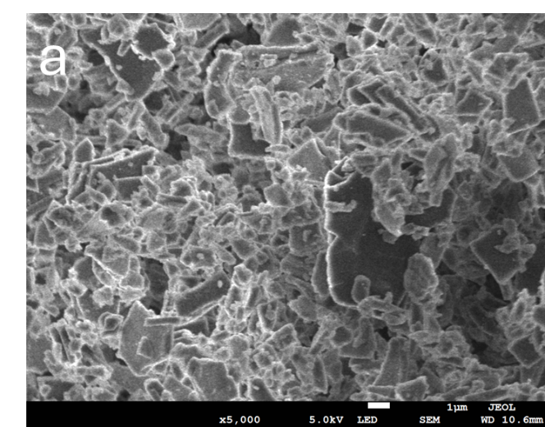 | 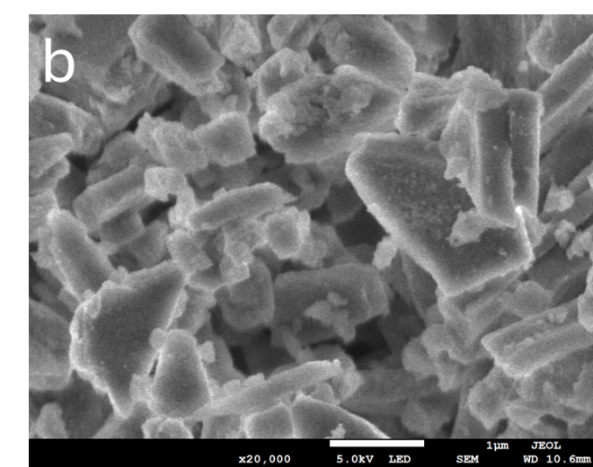
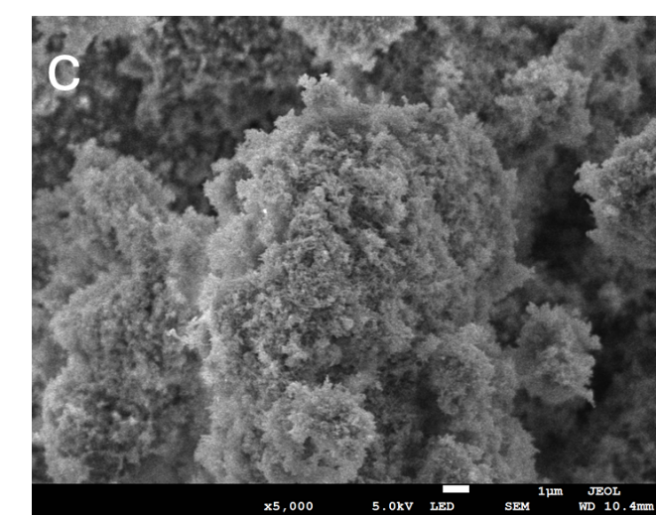 | 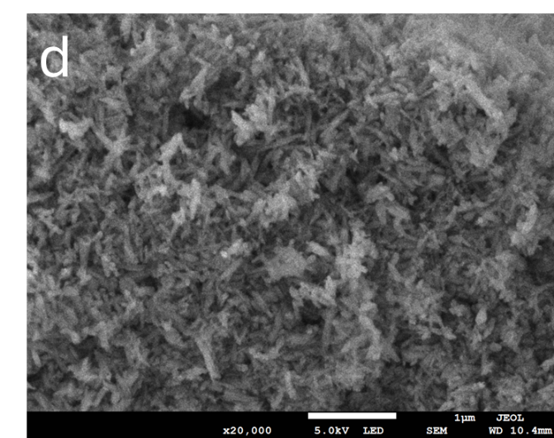
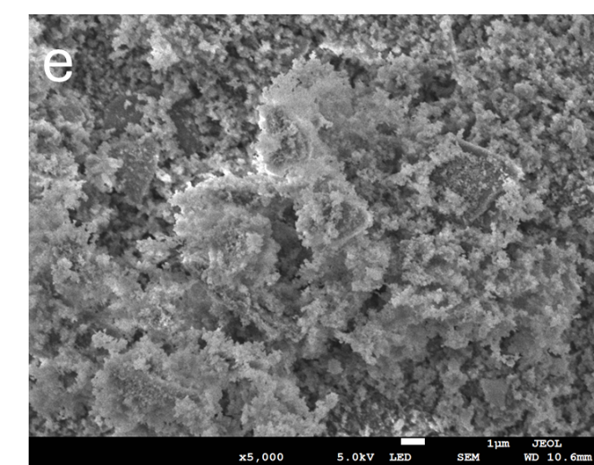 | 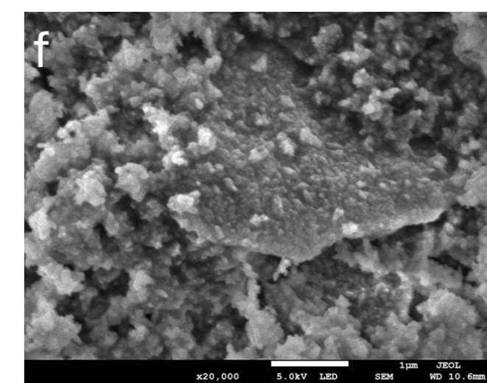
Figure 3 SEM microstructure images of synthesized HA samples and commercial HA samples with x5,000 and x20,000 magnifications. (a) & (b) Pearl platelets used in this study; (c) & (d) Synthesized HA particles for comparison; (e) & (f) p/CaP composite particles; newly formed amorphous CaP particles could be distinguished from the surface of pearl platelets. Scale bars at the bottom of images represent from (a) to (f) are 1 μm
The SEM analyses of particle samples showed the diverse morphological properties of composite powders as a result of different synthesis methods. Pearl powder samples exhibited a significantly different morphology from the HA samples, that is, a typical platelet structure on the micro and nano scales. The commercial unsintered HA powders demonstrated typical rod-like pin structures. Samples obtained from the precipitation method showed a structure more similar to that of the commercial sample. Samples synthesized from the hydrothermal technique showed a more amorphous structural morphology, which differs from the previous studies, suggesting that the design of the synthesis process by using the oven in this study requires further improvements to increase the crystallinity. Furthermore, the attachment of CaP crystals and pearl platelets as demonstrated from the SEM images, indicated that the incorporation of pearl and CaP is feasible in this study. A recent study conducted by Lotsari et al demonstrated that the existence of amorphous CaP clusters is beneficial for promoting the growth of bone apatites [31].

3.2 Composite scaffold properties
The ATR spectra of different scaffold samples including 10, 30, 50 wt.% pearl1_CaP9/CS (P1CaP9/CS), 10, 30, 50 wt.% P3CaP7/CS, and 10, 30, 50 wt.% P5CaP5/CS are displayed in Figure 4.
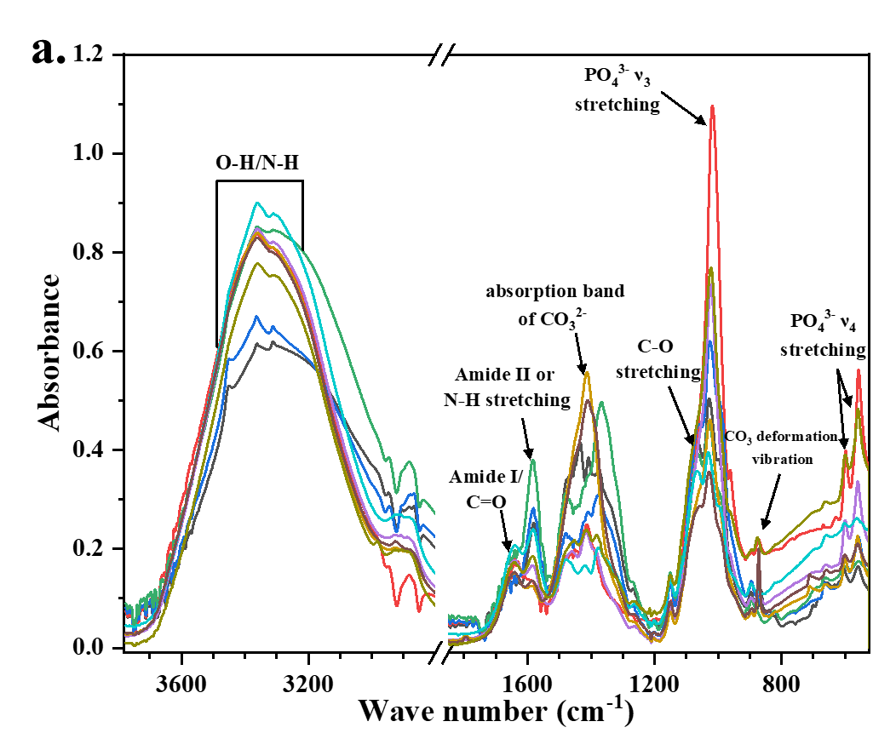 | 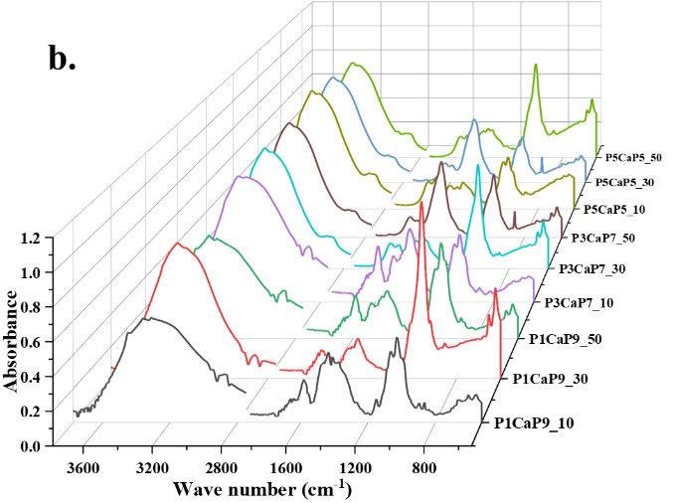
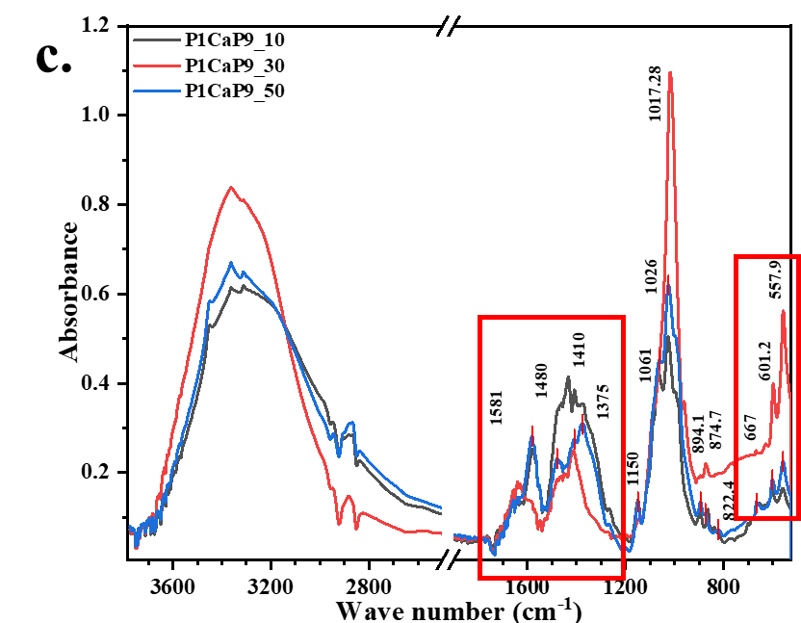 | 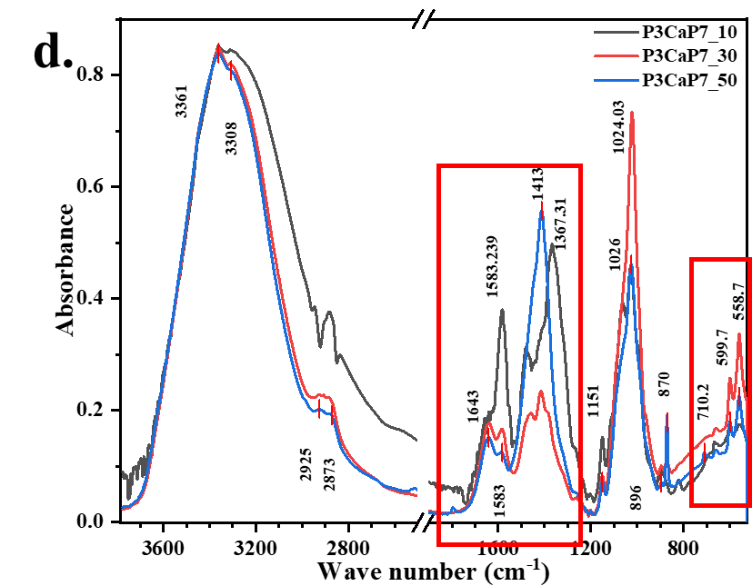
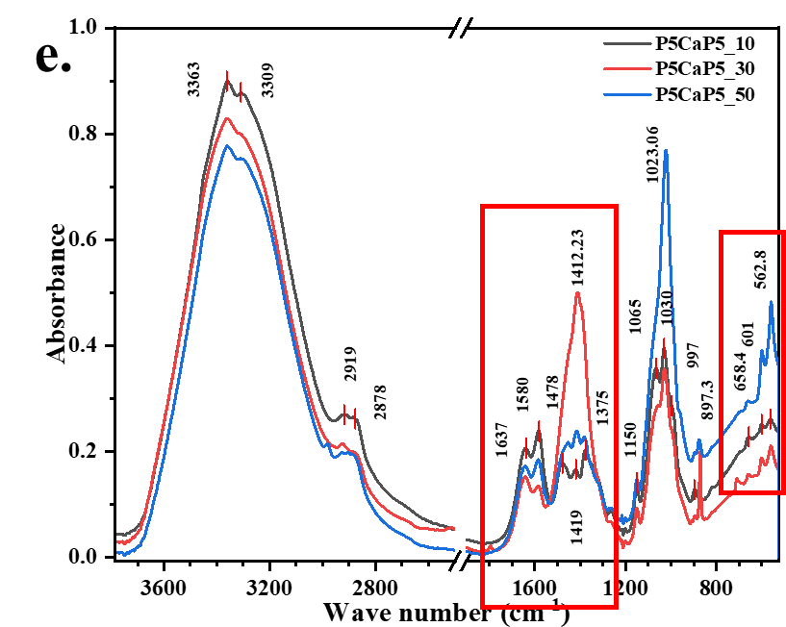
Figure 4 Comparison FTIR-ATR patterns of three different groups of p/CaP chitosan scaffolds of different compositions. The P_{x}CaP_{y} , the x and y stands for pearl to CaP ratio, 10, 30, 50 stands for wt.% of composite particles in chitosan scaffolds. (a) & (b) The overlay and stack ATR spectrums of 10, 30, 50 wt.% P1CaP9_CS, P3CaP7_CS and P5CaP5_CS groups; (c), (d), & (e) ATR comparison spectra for composite p/CaP scaffolds in different composition groups.
For the p/CaP composite CS scaffolds, the comparative spectrum is given in Figure 4. In comparison to sole CS, pearl/CS and HA/CS scaffolds, the p/CaP composite CS scaffolds exhibited the combined characteristic peaks of HA, pearl and CS. Due to the chemical properties of pearl platelets, CaCO₃ is dissolvable in acidic solution, and as the morphological images displayed in Fig. 5, the CaP particles are separately located on the surface of the pearl platelets. Therefore, this morphological structure cannot allow HA to encapsulate the pearl platelet resulting in the dissolution of the CaCO₃ that results in different intensity of the CO₃²⁻ deformation peak at roughly 869 cm⁻¹. A peak shift was observed in the spectrums, in the region near 1020 cm⁻¹, which was assigned to the PO₄³⁻ asymmetric stretching. With HA content decreasing, the P-O peak shifted from (P1CaP9/CS 30 wt.%) 1017 cm⁻¹ towards (P5CaP5/CS 50 wt.%) 1025 cm⁻¹. The intensity of the PO₄ band was also decreased in agreement with the decreasing trend in HA content. Moreover, the peak shift of the absorption carbonate band at around 1410 cm⁻¹ towards 1360 cm⁻¹ was observed in the spectra, and the intensity of the band increased proportionally to the increasing concentration of pearl powders. On the other hand, the crystallinity of composite particles decreased, as evidenced by the decreasing intensity of characteristic phosphate and carbonate peaks.
Comparative graphs presented in Fig 4 (c), (d), & (e) show the different weight percentages of scaffolds possessing same pearl to CaP ratio. The comparative spectra were divided in accordance with the composition of composite particles, The results showed that when the weight percentages of mineral particles were increased, the intensity of the absorption carbonate peak at 1415 cm⁻¹ increased, which covered the C-H bending peak and the C-N stretching peak existing in the chitosan matrix. This indicates that the dissolvement of peal powders released the free carbonated ions which were fixed by the cross-linked polymeric chitosan matrix. The phosphate ν₄ bands in the region of 520-660 cm⁻¹ were detected by the infrared spectroscopy. Only peaks centred at 601 and 558 cm⁻¹ showed well-defined sharp bands, which was in agreement with the previous study [29]. This result suggested that although part of the p/CaP composite particles can be dissolved by the HAc, a certain amount of CHA might also exist on the surface of the scaffold. In addition, it has been noticed that in P1CaP9 and P3CaP7 composite CS scaffolds, 30 wt.% samples possessed slightly more intensity of the phosphate peak at around 1017-1025 cm⁻¹, but differently in the p5h5 sample. This result might correspond with the detailed structural properties of p/CaP composites requiring further investigations.
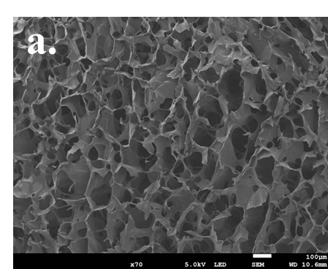 | 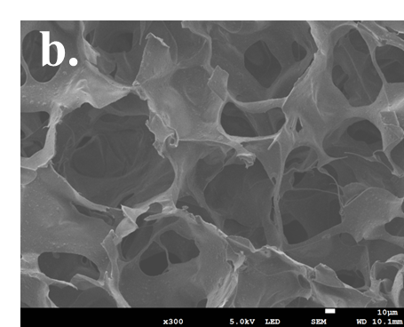
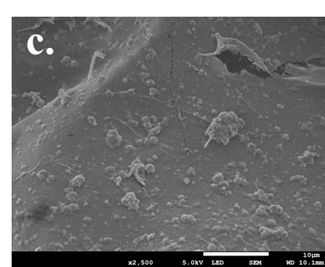 | 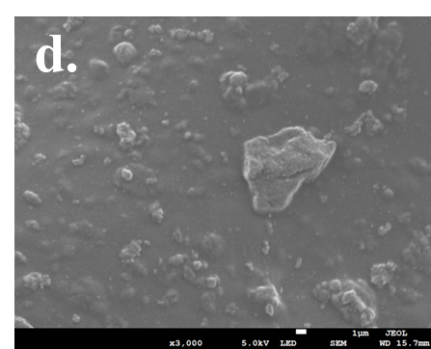
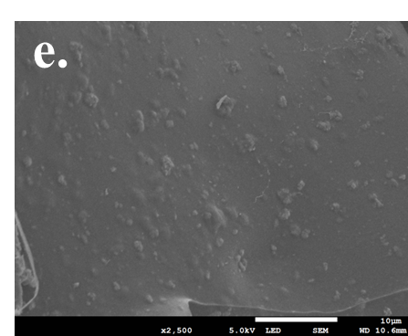 | 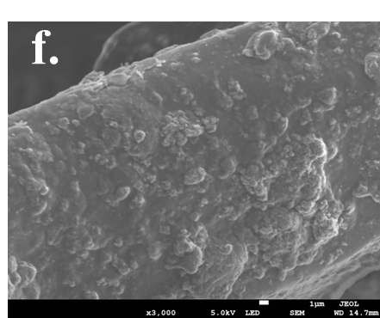
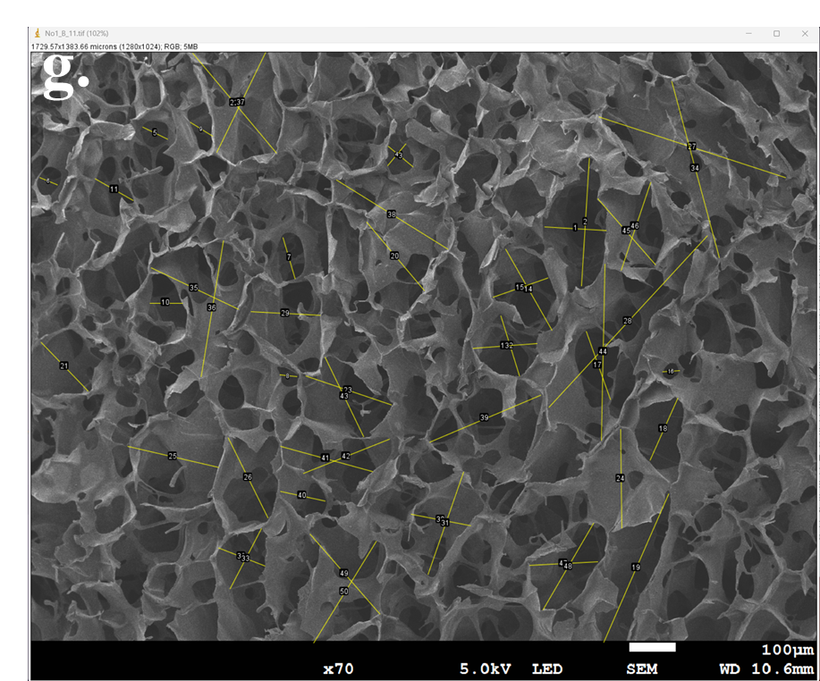 | 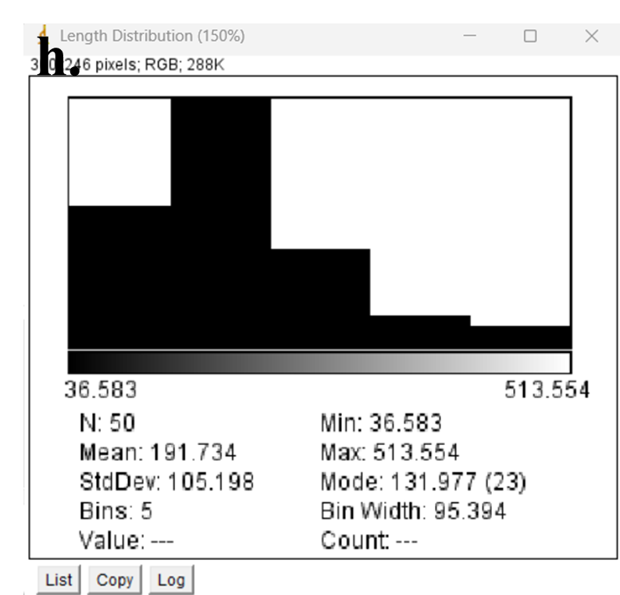
Figure 5 SEM microstructure images of pearl/CaP_CS scaffold samples under different magnifications. (a) & (b) Internal porous structure of the composite scaffolds (pore size ranging from 26 to 584 μm); . (c), (d), (e), & (f) The morphology of p/CaP composite scaffolds with different pearl to CaP ratio and p/CaP compositions. (c) & (d) P3CaP7_30_CS scaffold, (e) P1CaP9_30_CS scaffold, (f) P5CaP5_30_CS scaffold. (g) &(h) are presented using ImageJ for analysis of the diameter of pores in one SEM image for the composite scaffolds and the diameter distribution. Fig 5 (a) magnification x70, 100 μm; Fig 5 (b) magnification x100, 10 μm; Fig 5 (c) & (e) magnification x2,500, 10 μm; Fig 5 (d) & (f) magnification x3,000, 1 μm.
All scaffolds exhibited interconnected porosity and it was possible to observe the distribution of ceramic crystals loaded onto the scaffold. As shown in Figure 5 a-f, the combination of different concentrations of ceramic crystals and the different kinds of components did not lead to visible changes in the structure of scaffolds.
Similar pearl platelet morphology was observed from the pearl/CaP_chitosan composite scaffold in Figure 5 c and d. Moreover, the amorphous CaP particles were found embedded on the wall of chitosan scaffolds and attached on the pearl platelets. With increasing concentration of composite powders, p/CaP particles covered the walls of chitosan scaffold more thoroughly and were dispersed on the surfaces more uniformly. Moreover, the increasing concentration of p/CaP particles also decreased the porosity of scaffolds which was confirmed by the porosity estimation analysis. The change of pearl to CaP ratios also affected the porosity of scaffolds; with the higher concentration of pearl platelets, the porosity of scaffolds and the average pore size decreased slightly but the structure was not affected as demonstrated in Table 2.
Table 2. Diameters of pores from the SEM images of all scaffolds.
Names | N total | Mean | Standard Deviation |  | Minimum | Median | Maximum | Median absolute deviation
 |  | μm | μm | μm |  | μm | μm | μm
CS | 351 | 110.30 | 104.35 | 31.86 |  | 98.58 | 589.97 | 11.72
P1 | 358 | 121.40 | 115.40 | 32.18 |  | 99.27 | 595.87 | 22.14
P3 | 363 | 134.78 | 129.14 | 30.27 |  | 95.15 | 560.47 | 39.63
P5 | 373 | 114.50 | 108.88 | 30.19 |  | 82.98 | 558.97 | 21.52
H1 | 349 | 109.03 | 103.70 | 28.61 |  | 87.57 | 529.70 | 21.57
H3 | 388 | 118.86 | 113.54 | 28.56 |  | 91.47 | 528.81 | 27.38
H5 | 353 | 127.04 | 121.82 | 28.03 |  | 88.34 | 519.07 | 38.69
P1CaP9_10 | 347 | 121.88 | 116.40 | 29.43 |  | 83.35 | 544.97 | 28.53
P1CaP9_30 | 355 | 128.20 | 122.92 | 28.37 |  | 91.06 | 525.30 | 37.13
P1CaP9_50 | 358 | 128.93 | 123.07 | 31.49 |  | 107.73 | 582.67 | 20.23
P3CaP7_10 | 356 | 126.24 | 120.52 | 30.69 |  | 96.06 | 568.29 | 30.55
P3CaP7_30 | 362 | 138.07 | 132.25 | 31.22 |  | 107.20 | 578.07 | 20.88
P3CaP7_50 | 370 | 107.58 | 121.79 | 31.08 |  | 96.89 | 575.43 | 30.69
P5CaP5_10 | 349 | 110.85 | 115.96 | 26.24 |  | 100.49 | 485.95 | 34.36
P5CaP5_30 | 352 | 102.86 | 105.97 | 26.25 |  | 92.50 | 486.01 | 32.35
P5CaP5_50 | 355 | 99.52 | 104.17 | 28.75 |  | 88.88 | 532.34 | 27.71
This phenomenon may be associated with the agglomeration of p/CaP composite particles, which could block the pores of the CS matrix. The higher pearl to CaP ratio (from 10:90 to 50:50) additionally led to increased attachment of CaP onto the pearl surfaces, resulting in larger particle sizes and a subsequent decrease in the average pore size within the scaffold. This observation aligns with findings from previous studies [32-34].
The results of the porosity test were calculated and are summarized below in Table 3. Overall, the porosity of the scaffolds prepared in this research was relatively high, all over 60%, and the density of scaffolds increased because of incorporation of ceramic particles. In accordance with previous studies of porous scaffolds for bone regeneration [35-37], the porosity of scaffolds is an important parameter for the scaffolds but not the key factor. Higher porosity in scaffolds contributes to a greater surface area, favourable cell attachment and protein adhesion on the scaffold in vivo [35, 38]. On the other hand, restricted pore size and lack of space for infiltration forces cells to differentiate instead of proliferating, thus, relative high porosity with optimal pore size may be more appropriate for encouraging bone formation in vivo [39-41].

Table 3. Densities and porosities of all sample scaffolds.
 | Composition | Density (g/cm3) | Porosity
CS |  | 0.061 | 80.33±10.37%
P1 |  | 0.065 | 81.77±3.76%
P3 |  | 0.071 | 79.00±4.49%
P5 |  | 0.076 | 76.23±5.42%
H1 |  | 0.079 | 81.35±3.42%
H3 |  | 0.082 | 79.23±4.17%
H5 |  | 0.089 | 75.10±7.27%
P1CaP9_10 |  | 0.067 | 78.64±1.08%
P1CaP9_30 |  | 0.072 | 75.83±5.40%
P1CaP9_50 |  | 0.075 | 69.25±5.42%
P3CaP7_10 |  | 0.065 | 78.17±1.18%
P3CaP7_30 |  | 0.068 | 76.13±1.70%
P3CaP7_50 |  | 0.074 | 70.90±6.79%
P5CaP5_10 |  | 0.064 | 69.73±8.62%
P5CaP5_30 |  | 0.068 | 67.73±4.62%
P5CaP5_50 |  | 0.071 | 63.73±3.92%
The density of all scaffolds was increased with the incorporation of ceramic particles. Compared with different compositions of pearl: CaP ratio, with the increasing concentration of pearl powders, the density of scaffolds decreased which might be related to the coating effect of CaP; the density of CaP is higher than pearl powders (3.16 g/cm³ > 2.73 g/cm³). The highest porosity among all scaffolds was 81.77% from the P1_CS scaffold whilst the lowest porosity of scaffolds was 63.73% from the P5CaP5_50 CS scaffold. Combined with the diameter data from the SEM results, the porosity and the geometry of pores might be independent and random of these two factors. Statistically, the distribution of pores diameters shown in Table 2 is positively skewed, which means most of the pores generated by the freeze-drying technique have diameters in the range 30 to 200 μm.
All scaffold samples exhibited an elastic-plastic-elastic behaviour as shown in the curve, which might be assigned to their porous structure. A significant increase in compression strength and elastic modulus were observed in comparison with the mean value between sole CS scaffold and composite CS scaffolds. At the 70% strain point, the pure CS scaffold possessed the lowest mechanical strength, reaching approximately 74 kPa, while the pearl/CS 50 wt.% sample exhibited the highest strength at around 330 kPa.
The elastic modulus was calculated according to the stress-strain linear regression of the lower elastic region of all samples and the R² were all ≥0.998. The elastic modulus of the composite CS scaffolds was within the region of articular cartilage tissues reported to be in the range of 0.5 and 1.0 MPa [42, 43]. But comparing the Young’s modulus of human trabecular bone tissues which were reported previously to be in the range from 0.9 GPa to 2.0 GPa, the test results revealed that the chitosan based porous scaffolds might not be ideal compared to other hard tissue engineering scaffolds [44, 45].
However, with more stress applied to the scaffolds, due to the porous structure, the behaviour of the composite scaffolds showed a relatively good elastic performance(no significant break points were observed from the curves except for the HA/CS scaffold samples) as well as compressive strength. This improvement might conceivably result from the increasing Ca²⁺ and carbonate groups from the pearl or pearl/CaP components interacting with the amino groups in the CS [46, 47].

3.3 MG-63 cells growth on scaffolds
Following the measurement of particles and scaffold properties, the scaffolds underwent evaluation for in vitro culture of MG-63 cells.
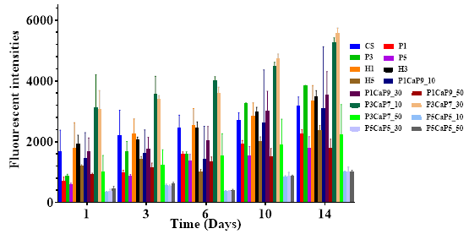
Figure 6 The cell proliferation and cytocompatibility analysed by the AB assay up to 14 days of cultures. 6 groups of samples were tested including the sole CS, the pearl_CS group, the HA_CS group, pearl/CaP(10:90)_CS group (P1CaP9), pearl/CaP(30:70)_CS group (P3CaP7), and pearl/CaP(50:50)_CS group (P5CaP5).
The fluorescent intensities of samples between different groups were in the vicinity of 500 to 3,000 in day 1 and most samples showed a slight increase during the first week of culture. The reasons for the different initial fluorescent intensities from different sample groups are probably due to the affinity between cells and the scaffolds that the migration and attachment process on different samples might be influenced by different factors, including the surface energy, porosity of scaffolds. Obviously, the P5CaP5 group showed the worst biocompatibility at each time point compared to the other p/CaP composite groups, the HA group and the pearl group. This might be correlated to the concentration of CaCO₃ contents that as mentioned in the study of incorporating high concentration of calcium carbonate with chitosan scaffold, as well as the lower porosity and the average pore size [48].
As time increases, MG-63 cells on all scaffolds proliferated obviously. During the first week of incubation, all samples show increasing proliferation of MG-63 cells except the P5CaP5 group samples. Moreover, cells proliferated on composite scaffolds in H1, H3, P3CaP7_10 and P3CaP7_30 groups more significantly than on the pure CS scaffold group, which would indicate the good cytocompatibility and encourage proliferation of MG-63. From day 6 to day 14, compared with the first incubation interval, a slightly higher proliferation of cell metabolic activities was observed; especially the P5CaP5 group samples show a significant increased fluorescent intensity at day 10. The highest cell viability was obtained with the P3CaP7_30 sample at day 14 which is similar to the P3CaP7_10 sample.
 | Original | Day 14
H3 | 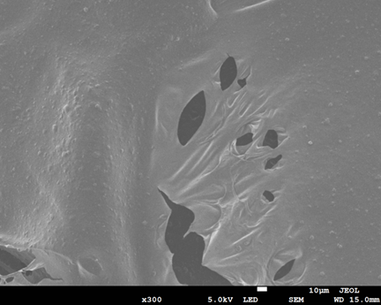
P3 | 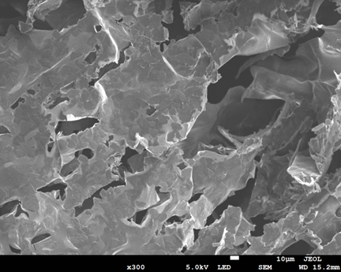 | 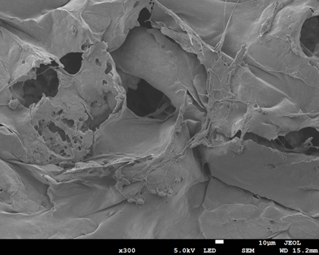
P1CaP9_30 | 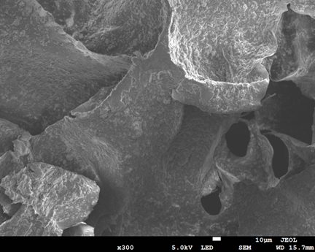 | 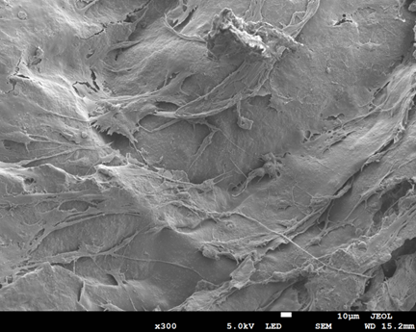
P3CaP7_30 | 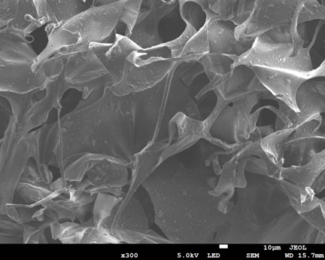 | 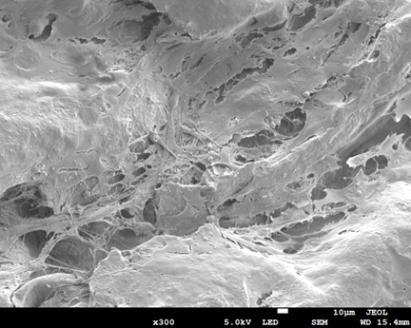

Figure 7 The comparative SEM images of various scaffolds, including the H3, P3, P1CaP9_30 and P3CaP7_30 scaffold samples, respectively; and samples with grown MG-63 cells after 14 days incubation. All images are at x300 magnifications, 10 μm scale bar.
The visible cell proliferation and attachment morphologies on the scaffold samples were observed by SEM at day 14, which would be a supportive method to confirm the results obtained from the AB assay.
As shown in Figure 7, all composite scaffolds exhibited a similar microstructure, with particles distributed on the chitosan matrix. On day 14, cells were observed successfully attached to the surface of each sample with extending morphology. Firstly, compared between P3 and H3 samples, cells were successfully distributed on the top surface on both scaffolds, and showed obvious differences between H3 and P3 in that more external cellular cross-linking morphologies could be observed from the P3 samples. It is revealing that pearl powder indeed affected the cell morphology on the scaffold surfaces. However, cell numbers on P3 scaffold were slightly reduced compared to the H3 scaffold, which corresponded to the result of the AB assay. In addition, the P1CaP9_30 and P3CaP7_30 scaffold samples showed a higher number of cell attachments compared to the P3 scaffold samples, and the cellular cross-linking structure could be more identified from the SEM images. Thus, the existence of the p/CaP composite particles not only showed cell proliferation ability, furthermore, the ability of promoting fibroblasts migration was also approved from this research.

4. Discussion
The synthesis of composite powders involving pearl and calcium phosphate (p/CaP) through three distinct methods, stemming from hydroxyapatite (HA) synthesis, represents an innovative approach. Amorphous CaP has garnered increasing attention in comparison to stoichiometric HA due to its crucial role in bone apatite nucleation and the mineralization process within the bone remodelling cycle. Previous studies, such as Raynaud’s (2002), have suggested that amorphous calcium phosphate (ACP) may be sequestered and deposited via intracellular and vesicular mechanisms in the gap zones of the collagen matrix. This proposed role positions ACP as a transient phase, acting as a precursor for subsequent apatite growth. Complementary in-vitro investigations, employing collagen as the organic scaffold, further substantiate the presence of ACPs at the gap zones of collagen, serving as a precursor stage before transforming into apatite. Earlier studies by Boonrungsiman et al., Omelon et al., and Rustom et al., have provided additional insights into the growth mechanism associated with the transformation of amorphous CaP to apatite [49-51]. Consequently, the anticipated outcome for p/CaP composite particles is an enhancement in biocompatibility and osteogenesis properties.
The SEM analysis of p/CaP composite samples uncovered a compelling Integration of embedded or attached crystals intricately distributed throughout the pearl platelets. Even at lower magnifications, the synthesized amorphous CaP crystal agglomerates were clearly visible, while at higher magnifications, an intricate, amorphous interconnected structure emerged. This unique amalgamation of pearl and CaP imparted distinctive morphological characteristics, particularly at higher magnifications, setting it apart from HA samples obtained through alternative synthesis methods. Significantly, the SEM images provided compelling evidence supporting the feasibility of incorporating both pearl and CaP in this study.
The attachment of CaP crystals and pearl platelets showcased promising interactions, substantiating the notion that amorphous CaP clusters, as observed in this study, play a pivotal role in fostering the growth of bone apatites. This observation aligns with the findings of Lotsari et al., underlining the critical importance of amorphous CaP clusters in the autocatalytic nucleation of HA and the formation of Ponsner's clusters [31]. The SEM results offer valuable morphological insights, laying the foundation for further explorations into the potential applications of the pearl/CaP composite in the realm of bone regeneration and related fields.
The freeze-dried composite scaffolds in this investigation showcased interconnected and porous structures with homogeneity. SEM characterization of the porous morphologies across all scaffolds revealed dimensions ranging from 26 to 600 µm, aligning with the requisites for cell migration and proliferation in bone tissue engineering. The surface morphologies of the pearl, HA, and p/CaP composite scaffolds exhibited distinctive rough structures. The HA/CS scaffold displayed a pin-like morphology attributed to the unique crystal structure of commercial HA. Conversely, pearl/CS scaffolds showed platelet crystal distribution on scaffold walls. The p/CaP_CS scaffolds presented a morphology combining pearl platelets and HA, but SEM revealed more dispersed amorphous crystal agglomerations.
FTIR-ATR spectroscopy was employed to characterize the chemical properties of the scaffolds. Limited differences in peak intensity between the bottom and top layers of all scaffold samples indicated a relatively homogeneous distribution of pearl, HA, and p/CaP composite, promising for their bioactive performance.
The mechanical properties of different scaffold groups demonstrated enhancements when comparing HA scaffold groups with the p/CaP scaffold groups. None of the scaffolds experienced breakage at 70% strain, and all specimens rebounded close to their initial state after testing. The highest mean compression strength at 70% in the composite chitosan scaffolds was noted at 330 kPa, specifically from the pearl 50 wt.% CS scaffold. Additionally, the highest elastic modulus reached up to 0.87 MPa.
This compressive test result is associated with the distinct morphological structures of pearl, HA, and p/CaP. As previously discussed, the platelet structure of pearl was more embedded on the chitosan matrix wall, while p/CaP scaffolds demonstrated larger agglomerations attached to the surface. Research by Zeng and Zhang proposed that the incorporation of pearl can significantly enhance the mechanical properties of composite chitosan microspheres, with cationic compounds from chitosan particles actively interacting with the organic matrix of pearl shell powders [52]. This perspective provides insight into the enhancement of mechanical strength of p/CaP chitosan scaffolds. However, increasing the pearl to CaP ratio to 50:50 resulted in larger particle sizes, causing clotting of internal pores, as indicated by decreased porosity in the porosity estimation section, as well as changes in the elastic modulus.
In cell culture studies, scaffold compositions did not show any cytotoxicity effect on the cells, and cells gradually proliferated during the culturing for up to 14 days. In the experiment group, the cell seeding density of 20,000 cells per scaffolds (Ø:12 mm x 5 mm) cultured in 24-well plate by using 1 mL growth media was found to be the optimal seeding condition. In this experiment, the initial cell attachment after 24 h was very different in samples, that the pearl chitosan groups demonstrated the worst cell attachment but the composite p/CaP group had significantly better cell activity. After 14-days, the beneficial effect of pearl, HA and CaP individually at increasing cell compatibility has been reported by different studies [15, 53, 54]. The effect of HA in contributing to absorption of serum proteins including fibronectins and vitronectins leading to the attachment of integrins and hence providing attachment of osteoblast precursor cells has been reported [55].
In the present study, the cell viability of samples exhibited variations between test intervals, and the cell proliferation performance with all compositions showed distinct patterns. The p/CaP group scaffolds, particularly the P3CaP7_30 scaffold, demonstrated the highest terminal fluorescent intensity after the 14-day incubation period. This finding suggests robust cell proliferation and activity in this specific composition. However, it is noteworthy that the P5CaP5 group exhibited the lowest fluorescent intensity, indicating comparatively lower cell proliferation.
Relevant studies by Zhang and Zhang, Zhang et al., and Li et al., provide insights into the impact of varying concentrations of CaP and pearl on cellular activity and proliferation [14, 54, 56, 57]. Zhang and Zhang focused on the uptake of macroporous chitosan/calcium phosphate composite scaffolds, revealing that increasing the concentration of CaP led to enhanced cellular activity and proliferation, supporting the formation of apatite [54]. Zhang et al., explored the incorporation of pearl powder content with PCL scaffolds, demonstrating that higher pearl contents, up to 80 wt.%, facilitated increased proliferation and osteogenesis [56]. Li et al studied nano-pearl powder/chitosan-hyaluronic acid porous composite scaffolds and concluded that higher pearl concentrations (0 to 25 wt.%) promoted cell proliferation and osteogenesis [14].
Furthermore, the topography of various scaffolds has been shown to influence cell culture test outcomes in previous studies [58-61]. Serving as a significant physical cue, scaffold topography in this investigation was found to be closely associated with particle distribution and compositions. SEM images depicted distinct topographical variations among the four samples presented in Figure 7. Moreover, samples exhibiting greater numbers of grooves/pores and particles adhering to the scaffold surface displayed higher AB assay results, consistent with prior research findings. However, the precise mechanism underlying the observed enhancement in cell proliferation on these scaffolds remains elusive. Therefore, further investigations are warranted to comprehensively understand the intricate relationship between scaffold topography and composite particles.
However, the observed poor cell proliferation reaction in the present study with a 50:50 ratio of pearl to CaP suggests a unique response that might be related to an unknown mechanism. This anomaly emphasizes the need for further in-depth investigation into the specific conditions and interactions at this particular composition ratio. Understanding the underlying factors influencing cell behaviour in response to different material compositions is crucial for optimizing scaffold design and enhancing their effectiveness in applications. The mechanism of precipitation attachment of pearl and CaP is not clear yet in this study, and most of work in this study can only provide the discussion of the properties of CaP. Moreover, as SEM images suggest, amorphous CaP enveloped the surface of the pearl platelets and the pearl platelets only provided extra Ca²⁺ and CO₃²⁻ as shown in FTIR-PAS spectra. However, the organic matrix of pearl has not been studied in this study but has been considered in the future experiment plan.

5. Conclusions
This study demonstrated the feasibility of preparing the p/CaP composite powder, incorporation of p/CaP into chitosan scaffolds, and demonstration of the non-cytotoxicity and the proliferation capability of the scaffold using the MG-63 cell lines involve in-vitro biological test.
The p/CaP composite powders were synthesized by the precipitation method. CaP covered the surface of pearl platelets. Pearl promoted the generation of CaP components during the synthesis process of HA and the carbonate groups played an important role.
FTIR-ATR analysis proved the distribution of p/CaP particles throughout the chitosan matrix quantitatively. Compressive mechanical analysis showed the incorporation of p/CaP composite powder into the chitosan matrix enhanced the compressive strength.
p/CaP_CS scaffolds demonstrated a higher degradation ratio than the HA groups and lower than the pearl groups, indicating the existence of CO₃ compounds, and amorphous CaP composite influenced the degradation process of the scaffold.
The fabricated porous p/CaP scaffolds were non-cytotoxic in the presence of MG-63 osteoblast cells. The 14-day cell culture results highlighted the optimal performance of scaffolds with a 30:70 pearl: CaP ratio, demonstrating enhanced proliferation and differentiation of osteoblasts. CaP ratios and p/CaP concentrations influenced biological response.

Author Contributions: Conceptualization, Z.Y., R.S. and I.R.; methodology, Z.Y. R.S. and I.R.; formal analysis, Z.Y.; investigation, Z.Y. and R.S.; resources, R.S., I.R. and T.E.L.D.; data curation, Z.Y.; writing—original draft preparation, Z.Y.; writing—review and editing, R.S., I.R. and T.E.L.D.; visualization, Z.Y.; supervision, I.R. and T.E.L.D.; project administration, R.S., I.R and T.E.L.D.; funding acquisition, Z.Y., R.S. and I.R. All authors have read and agreed to the published version of the manuscript.”
Data Availability Statement: available on request
Acknowledgments: We are grateful to the kind donation of pearl powders from the gN Pearl Group (Jingrun Zhenzhu, Hainan, China).
Conflicts of Interest: The authors declare no conflict of interest.

References
[1] R. Dimitriou, E. Jones, D. McGonagle, P.V. Giannoudis, Bone regeneration: current concepts and future directions, BMC Med 9(1) (2011) 66.
[2] H. Petite, V. Viateau, W. Bensaid, A. Meunier, C. de Pollak, M. Bourguignon, K. Oudina, L. Sedel, G. Guillemin, Tissue-engineered bone regeneration, Nat Biotechnol 18(9) (2000) 959-63.
[3] W. Wang, K.W.K. Yeung, Bone grafts and biomaterials substitutes for bone defect repair: A review, Bioact Mater 2(4) (2017) 224-247.
[4] R. Langer, D.A. Tirrell, Designing materials for biology and medicine, Nature 428(6982) (2004) 487-92.
[5] R. Lanza, R. Langer, J.P. Vacanti, A. Atala, Principles of tissue engineering, Academic press2020.
[6] J.W. Ager, G. Balooch, R.O. Ritchie, Fracture, aging, and disease in bone, Journal of Materials Research 21(8) (2006) 1878-1892.
[7] L.J.B. Melton Iii, Epidemiology of hip fractures: implications of the exponential increase with age, 18(3) (1996) S121-S125.
[8] F.C. Meldrum, Calcium carbonate in biomineralisation and biomimetic chemistry, International Materials Reviews 48(3) (2003) 187-224.
[9] J.W. Morse, R.S. Arvidson, A. Luttge, Calcium carbonate formation and dissolution, Chem Rev 107(2) (2007) 342-81.
[10] L.E. Murr, D.A. Ramirez, The Microstructure of the Cultured Freshwater Pearl, Jom 64(4) (2012) 469-474.
[11] J. Sun, B.J.R.A. Bhushan, Hierarchical structure and mechanical properties of nacre: a review, 2(20) (2012) 7617-7632.
[12] J. Pei, Y. Wang, X. Zou, H. Ruan, C. Tang, J. Liao, G. Si, P. Sun, Extraction, Purification, Bioactivities and Application of Matrix Proteins From Pearl Powder and Nacre Powder: A Review, Front Bioeng Biotechnol 9 (2021) 649665.
[13] E. Lopez, B. Vidal, S. Berland, S. Camprasse, G. Camprasse, C. Silve, Demonstration of the capacity of nacre to induce bone formation by human osteoblasts maintained in vitro, Tissue Cell 24(5) (1992) 667-79.
[14] X. Li, P. Xu, Y. Cheng, W. Zhang, B. Zheng, Q. Wang, Nano-pearl powder/chitosan-hyaluronic acid porous composite scaffold and preliminary study of its osteogenesis mechanism, Mater Sci Eng C Mater Biol Appl 111 (2020) 110749.
[15] Y.S. Liu, Q.L. Huang, A. Kienzle, W.E. Muller, Q.L. Feng, In vitro degradation of porous PLLA/pearl powder composite scaffolds, Mater Sci Eng C Mater Biol Appl 38 (2014) 227-34.
[16] J. Dai, J. Bai, J. Jin, S. Yang, G.J.A.E.M. Li, Stimulation by pearl of mineralization and biocompatibility of PLA, 17(11) (2015) 1691-1697.
[17] V.S. Kattimani, S. Kondaka, K.P.J.B. Lingamaneni, T.R. Insights, Hydroxyapatite–-Past, present, and future in bone regeneration, 7 (2016) BTRI. S36138.
[18] S. Koutsopoulos, Synthesis and characterization of hydroxyapatite crystals: a review study on the analytical methods, J Biomed Mater Res 62(4) (2002) 600-12.
[19] S.H. Maxian, J.P. Zawadsky, M.G. Dunn, In vitro evaluation of amorphous calcium phosphate and poorly crystallized hydroxyapatite coatings on titanium implants, J Biomed Mater Res 27(1) (1993) 111-7.
[20] M. Nagano, T. Nakamura, T. Kokubo, M. Tanahashi, M. Ogawa, Differences of bone bonding ability and degradation behaviour in vivo between amorphous calcium phosphate and highly crystalline hydroxyapatite coating, Biomaterials 17(18) (1996) 1771-1777.
[21] M. Nelson, G. Balasundaram, T.J. Webster, Increased osteoblast adhesion on nanoparticulate crystalline hydroxyapatite functionalized with KRSR, Int J Nanomedicine 1(3) (2006) 339-49.
[22] I. Karampas, C.J.V.S. Kontoyannis, Characterization of calcium phosphates mixtures, 64 (2013) 126-133.
[23] I. Denry, L.T.J.D.M. Kuhn, Design and characterization of calcium phosphate ceramic scaffolds for bone tissue engineering, 32(1) (2016) 43-53.
[24] R. Fada, M. Shahgholi, R. Azimi, N.F.J.A.J.f.S. Babadi, Engineering, Estimation of Porosity Effect on Mechanical Properties in Calcium Phosphate Cement Reinforced by Strontium Nitrate Nanoparticles: Fabrication and FEM Analysis, (2023) 1-11.
[25] J.P. Dillon, V.J. Waring-Green, A.M. Taylor, P.J. Wilson, M. Birch, A. Gartland, J.A.J.B.r.p. Gallagher, Primary human osteoblast cultures, (2012) 3-18.
[26] J. Balmain, B. Hannoyer, E. Lopez, Fourier transform infrared spectroscopy (FTIR) and X-ray diffraction analyses of mineral and organic matrix during heating of mother of pearl (nacre) from the shell of the mollusc Pinctada maxima, Journal of Biomedical Materials Research 48(5) (1999) 749-754.
[27] J.F. Wang, Q.F. Cheng, Z.Y. Tang, Layered nanocomposites inspired by the structure and mechanical properties of nacre, Chemical Society Reviews 41(3) (2012) 1111-1129.
[28] H.Y. Ma, I.S. Lee, Characterization of vaterite in low quality freshwater-cultured pearls, Materials Science & Engineering C-Biomimetic and Supramolecular Systems 26(4) (2006) 721-723.
[29] I. Rehman, W. Bonfield, Characterization of hydroxyapatite and carbonated apatite by photo acoustic FTIR spectroscopy, J Mater Sci Mater Med 8(1) (1997) 1-4.
[30] S. Raynaud, E. Champion, D. Bernache-Assollant, P. Thomas, Calcium phosphate apatites with variable Ca/P atomic ratio I. Synthesis, characterisation and thermal stability of powders, Biomaterials 23(4) (2002) 1065-72.
[31] A. Lotsari, A.K. Rajasekharan, M. Halvarsson, M. Andersson, Transformation of amorphous calcium phosphate to bone-like apatite, Nat Commun 9(1) (2018) 4170.
[32] I.K. Januariyasa, I.D. Ana, Y. Yusuf, Nanofibrous poly(vinyl alcohol)/chitosan contained carbonated hydroxyapatite nanoparticles scaffold for bone tissue engineering, Mater Sci Eng C Mater Biol Appl 107 (2020) 110347.
[33] K. Maji, S. Dasgupta, B. Kundu, A. Bissoyi, Development of gelatin-chitosan-hydroxyapatite based bioactive bone scaffold with controlled pore size and mechanical strength, J Biomater Sci Polym Ed 26(16) (2015) 1190-209.
[34] M. Sari, P. Hening, Chotimah, I.D. Ana, Y. Yusuf, Porous structure of bioceramics carbonated hydroxyapatite-based honeycomb scaffold for bone tissue engineering, Materials Today Communications 26 (2021) 102135.
[35] N. Abbasi, S. Hamlet, R.M. Love, N.T. Nguyen, Porous scaffolds for bone regeneration, J Sci-Adv Mater Dev 5(1) (2020) 1-9.
[36] G. Hannink, J.C.J.I. Arts, Bioresorbability, porosity and mechanical strength of bone substitutes: what is optimal for bone regeneration?, 42 (2011) S22-S25.
[37] V. Karageorgiou, D. Kaplan, Porosity of 3D biomaterial scaffolds and osteogenesis, Biomaterials 26(27) (2005) 5474-91.
[38] C.M. Murphy, M.G. Haugh, F.J.J.B. O'brien, The effect of mean pore size on cell attachment, proliferation and migration in collagen–glycosaminoglycan scaffolds for bone tissue engineering, 31(3) (2010) 461-466.
[39] S.H. Oh, I.K. Park, J.M. Kim, J.H. Lee, In vitro and in vivo characteristics of PCL scaffolds with pore size gradient fabricated by a centrifugation method, Biomaterials 28(9) (2007) 1664-71.
[40] Q.L. Loh, C. Choong, Three-dimensional scaffolds for tissue engineering applications: role of porosity and pore size, Tissue Eng Part B Rev 19(6) (2013) 485-502.
[41] B.C. Gross, J.L. Erkal, S.Y. Lockwood, C. Chen, D.M. Spence, Evaluation of 3D printing and its potential impact on biotechnology and the chemical sciences, ACS Publications, 2014.
[42] F. Guilak, W.R. Jones, H.P. Ting-Beall, G.M. Lee, The deformation behavior and mechanical properties of chondrocytes in articular cartilage, Osteoarthritis Cartilage 7(1) (1999) 59-70.
[43] V.C. Mow, S.C. Kuei, W.M. Lai, C.G. Armstrong, Biphasic creep and stress relaxation of articular cartilage in compression? Theory and experiments, J Biomech Eng 102(1) (1980) 73-84.
[44] A. Odgaard, F. Linde, The underestimation of Young's modulus in compressive testing of cancellous bone specimens, J Biomech 24(8) (1991) 691-8.
[45] J.Y. Rho, R.B. Ashman, C.H. Turner, Young's modulus of trabecular and cortical bone material: ultrasonic and microtensile measurements, J Biomech 26(2) (1993) 111-9.
[46] H.L. Kim, G.Y. Jung, J.H. Yoon, J.S. Han, Y.J. Park, D.G. Kim, M. Zhang, D.J. Kim, Preparation and characterization of nano-sized hydroxyapatite/alginate/chitosan composite scaffolds for bone tissue engineering, Mater Sci Eng C Mater Biol Appl 54 (2015) 20-5.
[47] J. Venkatesan, S.-K.J.M.d. Kim, Chitosan composites for bone tissue engineering—an overview, 8(8) (2010) 2252-2266.
[48] X. Liu, Z.J.S.M.i.M. Wang, Chitosan-calcium carbonate scaffold with high mineral content and hierarchical structure for bone regeneration, 4 (2023) 552-561.
[49] S. Boonrungsiman, E. Gentleman, R. Carzaniga, N.D. Evans, D.W. McComb, A.E. Porter, M.M. Stevens, The role of intracellular calcium phosphate in osteoblast-mediated bone apatite formation, Proc Natl Acad Sci U S A 109(35) (2012) 14170-5.
[50] S. Omelon, J. Georgiou, Z.J. Henneman, L.M. Wise, B. Sukhu, T. Hunt, C. Wynnyckyj, D. Holmyard, R. Bielecki, M.D. Grynpas, Control of vertebrate skeletal mineralization by polyphosphates, PLoS One 4(5) (2009) e5634.
[51] L.E. Rustom, M.J. Poellmann, A.J. Wagoner Johnson, Mineralization in micropores of calcium phosphate scaffolds, Acta Biomater 83 (2019) 435-455.
[52] M. Zeng, C. Qi, X.M. Zhang, Chitosan microspheres supported palladium heterogeneous catalysts modified with pearl shell powders, Int J Biol Macromol 55 (2013) 240-5.
[53] X.X. Zhao, S. Ng, B.C. Heng, J. Guo, L. Ma, T.T.Y. Tan, K.W. Ng, S.C.J. Loo, Cytotoxicity of hydroxyapatite nanoparticles is shape and cell dependent, Archives of Toxicology 87(6) (2013) 1037-1052.
[54] Y. Zhang, M. Zhang, Calcium phosphate/chitosan composite scaffolds for controlled in vitro antibiotic drug release, J Biomed Mater Res 62(3) (2002) 378-86.
[55] G. Wei, P.X. Ma, Structure and properties of nano-hydroxyapatite/polymer composite scaffolds for bone tissue engineering, Biomaterials 25(19) (2004) 4749-57.
[56] X. Zhang, X. Du, D. Li, R. Ao, B. Yu, B. Yu, Three dimensionally printed pearl powder/poly-caprolactone composite scaffolds for bone regeneration, J Biomater Sci Polym Ed 29(14) (2018) 1686-1700.
[57] Y. Zhang, M. Zhang, Synthesis and characterization of macroporous chitosan/calcium phosphate composite scaffolds for tissue engineering, J Biomed Mater Res 55(3) (2001) 304-12.
[58] G. Li, X. Zhao, W. Zhao, L. Zhang, C. Wang, M. Jiang, X. Gu, Y.J.B. Yang, Porous chitosan scaffolds with surface micropatterning and inner porosity and their effects on Schwann cells, 35(30) (2014) 8503-8513.
[59] G. Wang, Q. Ao, K. Gong, A. Wang, L. Zheng, Y. Gong, X.J.A.b. Zhang, The effect of topology of chitosan biomaterials on the differentiation and proliferation of neural stem cells, 6(9) (2010) 3630-3639.
[60] G.R. Ragetly, D.J. Griffon, H.-B. Lee, L.P. Fredericks, W. Gordon-Evans, Y.S.J.A.B. Chung, Effect of chitosan scaffold microstructure on mesenchymal stem cell chondrogenesis, 6(4) (2010) 1430-1436.
[61] A.M. Ross, Z. Jiang, M. Bastmeyer, J.J.S. Lahann, Physical aspects of cell culture substrates: topography, roughness, and elasticity, 8(3) (2012) 336-355.

