An Exploratory Analysis Investigating the Significant Turn Demands of the Premier League, FA Cup, League Cup and UEFA Europa League for an English Soccer Team

Erin Griffiths BSc (Hons) (2023)
This thesis is submitted to Lancaster University for the Master of Science Degree in Medical Sciences (MSc by Research).
Lancaster Medical School Faculty of Health and Medicine Lancaster University October 2023

Contents
Acknowledgements 5
Declaration 6
List of Tables 7
List of Figures 8
Glossary 9
1.0 Abstract 10
1.1 Objectives 10
1.2 Methods 10
1.3 Results 11
1.4 Conclusions 11
2.0 Introduction 12
2.1 General Football Demands 12
2.2 Change of Direction (COD) 13
2.2.1 Defining COD 13
2.2.2 Number of COD movements 13
2.3 Turn Characteristics 18
2.3.1 Angle of turns 18
2.3.2 Entry Speed of turns 19
2.3.3 Turn Duration 20
2.3.4 Deceleration 21
2.4 Competition Type 22
2.5 Tracking Systems 23
2.5.1 Light Detecting and Ranging (LiDAR) tracking systems 23
3.0 Methods 25
3.1 Research design: 25
3.2 Game Analysis and Player Data: 25
3.3 Turning Metrics 26
3.4 Statistical Analysis 27
4.0 Results 27
4.1 Total Number of Turns per Position 27
4.2 Turns by Angle and Position 28
4.2.1 Proportions of Turns Completed in Each Angle Group 32
4.3 Turns by Entry Speed and Position 34
4.3.1 Proportions of Turns Completed in Each Entry Speed Group 39
4.4 Investigating the Relationship between Entry Speed within Each Angle Group 41
4.4.1 Entry speed variations between positions for each angle group 42
4.5 Entry Speed and Turn Angle Incidence Rates 45
4.5.1 Distribution of all Turns by Angle and Entry Speed 47
4.6 Deceleration 48
4.7 Turn duration 50
4.8 Competition Differences 51
5.0 Discussion 55
5.1 Total number of Turns 55
5.2 Turns by Angle and Position 57
5.3 Turns by Entry Speed and Position 59
5.4 Entry Speed and Angle Groups 61
5.5 Turn Demands and Competition Types 62
5.6 Turn Duration 62
5.7 Deceleration 63
5.8 Limitations 64
5.9 Conclusion 64
References 66

Acknowledgements

I would like to take this opportunity to thank the people that have helped me with this study:
- Sportlight ® for trusting me with this project and providing me with the opportunity to work with data from the most elite teams in soccer.
- Dr. Kate Slade for always being there to help answer my coding questions and for just being so unbelievably helpful with everything!
- Dr. Chris Gaffney for always knowing the next step, reading through my work and giving me invaluable advice.
- My family and friends for their motivational pep-talks and encouragement throughout the whole process.
- Dr. Tim Barry, for his unwavering support throughout. Providing me with unlimited meetings, help and advice, whilst making the whole process as enjoyable and engaging as possible. A supervisor who has gone massively above and beyond all expectations, I’ll be forever grateful.

Declaration

All data presented within this thesis were collected by Sportlight®. This data was analysed and presented by myself.
I declare that all of the data presented is my own work unless stated otherwise and this thesis was constructed by myself. Appropriate referencing has been used for all the published literature referred to within this thesis. None of the data presented within this thesis has previously been submitted for assessment towards a higher degree.

Erin Griffiths October 2023

List of Tables
Table 1 – A Table summarising LITERATURE FINDINGS OF THE number of COD movements completed in Elite Soccer matches 16
Table 2 – Definitions of entry speed (ms⁻¹), turn angles (°) sub-categorisation. 26
Table 3 - Identifying the number of turns completed (for each angle category) per match for players in each position group. 29
Table 4 - Identifying the number of turns completed (for each entry speed category) per match for players in each position group.. 34
Table 5 – AVERAGE ENTRY SPEED FOR EACH ANGLE GROUP 32
Table 6 – MEAN TURN DURATION FOR EACH POSITION GROUP 41
Table 7 – MEAN TURN DURATION FOR EACH ANGLE GROUP 41
Table 8 – MEAN TURN DURATION FOR EACH ENTRY SPEED GROUP 41

List of Figures
Figure 1 - A photo sequence of key spatiotemporal features during a pre-planned COD pivot manoeuvre; taken for McBurnie et al., (2022). 21
Figure 2: Total turns per position group. 21
Figure 3: Total turns per position group for low angled turns 22
Figure 4: Total turns per position group for medium angled turns 23
Figure 5: Total turns per position group for high angled turns 23
Figure 6: The overall proportion of all turns completed for each angle group. 24
Figure 7(A-F): The proportion of turns completed for each angle group (per position). 25
Figure 8: Total turns per position group for low entry speed turns. 26
Figure 9: Total turns per position group for medium entry speed turns. 27
Figure 10: Total turns per position group for high entry speed turns. 27
Figure 11: Total turns per position group for very high entry speed turns. 28
Figure 12: the overall proportion of all turns completed for each entry speed group.. 29
Figure 13(A-F): The proportion of turns completed for each entry speed group (per position). 30
Figure 14: ENTRY SPEED VARIATIONS BETWEEN ANGLE GROUPS. 31
Figure 15: ENTRY SPEED FOR HIGH ANGLED TURNS (PER POSITION). 32
Figure 16: ENTRY SPEED FOR MEDIUM ANGLED TURNS (PER POSITION). 33
Figure 17: ENTRY SPEED FOR HIGH ANGLED TURNS (PER POSITION). 34
Figure 18: tHE PREVALENCE OF TURNS COMPLETED BY ENTRY SPEED AND TURN ANGLE, DEMONSTRATED BY A THERMAL GRADIENT. 35
Figure 19(A&B): FREQUENCY OF OVERALL TURNS COMPLETED BY ENTRY SPEED AND TURN ANGLE . 36
Figure 20: DISTRIBUTION OF ALL TURNS VIA TURN ANGLE AND ENTRY SPEED, DISPLAYED THROUGH RADIAL MARKERS. 37
Figure 21: DISTRIBUTION OF ALL TURNS VIA TURN ANGLE AND DECELERATION, DISPLAYED THROUGH RADIAL MARKERS. 38
Figure 22: CORRELATION BETWEEN ANGLE OF TURN AND DECELERATION RATE. 39
Figure 23: Total turns per COMPETITION TYPE (KNOCKOUT VS LEAGUE). 41
Figure 24: MEAN TURN COUNT PER MATCH IN EACH ANGLE GROUP FOR KNOCKOUT VS LEAGUE 42
Figure 25: MEAN TURN COUNT PER MATCH IN EACH ENTRY SPEED GROUP FOR KNOCKOUT VS LEAGUE. 43
Figure 26: DIFFERENCES BETWEEN OVERALL AVERAGE TURN ANGLE AND ENTRY SPEED FOR EACH COMPETITION 44
Figure 27: SUGGESTED TRAINING DRILL TO REPLICATE MATCH DAY TURN DEMANDS 51

Glossary
Abbreviation | Meaning
GPS | Global Positioning System
LPS | Local Positioning System
COD | Change of Direction
GK | Goalkeeper
FB | Full-Back
CD | Central Defenders
CM | Central Midfielders
WF | Winger Forwards
CF | Central Forwards
ms⁻¹ | Metres per second (unit of speed)
ms⁻² | Unit of acceleration/deceleration
s | Seconds
° | Degrees
$$\overline{X}$$ | Average (mean)
SD | Standard Deviation
SEM | Standard Error of Mean
Hz | Hertz
GRF | Ground Reaction Force
LiDAR | Light Detecting and Ranging
CK | Creatine Kinase
3D | Three Dimensional
UEFA | Union of European Football Association
FA | Football Association
CDM | Central Defensive Midfielder
CAM | Central Attacking Midfielder
ACL | Anterior Cruciate Ligament

Abstract

Objectives

It is understood that change of direction (COD) movements elicit different biomechanical loads and injury risk factors depending on nature of the associated turn characteristics. However, there is limited research exploring differences in COD movements completed by each position in elite English soccer teams who compete in the Premier League, UEFA Europa League, FA Cup and League Cup. This study therefore aimed to complete an exploratory analysis to increase the understanding of the significant turn demands for these soccer players.

Methods

Turning data was obtained from 49 match fixtures during 2022-23 season, from the Premier League (35 matches), UEFA Europa League (5 matches), League Cup (5 matches) and FA Cup (4 matches). All turn data was collected using Sportlight® LiDAR tracking system (Sportlight®, Oxford, UK; LiDAR). Significant turns were analysed from 29 soccer players, all from the same team. Significant turns were defined as: a change of direction with a deceleration ≥−2 ms⁻², an angle change in direction of travel ≥20°, and a subsequent acceleration ≥2 ms⁻², all within a 1 second duration. Turns were further categorized into: high (120-180°), medium (60-119°) and low (20-60°) angled turns, and very high (>7.0ms⁻¹), high (5.5-7.0 ms⁻¹), medium (3.0-5.5ms⁻¹), and low (<3.0ms⁻¹) entry speed turns.
Statistical analysis was completed to determine how turn demands varied between position groups and competition types. In addition to turn frequency, the turn characteristics analysed included: peak deceleration (ms⁻²), turn duration (s), entry speed (ms⁻¹), turn angle (°).

1.3 Results

Significant differences of increased turn frequency, turn angle and entry speed were identified between playing positions. Turn characteristics, such as entry speed, were also found to significantly increase depending on their interaction with other turn metrics, i.e. turn angle. Analysis of competition differences found no significances for comparisons between turn frequencies and turn characteristics.

1.4 Conclusions

This study further develops the knowledge of turn demands faced by English soccer players competing in the Premier League, League Cup, UEFA Europa League, and FA Cup. These findings aim to further educate practitioners of the more complex details of turn demands during match-play and influence return to play protocols, physical preparation strategies, drill design and rehabilitation programmes. Further research needs to be completed on the biomechanical loads injury risk factors associated with these findings.

2.0 Introduction

2.1 General Football Demands
Football is a complex sport whereby physical demands including prolonged high-intensity intermittent phases of play, rapid changes in velocity and direction, and unpredictable movement patterns are continually required by the players (Di Mascio, Ade and Bradley, 2015; Merks et al., 2022; Rampinini et al., 2022). The physical demands of football are often quantified using running metrics (Aquino et al., 2020), such as: distance covered, sprint distance, high-speed running distance, acceleration and deceleration (Aquino et al., 2020). Typically, an outfield player will cover a mean average of 10,000 m - 12,000 m during a match, though over the past decade soccer has athletically evolved and these distances are covered at a greater pace (Caldbeck, 2020). These figures can also vary depending on playing position, playing standard and sex (Bloomfield, Polman and O’Donoghue, 2007; Baptista et al., 2018; Caldbeck, 2020). In the industry, these metrics are predominantly collected using global positioning systems (GPS; Hennessy and Jeffreys, 2018). Though GPS systems have higher levels of validity compared to other tracking systems, such as local positioning systems (LPS) and video-motion capture, they do not give a fully comprehensive review of the demands of football matches or training due to their exclusion of change of direction (COD) metrics (Bampouras and Thomas, 2022). COD movement metrics are often overlooked due to the complex nature of collection but are essential for the success of multi-directional sports such as soccer (Dos Santos et al., 2018).

2.2 Change of Direction (COD)

2.2.1 Defining COD
The definition of COD has often varied throughout literature, with the term ‘agility’ being interchangeably used due to the lack of clear characterisation. The basis of many of these classifications for COD and agility is the “ability to change the direction of movement quickly and precisely” (Jeffreys, 2011). Nimphius et al., (2017) used the 2016 definition endorsed by the National Strength and Conditioning Association (NSCA) to define COD as “a specific event where one uses the “skills and abilities needed to explosively change movement direction, velocity or modes””. The difficulty with defining agility is partially due to the malleable nature of the definition depending upon the context of the situation (Jeffreys, 2011). Though there is still no specific, agreed-upon definition within the sports science community for agility (Čoh et al., 2018; Morral-Yepes et al., 2022), most researchers identify agility as being a COD movement ‘in response to a stimulus’ (Young, Dawson and Henry, 2015; Nimphius et al., 2017; Čoh et al., 2018). Meaning that a ‘COD’ movement can occur during both planned and agility based conditions (Nimphius et al., 2017). Hence why, when describing turning movements within a football match Dos’Santos et al., (2022), and the present study, uses COD synonymously with the term turning manoeuvres.

2.2.2 Number of COD movements
COD movements are integral and unavoidable in sports such as soccer (Dos'Santos et al., 2018). Despite the injury associations with this type of movement, research in this area is lacking with studies predominantly focusing on planned COD movements (Dos'Santos et al., 2018; Kadlubowski et al., 2021). Considering the potential effects neuromuscular aspects have on loading during unplanned movements (Hojka et al., 2016), and the reduction in turn duration during unplanned COD movements (Kai et al., 2021), it is imperative that more studies are completed to better understand COD metrics. A limited number of studies have looked at unplanned COD movements in a soccer context. Those which have often relied on low-validity based tracking systems or human-based analysis, with a variety of definitions for turns and therefore a large discrepancy in results have been produced (Table 1). These discrepancies mean gaining an understanding for the number of COD movements in an elite soccer match has become increasingly difficult. Bloomfield, Polman and O’Donoghue (2007) and Baptista et al., (2018) completed a positional based turn analysis for defenders, midfielders and strikers and found ~700, ~500 and ~600 turns per match, respectively (Bloomfield, Polman and O’Donoghue, 2007), compared to ~37, ~39, ~42 (Baptista et al., 2018). The large difference in absolute number of turns during a match between these two studies is likely explained by Baptista et al.,'s (2018) exclusion of turns in the 0-90° bracket, with Bloomfield, Polman and O’Donoghue's (2007) finding that 80% of the total number of COD were ≤90°. However, once turns in this realm are discarded from the Bloomfield, Polman and O’Donoghue's (2007) study the figures are still notably higher than Baptista et al., (2018). This raises questions surrounding other factors that have not been considered throughout these studies such as entry speed or overall turn time. Without a clear definition of these factors there is little distinction between when an arced run changes into a turn (Robinson, O’Donoghue and Nielson, 2011). Hence, the current research seeks to address this limitation and ensure future turn definition continuity through clear and specific turn characterisation.

Dos’Santos et al., (2022) were the first to use the term ‘significant turn’. A significant turn was defined as a movement beginning with a deceleration (≥−2ms⁻²) followed by an angle change in direction of travel (≥20°), and a subsequent acceleration (≥2ms⁻²), all within a 1 second duration. Though this may omit many lower intensity turns from analysis, it yields the benefit of a clear and precise definition which is at little risk of including non-turning movements, i.e. curvilinear running. By increasing the specificity of the criteria for defining a significant turn, Dos Santos et al., (2022) reported a clear reduction in number of turns detected compared to similar studies with alternate turn definitions (Table 1). Centre-midfielders completed the most turns per match at a mean of 38.4, and central forwards completing the least with a mean of 18.1 (Dos’Santos et al., 2022). Justification for this criterion, which is also used within the current study, is based on research highlighting that turns which occur at higher intensities (greater turn angle, entry speeds and shorter durations), elicit greater biomechanical loads and therefore greater injury risks (Dos’Santos et al., 2018). This increase in lower-limb loading and injury risk (Dos’Santos et al., 2018) provides a rationale to focus on these significant turns when trying to prevent injury. However, discounting all turns performed at a lesser-intensity to those considered a significant turn without clear evidence that these turns do not elicit high biomechanical loads or injury risk when performed at high frequencies, could negatively impact research-based training programs.
Examples of varied turn definitions during COD movements was further highlighted by Kai et al., (2021) who used the same local positioning system (ZXY Sport Tracking System, Trondheim Norway) as Baptista et al., (2018). Though the same form of measure was used, the definition of a turn, and therefore the inclusion criterion varied between studies. Kai et al., (2021) only analysed COD movements at an acceleration of >2ms⁻² and within the time points in which jerk (ms⁻³) changed from negative to positive (onset of the turn) and positive to negative (end of the turn). Jerk is calculated by differentiating acceleration (ms⁻²) by time (s) and is used to detect the onset and magnitude of human joint movement (Flash and Hogan, 1985; Kai et al., 2021). In contrast, Baptista et al., (2018) assigned no deceleration limits, however, only turns completed at ≥90° were analysed. When discarding turns ≤90° from the Kai et al., (2021) study to match the Baptista et al., (2018) research, the results in Kai et al., (2021) were still notably higher. Though no clear reason for this is present, given a higher exclusion criterion for Kai et al., (2021) would suggest opposite findings. It could be hypothesized that amateur footballers (Kai et al., 2021), complete more COD movements than elite performers (Baptista et al., 2018) as this appears to be one of the only differences in study design.
Overall, understanding the absolute values of COD movements within a soccer game is imperative on the journey to preparing players for competition COD load and preventing injury. More consistent definitions for COD movements are essential to increase the quality of research and findings, as current on-field studies present discrepancies which are too great to confidently apply to real-world training programs.

Table 1 – A Table summarizing number of COD movements completed in Elite Soccer matches. Jerk = calculated by differentiating acceleration (ms⁻²) by time (s) and is used to detect the onset of human joint movement and the magnitude of the movement (Kai et al., 2021). SD = Standard Deviation. $\overline{x}$ = Mean. SEM = Standard Error of the Mean. CD = Central Defender. FB = full-back. CM = Central Midfielder. WM = Winger Midfielder. CF = Central Forward.
Research Paper | Form of Measure | Turn Categorization/Definition | Outcome Results
Ade et al., 2016 | Computerized video tracking system (AMISCO Pro) | - Turns 0°-90° (Player turns ≤ ¼ circle)  - Turns 90°-180° (Player turns ≥ ¼ circle but ≤ ½ circle)  Turn data split into pre and post high-intensity (HI) effort both in and out of possession | See Ade et al., 2016 for position-based results of COD movements both pre-HI and post-HI efforts, in and out of possession.  No positional differences found.
Robinson et al., 2011 | Computerized video tracking system (Prozone3) | - When a player changes the aspect faced during movement irrespective of whether a path change in their movement occurs or not. The player may turn when moving or when remaining in the same location.  - Study focussed on path changes to detect COD. The COD movement occurs in the time bracket of -0.3s before the path change to +0.3s after the path change. A movement of 4${ms}^{-1}$ had to be detected within this time frame to ensure only high intensity turns were analysed.  ‘Sharp path change to the left’: -45° to -135°  ‘Sharp path change to the right’: +45° to +135°  ‘Disjointed path change’: -135° to +135° | COD (x̄ ± SEM):  Defenders:  Sharp to the Left: 29 ± 7  Sharp to the Right: 28 ± 8  Disjointed: 18 ± 5  Midfielders:  Sharp to the Left: 48 ± 12  Sharp to the Right: 43 ± 14  Disjointed: 24 ± 9  Forwards:  Sharp to the Left: 43 ± 3  Sharp to the Right: 42 ± 6  Disjointed: 19 ± 1
Baptista et al., 2019 | Stationary radio-based tracking system/local positioning system (ZXY Sport Tracking System) | A continuous and significant rotation of the body in one direction (derived from gyroscope and compass data). When a rotation in the opposite direction is measured, that will be the end of the previous turn and the start of the next turn. Due to the angle threshold used by ZXY Sport Tracking system only turns ≥90 degrees were analysed. | mean of: ~42 ± 13 (attackers), ~39 ± 13 (midfielders), and ~37 ± 12 (defenders).
Bloomfield et al., 2007 | Camera System (PlayerCam) and computerized time-motion analysis (the Observer system version 5.1) | Non-Timed  0°-90°  90°-180°  180°-270°  270°-360°  >360° | The players performed the equivalent of 726 ± 203 turns during the match; 609 ± 193 of these being of 0° to 90° to the left or right.
Granero-Gil et al., 2020 | Body mounted inertial sensor and GPS devices (WIMU PRO) | The specific event where one uses the “skills and abilities needed to change movement direction, velocity or modes”.  COD split into multiple intensity and time-based categories. | COD (x̄ ± SD):  CD: 556 ± 150  FB: 456 ± 167  CM: 491 ± 204  WM: 438 ± 174  CF: 412 ± 179
Kai et al., 2021 | Local Positioning System (ZXY Sports Tracking System) | - Acceleration must be >2ms⁻²  - The time points in which jerk (m/s³) changed from negative to positive and positive to negative were defined as the onset and end of the COD. | Number of COD per match (x̄ ± SD): 183 ± 39 across all positions  Twist Time (x̄ ± SD) : 0.89 ± 0.49s
Morgan et al., 2021 | Video footage analysed using manual performance notation software (Sportscode Gamebreaker Plus 10.3.36) | - COD was defined as a path change caused by an identifiable plant of a leg that led to the change in path travelled.  - CODs with walking or arced run immediately post were not included.  - Only out of possession COD movements were analysed | Number of COD (x̄ ± SD):  per match 304 ± 50.3 across all positions  CD: 299 ± 5  FB: 340 ± 48  CM: 336 ± 55  WM: 249 ± 64  CF: 304 ± 34
Dos’Santos et al., 2022 | LiDAR Tracking System (Sportlight®) | Significant Turn:  The occurrence where a player completed a deceleration (≤−2ms⁻²), n angle change in direction of travel (≥20°), and a subsequent acceleration (≥2ms⁻²) within a 1 second duration. | Number of significant turns per match (x̄ ± SD):  CD: 19 ± 6  FB: 20 ± 9  CM: 38 ± 8  WM: 27 ± 9  CF: 18 ± 7

2.3 Turn Characteristics
The number of COD movements that soccer players complete in a match have been widely reported; the biomechanical demands of these turns on the body are angle and velocity dependant (Besier et al., 2001; Havens and Sigward, 2015b; Sigward, Cesar and Havens, 2015; Nimphius, S., Callaghan, S., Bezodis, N. & Lockie, 2017; Schreurs, Benjaminse and Lemmink, 2017; Dos'Santos et al., 2018). Therefore, quantifying the number of COD movements alone lacks scientific purpose without the added context of entry speed and turn angle.
Historically, COD injury risk research focused on ground reaction force (GRF), joint kinetics and joint kinematics (Besier et al., 2001; McLean, Huang and Van Den Bogert, 2005). Recently, focus has switched to COD angle and approach velocity (Nimphius et al., 2017; Dos'Santos et al., 2018). The addition of these two variables can give us a better understanding of the mechanical loading properties in each turn completed by an athlete (Dos’Santos et al., 2018). Both of these factors influence the braking and propulsive force characteristics during the ‘plant phase’ (the final foot contact when changing direction), in turn, altering the biomechanical demands of the movement and therefore the injury risk and lower limb loading (Schot, Dart and Schuh, 1995; Schreurs, Benjaminse and Lemmink, 2017; Dos’Santos et al., 2018). Research has clarified the precise definition of a significant turn whilst analysing turn characteristics (Dos’Santos et al., 2022), therefore, it is imperative the current study uses the reproducible methodology to further develop understanding of the turn demands faced by elite soccer players. Hence, the current study aims to use a Premier League Soccer team to build-upon the analysis completed by Dos’Santos et al., (2022) to gain a comprehensive understanding of turning characteristics.

2.3.1 Angle of turns
Turn technique, magnitude of knee loading, magnitude of propulsive/breaking forces and acceleration/decceleration rates are all dependant on the angle a player performs a COD movement (Havens and Sigward, 2015a; Dos’Santos et al., 2018). Previous soccer-based studies, which predominantly focus on lower limb biomechanics, have found that larger ground reaction forces (GRFs) and knee moments are produced during higher angled turns (Besier et al., 2001; Havens and Sigward, 2015b; Sigward, Cesar and Havens, 2015).

Studies using gold standard motion analysis technology (Vicon, Oxford Metrics LTD, Oxford, England) and force platforms at 1500Hz (Sigward, Cesar and Havens, 2015) have found that increasing the COD, specifically 45° to 110°, significantly increased knee valgus moments. Non-contact anterior-cruciate ligament (ACL) injury risk is elevated with increased knee valgus , due to the decrease in peak lateral ground reaction force (GRF) produced (McLean, Huang and Van Den Bogert, 2005; Sigward and Powers, 2007; Sigward, Cesar and Havens, 2015). Besier et al., (2001) found similar results using the same equipment as well as a protocol which required participants to perform unplanned COD movements. Significantly larger knee valgus, internal/external moments and GRF, and therefore increased knee ligament injury risk, were found at higher COD angles when compared to linear running. This was attributed to internal rotation moment, during the weighting phase (as the foot contacts the ground), found to be up to 4 times the magnitude of the external rotation moment experienced during linear running.
Though gold-standard testing equipment was used alongside a reproducible and robust study design for both studies (Besier et al., 2001; Sigward, Cesar and Havens 2015), neither were able to analyse COD movements with high entry speeds. Besier et al., (2001) were restricted by the limits of the 50Hz motion analysis system used alongside the VICON to a 3ms⁻¹ ‘run up speed’. Sigward, Cesar and Havens (2015) required all athletes to perform their COD movement with an entry speed between 4.5-5.5ms⁻¹. Dos’Santos et al., (2022) observed wide players (WM, FB) to have performed over 8% of all turns above the 5.55ms⁻¹ threshold, these higher intensity turns are likely to be of more interest to practitioners due to their potential to generate greater knee joint loading, fatigue, tissue damage, as well as successful performance outcomes such as goal scoring (Dos'Santos et al., 2018; Caldbeck, 2020; Dos’Santos et al., 2022). Therefore, though both studies will improve the understanding of the mechanical loading factors at lower entry speed, it is imperative to develop these studies to replicate the higher intensity COD movements completed in competition. Additionally, Sigward, Cesar and Havens (2015) only tested the two COD angles of 45° and 110°; analysis of more COD angles with reduced spacing, such as the present study, should provide more detail to hopefully direct future studies to conclude how sharp a turn must be to constitute a significant increase in biomechanical loading.

2.3.2 Entry Speed of turns
Increased speed and COD duration is associated with positive performance outcomes in soccer such as goal scoring and assists (Caldbeck, 2020; Dos’Santos et al., 2022). Greater turn entry speed has demonstrated an increase in the level of deceleration required to change direction; rapid decelerations during these type of movements have been shown to elevate muscle damage and mechanical stress through eccentric muscle actions as well as increase injury risk (Schot, Dart and Schuh, 1995; Havens and Sigward, 2015b; Dos'Santos et al., 2018).
However, measuring turn entry speed often comes as a byproduct of measuring other factors or acts as a dependant variable in studies which are focussing on turn angle; very few studies have directly investigated the effect of entry speed on COD biomechanics. This could potentially be attributed to the difficult nature of participants sustaining and completing COD movements at constant entry speeds. This was evidenced by Besier et al., (2001) who dicarded all results for COD movements at 60° with a ‘run up speed’ of 3.0 ms⁻¹ as it was deemed ‘too difficult’ for the soccer players to perform. Kai et al., (2021) found that that entry speed at >5.5ms⁻¹ corresponded to low COD angles of 0-30°, likewise, Fitzpatrick, Linsley and Musham, (2019) demonstrated on the English U18 Premier League that locomotion speeds above 6.75 ms⁻¹ also ranged from 0-30° (Kai et al., 2021). These movements were identified as being close to linear locomotion (Kai et al., 2021). Further research needs to completed on the mechanical loading repercussions of these movements to determine whether they should be involved in turn specific studies in the future.
A soccer based study completed by Nedergaard, Kersting and Lake, (2014) used a 500Hz triaxial accelerometer (DTS 3D, accelerometer (±16 g), Noraxon USA Inc., Scottsdale, USA) and a 500Hz, 12 camera motion capture system (Oqus 400, Qualisys AB, Gothenburg, Sweden) to three dimensionally (3D) model the 10 male soccer players performing 135° cutting movements at a variety of approach speeds. The approach speed was measured using timing gates (Brower Timing Systems, Draper, Utah, USA) with only the three steps prior to COD movement being analysed. The findings showed that increasing entry speed significantly increased: peak knee valgus moment; trunk decelerations during all three foot contacts; peak ankle and knee velocities across steps. However, there was no significant increase in peak posterior GRF. Additionally, the peak trunk deceleration rates were reported to be at their greatest in the steps preceding the final pivot step. Therefore, those who are using force platforms to analyse mechanical loading properties during the pivot itself, should further investigate the phase prior to turning to gain a more comprehensive understanding of the overall mechanical impacts of COD movements. It would be beneficial to repeat this study with a larger sample size and ensure all soccer players are of elite training status as training status or competition level was not declared. The current study aims to provide knowledge which would become the foundations for a study analysing direct biomechanical loads for COD movements in elite soccer players, as previously described. Understanding the completion frequency of each turn type (based upon entry speed and turn angle category), will be imperative when determining injury risk and lower-limb loading factors for players on both a match-by-match and per-season basis.

2.3.3 Turn Duration
Turn duration is not a universally uniform measure for a COD movement, it is dependent the definition provided for the start and end of the turn by those completing the analysis. Research that has analysed turn duration of COD movements is lacking. Indeed, those that have been completed are hard to compare due to the difference in definitions.
Kai et al., (2021) found turn duration to be: 0.89 ± 0.49s. Jerk was used as the metric to determine the onset and end of each COD movement; this virtually unused methodology makes it difficult to compare to other turn duration results found. For example, Granero-Gil et al., (2020) defined any COD locomotion that lasts more than 0.8s as curvilinear running. Hence, though a similarity, many of the turns analysed by Kai et al., (2021) would have not been considered a COD movement by Granero-Gil et al., (2020), further highlighting the need to create a consistent definition so turn characteristics thresholds can be set via reproducible research. Once a threshold is created, research needs to be developed to understand the implications of increased/decreased turn duration, this context will be imperative for practitioners when considering turns in injury prevention and drill-design. It is also important to consider that turn duration findings will be impacted by the method of analysis; a low sampling rate may negatively impact the accuracy of conclusions drawn by researchers.

2.3.4 Deceleration
Soccer players have demonstrated that they complete significantly more high intensity decelerations than accelerations (Harper, Carling and Kiely, 2019). Deceleration actions play a key role in reducing whole-body momentum (McBurnie et al., 2022), however, a successful deceleration is one that distributes the force effectively rather than one that solely reduces momentum (Harper, 2023). Decelerations impose both performance and injury-risk implications (Harper, 2023). Injury risk increases for players who ineffectively decelerate momentum prior to COD, thus causing an increase in knee joint mechanical loading during the final foot contact (see Figure 1) (McBurnie et al., 2022).
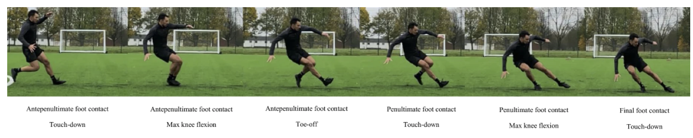
Figure 1 - A photo sequence of key spatiotemporal features during a pre-planned COD pivot manoeuvre; taken for McBurnie et al., (2022).
High intensity decelerations require eccentric breaking forces which can cause damage to the soft-tissue structures, leading to elevated levels of creatine kinase (CK, an indirect marker of muscle damage) in the 72hr period following performance (Howatson and Milak, 2009; A Faulkner, 2014; McBurnie et al., 2022). Accurately monitoring frequencies of high intensity decelerations becomes essential during busy fixture periods throughout a soccer season as an under-prepared athlete may begin to experience chronic elevated CK, resulting in an individual’s capacity to skilfully dissipate braking loads decreasing through diminished coordinative movement proficiency, leading to further tissue damage and increased injury risk (Harper and Kiely, 2018; McBurnie et al., 2022).

Reducing in-game decelerations would potentially decrease injury risk and tissue damage, however, it could negatively affect performance outcomes (Oliva-Lozano et al., 2021; Rhodes et al., 2021). Total decelerations, above -3ms⁻², were found to significantly increase in matches that were won in English Soccer League Two (Rhodes et al., 2021). Similarly, peak deceleration value significantly increased when winning matches in Spanish LaLiga 2 (Oliva-Lozano et al., 2021). Therefore, conclusions can be drawn, from a performance perspective, that athletes should focus on increasing the frequency and magnitude of their deceleration action (Harper, Carling and Kiely, 2019). To ensure a successful performance-injury risk trade-off occurs, practitioners must ensure athletes become accustomed to intense decelerations as this has been shown to reduce CK and associated detriments in neuromuscular performance (Brown et al., 2016). Though this will not be possible without a greater understanding of the frequency and magnitude of the decelerations completed prior to COD movements, as all current research predominantly focuses on linear movements. Through not considering all forms of decelerations, practitioners are in danger of underpreparing their athletes to the demands of a match, which in turn could lead to increase injury risk.
This study aimed to increase the level of detail currently available in scientific literature through analysing the relationship between entry speed/turn angle and deceleration prior to COD movements. Understanding the incidence rates of decelerations in relation to these other key turn characteristics will aid return-to-play protocols as well as advise practitioners on deceleration rates required during training sessions to adequately prepare players for match day demands.

2.4 Competition Type
It is understood that competition type can increase external load, with Rites et al., (2022) finding national tournaments elicit greater external loads (total distance and acceleration/deceleration frequencies) from soccer players than regional tournaments, which was attributed to increased effort levels. However, increasing the quality of opposition (Goncalves et al., 2021) and game importance (Link and De Lorenzo, 2016) has been shown to increase external load; therefore, it must be considered that the observed differences could be due to these factors rather than solely increased effort. The current literature has rarely completed competition-based load analysis on a top-flight elite soccer team. The impact of competition may vary between training status, for example, many players within the Premier League play for their respective national teams, therefore, the discrepancy in game intensity may not be as large between league and international matches, as that of a lower league, younger team that these studies have previously focussed on (Rites et al., 2022; Goncalves et al., 2021). Future research should focus on top-flight, elite football and further explore how game intensity varies between regional and international fixtures.
To the author’s knowledge, no study has determined the effect of competition type (knockout vs. league) on COD movements. It is important to dechipher whether these previously observed effects on opposition quality and game importance will affect turn frequency and characteristics, to ensure practitioners are preparing players for the demands of each type of competition. As Link and De Lorenzo (2016) determined game importance as the potential impact on following season and competition outcomes, it is assumed knockout football will be perceived as more important due to all match results having direct and immediate impact on competition outcome.

2.5 Tracking Systems
Tracking technology, from a sports science perspective, is used predominantly for external-load monitoring in an effort to reduce injury incidence rates and optimize performance (Weston, 2018). Daily use of this equipment allows for session-to-session adjustment of training periodisation to ensure that the training loads physically prepare players for the demands of a match (Buchheit et al., 2014; Theodoropoulos, Bettle and Kosy, 2020). Table 1 highlights the range of tracking systems used to identify external loads of soccer players. The current industry-dominating tracking system in soccer is the global positioning system (GPS) (Rago et al., 2020). Since the in-competition legalization of GPS technology in 2015 by the International Football Association Board, it has been used by practitioners world-wide to provide on-pitch, external load metrics (Rago et al., 2020). It boasts benefits such as its relative affordability, its portable nature, and an instant feedback system; allowing for constant monitoring during both training and matches (Buchheit et al., 2014; Bampouras and Thomas, 2022). These GPS systems, when evaluated against the gold-standard 3D-motion capture system, yielded lower error values than other tracking systems such as video-based systems and local positioning systems (LPS)(Bampouras and Thomas, 2022). However, with the recent integration of LiDAR technology, some of the current limitations faced by GPS, for example, satellite signals being blocked by stadiums/buildings, negative correlation between number of satellites signalling to the receiver and total distance and velocity measurement error, could lead to reduced usage in elite soccer. However, a validity study directly comparing LiDAR and GPS needs to be completed before any conclusions can be drawn from these assumptions.

2.5.1 Light Detecting and Ranging (LiDAR) tracking systems
LiDAR is prevalent in industries such as transport (Williams et al., 2013), ecological sciences (Eitel et al., 2016) and archaeology (Beckett, 2014). Recently, Sportlight®, a technology start-up company, has adapted this LiDAR technology alongside artificial intelligence (AI) to monitor key performance indicators (KPI’s), including COD metrics, for athletes. LiDAR technology can calculate speed and acceleration based on distance measures (Bampouras and Thomas, 2022). Distance metrics are attained through measuring time taken for infrared lasers to reach, reflect and return to the intended target (Bampouras and Thomas, 2022). Sportlight® provides both portable and built-in LiDAR systems which boast zero requirement for calibration and non-invasive qualities, i.e. no wearable required (Clark et al., 2019; Bampouras and Thomas, 2022).
Initial validity testing was completed on the portable Sportlight® LiDAR tracking system, through comparison to the gold-standard 64x camera motion capture system (MoCap) sampling at 100Hz (Vantage, Vicon, Oxford, UK; 3D) (Bampouras and Thomas, 2022). The study concluded high levels of validity with velocity and acceleration root mean square error (RMSE) values ranging from 0.08 to 0.12 ms⁻¹ and 0.36 to 0.60 ms⁻² respectively (Bampouras and Thomas, 2022). Clark et al., (2019) also found LiDAR tracking systems (Garmin, USA) to accurately assess walking and running speed when directly compared to 9x camera motion capture system (3DMA). All correlation and intraclass correlation coefficient analyses exceeded the thresholds for excellent agreement. However, this study only measured validity from 4.0-7.0 meters(m) and Bampouras and Thomas (2022) from a short range of 10x20m indoor area. To confidently define this as a highly valid tracking system, further validity studies should be considered at the distance the LiDAR systems are used during soccer matches. This is challenging, however, as gold standard motion analysis cannot be installed in a space large enough to mimic a match situation. Comparisons to other tracking technology, such as GPS, at equal distances could be considered instead. No studies have measured the validity of Sportlight® COD metrics (entry speed (ms⁻¹);exit speed (ms⁻¹); turn angle (°)); research on this is imperative to validate Dos’Santos et al., (2022) and the current study.
Another highly popular form of portable LiDAR is the Garmin LiDAR Lite V3 sensor, which works in a similar way to Sportlight’s® LiDAR technology, and has been researched in many distance measuring studies (Blankenau et al., 2018; Caves, Davis and DeRuyter, 2018; Liu, 2018). The sensor technology has been developed for uses such as walking speed detection (Caves, Davis and DeRuyter, 2018) and detecting moving vehicles’ proximity to cyclists (Blankenau et al., 2018). It measures distances to targets by illuminating an object with a pulsed laser light and measuring the reflected pulses (Rahman, Saufi and Ahmad, 2020). This is a system which samples at 270Hz (Garmin, 2022), a frequency of analysis that would be unattainable for the current study due to an overload of data if sustained through a ninety minute match for 11 players. Additionally, practitioners require rapid-feedback responses from tracking systems, this process could be negatively impacted if the sample rate and therefore the data-processing time was to increase to larger than 10Hz.
However, with the current project using the Sportlight® system which samples at 10Hz, it should be considered that the validity of time-based metrics, such as turn duration (s), may be compromised. A validity and reliability study should be completed between Sportlight’s® LiDAR system and other systems with similar functionality, such as the Garmin LiDAR Lite V3 sensor, to determine the best sampling rate for all performance measures.

Table 2 - A summary of the pros and cons of different tracking technology.
Tracking System | Pros | Cons
Local Positioning Systems (LPS) | - Often analyse movements at higher frequencies than GPS therefore they provide more detailed outputs.  - LPS work in indoor and urban environments with no reduction in accuracy.  - Test-retest reliability has been shown to be better than GPS and video tracking systems.  (Bastida-Castillo et al., (2019); | - The installation of antenna-based LPS could influence the outcome measures from on system to another (i.e. height and shape).  - LPS systems increase their error when a rapid change of direction occurs, therefore this system is more suitable for linear metrics.  (Pino-Ortega et al., 2022; Linke et al., 2018)
Global Positioning Systems (GPS) | - Accessible and affordable  - No reliance on external facilities  - Real-time data allowing adaptions during session  - Accurate linear metrics  (Buchheit et al., 2014; Bampouras and Thomas, 2022) | - Reduced accuracy in urban areas and indoor spaces.  - Negative correlation between the number of satellites signalling to the receiver and total distance and velocity measurement error.  - Invasive: players have to wear a device.  - Home side data only.  (Bampouras and Thomas, 2022)
Light Detecting and Ranging (LiDAR) Systems | - Accurate instantaneous velocity and acceleration compared to gold standard motion capture.  - Non-invasive  - Both portable and non-portable options  - Measures precise movements such as COD  - Zero requirement for calibration  (Bampouras and Thomas, 2022; Clark et al., 2019) | - No reliability or validity study currently published for COD metrics.  - Expensive  - No instantaneous feedback system
Video Tracking Systems | - Most accurate measure of total distance in soccer specific scenarios, i.e. small-sided games.  - Not affected by satellite location, nor surrounding environment.  (Linke et al., 2018) | - Instantaneous speed and acceleration errors are significantly higher than GPS and LPS.  - Significantly higher spatial errors in the y-axis, this is attributed to incorrect detection of the centre of mass on the y-axis of the athlete.  (Linke et al., 2018)

This study aimed to use Sportlight’s® LiDAR technology to determine the turn demands experienced by soccer players in the Premier League, UEFA Europa League, FA Cup and League Cup.
Objectives:
- Complete in-depth turn characteristic analysis for each playing position (GK, CD, FB, CM, WF, CF).
- Analyse the relationship between different turn characteristics.
- Determine if there are any differences in turn demands between competitions (Premier League, FA Cup, League Cup and UEFA Europa League).
- Apply the findings to begin to create resources for practitioners to build upon. This will long-term ensure injury-prevention, rehabilitation and return-to-play programmes can be adapted to ensure English Soccer Teams are prepared for the COD faced during matches.

3.0 Methods

3.1 Research design:
Study 1: Longitudinal observational cohort design, whereby an exploratory analysis was completed on turn count and turn characteristics for all significant turns completed across all competitions (Premier League, FA Cup, League Cup, UEFA Europa League).
Study 2: Longitudinal between-environment comparative design, whereby turn count and characteristics was compared between different competition types.

3.2 Game Analysis and Player Data:
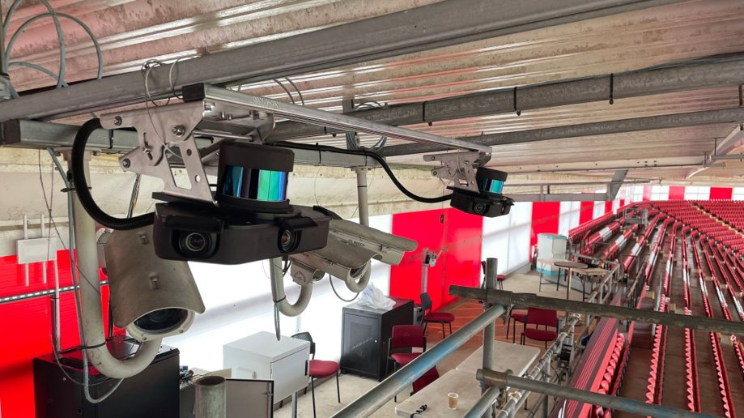
Turning data was obtained from 49 match fixtures during 2022-23 season, from the Premier League (35 matches), UEFA Europa League (5 matches), League Cup (5 matches) and FA Cup (4 matches). All turn data was collected using Sportlight® LiDAR tracking system (Sportlight®, Oxford, UK; LiDAR; see Figure 2). For home matches, the single-sensored system was permanently mounted 7 metres above pitch height, sampling at 1.2million spatial readings per second over a 200 m range at 10Hz. Data was collected for away games where Sportlight® was installed.
Figure 2 - LiDAR (Sportlight): The laser-based remote sensor system installed into a Premier League stadium.
The proprietary software utilized in conjunction with the LiDAR system facilitated the tracking of all movements occurring on the pitch. Clusters of moving points were detected to pinpoint the positions of players in the foreground plane. The software then determined the centre of each cluster, a method proven to yield accurate positional data when compared to a 3D motion capture system utilizing a four-marker pelvis model (Bampouras & Thomas, 2022; Dos’Santos et al., 2022). To ensure each cluster point was continually allocated to the same player the LiDAR system worked in conjunction with three cameras which captured high-resolution imagery (Sony IMX253, 12.4MPx, 10fps synchronized with the LiDAR data). Their output was fed into an artificial intelligence system, which undertook the temporal tracking of individual clusters and the re-identification of players using previously captured imagery. Gait-neutralized velocity was computed by subjecting the raw velocity data to a fourth-order low-pass Butterworth filter (with a 1 Hz cut-off; Bampouras & Thomas, 2022). Gait-neutralized acceleration was defined as the alteration in gait-neutralized velocity over time (Bampouras & Thomas, 2022; Dos’Santos et al., 2022). The Sportlight® system's output provided both positional data and derived metrics for turning.
Overall, data from 29 (Age 27 ± 4.3 yrs; height 183.7 ± 6.7 cm; mass 74.7 ± 6.7kg) different players were analysed. All players were grouped into similar positional group seen in previous research (Ade et al., 2016; Dos’Santos et al., 2022): goalkeeper (GK: n = 3), central defender (CD: n = 4), full-back (FB: n = 5), central midfielder (CM: n = 8), winger forward (WF: n = 6), central forward (CF: n = 3). Variations from previous research are found in using the term ‘winger forward’ instead of ‘winger midfielder’ as this is a more applicable term for the wide players considering the teams formation. GK’s were also analysed as very little research has been conducted on turns completed in this position. Through freely-available online information, formation was determined to be predominantly 4-2-3-1 (42 matches), other formations included: 4-3-3 (5 matches) and 4-1-4-1 (2 matches). If players had played in multiple positions, they were categorized into the position group in which they had played most matches. No player had played less than 80% of their games in their allocated position group. Analysis, which considered per-match averages, only included turn data from players who played >85 minutes as this is considered a ‘full-session’ by Sportlight®. Analysis which looked at individual turn characteristics, i.e. average entry speed (ms⁻¹) for each turn category, considered all turns, regardless of the athletes playing time. Ethical approval was granted by Lancaster Medical School’s review board (ID: LMS-23-1-Griffiths), the soccer team consented via Sportlight® to obtain and publish the data for research purposes. All player data was anonymised upon collection.

3.3 Turning Metrics
Turn data was only collected and analysed if considered ‘significant’ (Dos’Santos et al., 2022). Specifically, this was defined as a change of direction with a deceleration ≥-2 m/s², an angle change in direction of travel ≥20°, and a subsequent acceleration ≥2 m/s², all within a 1 second duration. Turns were further sub-categorised by angle and entry speed (Table 2) (Dos’Santos et al., 2022).

Table 3 – Definitions of entry speed (ms⁻¹), turn angles (°) sub-categorisation.
Sub-Category | Definition
Low Entry Speed | <3.0ms⁻¹
Medium Entry Speed | 3.0-5.5ms⁻¹
High Entry Speed | 5.5-7.0 ms⁻¹
Very High Entry Speed | >7.0ms⁻¹
Low Angle | 20- 59°
Medium Angle | 60-119°
High Angle | 120-180°

Entry speed was classified as the instantaneous speed of the player upon initiation of the deceleration (when the players deceleration exceeded ≤−2 m/s²) (Dos’Santos et al., 2022). The angle of the turn was computed as the angle between the acceleration and deceleration vector, demonstrated in Figure 3, in the horizontal plane based on the estimated whole-body centre of mass (estimations were based on cluster points used to localize players by proprietary software) (Dos’Santos et al., 2022; Bampouras & Thomas, 2022). Peak deceleration (≥−2 m/s², upon entry to the turn) and turn duration (<1s, time from initiation of deceleration to initiation of acceleration) was also analysed. Frequency of total significant turns and entry speed/turn angle sub-categories were calculated.

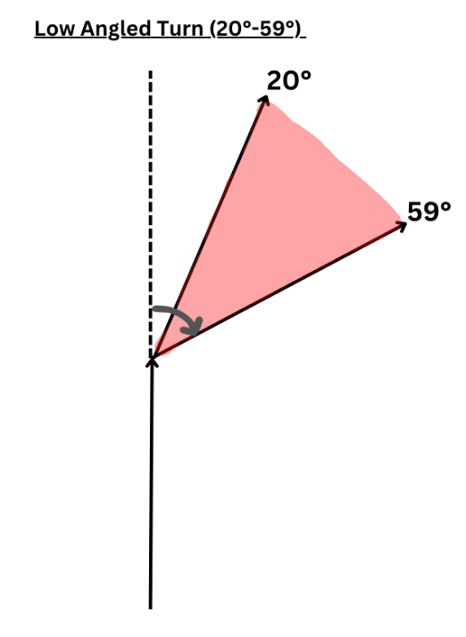
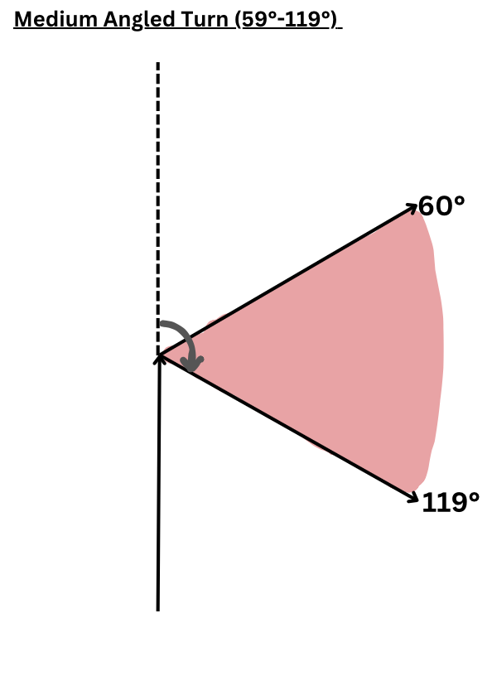
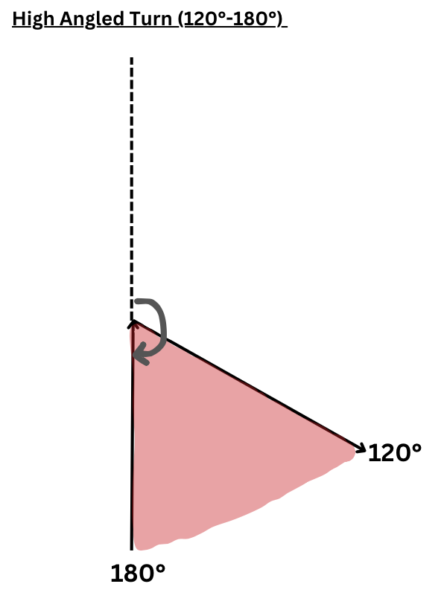
Figure 3 – Diagram representing high (120°- 180°), medium (60°-119°) and low angled (20°-59°) turns.

3.4 Statistical Analysis
Statistical analyses were performed using the coding software R (version 2023.06.1+524). Normality was assessed using a Kolmogorov-Smirnov test. For variables with >5000 data points, a density graph was used to visually determine normality; analysis confirmed all tests were non-parametric. Positional differences of turn characteristics and frequencies were determined via Kruskal-Wallis tests. Differences in turn characteristics between competitions were calculated using a Mann-Whitney U test. Statistical significance was defined as p < 0.05 for all tests. In the event of a significant result, the Dunn test (1964) pairwise comparison, adjusted via the Holm correction, was applied. Epsilon squared effect sizes were also calculated for all Kruskal-Wallis tests; 0.01 - 0.059 (small effect), 0.06 - 0.139 (moderate effect) and ≥ 0.14 (large effect)(Cohen, 1988; Khalilzadeh and Tasci, 2017). All data presented for positional and competition comparisons reflect the average turning frequency per match. Pie charts, polar scatter charts, histograms and heat maps were used to display turn incidence rates, across the entire season. Chi-squared tests were used to examine the differences between the categorical variables displayed on the pie charts. Pearson’s r correlation tests were completed on the deceleration scatter graphs to identify correlation.

4.0 Results

4.1 Total Number of Turns per Position

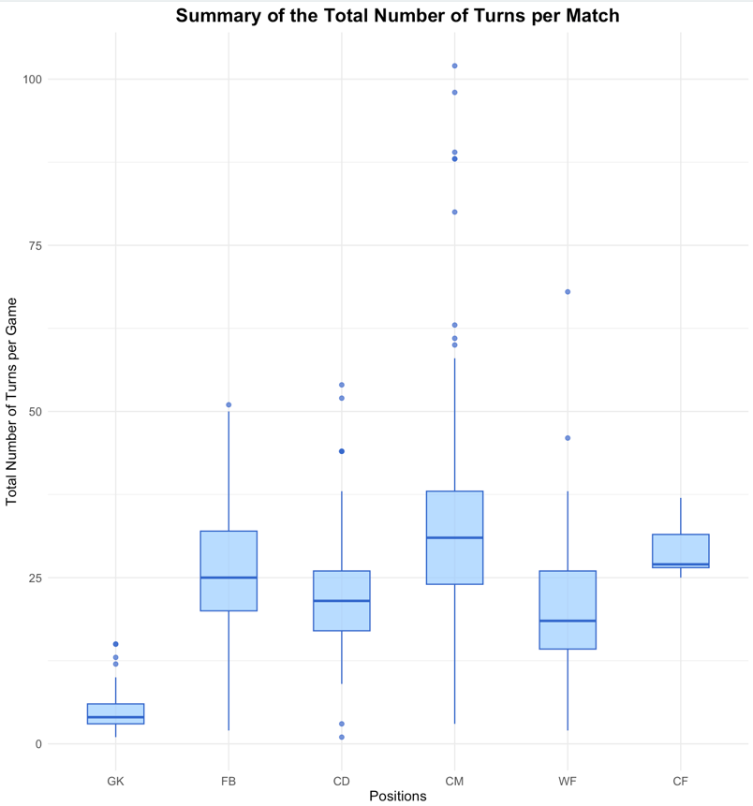
CM performed significantly more turns on average per match than WF and GK (H₅ = 154.25, p < 0.01). The overall average number of turns per player per match was 24.5, when focussing on position specific averages per match the results were as followed - GK:4.77 ± 3.32, FB:26.36 ± 10.32, CD:22.82 ± 9.41, CM:34.52 ± 17.93, WF:20.70 ± 11.18, CF:29.83 ± 4.49. The interquartile range (IQR; length of the box), median (intersecting line within the box), range (solid line) and outliers (singular points) are displayed on Figure 3.

Figure 4: Total turns per position group. GK: Goal Keeper, FB: Full Back, CD: Central Defender, CM: Central Midfielder, WF: Winger Forward, CF: Central Forward. ε² = 0.410 (large). CM>GK,WF (p<0.05).

4.2 Turns by Angle and Position

GK were found to perform significantly less low angled turns than FB, CD and CM (H₅ = 28.36, p <0.01), however, no significant differences were found between outfield players (p > 0.05) (Figure 4). Medium angled turns showed CM performing significantly higher turn counts than all position groups other than CF, and GK performing significantly less medium angled turns than all position groups (H₅ = 79.24, p < 0.01)(Figure 5) Similar findings were identified for high angle turn counts per match with CM and FB performing significantly more medium angled turns than GK, CD and WF and GK completing significantly less than CD, WF and CF (H₅ = 143.47, p < 0.01)(Figure 5). Differences between overall means, medians and IQR for each turn angle category are displayed in Table 3.
 | GK | FB | CD | CM | WF | CF | Overall
Low Angle | 1.44±0.73 | 2.88±1.69 | 3.03±1.76 | 3.38±1.96 | 2.48±1.56 | 1.71±0.95 | 2.92±1.79
Medium Angle | 1.57±1.16 | 6.05±3.50 | 5.47±2.50 | 7.38±3.48 | 4.40±2.36 | 7.00±1.15 | 5.82±3.35
High Angle | 3.59±  2.47 | 18.10±  7.65 | 15.03±  8.31 | 23.86±  15.72 | 14.38±  8.98 | 20.57±  3.51 | 16.84±  12.14
Low Angle  (Median) | 1.00 | 3.00 | 3.00 | 3.00 | 2.00 | 1.00 | -
Medium Angle  (Median) | 1.00 | 5.00 | 5.00 | 7.00 | 4.00 | 7.00 | -
High Angle  (Median) | 3.00 | 17.00 | 13.00 | 19.00 | 13.50 | 20.00 | -
Low Angle (IQR) | 1.00 | 2.00 | 2.00 | 2.00 | 2.00 | 1.50 | -
Medium Angle  (IQR) | 1.00 | 4.75 | 3.00 | 5.00 | 3.00 | 1.50 | -
High Angle  (IQR) | 2.00 | 10.00 | 6.00 | 11.00 | 8.75 | 5.50 | -
Table 4 - Identifying the number of turns completed (for each angle category) per match for players in each position group. ($\overline{X}$± SD). Inter-quartile range (IQR),
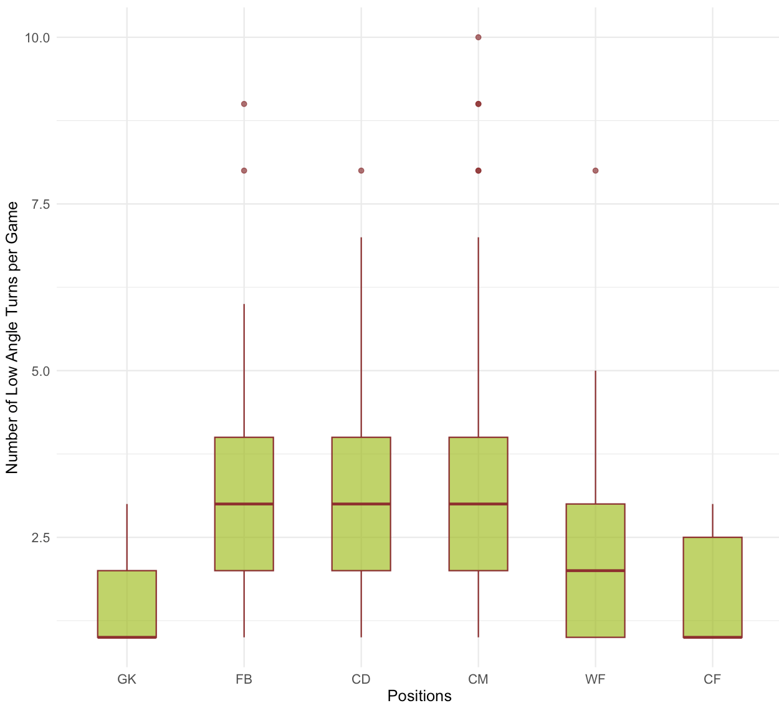
The interquartile range (IQR; length of the box), median (intersecting line within the box), range (solid line) and outliers (singular points) of low angled turns (Figure 4), medium angled turns (Figure 5), and high angled turns (Figure 6) are displayed.
Figure 4: Total turns per position group for low angled turns. ε² = 0.076 (moderate). CM>GK,FB,CD,WF (p<0.05); FB>WF(p<0.05); GK<FB,CD,CM,WF,CF

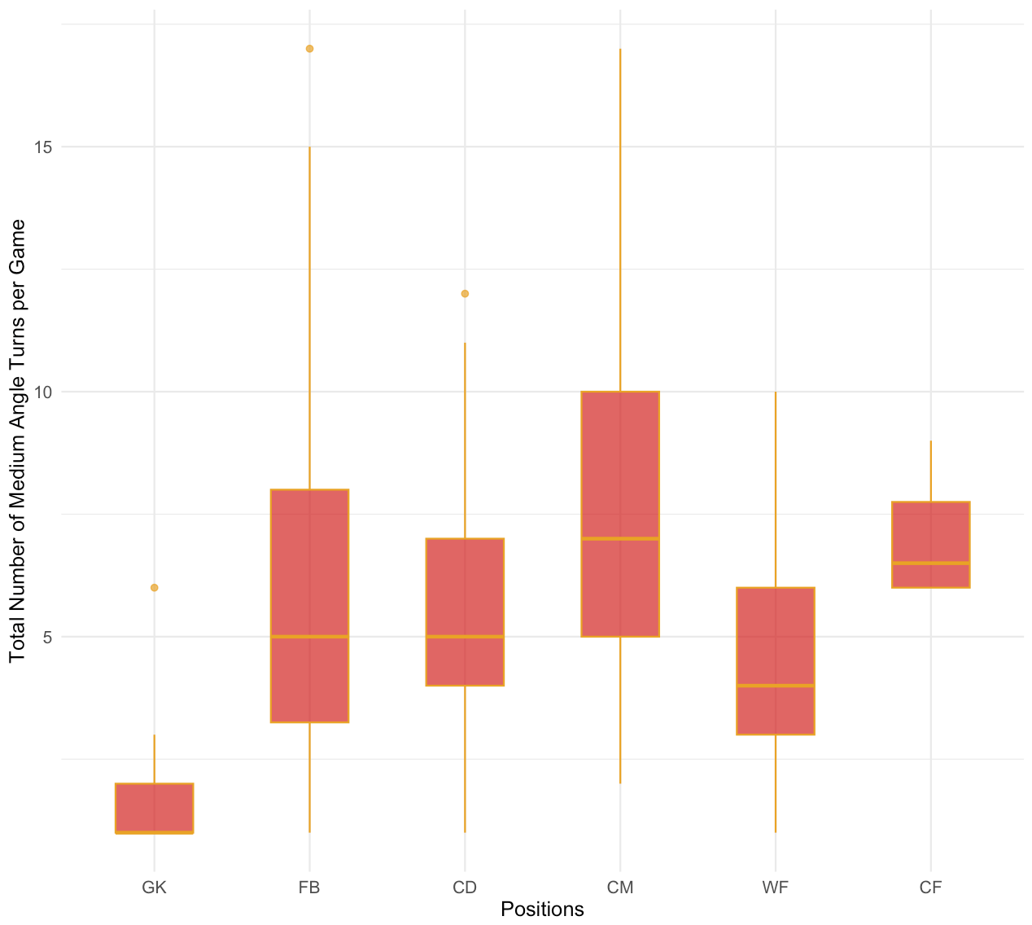
Figure 5: Total turns per position group for medium angled turns. ε² = 0223 (large). CM>GK,WF,FB,CD (p<0.05), GK<FB,CD,CM,WF,CF (p<0.05).

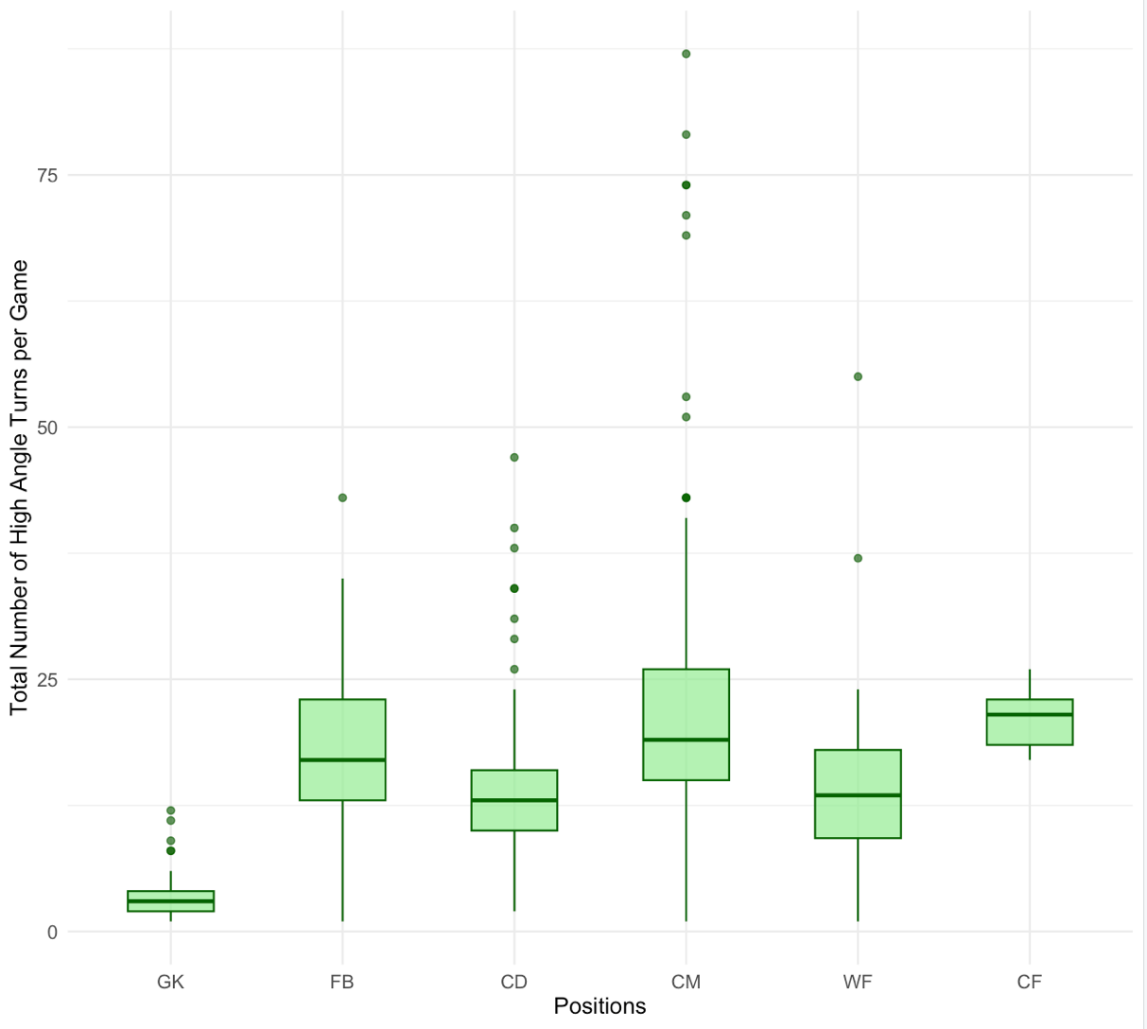

Figure 6: Total turns per position group for high angled turns. ε² = 0.384(large). CM,FB>GK,CD,WF(p<0.05), GK<CD,WF,CF.

4.2.1 Proportions of Turns Completed in Each Angle Group

A visual representation of the proportion of turns completed in each angle group. Significant differences were found between the observed incidence rates of turns in each turn category, X² (2, 14307) = 7932.58, p = .001.
Standardized residuals of 71.30 (high angle), -23.28 (medium angle) and -48.03 (low angle), show the deviations from the expected frequencies.
Figure 5 demonstrates proportional turn angle incidence rate similarities between position groups, despite a large range in sample size (224-5693):
GK: X² (2, 224) = 165.06, p = .000; FB: X² (2, 2862) = 1615.7, p = .001; CD: X² (2, 2041) = 989.11, p = .001; CM: X² (2, 5693) = 3169.5, p = .001; WF: X² (2, 2778) = 1655.9, p = .001; CF: X² (2, 709)= 319.97, p = .001.

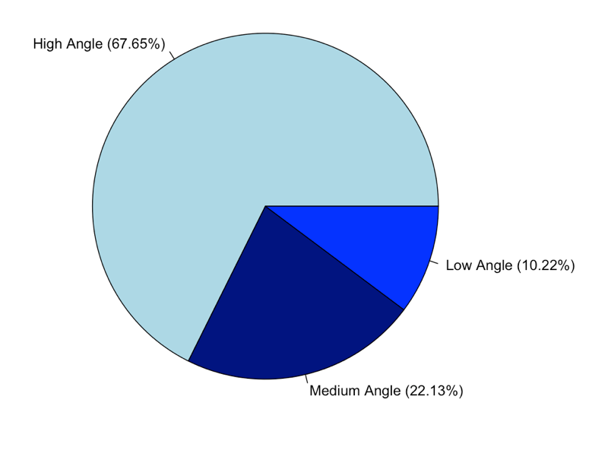

Figure 6: The proportion of all turns completed, in all competitions, for each angle group. Low Angle: 20°-60°, Medium Angle: 60.1°-120°, High Angle: 120.1°-180°.

A
D
B
E
C
F

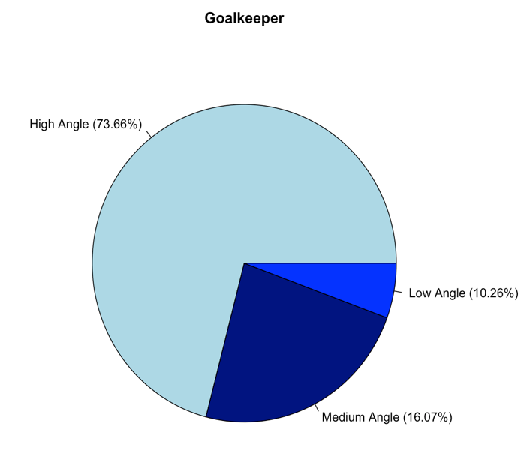
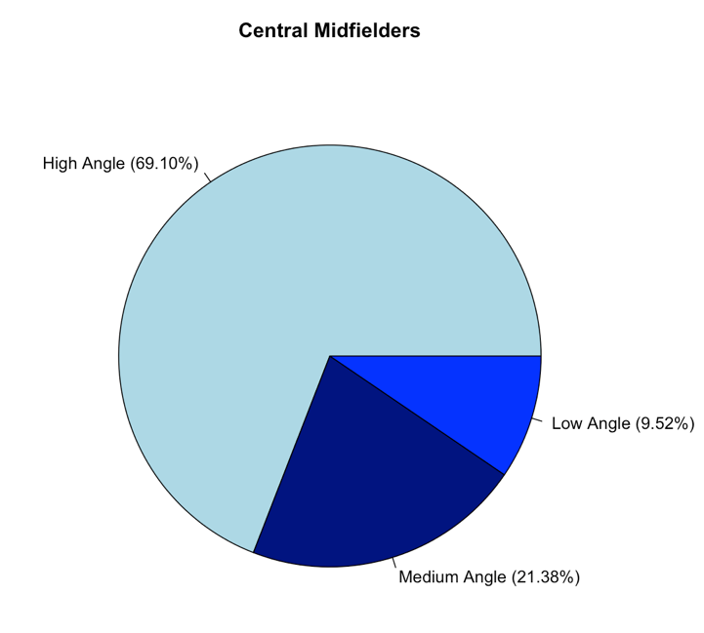

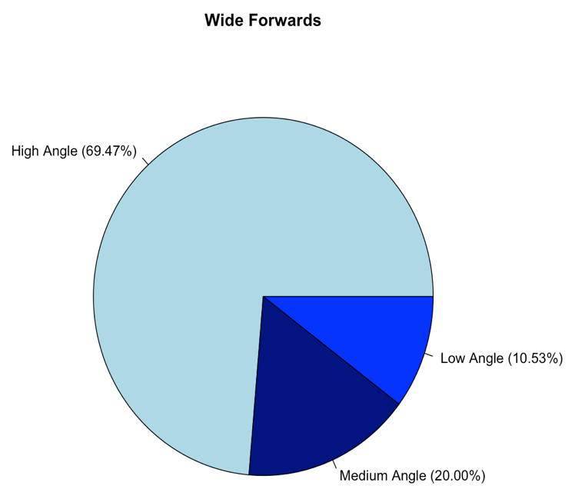
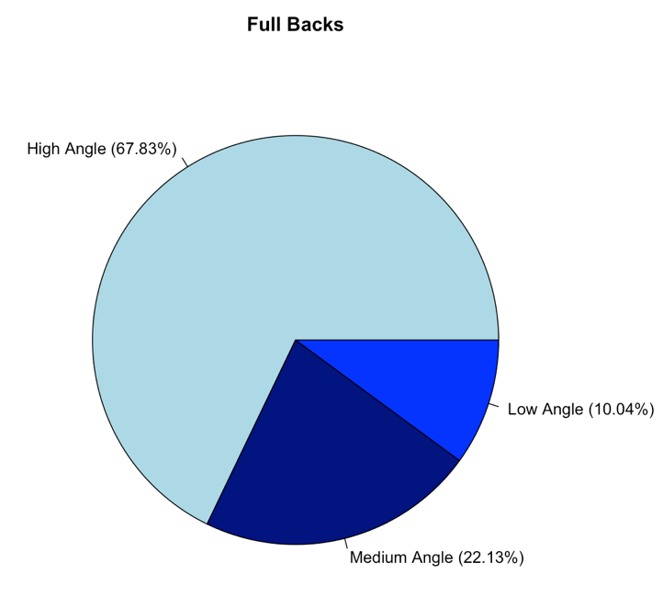

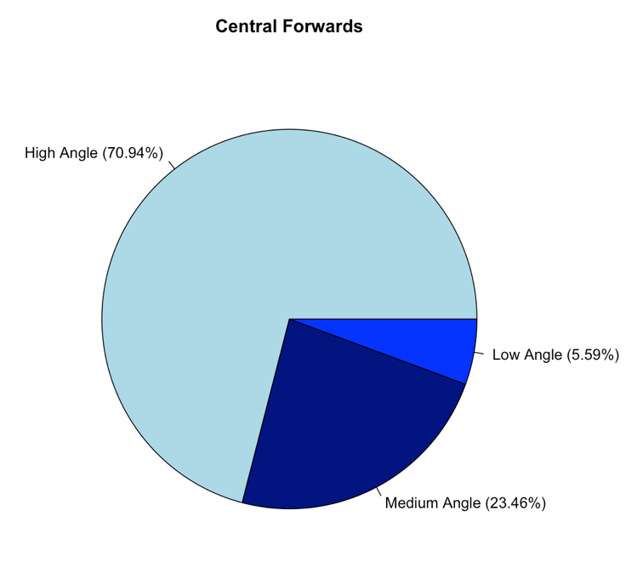
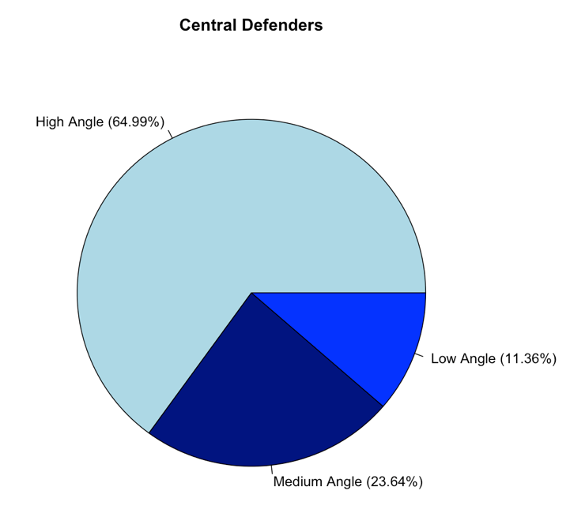
Figure 7: The proportion of all turns completed, in all competitions, for each angle group, per position. Low Angle: 20°-60°, Medium Angle: 60.1°-120°, High Angle: 120.1°-180°. The proportion of turns for each position can be seen as follows: (A) Goal Keepers; (B) Full Backs; (C) Central Defenders; (D) Central Midfielders; (E) Winger Forwards; (F) Central Forwards.

4.3 Turns by Entry Speed and Position

GK performed significantly less low entry speed turns than all outfield positions (FB,CD,CM,WF,CF) (H₅ = 114.89, p < 0.01); CM performed significantly more low entry speed turns than FB and WF (p <0.05); CD performed significantly more low entry speed turns than WF (p <0.05). Significant differences were also identified between positions for medium entry speed turns (H₅ = 135.54, p < 0.01), with GKs performing significantly less than all outfield positions (p <0.05) whilst CM performed significantly more than CD, FB and WF (p <0.05) and FB completed significantly more than WF (p <0.05). CD completed significantly more medium entry speed turns on average per match than CM, FB, and WF (H₅ = 34.43, p < 0.01). Overall $\overline{X}$± SD, median and IQR for each turn entry speed and position are displayed below (Table 4).
Table 5 - Identifying the number of turns completed (for each entry speed category) per match for players in each position group. ($\overline{X}$± SD). Inter-quartile range (IQR).
 | GK | FB | CD | CM | WF | CF | Overall
Low Entry Speed | 2.9±2.1 | 9.0±3.8 | 9.6±3.7 | 11.7±5.1 | 7.2±3.7 | 10.0±3.8 | 9.0±4.8
Medium Entry Speed | 2.4±1.8 | 14.9±7.7 | 12.5±7.4 | 20.9±14.4 | 11.3±7.8 | 16.6±7.8 | 14.3±11.1
High Entry Speed | 1.2±0.5 | 2.6±1.7 | 1.4±0.7 | 2.5±1.5 | 2.7±1.9 | 2.4±1.3 | 2.3±1.5
Very High Entry Speed | NA | 1.0±0.2 | 1.0±0.0 | 1.2±0.4 | 1.1±0.3 | 1.0±0.0 | 1.1±0.3
Low Entry Speed  (Median) | 3.00 | 8.00 | 9.00 | 11.50 | 7.00 | 8.00 | -
Medium Entry Speed  (Median) | 2.00 | 14.00 | 11.00 | 17.00 | 10.00 | 17.00 | -
High Entry Speed  (Median) | 1.00 | 2.00 | 1.00 | 2.00 | 2.00 | 2.50 | -
Very High Entry Speed  (Median) | 1.00 | 1.00 | 1.00 | 1.00 | 1.00 | 1.00 | -
Low Entry Speed (IQR) | 2.00 | 4.00 | 5.00 | 6.25 | 5.00 | 3.50 | -
Medium Entry Speed (IQR) | 1.00 | 11.00 | 6.00 | 10.50 | 6.75 | 2.00 | -
High Entry Speed (IQR) | 0.25 | 1.50 | 1.00 | 2.00 | 1.00 | 2.00 | -
Very High Entry Speed (IQR) | 0.00 | 0.00 | 0.00 | 0.00 | 0.00 | 0.00 | -

The interquartile range (IQR; length of the box), median (intersecting line within the box), range (solid line) and outliers (singular points) of low entry speed turns (Figure 8), medium entry speed turns (Figure 9), high entry speed turns (Figure 10) and very high entry speed turns (Figure 11) are displayed.

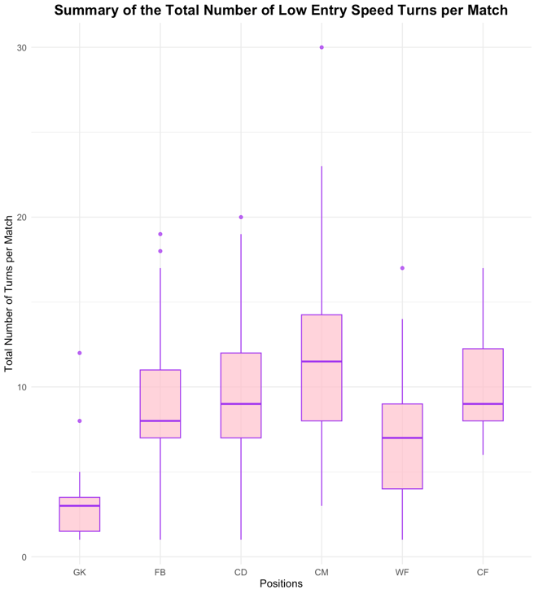

Figure 8: Frequency of low entry speed turns (<3ms⁻¹ ) per match, for each position group. ε² = 0.307 (large). GK<FB,CD,CM,WF,CF (p<0.05) CM>FB,WF (p<0.05) CD>WF (p<0.05)

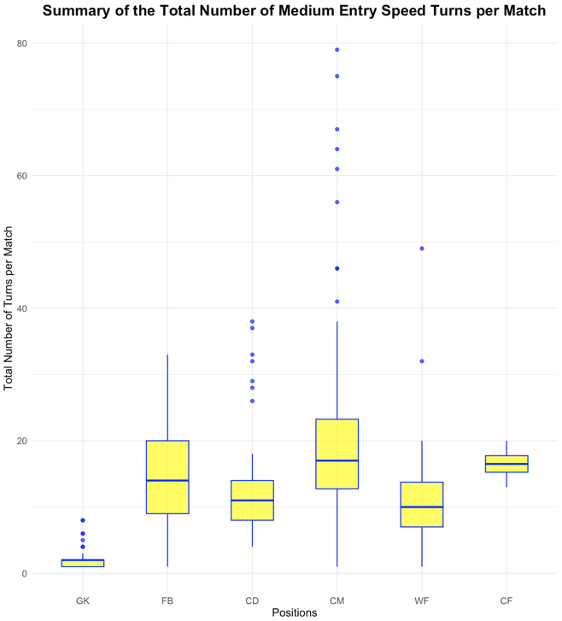

Figure 9: Frequency of medium entry speed turns (3-5.5ms⁻¹) per match, for each position group. ε² = 0.369 (large). GK<FB,CD,CM,WF,CF (p<0.05) CM>CD,FB,WF (p<0.05) FB>WF (p<0.05)

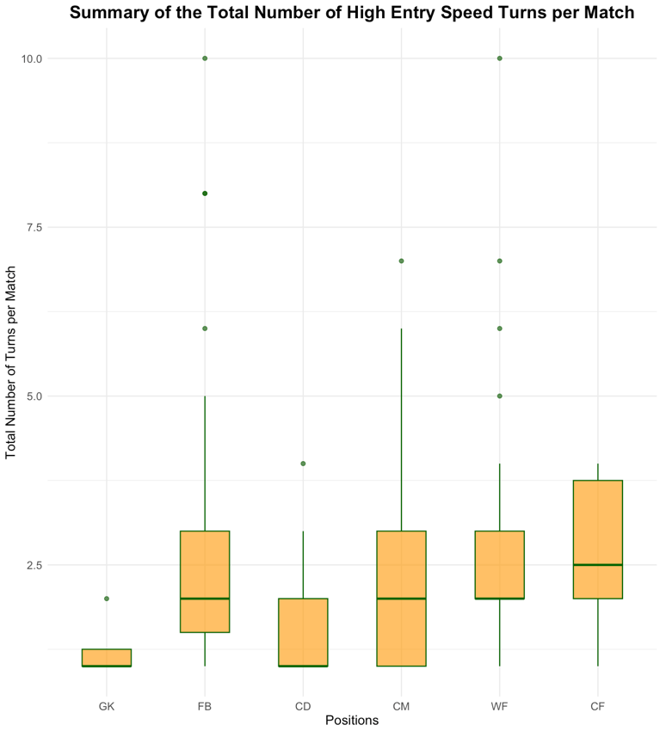

Figure 10: Frequency of high entry speed turns (5.5-7ms⁻¹) per match, for each position group. ε² = 0.117 (moderate). CM, FB, WF>CD (p<0.05)

4.3.1 Proportions of Turns Completed in Each Entry Speed Group

A visual representation of the proportion of turns completed in each angle group.
Significant differences (p <0.05) in the incidence rates of turns in each entry speed (ms⁻¹) group were found: X²(3, 14307) = 11933, p = .001.
Standardized residuals of -57.54 (very high entry speed), -43.92 (high entry speed), 78.53 (medium entry speed) and 22.93 (low entry speed), show the deviations from the expected frequencies.

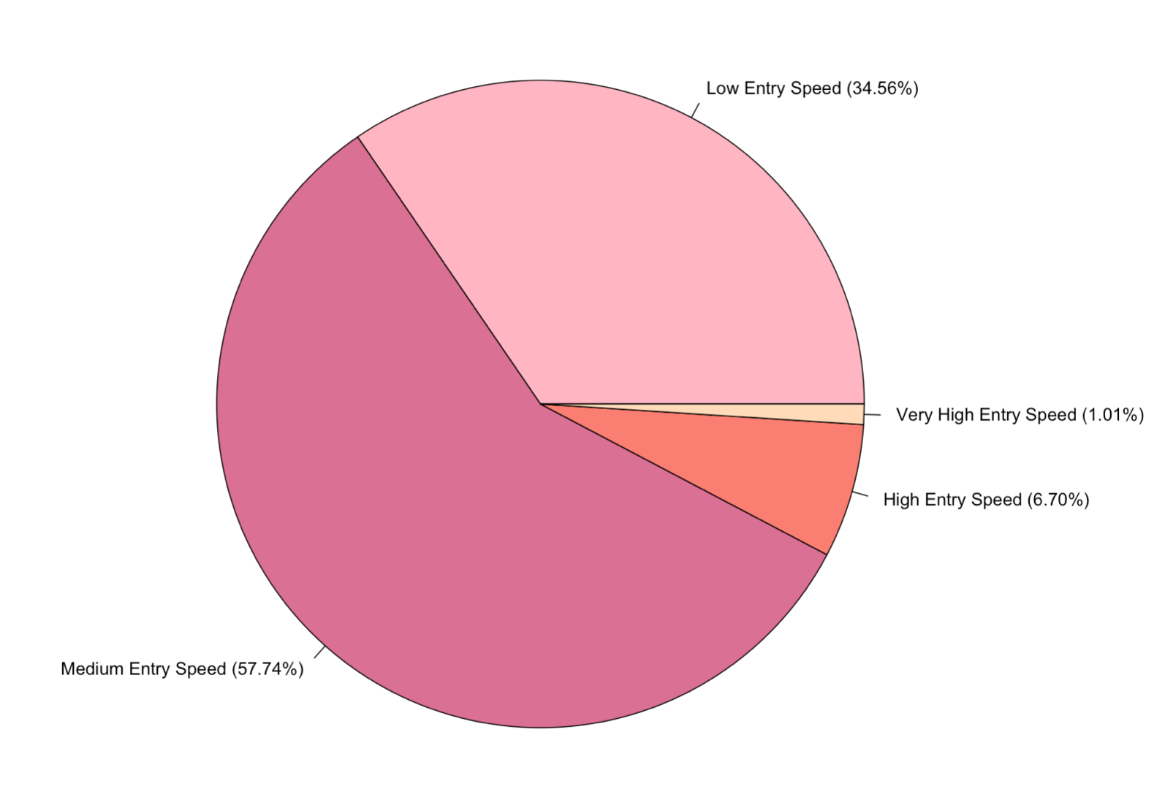

Figure 12: A pie chart to show the proportion of all turns completed, in all competitions, for each entry speed (ms⁻¹) group. Low Entry Speed: <3 ms⁻¹, Medium Entry Speed: 3-5.5 ms⁻¹, High Entry Speed: 5.5-7 ms⁻¹, Very High Entry Speed: >7 ms⁻¹
Figure 13 demonstrates proportional turn angle incidence rate similarities between position groups, despite a large range in sample size (224-5693):
GK: X² (2, 224) = 102.38, p = .001; FB: X² (2, 2862) = 2229, p = .001; CD: X² (3, 2041) = 1741, p = .001; CM: X² (3, 5693) = 5169.5, p = .001; WF: X² (3, 2778) = 2125.6, p = .001; CF: X² (3, 709)= 570.13, p = .001.

A
D
B
E
C
F
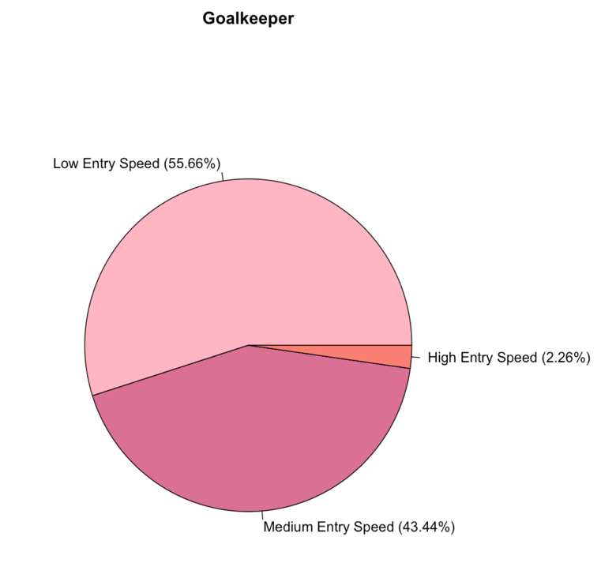
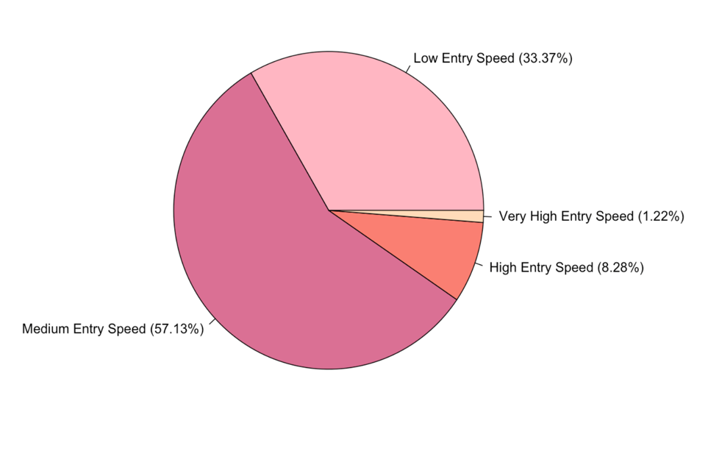

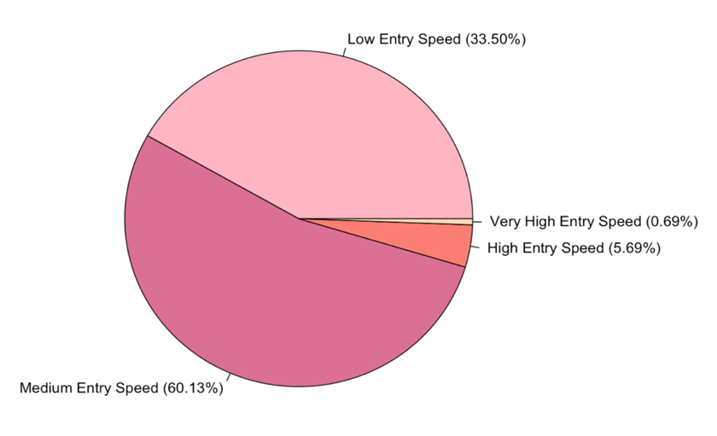
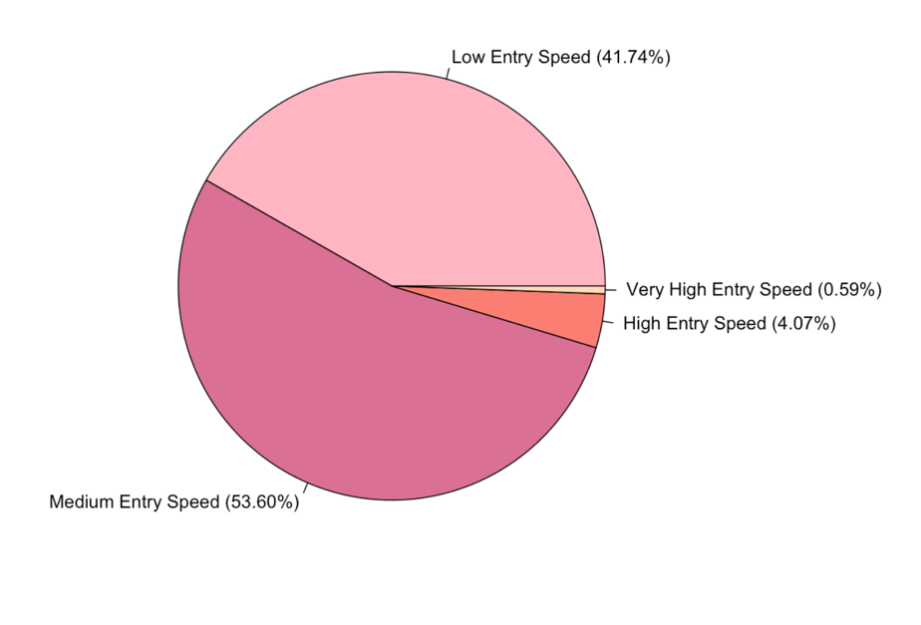

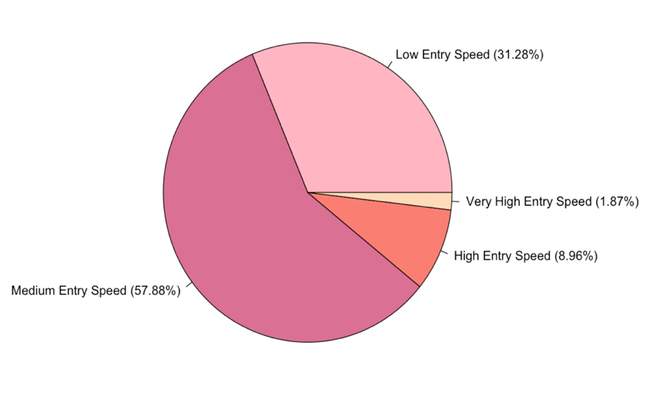
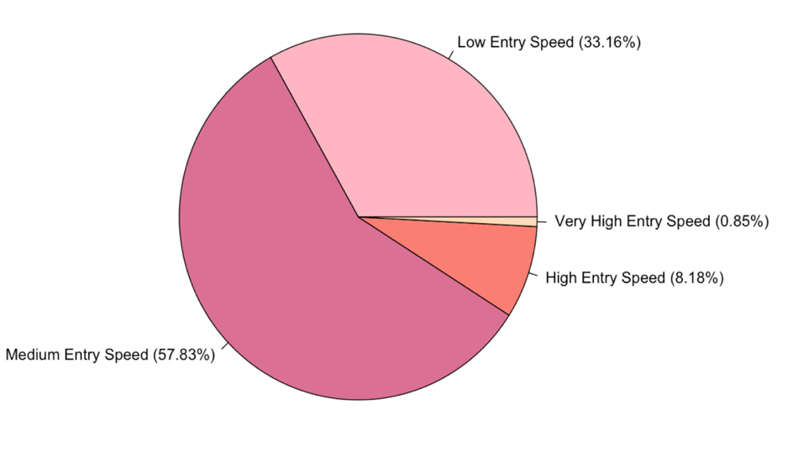

Figure 13: The proportion of all turns completed, in all competitions, for each entry speed group (ms⁻¹) group, per position. The proportion of turns for each position can be seen as follows: (A) Goal Keepers; (B) Full Backs; (C) Central Defenders; (D) Central Midfielders; (E) Winger Forwards; (F) Central Forwards.

4.4 Investigating the Relationship between Entry Speed within Each Angle Group
High angled turns were found to elicit significantly lower entry speeds than medium and low angled turns (H₂ = 56.10, p < 0.01). The small effect size must be noted, ε²[H] = 0.004. Difference between means can be seen in Table 5. The IQR, outliers, range and median entry speed for each angle group are demonstrated in Figure 14.
Table 6 – Mean entry speed (ms⁻¹) for each angle group
Angle Group | Mean Entry Speed (ms⁻¹)
High Angle | 3.48
Medium Angle | 3.63
Low Angle | 3.66

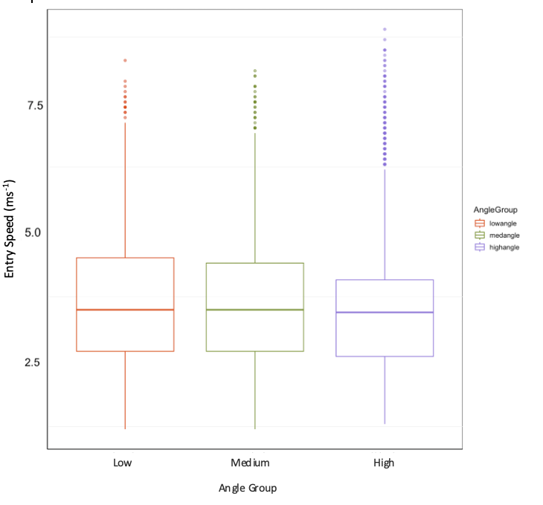

Figure 14 – Identifying the relationship between turn entry speed (ms⁻¹) and turn angle group.

4.4.1 Entry speed variations between positions for each angle group

CD performed significantly slower entry speed high angled turns than FB, CM, WF and CF; GK performed significantly slower entry speed high angled turns than FB, CM, WF and CF (H₅ = 102.93, p < 0.01). FB, CM, WF and CF completed significantly faster medium angle turns than GK and CD, whilst CM were significantly slower than WF in this turn category (H₅ = 77.25, p < 0.01). Significant positional differences in entry speed for low angled turns were as followed: CD<CF,FB,WF; WF>GK,CM,CD; GK<FB,CD,CM,WF,CF (H₅ = 77.25, p < 0.01) The entry speed median, IQR, range and outliers can be found in Figure 15 (high angle), Figure 16 (medium angle) and Figure 17 (low angle) for all playing positions. Overall effect sizes: position group ε²[H] = 0.014, and angle group ε²[H] = 0.003.
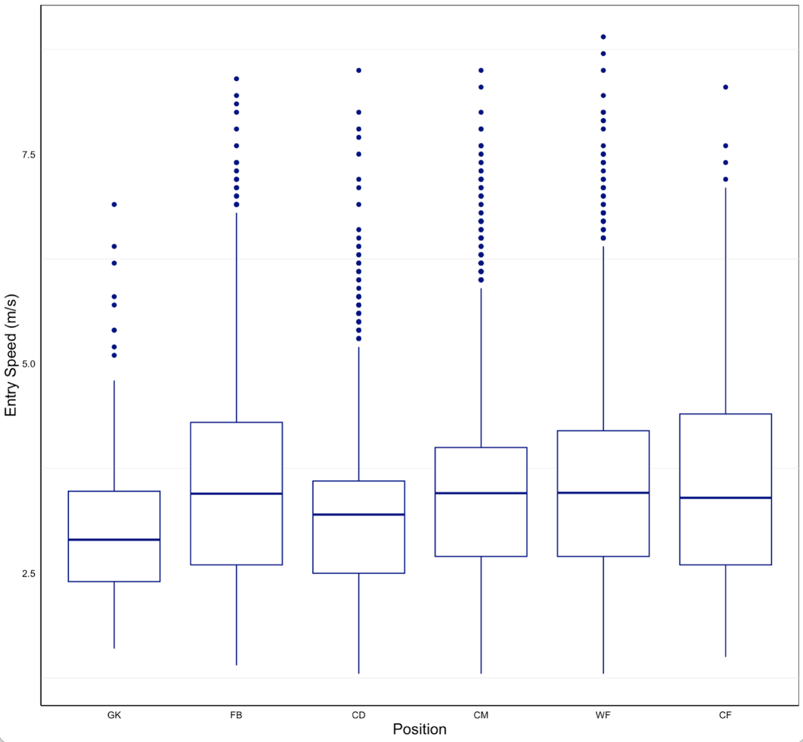

Figure 15 – Entry speed (ms⁻¹) for high angled turns for each position group. ε² = 0.010(small). CD<FB,CM,WF,CF. GK<FB,CM,WF,CF
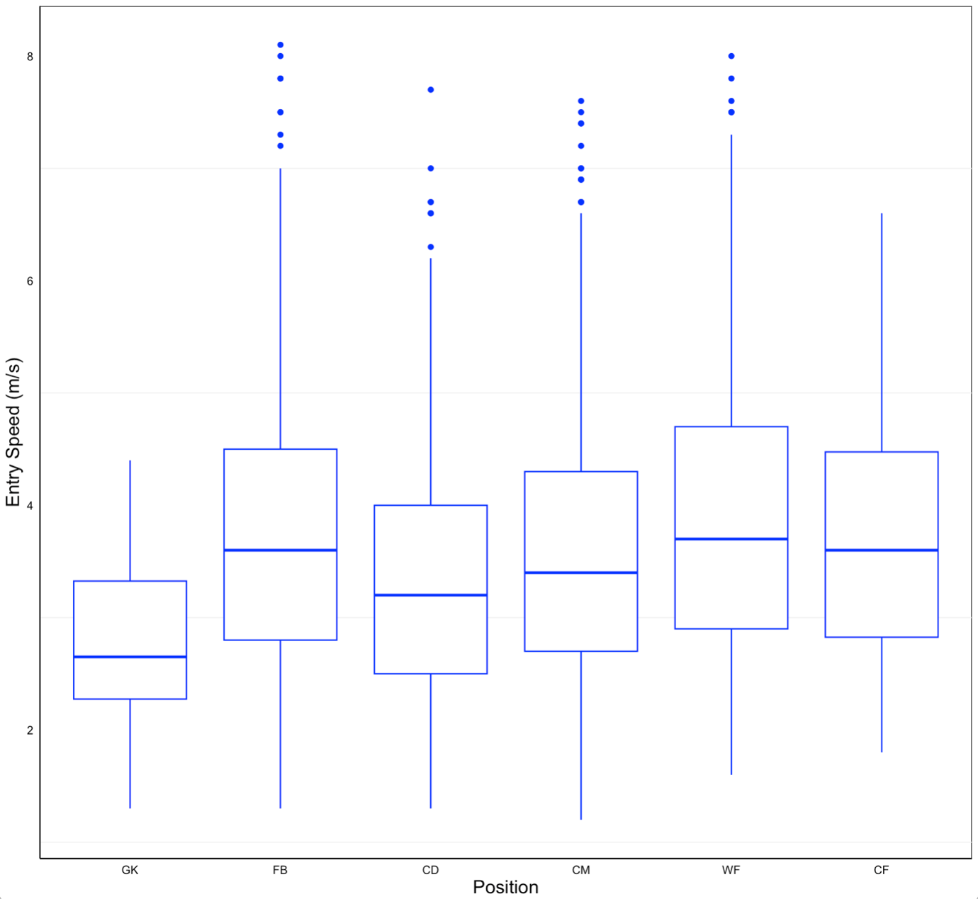

Figure 16 – Entry speed (ms⁻¹) for medium angled turns for each position group. ε² = 0.023(small) CD<FB,CM,WF,CF. GK<FB,CD,CM,WF,CF. CM<WF

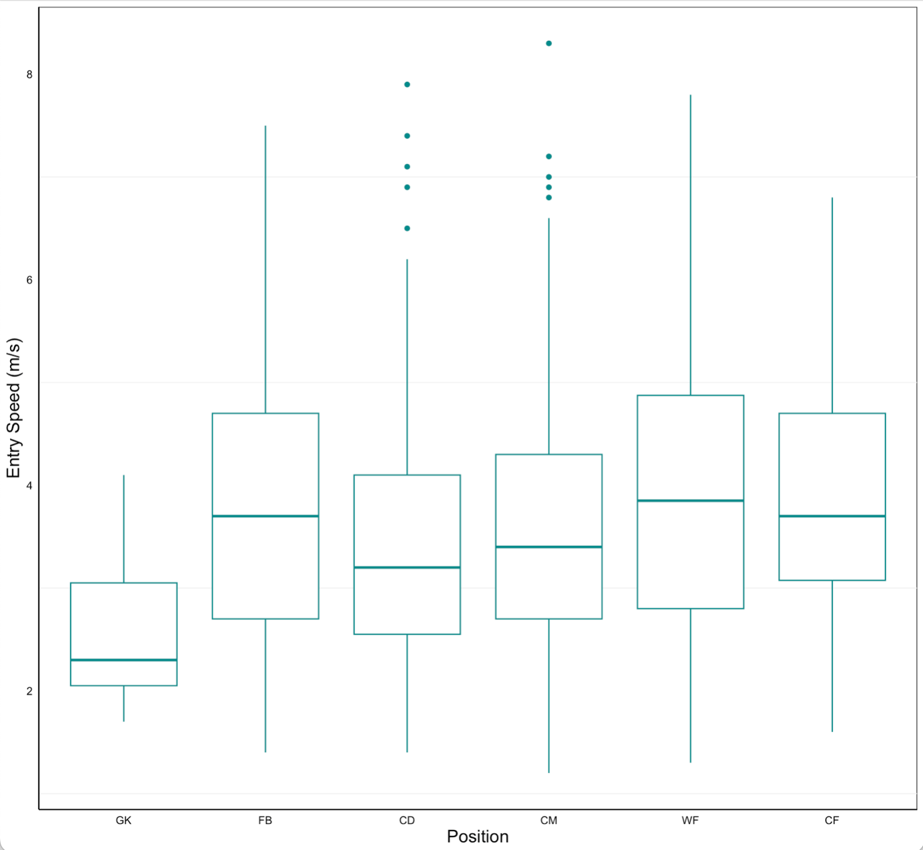

Figure 17 – Entry speed (ms⁻¹) for low angled turns for each position group. ε² = 0.027(small) CD<CF,FB,WF. WF>GK,CM,CD, GK<FB,CD,CM,WF,CF

4.5 Entry Speed and Turn Angle Incidence Rates

The scatter plot, heat map (Figure 14), demonstrates that the highest prevalence of turns occur at a high angle and medium entry speed. Dark blue indicates low incidence rates and red indicates the highest frequency of turns. These findings indicate clear high incidence rates within the boundaries of 125-130° and 3.40-3.60ms⁻¹. These findings can be confirmed using the histograms below (figure 19a & 19b)

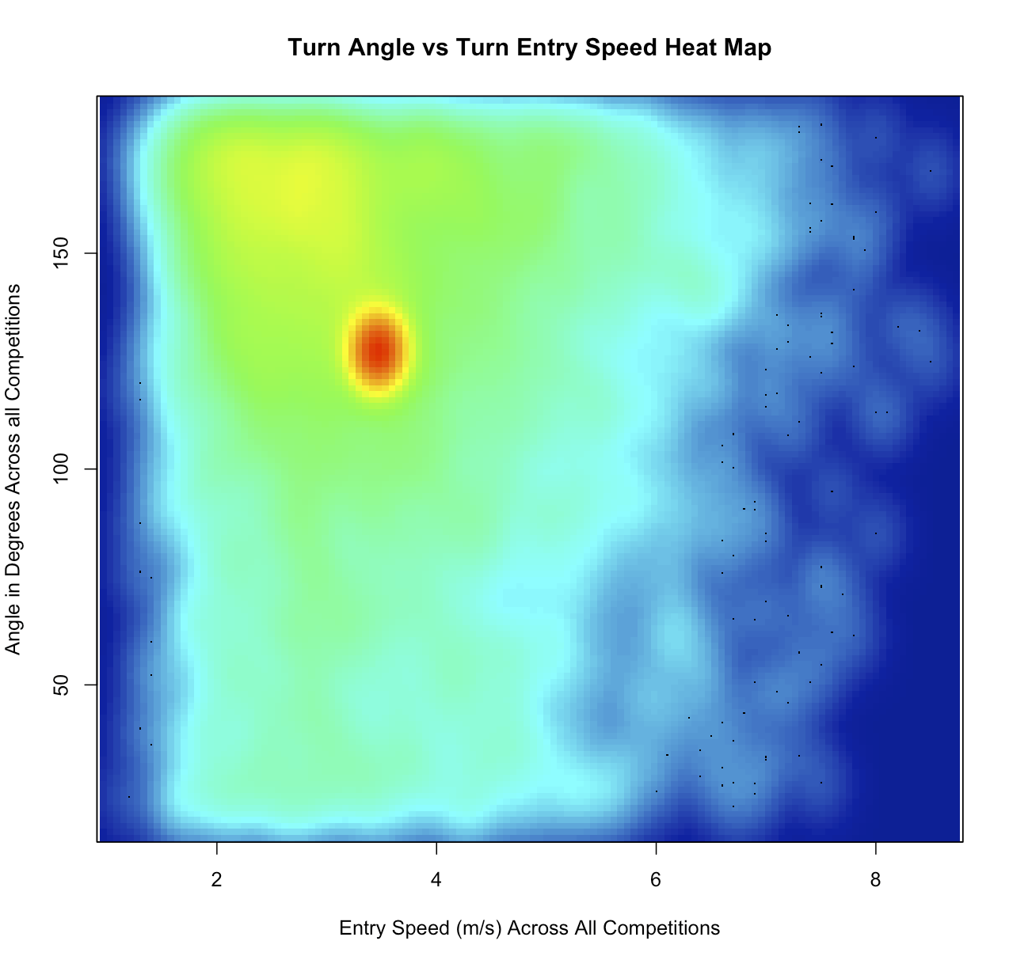

Figure 18: The prevalence of turns completed by entry speed (m/s) and turn angle (degrees), demonstrated by a thermal gradient.

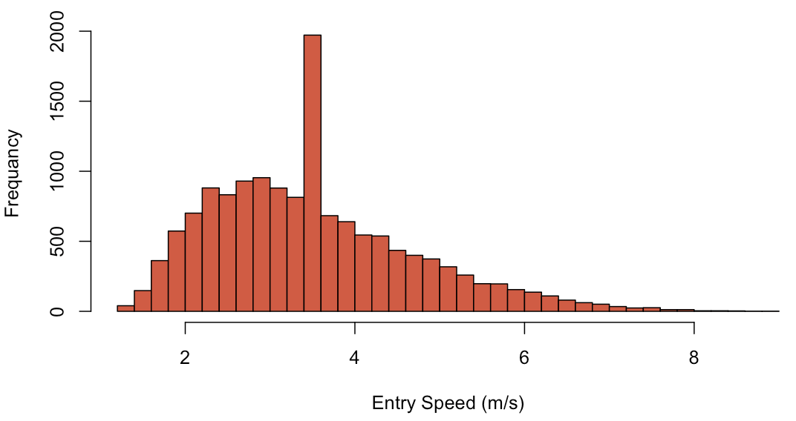

A

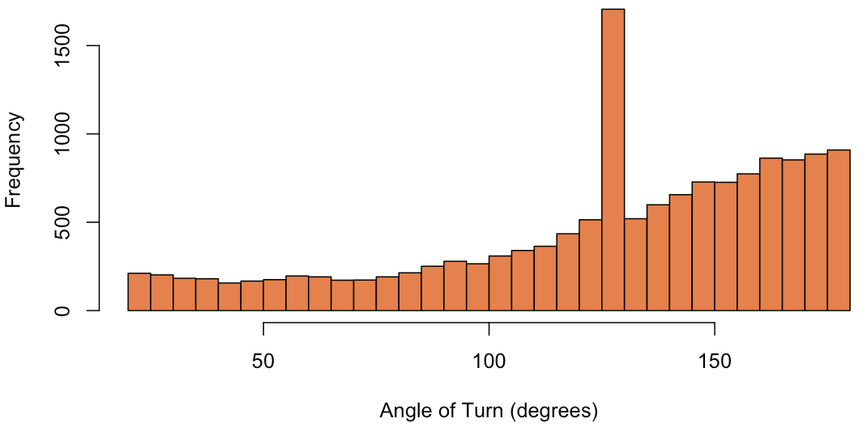
Figure 19a & 19b - cumulating turns from across all competitions, this figure highlights the increased frequency of turns within specific angle and entry speed parameters.
B

4.5.1 Distribution of all Turns by Angle and Entry Speed

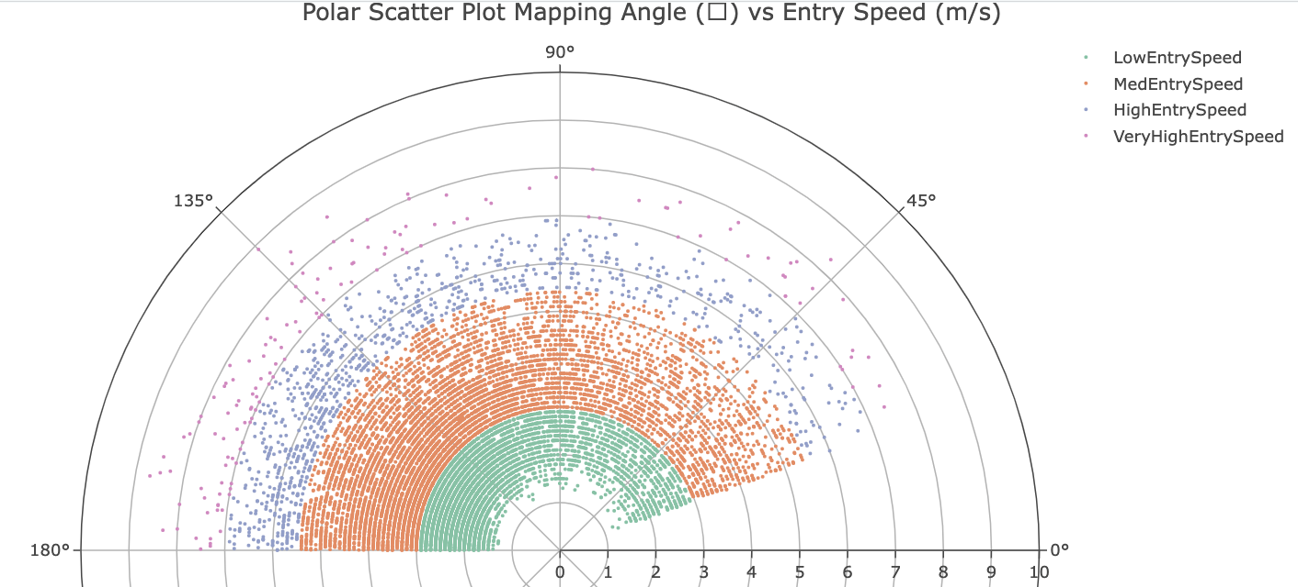
A graph highlighting: high occurrence rates of turns at a high angle and low to medium entry speeds (ms⁻¹) and low occurrence rates of turns at low angle/very high and high entry speed. Figure 21 displays turns via entry speed (radial markers) and turn angle (degrees plotted on circumference).
Figure 20: A polar scatter graph plotting every turn throughout the season from 0°-180°. Entry speed (ms⁻¹) displayed as radial markers. Low Entry Speed: <3 ms⁻¹, Medium Entry Speed: 3-5.5 ms⁻¹, High Entry Speed: 5.5-7 ms⁻¹, Very High Entry Speed: >7 ms⁻¹

4.6 Deceleration

A graph showing the high turn rate occurring with a high turn angle and deceleration of -3ms⁻² to -4.5ms⁻² and the low turn rate occurring with a deceleration of <-5ms⁻² and >-2.5ms⁻² in the medium and low turn angle category. Figure 21 displays turns via deceleration (radial markers) and turn angle (degrees plotted on circumference).
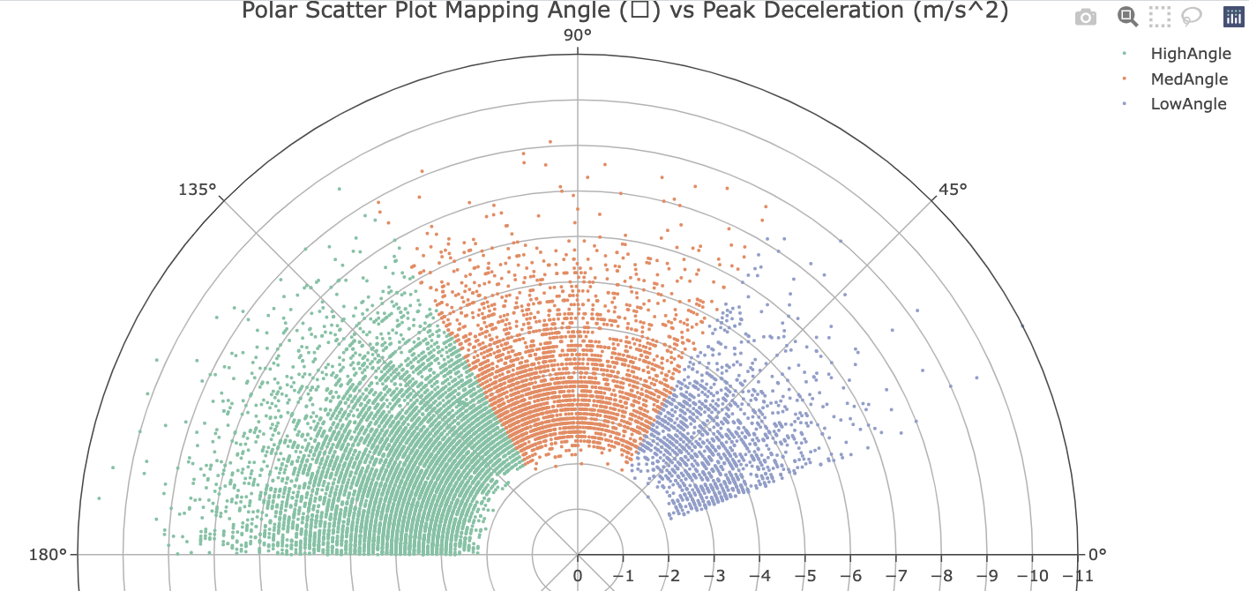
Figure 21: A polar scatter graph plotting every turn throughout the season from 0°-180°. Deceleration (ms⁻²) displayed as radial markers. Low Angle: 20°-60°, Medium Angle: 60.1°-120°, High Angle: 120.1°-180°.

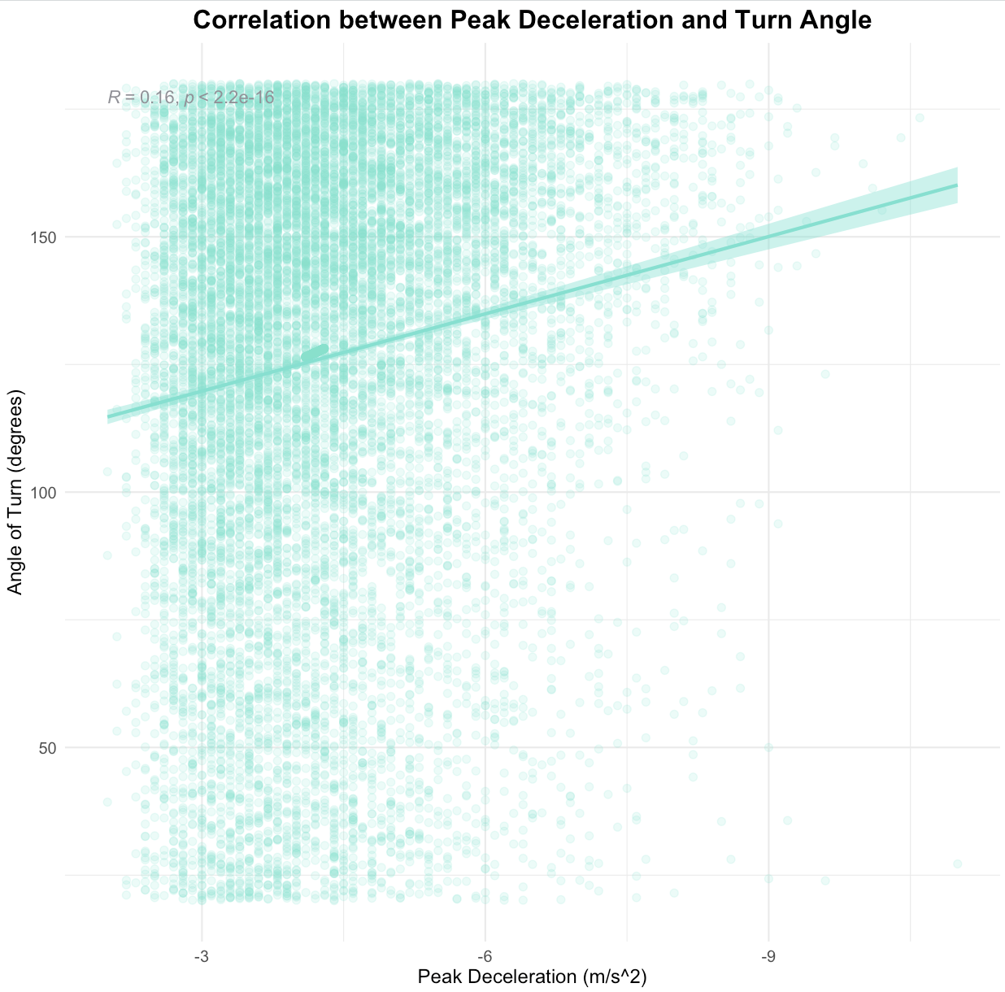
Figure 22 displays all turns throughout the season, recorded by their peak deceleration (ms⁻²) and turn angle to demonstrate the relationship between these two turn characteristics. There is a weak positive correlation between peak deceleration (ms⁻²) and turn angle (°); r(14386) = .16, p <.001 (Figure 22).
Figure 22: The correlation between the angle of turn (°) and the peak deceleration (ms⁻²) on the entry to the turn.

4.7 Turn duration

 | GK | FB | CD | CM | WF | CF
Turn Duration | 0.45±0.17 | 0.44±0.18 | 0.45±0.17 | 0.45±0.17 | 0.44±0.17 | 0.46±0.18
No significant difference was found in turn duration between angle groups or position groups
Table 6: Mean and standard deviation (SD) turn duration for each position group. GK: Goal Keeper, FB: Full Back, CD: Central Defender, CM: Central Midfielder, WF: Winger Forward, CF: Central Forward. ε²[H] = 0.001 (small)
(p > 0.05). Significance was found with low entry speed turn duration being significantly higher than all other entry speed group (H₃ = 171.3, p<0.01).
 | Low Angle (°) | Medium Angle (°) | High Angle (°)
Turn Duration | 0.43 ± 0.16 | 0.48 ± 0.19 | 0.51 ± 0.20
Table 8: Mean and standard deviation (SD) turn duration for each entry speed(ms⁻¹) group. Low Entry Speed: <3 ms⁻¹, Medium Entry Speed: 3-5.5 ms⁻¹, High Entry Speed: 5.5-7 ms⁻¹, Very High Entry Speed: >7 ms⁻¹
Table 7: Mean and standard deviation (SD) turn duration for each angle (°) group. Low Angle: 20°-60°, Medium Angle: 60.1°-120°, High Angle: 120.1°-180°.
.

 | Low Entry Speed  (ms⁻¹) | Medium Entry Speed  (ms⁻¹) | High Entry Speed  (ms⁻¹) | Very High Entry Speed  (ms⁻¹)
Turn Duration | 0.47 ± 0.18 | 0.44 ± 0.17 | 0.43 ± 0.18 | 0.41 ± 0.17

4.8 Competition Differences

There were no significant differences between the number of turns completed per match, as a team, when analysing knockout vs league soccer (p > 0.05; ε²=0.02 (small)).

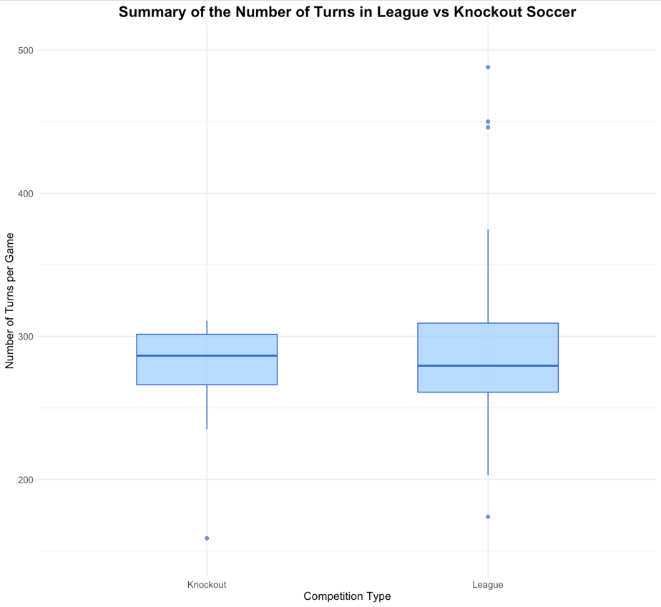

Figure 23: The number of turns completed per game as a team. (p>0.05)

No significant differences were found between knockout and league football for high, medium and low (p > 0.05) angled turns.
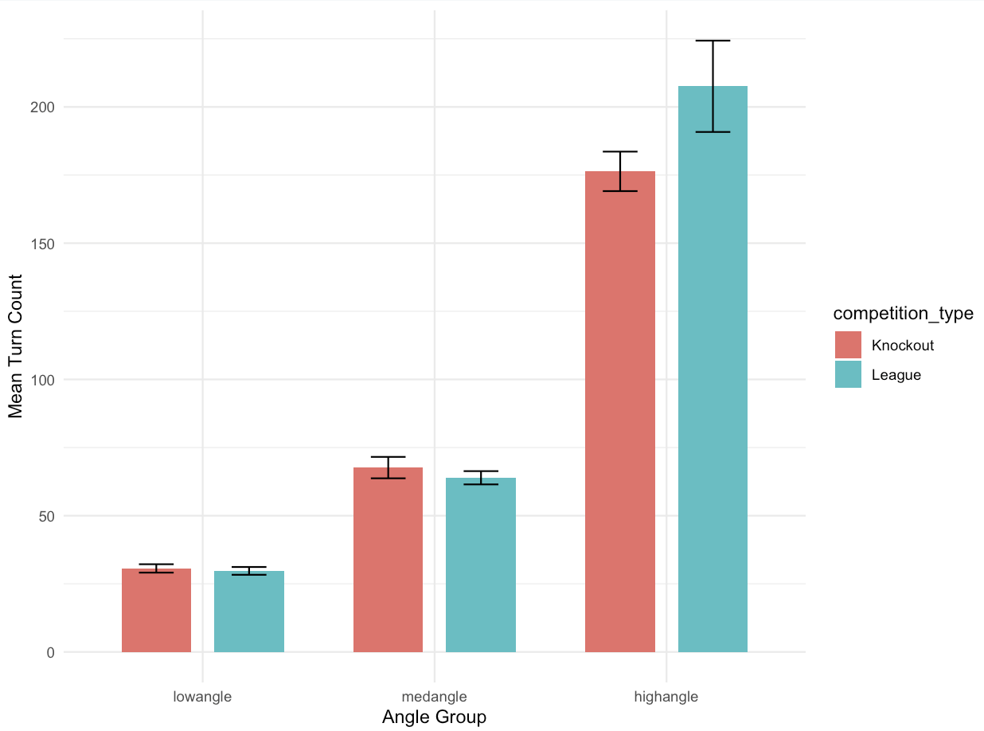

Figure 24: Differences in the mean number of turns completed per match as a team in each angle group for each competition type. Low Angle: 20°-60°, Medium Angle: 60.1°-120°, High Angle: 120.1°-180°. ε² = 0.027(small). Standard error bars are displayed.

No significant differences were found between knockout and league football for very high, high, medium and low (p > 0.05) angled turns.

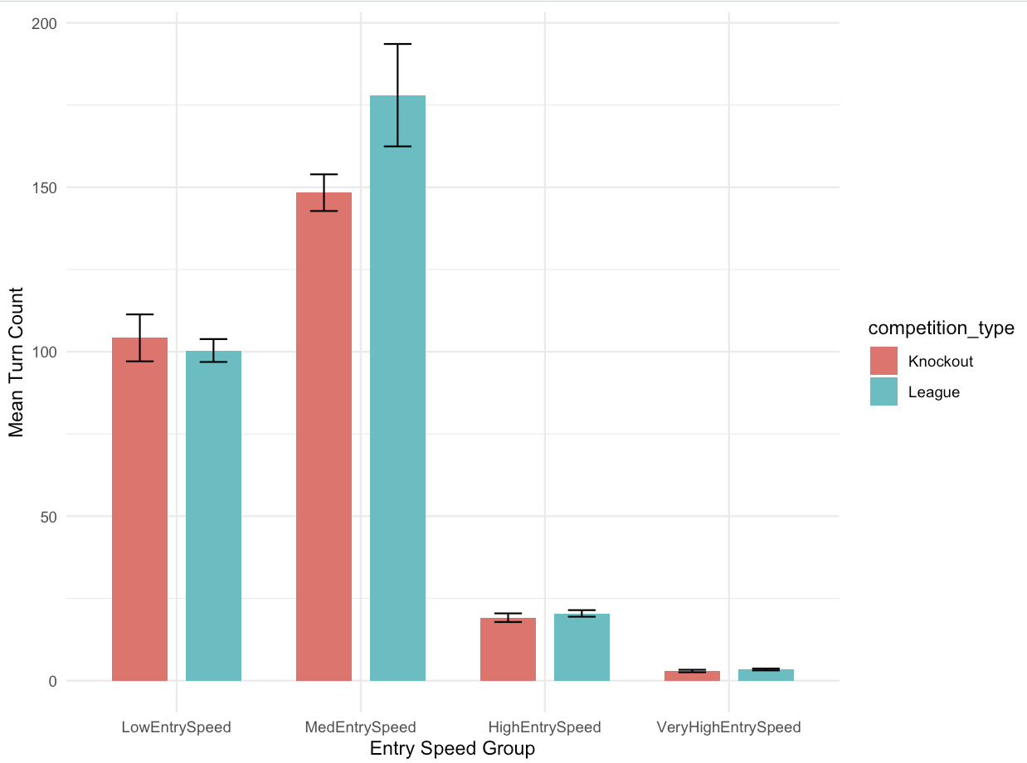

Figure 25: Differences in the mean number of turns completed per player in each entry speed group for each competition type. Low Entry Speed: <3 ms⁻¹, MedEntry Speed: 3-5.5 ms⁻¹, High Entry Speed: 5.5-7 ms⁻¹, Very High Entry Speed: >7 ms⁻¹. Standard error bars are displayed.

Figure 26 demonstrates that competition type does not influence turning characteristics (Angle: p > 0.05 (ε²=0.048); Entry Speed: p > 0.05 (ε²=0.060)).
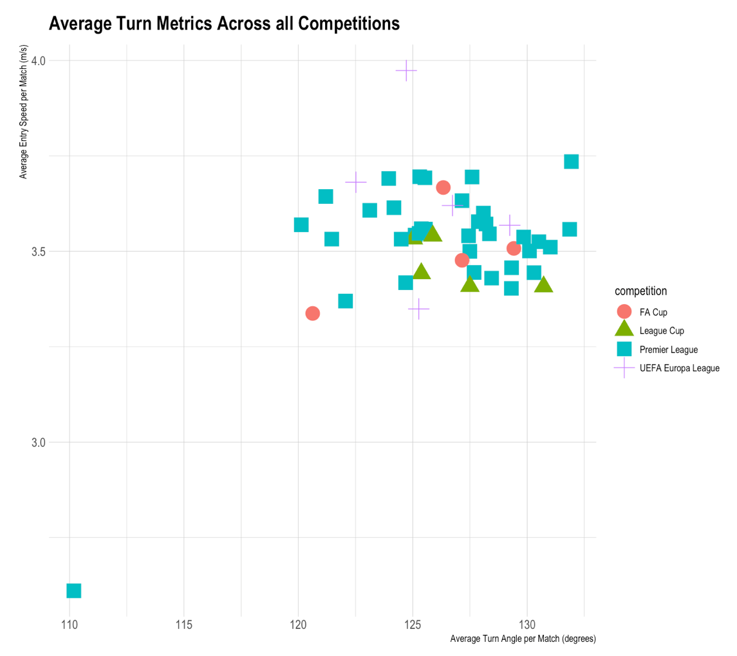

Figure 26: A scatter graph highlighting the difference in key turn characteristics (turn angle (°), turn entry speed (ms⁻¹)) between different soccer competitions.

5.0 Discussion
The present study follows research by Dos’Santos et al., (2022) who investigated the demands of turns in the Premier League over a course of a season; specifically focussing on turn entry speed (ms⁻¹), turn angle (°) and total turns. This study sought to build on Dos’Santos et al., (2022) findings through further consolidation of results via turn demands in the Premier League, in addition to investigating turn demands in the Europa League, FA Cup and League Cup. Greater depth of analysis was completed through a breakdown of turn duration (s), deceleration (ms⁻²) and within-variable differences, i.e. mean entry speed variances between angle groups. The overall objective was to develop a comprehensive view of turn demands for elite footballers, using LiDAR technology, to ensure practitioners can better advise position-specific training programmes, that emulate match-day demands.

5.1Total number of Turns
Findings for the present study differed to Dos’Santos et al., (2022) with the turn totals for both studies being represented in Table 9.

Table 9 - Total turns per match for each position group ($\overline{X}$± SD). Winger forward (WF) has been directly compared to Winger Midfielder (WM) as the current study analysed a team who used WF, therefore acting as the equivalent to a WM in the 4-4-2 formation in Dos’Santos et al., (2022). NA represents ‘non-applicable’ as Dos’Santos et al., (2022) didn’t include GK in their study. P values represent significant differences between the current study and Dos’Santos et al., (2022).
Position | Present Study | Dos’Santos et al., (2022) | p value
GK | 4.8 ± 3.3 | NA | NA
FB | 26.4 ± 10.3 | 19.9 ± 8.6 | p > 0.05
CD | 22.8 ± 9.4 | 18.6 ± 6.4 | p > 0.05
CM | 34.5 ± 17.9 | 38.4 ± 8.0 | p > 0.05
WF/WM | 20.7 ± 11.2 (WF) | 27.1 ± 8.6 (WM) | p > 0.05
CF | 29.8 ± 4.5 | 18.1 ± 6.9 | p < 0.05

Dos’Santos et al., (2022) found significant differences (p<0.01) with CM>FB,CD,WM,CF and WM>FB,CD,CF with an effect size of ε² = .475 (large; Cohen, 1988). Whereas, the present study only found a significant difference (p <0.05) with CM>GK,WF with and effect size of ε² = .587 (large; Cohen, 1988). CMs demonstrated significantly higher turn counts than other positions, which aligns with the findings of Dos’Santos et al., (2022) and can be attributed to their dual attacking and defending roles (Dos’Santos et al., 2022) with CM often considered a ‘pivot’ position. Nonetheless, these findings have not translated in other studies which have grouped WM and CM together as ‘midfielders’ (Bloomfield, Polman and O’Donoghue, 2007; Robinson, O’Donoghue and Nielson, 2011), suggesting WM have consistently performed a lower turn frequency than CM’s.
Not all positional turn frequency findings aligned with Dos’Santos et al., 2022 (Table 9). These disparities could be attributed to formation differences. Dos’Santos et al., (2022) analysed a team who consistently played in a 4-4-2 formation whereas the current study’s subject group played in predominantly a 4-2-3-1 formation (86% of matches analysed). However, these formations were often fluid throughout the match giving different roles to each position to adapt to the game scenario. Though there is no specific research to support this, it could be hypothesised that FBs could have been required to play in a more attacking role in the current study, than that required of a FB in a 4-4-2 formation; this could explain a greater quantity of change of direction movements as players adapt to a dual responsibility of attacking and defending. Indeed, this also explains the expected increase of total turns identified in WM compared to WF. High variability was found within the CM turn count (3-102), and could be attributed to the variety of roles that exist within this CM bracket (ie centre-defensive-midfielders (CDM) and centre-attacking-midfielders (CAM)). Future research should consider splitting position groups further to accommodate for these varied roles within the same position (i.e. wing backs, full backs, CDM, CAM).

The discrepancies in standard deviations (SD) between studies, with the current study having larger SD than Dos’Santos et al., (2022) (Table 9) could likely be explained by the variances in methodologies. The present study analysed turn data for all players who played over 85 minutes, as this is considered a ‘complete performance’ by Sportlight®. In contrast, Dos’Santos et al., (2022) completed analysis whereby turn data for like-for-like substitutions were considered as the same observation. Rationale for the current study not completing this style of analysis was the lack of consistent formation played by the subject team, resulting in few like-for-like substitutions. The average time recorded for all observations in the present study was 95 minutes (mins), however, session time ranged from 85.1-105.4mins. Dos’Santos et al., (2022) considered the full playing time for all observation therefore, it is likely their session duration range is much narrower. This may have also attributed to the differences in the turn frequency match-to-match variability with lows of 2 turns per match (FB, WF, GK) and a high of 102 (CM) in the current study, as highlighted in Figure 1, compared to Dos’Santos et al., (2022) range of 7(CF)-52(WM, FB). This will have also contributed to the larger standard deviations of turn counts in the present study. The results appear to show greater consistency in turn count for CFs, shown by smaller SD in comparison to other outfield positions, however, it should be noted that there was a restricted sample size as there we only 6 occasions where a CF played >85mins across all competitions. This will also likely contribute to the significant difference between the two CF values.

Though differences were found between the current study and Dos’Santos et al., (2022), they align far closer to each other than the rest of the research field. Many studies found vastly different results for number of turns completed per player/position during soccer matches (see Table 1). Bloomfield, Polman and O’Donoghue (2007) found players completed approximately 700 turns per match compared to the current study’s findings of 24.5. Similarly, Kai et al., (2021) found an average number of turns to be 183 ± 39 across all positions. The large difference in results could be attributed to the inclusion of <20° turns in the mentioned studies, as the majority of COD that movements occur are <90° (~600 of the ~700 turns) (Bloomfield, Polman and O’Donoghue, 2007) it is likely a high proportion of these occurred at an angle of <20° (see section 2.2). It must also be considered this study is 26 years old, therefore, these findings may not align to the current study due to advancements in forms of measurements and styles of play in soccer. Turns completed at <20° were excluded from the current study due to their near linear motions (Kai et al., 2021), which do not elicit the high biomechanical loads (Dos’Santos et al., 2018) that this study aimed to focus on during significant turns. Both comparison studies also had methodological limitations including non-elite subject groups (Kai et al., 2021) and use of notational analysis (Bloomfield, Polman and O’Donoghue, 2007).
The differences in position specific turn counts between past literature (Table 1) compared to the present findings (Table 3) could be attributed to differences in form of measure. The range of data collection methods include; GPS (Granero-Gil et al., 2020), local positioning systems (Baptista et al., 2018; Kai et al., 2021) and notational analysis (Bloomfield, Polman and O’Donoghue, 2007; Robinson, O’Donoghue and Nielson, 2011; Ade, Fitzpatrick and Bradley, 2016), which has resulted in high levels of variability between findings across all studies. With COD ability discriminating between elite and sub-elite (Alanen et al., 2023), it is likely the large variances between subject groups training status will also increase inconsistencies between findings. Only Bloomfield, Polman and O’Donoghue (2007) and Dos’Santos et al., (2022) have also completed turn count analysis on Premier League soccer players. This calls for further COD analysis to be completed on Premier League and other ‘top-flight’ soccer leagues.

5.2 Turns by Angle and Position
Figure 6 highlights the significantly larger number of high angle turns (67.7%) completed across the course of the season, compared to medium (22.1%) and low angle (10.2%) turns. Figure 7 also demonstrates a reduced incidence rate of turns between 20°-90°. These results do not necessarily match the literature that have similar subject groups with Bloomfield, Polman and O’Donoghue (2007) finding ~600 of the ~700 turns were completed at <90° and ~100 per match were completed in the 90°-180° in Premier League soccer players. It must be noted, however, that the present study is focussed only on significant turns, therefore including only turns which involve a deceleration of ≤-2ms⁻². It is possible a high number of COD movements which occur at an angle <90° were emitted from analysis as they do not require as high a deceleration rate for the COD to occur (Schot, Dart and Schuh, 1995; Dos’Santos et al., 2018). Likewise, large discrepancies in the 90°-180° bracket could again be attributed to the higher exclusion criteria that is involved with only analysing ‘significant turns’, in the current study.
Figure 19b shows a clear peak of high angled turn frequency at 125°-130°. This finding should inform practitioners, when designing drills for training and return-to-play protocols, to focus primarily on turns within this angle bracket. An example drill has been designed in Figure 27.
Practitioners can make this, and any other turn-based drill, position-specific by monitoring the volume of repetitions completed rather than altering the angles within the drill. This is due to all positions being shown to perform proportionally the same split of high, medium and low angled turns (Figure 7). However, positional differences in frequency of COD movements vary between angle groups, such as: CM and FB can be seen to perform significantly more high angled turns (Figure 5), whereas only CM performed significantly higher medium angled turns (Figure 4).
There is an understanding that sharper COD movements elicit greater lower body loading, larger GRF’s and knee moments (Besier et al., 2001; Havens and Sigward, 2015b; Sigward, Cesar and Havens, 2015; Dos’Santos et al., 2018). Increases in knee valgus and internal knee abduction moments have also been reported during sharper COD movements (Besier et al., 2001; Havens and Sigward, 2015b; Sigward, Cesar and Havens, 2015; Dos’Santos et al., 2018). The increase in these mechanisms of movement have direct ACL injury risk consequences (Olsen et al., 2004; Waldén et al., 2015; Montgomery et al., 2018). These movements, however, are unavoidable in sports therefore it is imperative practitioners ensure athletes can perform these high angled turns with the correct mechanics (Dempsey et al., 2007, 2009; Kristianslund et al., 2014; Jones, Herrington and Graham-Smith, 2015, 2016) and have the physical capabilities to endure the knee-loading associated with them (Weinhandl et al., 2014; Suchomel, Nimphius and Stone, 2016; Dos’Santos et al., 2018). Correct mechanics can be demonstrated by sufficient trunk control and no knee valgus (Dempsey et al., 2007, 2009; Jones, Herrington and Graham-Smith, 2015, 2016; Dos’Santos et al., 2018). Therefore, it is vital that the current findings help improve the knowledge of the frequencies of these high angled turns so practitioners can adequately prepare players for the high biomechanical loads and ensure correct execution to reduce injury risk factors.

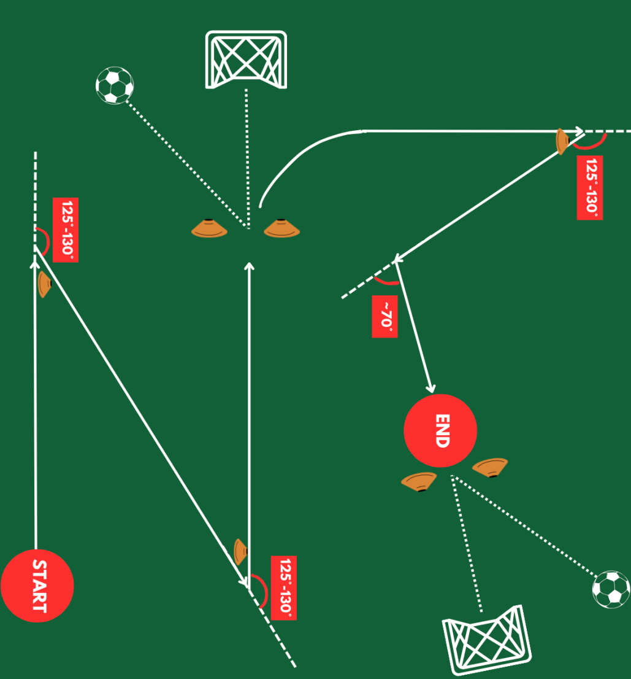

Figure 27 - An example of a drill-design that focuses primarily on 125-130 turns to reflect the findings which highlight high incidence rates within this turn bracket during match play.

5.3 Turns by Entry Speed and Position
Increasing the speed of entry to turns has been evidenced to increase many injury risk factors such as peak knee valgus moment (Vanrenterghem et al., 2012; Kimura and Sakurai, 2013; Nedergaard, Kersting and Lake, 2014), trunk deceleration (Nedergaard, Kersting and Lake, 2014) and peak posterior ground reaction forces (Dai et al., 2019). Developing our research understanding of turn entry speed demands for each position will aid injury risk reduction, through more accurate physical preparation. Turns categorized in the ‘high’ and ‘very high’ entry speed brackets are likely to elicit the greatest biomechanical load due to increased reductions in velocity (change of momentum) requirements to change direction and therefore increased ground reaction forces and knee loading (Dos’Santos et al., 2018). Though it should be noted that, following the law of impulse (Impulse = Force (N) x Time (s)), if the duration of the turn increases, as has been found with low entry speed turns (Table 8), a reduction in momentum and therefore GRF will be present. Only 7.7% of all turns were completed at a ‘high’ or ‘very high’ entry speed, suggesting only a small percentage of turns carry the highest injury risk factors, though it is these COD movements, completed at high speeds, which elicit the greatest performance outcomes (Hader, Palazzi and Buchheit, 2015; Dos’Santos et al., 2018). Proportionally, all outfield positions completed similar numbers of these ‘high’ and ‘very high’ entry speed turns, with a range of 10.8% (CD’s) to 4.7% (FB’s). Though CD performed proportionally the largest amount of ‘high’ and ‘very high’ turns, when analysing absolute data, CD performed significantly less high entry speed turns per match than CM, WF and FB’s. These findings in WF and FB could be attributed to teams often using their fastest players in wide positions due to these areas often needing to be exploited in build-up play to achieve a goal and pace being a relied upon mechanism for this exploitation. Abbott, Brickley and Smeeton (2018) found wide attackers and wide defenders to hit significantly higher peak speeds (ms⁻¹) than all other outfield positions, further supporting this argument. As CM performed significantly higher overall turns, likely due to their dual attacking and defending role and therefore their increase in game-involvement, it is unsurprising they have a significantly greater number of ‘high’ and ‘very high’ entry speed turns as this is in keeping with the total increase in turns throughout most other categories.
Throughout all outfield positions, medium entry speed turns were performed significantly more than any other entry speed category (~57.7%). Goalkeepers performed the most turns in the low entry speed category. Many studies have categorised ‘fast’ approach speed to COD movements to be between 4.0-5.0ms⁻¹ (Vanrenterghem et al., 2012; Nedergaard, Kersting and Lake, 2014) which falls within the ‘medium’ category for this study. In these studies where turn entry speed has been analysed, there have been factors which may explain these lower boundaries: Nedergaard, Kersting and Lake (2014) failed to identify the training status of the participants and Vanrenterghem et al., (2012) completed their studies on females. With COD speed and ability being identified as a discriminator between elite and sub elite (Reilly et al., 2000) and sex of participant having known physiological effects (Thomas et al., 2020), both training status (Reilly et al., 2000) and participant sex (Thomas et al., 2020) will have influenced the relativity of the category boundaries, hence why the current study positively adjusted the boundaries to align with the elite participant’s speeds. This must be acknowledged when interpreting biomechanical load findings which use these lower boundaries to describe ‘fast’ turns. More research should be completed to determine how biomechanical load varies for different turn entry speeds in elite compared to sub-elite. Significant increases in lower limb loading and injury risk factors have been identified during turns completed with these 4.0-5.0ms⁻¹ approach speeds, which falls into the category of ‘medium entry speed’ in the current study (Vanrenterghem et al., 2012; Nedergaard, Kersting and Lake, 2014; Dos’Santos et al., 2018). This is why the findings that significantly more turns occur at a medium entry speed than any other entry speed group is highly important as we know that players are undergoing high biomechanical loads at high frequencies throughout the match, therefore preparation must focus on turns at this speed to ensure accurate physical preparation (Figure 27).

5.4 Entry Speed and Angle Groups
Though Dos’Santos et al., (2022) completed a fully comprehensive analysis on both turn entry speed and turn angle, there was no combined analysis of the relationship between these two variables. The current study aimed to further analyse these key turn characteristics to gain a greater level of understanding of the overall turn demands. Figure 14 demonstrates high angled turns elicit significantly lower turn entry speeds compared to medium and low angled turns. Though this may be impacted by the low effect size,it is also a finding explained by pre-emptive measures players will have to take when entering a turn as they may enter at a slower speed to ensure more efficient deceleration and subsequent change of direction (Dos’Santos et al., 2018). This finding is one that is understood throughout the literature (Besier et al., 2001; Fitzpatrick, Dos’Santos et al., 2018; Linsley and Musham, 2019; Kai et al., 2021), however, this is often in controlled conditions where the participant is aware of the angle of the turn prior to completion. The current study, therefore, highlights that similar outcomes are found even with additional neuromuscular components when turning in response to a stimulus.

Dos’Santos et al., 2022 reported that ~63-70% of all turns were completed at a high turn angle, alongside ~43.3-56.8% of all turns completed at a medium entry speed (3.0-5.5ms⁻¹). The current category boundaries could be considered broad as significant differences in biomechanical loading factors have been found between entry speeds of 3.82 ± 0.36ms⁻¹ and 4.82 ± 0.58ms⁻¹ (Nedergaard, Kersting and Lake, 2014), as well as turn angles of 90° and 180° (Schreurs, Benjaminse and Lemmink, 2017). These figures are similar to the boundaries of the most frequented turn categories (medium entry speed and high turn angle). Hence, the current study acknowledged the importance of determining where within these categories the highest incidence rates of turns occurred to ensure correct understanding of biomechanical load effects. Figure 14 combines both turn angle and entry speed to highlight the high incidence rate of turns, which occurred over the season, between 125-130° and 3.40-3.60ms⁻¹. Though this aligns with Dos’Santos et al., (2022), further research should be completed using the current turn definition to determine if this hot spot of turn frequency rate is an accurate representation of all ‘significant’ turns or a limiting factor. For example, it could be hypothesised that turns at high turn angles and medium to very high entry speeds may still elicit very high biomechanical loads but may not be included in analysis due to change of direction time being >1 second. Equally, Figure 20 highlights the low incidence rates of turns completed at a low angle and high/very high entry speed. It is understood that increased entry speed corresponds to decreased COD angle (Besier et al., 2001; Fitzpatrick, Linsley and Musham, 2019; Kai et al., 2021), though, factors such as decreased requirements for deceleration (Harper, 2023) may explain their exclusion from this study, rather than their lack of existence within matches.

5.5 Turn Demands and Competition Types
Previously differences in external load intensity had been identified based upon opposition quality (Goncalves et al., 2021), game importance (Link and De Lorenzo, 2016), and tournament standard (i.e. national vs regional) (Rites et al., 2022). Despite these previous findings, the current study found no significant differences between turn characteristics when comparing knockout vs. league soccer (Figure 23-26). Previous research, which has focused on external load intensity across competition types, has never analysed turn intensity, therefore it can be concluded that turns do not follow the same pattern as other key performance indicators such as total distance covered, maximum sprint speed and number of accelerations/decelerations. It could be hypothesised that the turn definition for the current study is specific to ‘significant’ turns already, therefore, finding a significant difference between already high intensity turns may be unlikely. Equally, research on external load in different competition types has yet to analyse turns, nor has research often studied top-flight elite soccer teams, therefore, previously drawn conclusions which attribute intensity differences to opposition quality (Goncalves et al., 2021) and tournament standard (Rites et al., 2022) may not be applicable to the current study.

5.6 Turn Duration
Very few studies have analysed turn duration (Granero-Gil et al., 2020; Kai et al., 2021) despite the knowledge that soccer players experience the greatest performance outcomes through faster COD (Hader, Palazzi and Buchheit, 2015). This is likely due to the difficult nature of data collection for this metric; with such a small unit of measurement it requires forms of measurement which are precise enough to accurately determine turn duration, this is equipment is not widely available. The current study found an overall average turn duration of 0.45 ± 0.17s which is ~50% faster than the only other known reported turn duration study of 0.89 ± 0.49s (Kai et al., 2021). This is likely due to the difference in inclusion criteria and definitions of the beginning and end of the turn. The current study included only turns under one second, whereas Kai et al., (2021) didn’t have a time restriction. In addition, the current study required the athletes to be decelerating at ≤−2 ms⁻² prior to the turn and subsequently accelerate ≥2ms⁻² after the COD movement, hence only the turns at a high intensity were analysed; compared to Kai et al., (2021) who put no restrictions on acceleration or deceleration, measuring the start and end through jerk (detecting the onset and offset of human movement). Hence, it is unsurprising the current study had a faster average duration.

No significant differences were found between position groups or angle groups for turn duration (Table 6 & 7), though low entry speed turns were found to be completed significantly slower than medium and high entry speed (Table 8). Higher entry speeds have corresponded with lower turn angle throughout literature (Besier et al., 2001; Fitzpatrick, Linsley and Musham, 2019; Kai et al., 2021), the current study supports this through demonstrating that lower entry speeds correspond with higher turn angle (Table 5; Figure 14). Turns which are high angled require greater changes in momentum and elicit larger biomechanical demands (Dos’Santos et al., 2018), which likely increases turn duration. This was supported by the current studies findings with the turns completed at a lower entry speed found to elicit longer turn durations, and low entry speed turns being frequented most often during high angle turns. However, it must also be considered that the small effect size reduces the statistical power of all findings within this analysis group. For example, though a significance has been found, when applied to a practical context, the difference of 0.06s between the longest duration (low entry speed: 0.47±0.18s) and the shortest duration (very high entry speed: 0.41±0.17s) becomes negligible. Additionally, it must be noted that analysing a metric such as COD duration with a LiDAR system that samples at only 10Hz, reduces the accuracy of the findings to 0.1s. Further research should be completed at a higher sampling rate to gain a truer representation of COD duration. This would allow measurements to be recorded in milliseconds, and therefore, be more accurate.

5.7 Deceleration
Turns were only analysed for the current study if a deceleration of ≥-2ms⁻² was detected prior to the COD movement. Despite -2ms⁻² being the boundary, Figure 21 demonstrates very few turns completed between -2ms⁻² and -2.5ms⁻². High angled turns were performed significantly more than both medium and low angled turns, it is understood that higher turn angles require larger changes of momentum and therefore, assuming similar entry speed, greater levels of deceleration (Dos’Santos et al., 2018). Therefore, turns which are likely to require the lowest deceleration rate are those completed at a low turn angle and low entry, the infrequent nature of this turn type within the study could explain the sparsely populated area in Figure 21 between -2ms⁻² and -2.5ms⁻².
The highest frequency of turns was completed at a deceleration rate between -3ms⁻² and -4.5ms⁻² (Figure 21). To the authors knowledge, there are no studies which have analysed deceleration rate upon entry to a COD within a field setting, therefore there are no direct comparison to be made. Figure 22 demonstrates the highest concentration of these turns occur at a high turn angle. It is understood that horizontal deceleration elicits large external moments that are generated upon ground contact (Colby et al., 2000; McBurnie et al., 2022); Figure 1 demonstrates the near horizontal nature of high angled turns, therefore, it is essential a high degree of muscle pre-activation is completed to effectively support the demands of these decelerations (Colby et al., 2000; McBurnie et al., 2022). Practitioners focus primarily on linear deceleration to protect against hamstring injuries within training sessions. Findings from the current study should be used to adapt long term training programmes to ensure decelerations are also completed in a turning context to reduce lower limb joint injury risk. An important step would be for practitioners to use the LiDAR system to familiarize themselves with a deceleration rate both -3ms⁻² and -4.5ms⁻², with the aim of later demonstrating then identifying correct deceleration rates of the players during turn specific drills.

5.8 Limitations

Limitations within the current study are predominantly due to the novel nature of the research and the need to refine on a trial-and-error basis to ensure optimum definitions, exclusion criterion, and sampling rates. Reliability and validity studies for the Sportlight® LiDAR system for COD specific metrics, such as turn duration and turn angle, need to be completed before these results can be verified. Additionally, future research should state the height of all LiDAR systems within all stadiums to ensure consistency in form of measure.
Including players which have completed >85 minutes per match, rather than like-for-like substitutions being considered the same observation, reduces the participant sample size; CF’s contained only 3 soccer players, reducing the reliability of findings. Future research should consider recording formations and positional swaps during games to ensure substitutions don’t result in lost data. Furthermore, formation changes within games should be considered; the current study recorded only the starting position of the player, therefore, multiple positions may be included within one observation if player have changed position mid-match.

5.9 Conclusion

To conclude, this study further developed the knowledge of the turn demands faced by a Premier League Soccer team who also compete in the FA Cup, League Cup and UEFA Europa League. This was achieved through analysis of turn frequency and the turn characteristics: entry speed, turn angle, deceleration and COD duration. CM’s were found to perform significantly more turns than GK and WF. High angled, medium entry speed turns were significantly the most frequently performed, with both turn angle and entry speed proportions remaining similar throughout all outfield positions. Deceleration was influenced by the high proportion of high angled turns, resulting in the most frequently performed deceleration rate between -3ms⁻² and -4.5ms⁻². No significant differences were found between angle group or position for COD duration. Low entry speed turns were found to have significantly longer COD durations than all other entry speed groups. Competition differences were found to be negligible for both turn frequency and turn characteristics.
These findings should educate practitioners of the more complex details of turn demands within match-play; return-to-play protocols, physical preparation strategies, drill design and rehabilitation programmes should all focus on the specific turns which occur the most during matches. Determining the biomechanical impacts of these findings were beyond the scope of this thesis but need to be examined in future research to determine how these turn demands equate to biomechanical load and injury risk.

References

Abbott, W., Brickley, G. and Smeeton, N. J. (2018) ‘Physical demands of playing position within English Premier League academy soccer’, Journal of Human Sport and Exercise, 13(2), pp. 285–295. doi: 10.14198/jhse.2018.132.04.

A Faulkner, J. (2014) ‘Multiple Sprint Exercise with a Short Deceleration Induces Muscle Damage and Performance Impairment in Young, Physically Active Males’, Journal of Athletic Enhancement, 03(02). doi: 10.4172/2324-9080.1000144.
Ade, J., Fitzpatrick, J. and Bradley, P. S. (2016) ‘High-intensity efforts in elite soccer matches and associated movement patterns, technical skills and tactical actions. Information for position-specific training drills’, Journal of Sports Sciences. Routledge, 34(24), pp. 2205–2214. doi: 10.1080/02640414.2016.1217343.

Alanen, A.-M. et al. (2023) ‘Capturing in Season Change-of-Direction Movement Pattern Change in Youth Soccer Players with Inertial Measurement Units’, Biomechanics, 3(1), pp. 155–165. doi: 10.3390/biomechanics3010014.

Aquino, R. et al. (2020) ‘Relationships between running demands in soccer match-play, anthropometric, and physical fitness characteristics: a systematic review’, International Journal of Performance Analysis in Sport, 20(3), pp. 534–555. doi: 10.1080/24748668.2020.1746555.

Bampouras, T. M. and Thomas, N. M. (2022) ‘Validation of a LiDAR - based player tracking system during football - specific tasks’, Sports Engineering. Springer London, 25(1), pp. 1–6. doi: 10.1007/s12283-022-00372-7.

Baptista, I. et al. (2018) ‘Position specific player load during matchplay in a professional football club’, PLoS ONE, 13(5), pp. 1–10. doi: 10.1371/journal.pone.0198115.
Bastida-Castillo A, Gómez-Carmona CD, De La Cruz Sánchez E, et al. Comparing accuracy between global positioning systems and ultra-wideband-based position tracking systems used for tactical analyses in soccer. Eur J Sport Sci 2019; 19: 1157–1165.

Beckett, R. G. (2014) ‘Paleoimaging: A review of applications and challenges’, Forensic Science, Medicine, and Pathology, 10(3), pp. 423–436. doi: 10.1007/s12024-014-9541-z.

Besier, T. F. et al. (2001) ‘External loading of the knee joint during running and cutting maneuvers’, Medicine and Science in Sports and Exercise, 33(7), pp. 1168–1175. doi: 10.1097/00005768-200107000-00014.

Blankenau, I. et al. (2018) ‘Development of a Low-Cost LIDAR System for Bicycles’, SAE Technical Papers, 2018-April, pp. 1–9. doi: 10.4271/2018-01-1051.

Bloomfield, J., Polman, R. and O’Donoghue, P. (2007) ‘Physical demands of different positions in FA Premier League soccer’, Journal of Sports Science and Medicine, 6(1), pp. 63–70.

Brown, M. A. et al. (2016) ‘Adaptation to damaging dance and repeated-sprint activity in women’, Journal of Strength and Conditioning Research, 30(9), pp. 2574–2581. doi: 10.1519/JSC.0000000000001346.

Buchheit, M. et al. (2014) ‘Integrating different tracking systems in football : multiple camera semi-automatic system , local position measurement and GPS technologies technologies’, Journal of Sports Sciences. Routledge, 32(20), pp. 1844–1857. doi: 10.1080/02640414.2014.942687.

Caldbeck, P. (2020) ‘CONTEXTUAL SPRINTING IN PREMIER LEAGUE FOOTBALL PAUL MICHAEL CALDBECK A thesis submitted in partial fulfilment of the requirements of Liverpool John Moores University for the degree of Professional Doctorate February 2020’, (February).

Caves, K., Davis, L. and DeRuyter, F. (2018) ‘Development and evaluation of a device to measure walking speed’, Lecture Notes in Computer Science (including subseries Lecture Notes in Artificial Intelligence and Lecture Notes in Bioinformatics), 10897 LNCS(3002011430), pp. 468–471. doi: 10.1007/978-3-319-94274-2_68.

Clark, R. A. et al. (2019) ‘Validity of a low-cost laser with freely available software for improving measurement of walking and running speed’, Journal of Science and Medicine in Sport. Sports Medicine Australia, 22(2), pp. 212–216. doi: 10.1016/j.jsams.2018.07.005.

Čoh, M. et al. (2018) ‘Are change-of-direction speed and reactive agility independent skills even when using the same movement pattern?’, Journal of Strength and Conditioning Research, 32(7), pp. 1929–1936. doi: 10.1519/JSC.0000000000002553.

Colby, S. et al. (2000) ‘Electromyographic and kinematic analysis of cutting maneuvers. Implications for anterior cruciate ligament injury’, American Journal of Sports Medicine, 28(2), pp. 234–240. doi: 10.1177/03635465000280021501.

Dai, B. et al. (2019) ‘The effect of performance demands on lower extremity biomechanics during landing and cutting tasks’, Journal of Sport and Health Science, 8(3), pp. 228–234. doi: 10.1016/j.jshs.2016.11.004.

Dempsey, A. R. et al. (2007) ‘The effect of technique change on knee loads during sidestep cutting’, Medicine and Science in Sports and Exercise, 39(10), pp. 1765–1773. doi: 10.1249/mss.0b013e31812f56d1.

Dempsey, A. R. et al. (2009) ‘Changing sidestep cutting technique reduces knee valgus loading’, American Journal of Sports Medicine, 37(11), pp. 2194–2200. doi: 10.1177/0363546509334373.

Di Mascio, M., Ade, J. and Bradley, P. S. (2015) ‘The reliability, validity and sensitivity of a novel soccer-specific reactive repeated-sprint test (RRST)’, European Journal of Applied Physiology, 115(12), pp. 2531–2542. doi: 10.1007/s00421-015-3247-0.
Dos’Santos, T. et al. (2017) ‘Mechanical Determinants of Faster Change of Direction Speed Performance in Male Athletes’, Journal of Strength and Conditioning Research, 31(3), pp. 696–705. doi: 10.1519/JSC.0000000000001535.

Dos’Santos, T. et al. (2018) ‘The Effect of Angle and Velocity on Change of Direction Biomechanics : An Angle-Velocity Trade-Off Sharper CODs Increase the Relative Lower Body Loading COD Task Execution : Intended Angle does not Reflect Executed Angle Changing Direction : An Angle-Velo’, pp. 45–47.

Dos’Santos, T. et al. (2022) ‘What are the significant turning demands of match play of an English Premier League soccer team?’, Journal of Sports Sciences. Routledge, 40(15), pp. 1750–1759. doi: 10.1080/02640414.2022.2109355.

Eitel, J. U. H. et al. (2016) ‘Beyond 3-D: The new spectrum of lidar applications for earth and ecological sciences’, Remote Sensing of Environment, 186, pp. 372–392. doi: 10.1016/j.rse.2016.08.018.

Fitzpatrick, J. F., Linsley, A. and Musham, C. (2019) ‘Curved sprinting during football match-play Running the curve: a preliminary investigation into curved sprinting during football match-play’, Sport performance & science reports, 55(1), pp. 1–3.

Flash, T. and Hogan, N. (1985) ‘The coordination of arm movements: An experimentally confirmed mathematical model’, Journal of Neuroscience, 5(7), pp. 1688–1703. doi: 10.1523/jneurosci.05-07-01688.1985.

Garmin (2022) ‘LIDAR-LITE V3HP Operation manual and technical specifications’, (April), pp. 1–10. Available at: https://static.garmin.com/pumac/LIDAR-Lite_v3HP_Instructions_EN.pdf.

Goncalves, L. G. C. et al. (2021) ‘Effects of match location, quality of opposition, match outcome, and playing position on load parameters and players’ prominence during official matches in professional soccer players’, Human Movement, 22(3), pp. 35–44. doi: 10.5114/hm.2021.100322.

Granero-Gil, P. et al. (2020) ‘Influence of playing position and laterality in centripetal force and changes of direction in elite soccer players’, PLoS ONE, 15(4), pp. 1–13. doi: 10.1371/journal.pone.0232123.

Hader, K., Palazzi, D. and Buchheit, M. (2015) ‘Change of direction speed in soccer: How much braking is enough?’, Kinesiology, 47(1), pp. 67–74.

Harper, D. J. and Kiely, J. (2018) ‘Damaging nature of decelerations: Do we adequately prepare players?’, BMJ Open Sport and Exercise Medicine, 4(1), p. 7647. doi: 10.1136/bmjsem-2018-000379.

Harper, D. J., Carling, C. and Kiely, J. (2019) ‘High-Intensity Acceleration and Deceleration Demands in Elite Team Sports Competitive Match Play: A Systematic Review and Meta-Analysis of Observational Studies’, Sports Medicine. Springer International Publishing, 49(12), pp. 1923–1947. doi: 10.1007/s40279-019-01170-1.

Havens, K. L. and Sigward, S. M. (2015a) ‘Cutting mechanics: Relation to performance and anterior cruciate ligament injury risk’, Medicine and Science in Sports and Exercise, 47(4), pp. 818–824. doi: 10.1249/MSS.0000000000000470.

Havens, K. L. and Sigward, S. M. (2015b) ‘Whole body mechanics differ among running and cutting maneuvers in skilled athletes’, Gait and Posture. Elsevier B.V., 42(3), pp. 240–245. doi: 10.1016/j.gaitpost.2014.07.022.

Hennessy, L. and Jeffreys, I. (2018) ‘The current use of GPS, its potential, and limitations in soccer’, Strength and Conditioning Journal, 40(3), pp. 83–94. doi: 10.1519/SSC.0000000000000386.

Hojka, V. et al. (2016) ‘A systematic review of the main factors that determine agility in sport using structural equation modeling’, Journal of Human Kinetics, 52(1), pp. 115–123. doi: 10.1515/hukin-2015-0199.

Howatson, G. and Milak, A. (2009) ‘Exercise-induced muscle damage following a bout of sport specific repeated sprints’, Journal of Strength and Conditioning Research, 23(8), pp. 2419–2424. doi: 10.1519/JSC.0b013e3181bac52e.

Jeffreys, I. (2011) ‘A task-based approach to developing context-specific agility’, Strength and Conditioning Journal, 33(4), pp. 52–59. doi: 10.1519/SSC.0b013e318222932a.

Jones, P. A., Herrington, L. C. and Graham-Smith, P. (2015) ‘Technique determinants of knee joint loads during cutting in female soccer players’, Human Movement Science, 42(August), pp. 203–211. doi: 10.1016/j.humov.2015.05.004.

Jones, P. A., Herrington, L. C. and Graham-Smith, P. (2016) ‘Technique determinants of knee abduction moments during pivoting in female soccer players’, Clinical Biomechanics, 31(January), pp. 107–112. doi: 10.1016/j.clinbiomech.2015.09.012.

Jones, P. A., Smith, L. C. and Stones, S. (2014) ‘a Comparison of Braking Characteristics Between Pre-Planned and Unanticipated Changing Direction Tasks in Female Soccer Players: an Exploratory Study’, Bases, 33(June), p. 2009.

Kadlubowski, B. et al. (2021) ‘Influence of linear-sprint performance, concentric power and maximum strength on change of direction performance in elite youth soccer players’, German Journal of Exercise and Sport Research, 51(1), pp. 116–121. doi: 10.1007/s12662-020-00692-5.

Kai, T. et al. (2021) ‘A new approach to quantify angles and time of changes-of-direction during soccer matches’, PloS one, 16(5), p. e0251292. doi: 10.1371/journal.pone.0251292.

Khalilzadeh, J. and Tasci, A. D. A. (2017) ‘Large sample size, significance level, and the effect size: Solutions to perils of using big data for academic research’, Tourism Management. Elsevier Ltd, 62, pp. 89–96. doi: 10.1016/j.tourman.2017.03.026.

Kimura, K. and Sakurai, S. (2013) ‘A Sidestep Cut Preparation Strategy Decreases the External Load Applied to the Knee Joint’, International Journal of Sport and Health Science, 11(0), pp. 109–117. doi: 10.5432/ijshs.201309.

Kristianslund, E. et al. (2014) ‘Sidestep cutting technique and knee abduction loading: Implications for ACL prevention exercises’, British Journal of Sports Medicine, 48(9), pp. 779–783. doi: 10.1136/bjsports-2012-091370.

Link, D. and De Lorenzo, M. F. (2016) ‘Seasonal pacing - Match importance affects activity in professional soccer’, PLoS ONE, 11(6), pp. 1–10. doi: 10.1371/journal.pone.0157127.
Liu, A. (2018) DESIGN AND DEVELOPMENT OF AN AFFORDABLE TELEMETRY SYSTEM FOR NAVIGATION OF AUTONOMOUS VEHICLE.

McBurnie, A. J. et al. (2022) ‘Deceleration Training in Team Sports: Another Potential “Vaccine” for Sports-Related Injury?’, Sports Medicine. Springer International Publishing, 52(1), pp. 1–12. doi: 10.1007/s40279-021-01583-x.

McLean, S. G., Huang, X. and Van Den Bogert, A. J. (2005) ‘Association between lower extremity posture at contact and peak knee valgus moment during sidestepping: Implications for ACL injury’, Clinical Biomechanics, 20(8), pp. 863–870. doi: 10.1016/j.clinbiomech.2005.05.007.

Merks, B. M. T. et al. (2022) ‘Quantifying change of direction load using positional data from small-sided games in soccer’, Science and Medicine in Football, 6(2), pp. 234–240. doi: 10.1080/24733938.2021.1912382.

Montgomery, C. et al. (2018) ‘Mechanisms of ACL injury in professional rugby union: A systematic video analysis of 36 cases’, British Journal of Sports Medicine, 52(15), pp. 994–1001. doi: 10.1136/bjsports-2016-096425.

Morral-Yepes, M. et al. (2022) ‘Assessing the Reliability and Validity of Agility Testing in Team Sports: A Systematic Review’, Journal of Strength and Conditioning Research, 36(7), pp. 2035–2049. doi: 10.1519/JSC.0000000000003753.

Nedergaard, N. J., Kersting, U. and Lake, M. (2014) ‘Using accelerometry to quantify deceleration during a high-intensity soccer turning manoeuvre’, Journal of Sports Sciences. Routledge, 32(20), pp. 1897–1905. doi: 10.1080/02640414.2014.965190.

Nimphius, S., Callaghan, S., Bezodis, N. & Lockie, R. (2017) ‘Cronfa - Swansea University Open Access Repository Change of direction and agility tests : Challenging our current measures of performance Running head : Validity of COD and agility assessment 1 Centre for Exercise and Sports Science Research , School of’, Strength and Conditioning Journal, 1.

Oliva-Lozano, J. M. et al. (2021) ‘Impact of contextual variables on the representative external load profile of Spanish professional soccer match-play: A full season study’, European Journal of Sport Science, 21(4), pp. 497–506. doi: 10.1080/17461391.2020.1751305.

Olsen, O. E. et al. (2004) ‘Injury mechanisms for anterior cruciate ligament injuries in team handball: A systematic video analysis’, American Journal of Sports Medicine, 32(4), pp. 1002–1012. doi: 10.1177/0363546503261724.
Pino-Ortega, J., Oliva-Lozano, J.M., Gantois, P., Nakamura, F.Y. and Rico-Gonzalez, M., 2022. Comparison of the validity and reliability of local positioning systems against other tracking technologies in team sport: A systematic review. Proceedings of the Institution of Mechanical Engineers, Part P: Journal of Sports Engineering and Technology, 236(2), pp.73-82.

Rahman, A. H. A., Saufi, A. I. and Ahmad, I. (2020) ‘Development of portable ranging integrated measurement (P.R.I.Me) using Garmin’, AIP Conference Proceedings, 2291(March 2021). doi: 10.1063/5.0027592.

Rampinini, E. et al. (2022) ‘Peripheral muscle function during repeated changes of direction in professional soccer players’, European Journal of Applied Physiology, 122(9), pp. 2125–2134. doi: 10.1007/s00421-022-04988-2.

Reilly, T. et al. (2000) ‘A multidisciplinary approach to talent identification in soccer’, Journal of Sports Sciences, 18(9), pp. 695–702. doi: 10.1080/02640410050120078.

Rhodes, D. et al. (2021) ‘The effect of high-intensity accelerations and decelerations on match outcome of an elite english league two football team’, International Journal of Environmental Research and Public Health, 18(18). doi: 10.3390/ijerph18189913.

Rites, A. et al. (2022) ‘Do contextual factors, tournament level, and location affect external match load in elite Brazilian youth soccer players?’, Journal of Physical Education and Sport, 22(11), pp. 2898–2903. doi: 10.7752/jpes.2022.11366.

Robinson, G., O’Donoghue, P. and Nielson, P. (2011) ‘Path changes and injury risk in English FA Premier League soccer’, International Journal of Performance Analysis in Sport, 11(1), pp. 40–56. doi: 10.1080/24748668.2011.11868528.

Schot, P., Dart, J. and Schuh, M. (1995) ‘Biomechanical analysis of two change-of-direction maneuvers while running’, Journal of Orthopaedic and Sports Physical Therapy, 22(6), pp. 254–258. doi: 10.2519/jospt.1995.22.6.254.

Schreurs, M. J., Benjaminse, A. and Lemmink, K. A. P. M. (2017) ‘Sharper angle, higher risk? The effect of cutting angle on knee mechanics in invasion sport athletes’, Journal of Biomechanics. Elsevier Ltd, 63, pp. 144–150. doi: 10.1016/j.jbiomech.2017.08.019.

Serpell, B. G., Young, W. B. and Ford, M. (2011) ‘Are the perceptual and decision-making components of agility trainable? A preliminary investigation’, Journal of Strength and Conditioning Research, 25(5), pp. 1240–1248. doi: 10.1519/JSC.0b013e3181d682e6.

Sigward, S. M. and Powers, C. M. (2007) ‘Loading characteristics of females exhibiting excessive valgus moments during cutting’, Clinical Biomechanics, 22(7), pp. 827–833. doi: 10.1016/j.clinbiomech.2007.04.003.

Sigward, S. M., Cesar, G. M. and Havens, K. L. (2015) ‘Predictors of frontal plane knee moments during side-step cutting to 45 and 110 degrees in men and women: Implications for anterior cruciate ligament injury’, Clinical Journal of Sport Medicine, 25(6), pp. 529–534.

Suchomel, T. J., Nimphius, S. and Stone, M. H. (2016) ‘The Importance of Muscular Strength in Athletic Performance’, Sports Medicine. Springer International Publishing, 46(10), pp. 1419–1449. doi: 10.1007/s40279-016-0486-0.

Theodoropoulos, J. S., Bettle, J. and Kosy, J. D. (2020) ‘The use of GPS and inertial devices for player monitoring in team sports: A review of current and future applications’, Orthopedic Reviews, 12(1), pp. 2016–2017. doi: 10.4081/or.2020.7863.

Thomas, C. et al. (2020) ‘Male and female soccer players exhibit different knee joint mechanics during pre-planned change of direction’, Sports Biomechanics, p. 1998. doi: 10.1080/14763141.2020.1830160.

Vanrenterghem, J. et al. (2012) ‘The effect of running speed on knee mechanical loading in females during side cutting’, Journal of Biomechanics, 45(14), pp. 2444–2449. doi: 10.1016/j.jbiomech.2012.06.029.

Waldén, M. et al. (2015) ‘Three distinct mechanisms predominate in noncontact anterior cruciate ligament injuries in male professional football players: A systematic video analysis of 39 cases’, British Journal of Sports Medicine, 49(22), pp. 1452–1460. doi: 10.1136/bjsports-2014-094573.

Weinhandl, J. T. et al. (2014) ‘Reduced hamstring strength increases anterior cruciate ligament loading during anticipated sidestep cutting’, Clinical Biomechanics, 29(7), pp. 752–759. doi: 10.1016/j.clinbiomech.2014.05.013.

Weston, M. (2018) ‘Training load monitoring in elite English soccer: a comparison of practices and perceptions between coaches and practitioners’, Science and Medicine in Football. Routledge, 2(3), pp. 216–224. doi: 10.1080/24733938.2018.1427883.

Williams, K. et al. (2013) Synthesis of transportation applications of mobile LIDAR, Remote Sensing. doi: 10.3390/rs5094652.

Young, W. B., Dawson, B. and Henry, G. J. (2015) ‘Agility and change-of-direction speed are independent skills: Implications for training for agility in invasion sports’, International Journal of Sports Science and Coaching, 10(1), pp. 159–169. doi: 10.1260/1747-9541.10.1.159.

