Spatio-temporal distribution and sexual segregation in the Critically Endangered Angelshark (Squatina squatina) in Spain’s largest marine reserve

Lucy R. Mead^{1,6}*, David Jiménez Alvarado², Eva Meyers³, Joanna Barker⁴, Michael Sealey⁵, Maria Belén Caro⁵, Hector Toledo⁵, Charlotte Pike⁴, Matthew Gollock⁴, Adam Piper¹, Gail Schofield^{6†}, Edy Herraiz⁷, David M.P. Jacoby⁸

¹Institute of Zoology, Zoological Society of London, London postcode, UK
²IU-ECOAQUA, Universidad de Las Palmas de Gran Canaria, Las Palmas, Spain
³LIB, Museum Koenig Bonn, Leibniz Institute for the Analysis of Biodiversity Change Bonn, Germany
⁴Conservation and Policy, Zoological Society of London, London, UK
⁵Angel Shark Project: Canary Islands, Islas Canarias, SPAIN
⁶School of Biological and Behavioural Sciences, Queen Mary University of London, London, UK
⁷La Graciosa Divers, Islas Canarias, SPAIN
⁸Lancaster Environment Centre, Lancaster University, Lancaster, UK

† Deceased
*Corresponding author: lucy.mead@ioz.ac.uk

Running page head: Angelshark distribution and sexual segregation

ABSTRACT
Establishing how threatened wildlife are distributed spatially and temporally is essential for effective conservation and management planning. While many shark species are threatened globally, knowledge on sex-specific differences in behaviour and fine scale habitat use remains limited, hindering the implementation of appropriate conservation actions. Here, acoustic telemetry was used to investigate sex-specific space use in the Critically Endangered Angelshark Squatina squatina in the Canary Islands (Atlantic Ocean), a key stronghold for the species. We collected data on space-use, residency and movement of adult males (n = 32) and females (n = 72) in Spain’s largest marine reserve (La Graciosa Marine Reserve) over four years (2018 - 2022). Presence in offshore sites (> 80 m depth) indicated long-term utilisation of deep-water habitat, not previously observed in this species. Males were more likely to be detected in deep water and displayed significantly greater levels of activity and roaming behaviour than females. Patterns of behaviour in shallow waters indicated both social and habitat sexual segregation. Diel variability was also recorded, with greater activity occurring nocturnally. This study demonstrates the importance of considering spatiotemporal distribution of both sexes, horizontally and vertically, when designing effective conservation measures.

KEY WORDS: Acoustic telemetry, Angel Shark, Conservation, Distribution, Sexual segregation, Spatial ecology
- INTRODUCTION

Understanding how animals are distributed throughout their habitat allows the development of effective management and conservation measures, along with mitigating anthropogenic threats across varying spatial and temporal scales (Wilson et al. 2004, Speed et al. 2010, Runge et al. 2014). This process is complicated when different sexes and age/size classes use habitats differently in time and space, resulting in variation in exposure to anthropogenic threats within a population (Mucientes et al. 2009, Jacoby et al. 2012, Schofield et al. 2020). Over a third of chondrichthyan (sharks, rays and chimeras) species are estimated to be threatened with extinction, primarily as a result of overfishing and habitat loss (Dulvy et al. 2021). It is therefore important to address data gaps and understand how space use varies between sexes and over time for this group, in order to implement appropriate conservation actions and protective measures (Holt et al. 2013, Hyde et al. 2022).

Sexual segregation occurs when sex differences in space-use, movement, and both seasonal and diel distribution, result in complete or partial segregation of males and females outside of the breeding season. This phenomenon has been documented throughout the animal kingdom, and is generally classified into two forms: habitat segregation and social segregation. Habitat segregation is characterised by differing responses, preferences and tolerances in relation to physical and environmental characteristics, such that males and females use different habitats (Ruckstuhl & Neuhaus 2005). Social segregation occurs where behavioural differences lead to either aversion between sexes and/or affinity within sexes (Wearmouth & Sims 2008, Dell’Apa et al. 2016). This can occur in the absence of habitat segregation, where both sexes use the same areas but remain temporally segregated (Ruckstuhl & Neuhaus 2005, Fury et al. 2013). However, sexual segregation can lead to differential exposure to threats. For example, Simpfendorfer et al. (2002) and Mucientes et al. (2009) suggested that declines in male blue shark abundance may be driven by sexual segregation, with greater male overlap with fisheries exploitation. Consequently, to avoid bias in future conservation and management strategies, the space-use and movement of both sexes must be accounted for. This is particularly challenging in the marine environment, where the added dimension of depth use contributes to the complexity of this phenomenon (Wearmouth & Sims 2008). In chondrichthyans, particularly sharks, sexual segregation and differential space use outside the breeding season has been widely documented (e.g. Wearmouth & Sims 2008, Vandeperre et al. 2014).

Sexual segregation and sex differences in distribution can operate over varying spatial and temporal scales, characterised by fluctuations and variability both seasonally and diurnally. Seasonal migration in animals often occurs in response to environmental conditions, reproductive requirements and resource availability, and can result in distribution shifts over large areas (Schofield et al. 2010, Shaw 2016). In many species, this shift can occur as part of an annual cycle, before individuals return to smaller core areas (Furey et al. 2018). Movement cycles can also occur over diurnal timescales, whereby shorter-term changes in space-use and activity are driven by diel fluctuation in foraging opportunities, predator/competitor presence and abiotic factors such as light intensity and temperature (Reebs 2002, Lowerre-Barbieri et al. 2021). Such patterns can occur both horizontally and vertically, and therefore depth-use is an important consideration when investigating distribution. In chondrichthyans, coastal bottom-dwelling species with limited depth distribution have consistently been found to be disproportionately vulnerable to extinction, due to proximity to human populations and exposure to multiple overlapping threats including coastal development, pollution and overfishing (Dulvy et al. 2014, 2021). Indeed, catastrophic declines have been observed in many species of sawfish (Pristidae), wedgefish (Rhinidae), guitarfishes (Rhinobatidae) and giant guitarfishes (Glaucostegidae), as well as angel sharks (Squatinidae). For example, abundant in West African coastal waters as recently as the 1960s, the African wedgefish Rhynchobatus luebberti is now listed as Critically Endangered and only two individuals have been recorded in the last decade (Kyne et al. 2020). Thus, species distribution in all dimensions (including time) not only affects how best to mitigate threats, but also determines inherent vulnerability to these threats in the first instance.

The Angelshark Squatina squatina is a large flat-bodied shark, listed as Critically Endangered on the IUCN Red List of Threatened Species (Morey et al. 2019). Formerly widespread throughout the Northeast Atlantic and Mediterranean Sea, overexploitation and coastal habitat degradation have driven drastic range declines in S. squatina, and remaining populations are generally small, isolated and fragmented (Miller 2016, Gordon et al. 2019, Lawson et al. 2020). The Canary Islands have been suggested as a key stronghold for this species, providing crucial habitat for both juveniles and adults (Barker et al. 2016, Meyers et al. 2017, Jiménez‐Alvarado et al. 2020, Lawson et al. 2020). Despite full protection under the Spanish Catalogue of Threatened Species, S. squatina remains threatened by fishing and habitat degradation across the archipelago. Evidence of seasonality and sex differences in presence, movement and depth distribution have been observed to varying degrees in parts of S. squatina range (Meyers et al. 2017, Bom et al. 2020, Ellis et al. 2021, Noviello et al. 2021, Barker et al. 2022). Around the Canary Islands, it is hypothesised that breeding occurs nearshore in autumn and winter, with males then moving into deeper offshore areas while females remain close to the coast year-round (Meyers et al. 2017, Tuya et al. 2020, Noviello et al. 2021). S. squatina primarily occupy shallow inshore coastal waters and have only been reported in up to 150 m depth. However, other angel shark species have been observed in over 600 m depth, providing evidence that utilisation of deep water could occur in S. squatina (Ebert & Stehmann 2013, Fortibuoni 2016, Miller 2016, Ellis et al. 2021). Diel variation in adult behaviour and space-use has also been noted, with angel sharks usually described as nocturnally active and diurnally sedentary (Pittenger 1984, Ebert & Stehmann 2013, Miller 2016).

To date, information on S. squatina ecology and behaviour has come from underwater visual census, visual ID tagging and citizen science, especially in the form of diver observations and fisheries records. Although such information remains crucial, the cryptic nocturnal nature of S. squatina may result in incomplete descriptions of spatiotemporal presence and distribution (Meyers et al. 2017, Noviello et al. 2021), potentially limiting conservation outcomes.

Here, we used acoustic telemetry to investigate spatial and temporal distribution in relation to sex differences and explore putative sexual segregation in adult S. squatina in the La Graciosa Marine Reserve (LGMR) in the Canary Islands. The principal objectives were to investigate population level and sex-specific variation with respect to: (1) space-use and residency, (2) depth use, (3) seasonal activity and (4) diel activity. We hypothesised: (1) females would occupy shallower habitat compared to males, based on local diver observation and on theorised offshore movement in males, (2) male and female space use would overlap more during winter (November to January) because breeding is thought to occur at this time, (3) both sexes would be more active at night based on diver observations of greater movement nocturnally. Our results provide fundamental evidence-based information to inform improved conservation and management of S. squatina within LGMR, Spain’s largest marine reserve and a critical habitat for this species.
- MATERIALS & METHODS

  - Study site

The Canary Islands are a Spanish archipelago situated in the North Atlantic (Fig. 1), approximately 100 km west of the Moroccan and West Saharan coastline. Stretching nearly 500km East to West, the marine environment around the islands is characterised by a strong longitudinal oceanographic gradient, driven by the proximity to the West African coast and seasonal coastal upwelling. Consequently, temperature, salinity, nutrient concentration and species structure vary across the islands (Meyers et al. 2017, Lawson et al. 2020), creating a highly biodiverse marine environment, suitable for both temperate and tropical species (Barker et al. 2016). For coastal species such as Squatina squatina, the Canary Islands provide a huge variety of habitats and conditions as well as a diversity of prey species (Lawson et al. 2020).

LGMR encompasses 70,764 ha and includes a series of islets to the north of Lanzarote (Fig. 1) characterised by a coastal desert climate and particularly fragile terrestrial and marine ecosystems (Baztan et al. 2014). Whereas all other islands across the Canary archipelago are separated by abyssal depths, Fuerteventura, Lanzarote and the LGMR islands are connected by shallow shelf waters (Barker et al. 2016), which may have implications for S. squatina movement and connectivity in the area (Meyers et al. 2017). LGMR was established in 1995 and has three zones: 60% of the marine reserve is in interior waters (under control of the Canary Island Government), 40% of the marine reserve is in exterior waters (under control of the Spanish Government), and there is a small integral reserve, which is a strict no-take zone. Scuba diving activities and some recreational and commercial fishing activities are permitted in the interior waters and exterior waters, but are closely regulated using permits given to a limited number of fishers using traditional gears. Despite being the largest marine reserve in Spain, regulations in LGMR are effectively controlled and enforced and there is a detailed Management Plan. However, this plan pre-dates the listing of S. squatina on the Spanish Endangered Species List, and does not currently include S. squatina as a species of interest or in any species-specific protective measures.Based on frequent diver observations and research conducted by Angel Shark Project: Canary Islands, the area has been identified as an important hotspot for both male and female S. squatina (Meyers et al. 2017). LGMR therefore presents a unique opportunity for scientific research and conservation, as well as responsible dive tourism with S. squatina as a flagship species.

  - Telemetry array configuration

An acoustic telemetry array was configured to quantify S. squatina presence within LGMR. Receivers (Innovasea, Halifax, Canada) were deployed in 12 locations (Fig. 2), chosen based on: (a) areas identified during visual ID tagging surveys, (b) information provided by the local dive centre, La Graciosa Divers, (c) habitat variation and (e) logistical limitations and accessibility for dive-based retrieval and maintenance. Receivers (model VR2Tx and VR2W) were placed in 10 shallow water locations (10 to 24m water depth), and Acoustic Release receivers (VR2AR) were placed in two deep water locations (86m and 120m). Locations were broadly classified into habitat types – ‘shallow sheltered coast’, ‘shallow open coast‘, ‘shallow channel’ and ‘deep offshore’ (see S1.). While most receivers were originally deployed in July 2018, five (L1, L2, L4, L11 and L12) were deployed at later dates as the study expanded.

  - Animal capture and tagging

Tagging was carried out across various dive sites around La Graciosa in November 2018 to 2021, and in July 2018 at the start of the study (Fig. 2). November was chosen based on diver observations of a peak in S. squatina sightings and presence of males at this time of year, enabling both sexes to be captured in the sample, albeit in different frequencies. An in situ, external attachment methodology was developed to enable underwater tagging of adult S. squatina (>80 cm total length), removing the need for capture and surface procedures and thus reducing stress and disturbance to these Critically Endangered sharks. In short, resting sharks were approached on SCUBA equipment and restrained by two divers using a purpose-built cage to fit around the individual, leaving the dorsal fin and caudal section exposed to tag and take genetic samples (Fig. 3). A bespoke applicator was used to attach the tag and harness to the shark through the first dorsal fin. The process was usually completed in under two minutes. To increase our chances of encountering a buried shark, a team of divers swam parallel to one another in a wide transect and individuals were opportunistically selected for tagging. Individuals were determined to be appropriate for tagging based on visual estimation of size; only mature sharks (> 80 cm total length) were tagged. After tag application and fin clip taken for genetic analysis, the shark was sexed based on the presence or absence of claspers and released.

Sharks were tagged with coded V9 (n = 84) and later with V13 (n = 20) acoustic transmitters (high power output, 90-150 second delay) which continue to transmit for the duration of their battery life (estimated by the manufacturers as 346 and 522 days respectively). The tag weight did not exceed 2% of the shark weight in any case. Between July 2018 and November 2021, transmitters were attached to 104 adult S. squatina (72 females and 32 males) during five tagging campaigns. This female-biased tagging sample reflects the opportunistic nature of animal selection and likely sex ratio of S. squatina presence in areas where and when tagging was carried out.
  - Receiver range testing

Range testing of receivers was carried out to determine the approximate maximum distance at which acoustic transmitters can be detected. Range estimates can vary considerably between locations and on a diel and seasonal temporal scale and therefore provide important information on the probability of a tagged shark being detected at different receivers across the study area (Kessel et al. 2014). Three methods of range testing were carried out, depending on receiver type, using either a hydrophone, test tag or sentinel tags. Estimates for each location are included in Figure 2. At location L5, sentinel tags were placed over approximately two days to investigate diel variation in detection range and efficiency at the range boundary (as estimated with a hydrophone). Detection efficiency approximately 30 m inside the range boundary ranged from 33 % to 92 %, with fluctuation occurring across both diel periods. This indicates that diel detection patterns observed in the present study are unlikely to be driven by diel shifts in receiver detection range. Further details on range testing are included in S2.

  - Data analysis

    - Data cleaning and pre-processing

Acoustic detections were filtered to remove unrecognised tag IDs, internal tags associated with VR2Tx or VR2AR receivers, and range test tags. For each individual, detections recorded 48 hours post-tagging were removed before analysis to avoid any potential impacts of the tagging procedure on behaviour. Although observations of sharks during tagging and immediately afterwards suggested little impact, removal of this period was judged to be a sensible precaution.

    - Spatial analysis

All data processing, analysis and visualisation was carried out in R Studio (Version 2021.09.1) and QGIS (Version 3.16.1) environments. Spatial presence of tagged S. squatina was plotted as detections and number of individuals at each receiver location throughout the entire study period. Overall male to female ratios were also mapped for each location. The following detection metrics were calculated for each individual: detection count, number of days detected, days monitored (the number of days between tagging and last recorded detection) and number of receivers visited.

For each shark, total detection count was reduced to unique shark-date and shark-date-site detections, reflecting the number of days an individual was present in the whole array, and at each receiver location (after Andrews et al. 2010). These unique counts were summed to investigate spatial and temporal patterns in presence. Raw detections were grouped into individual residence events, quantified in terms of frequency and duration (after Meyer et al. 2009, 2018) using the VTrack RunResidenceExtraction (Campbell et al. 2012) function. An event started when two consecutive detections were recorded at the same receiver and ended either when the individual was not detected for 60 minutes or was detected at a different receiver. Residency to the study area was quantified by calculating a Residency Index (RI) for each individual. In each case, the number of days detected across the whole array was divided by the total number of days the individual was monitored. RI values range from 0 to 1, where 1 indicates 100% residency and presence in the study area on all days monitored. A roaming index was also calculated for each individual, to quantify space-use and movement, where the number of receiver locations visited was divided by the total number of locations in the study area at the time a given individual was being monitored. In this case a value of 1 indicates that 100% of available locations were visited. Due to the data being continuous as well as non-normally distributed, sex differences in all metrics were investigated using non-parametric, Mann-Whitney U tests (Mann & Whitney 1947).

To examine levels of residence to specific areas within the array, a spatially explicit index (RI_{spatial}) was calculated (after Hussey et al. 2017, Cochran et al. 2019). For each individual and each receiver, the number of days detected was divided by the days monitored in the whole array. Variation in receiver deployment dates was accounted for in calculations. RI_{spatial} values for each receiver were compared across the array using a non-parametric Kruskal-Wallis test (Kruskal & Wallis 1952) for comparing unequal, independent samples, and post-hoc pairwise Wilcoxon tests (Wilcoxon 1945).

    - Temporal analysis

Spatiotemporal patterns and sex ratios were examined by comparing monthly male and female presence. Patterns of male and female overlap and separation and possible sexual segregation were then identified. For diel analysis, time was divided into 12-hour diel periods, where 07:00 – 19:00 was classified as diurnal and 19:00 to 07:00 as nocturnal, based on average nautical sunrise and sunset times throughout the year. To make diel and sex comparisons, detection frequency was calculated as mean detection count per diel period for each individual, whereby total diurnal and nocturnal detection counts were divided by each individual’s number of days monitored. A diel-specific roaming index was also calculated for each individual, where the number of receiver locations visited during both diurnal and nocturnal periods was divided by the total number of locations in the study area at the time a given individual was being monitored. Wilcoxon Signed Rank tests were carried out to compare mean diurnal and nocturnal detection counts for males and for females.
- RESULTS

After data cleaning and filtering, a total of 145,290 detections were recorded between July 2018 and April 2022. Of the 104 tagged individuals, 88% (n = 92) were detected, comprising 88% (n = 28) of tagged males and 89% (n = 64) of tagged females (Table 1). A further 8 individuals were only detected within 48 hours of tagging and therefore excluded from analysis. Four tagged individuals were never detected. Days monitored ranged from 4 to 364 days (185.72 ± 136.93 [mean ± SD]), and days detected from 1 to 145 days (19.82 ± 22.08). Broadly, shallow open coast receivers recorded the fewest detections across the array, with presence concentrated in shallow sheltered coast (L5) and shallow channel habitat locations (L7, L8, L9), as well as deep offshore receiver (L11).

  - Spatial distribution and sex differences

Males had a significantly greater roaming index (U = 609, p = 0.007) and receiver visits were significantly shorter in duration (U = 864283, p < 0.001) compared to females (Table 1). No significant sex difference was observed in Residency Index (U = 1031.5, p = 0.252), days monitored (U = 767, p = 0.276) or days detected (U = 862.5, p = 0.779) (Table 1).

Qualitatively, females were more likely to be recorded at shallow locations (<30 m bathymetry) across the study site, while males were more likely recorded in deep locations (>80 m bathymetry), with 44% of tagged males and 17% of tagged females detected in deep habitat. In particular, 52% of detected individuals were male at one deep offshore location (L11, 86 m; n = 25 individuals), while this was 100% males at the other (L2, 120 m; n = 1) and one shallow open coast location (L1, which requires movement through deep water to access; n = 1).

The duration of residency events at deep offshore sites averaged 2.42 h (range: 0.02 h to 33.45h) showing that adult Squatina squatina of both sexes utilise this habitat, rather than transiting through. Across shallow sites , variability in detections and numbers of individuals was recorded, as well as significant variation in Spatial Residency (RI_{spatial}) by location (H(8) = 52.612, p = <0.001). Overall, presence was concentrated in shallow waters (between Lanzarote and La Graciosa, Fig. 4), with 51% and 20% of all shark-date-site detections occurring in the shallow sheltered coast (L5) and shallow channel (L8) receivers, respectively (Fig. 5). No detections were recorded on shallow open coast receiver L12, although this receiver was only deployed in April 2021.

  - Monthly distribution and sex differences

As hypothesised, presence of both sexes peaked in November and December, with 36% of all female shark-date-site detections and 48% of all male shark-date-site detections occurring in these two months alone. Both female and male individuals were detected in every month of the year, suggesting year-round presence in the study area. Although females outnumbered males in every month of the year in the whole study area, this was not true of all locations and high levels of spatiotemporal variation in sex ratios were observed. Three notably different temporal sex ratio patterns were identified, each associated with a distinct habitat type, described below (Table 2.). The proportion of males and females was plotted for every month of the study at locations where these distinct sex ratio patterns were identified (Fig. 6).

At shallow open coastline locations (L4, L6 and L10), monthly presence was almost entirely sexually segregated. While these areas were used by both sexes, males and females were never present during the same month. At shallow sheltered coastline (L5) sex ratio patterns appeared strongly seasonal, with consistent arrival of males in late autumn and co-occurrence of sexes throughout winter. Male and female co-occurrence was rarely observed outside of autumn and winter, suggesting seasonal sexual segregation. At the easterly deep offshore site (L11), both sexes were present and sometimes co-occurred, although no clear temporal pattern could be identified. Females were rarely present without male(s), strengthening the evidence for male-biased use of deep habitat.

  - Diel variation and sex differences

Overall, detection frequency was greater during the day than at night in both sexes, with 59% of all female detections and 61% of all male detections occurring diurnally. However, while this diel difference was significant in females (V = 1034, p = 0.027), in males it was not (V = 220, p = 0.125) (Fig. 7). These results suggest that while female activity is nocturnally and diurnally variable, male activity remains more consistent across diel periods. In females, diel results indicate diurnal stationary behaviour and greater activity levels nocturnally. In males, results indicate less diel variability in activity levels and apparent lack of stationary behaviour regardless of diel period. The diel roaming index was significantly greater nocturnally than diurnally for both females (V = 34.5, p < 0.001) and males (V = 19, p = 0.002) (Fig. 7).
- DISCUSSION

This study used acoustic telemetry to investigate seasonal and sex-based patterns of space-use and residency in adult S. squatina in LGMR in the Canary Islands. Significant sex differences in space-use were found, and a male-bias in presence and utilisation of deep habitat was observed, indicative of different types of segregation strategy. Spatiotemporal variation in sex ratios of S. squatina presence was evident, with some indication of both social and habitat segregation within the study area. Results also indicated variation in space-use and activity between diel periods and between sexes. The present study provides the first ever long-term tracking data on this species, beginning to address key knowledge gaps relating to adult S. squatina ecology and behaviour, especially in the context of sex differences and putative sexual segregation.

  - Spatial distribution and depth use

Male S. squatina were found to visit a greater number and proportion of receivers, but for shorter durations, than females. In combination, these findings may indicate greater levels of activity and mobility in males. Observations by local divers and the research dive team support this finding, reporting that males are often swimming when sighted and rarely found buried. Greater male activity has been observed in several terrestrial and marine species, ranging from small-spotted catsharks Scyliorhinus canicula (Wearmouth et al. 2012) and European minnows Phoxinus phoxinus (Griffiths et al. 2014) to grey seals Halichoerus grypus (Lidgard et al. 2020) and mountain lions Puma concolor (Beier et al. 1995). In Port Jackson sharks Heterodontus portusjacksoni (Kadar et al. 2019), lemon sharks Negaprion brevirostris (Pillans et al. 2021) and common stingrays Dasyatis Pastinaca (Chaikin et al. 2020), greater male activity has been explained by differences in reproductive strategy, whereby males actively search for females, covering greater areas and distances in order to maximise female encounters and mating opportunities, promoting enhanced reproductive success through anisogamy. With S. squatina detections recorded most frequently in winter – hypothesised to be the mating season (Meyers et al. 2017) – active mate searching by males may therefore explain these activity and space-use patterns, and future research addressing this will be important.

Both male and female S. squatina were present in deep water, with residency data suggesting prolonged utilisation of deep habitat, not previously observed in this species. The male-bias in presence at deep locations potentially indicates depth-based habitat preference by sex, with males more likely to utilise these than females. Sims et al. (2006) found that male Scyliorhinus canicula only moved into warm water to feed before returning to cooler water for rest and digestion. Sex-based depth preference may therefore relate to associated temperatures, with male preference for cooler deep water. It should be noted that monitoring only occurred in two deep locations and therefore conclusions relating to depth-use may not be representative of other deep areas and should be considered with caution. Given the relationship between depth distribution of coastal bottom-dwelling elasmobranchs and exposure to anthropogenic pressures as hypothesised by Dulvy et al. (2014), further research into depth-use by adult S. squatina is a priority.

  - Seasonal sex ratios and sexual segregation

When examined over monthly and seasonal timescales, sex ratios of S. squatina presence were variable throughout the study area, and patterns at some locations indicated sexual segregation. Shallow open coastal locations tended to be used by both sexes, but over different monthly periods, such that males and females remained entirely separate. As habitat segregation can be ruled out in this case, social segregation may explain this pattern. In marine species, this segregation is often related to the social aversion hypothesis. Males and females tend to have divergent reproductive strategies, with males generally maximising reproductive success by mating frequently (Darden & Croft 2008). Resultant aggressive mating behaviour is costly for females due to injury and energetic expenditure (Sims et al. 2001, Jacoby et al. 2012). In particular, S. squatina mating behaviour involves males biting onto the female pectoral fin and moving upwards into the water column. Although not quantified, this activity, alongside the need to re-bury in sediments following mating, is likely to involve significant energy expenditure. Aggression avoidance can ultimately lead to sex-separated space-use outside of the mating season, as observed in several aquatic species including blue sharks Prionace glauca (Vandeperre et al. 2014), S. canicula (Wearmouth et al. 2012), Trinidadian guppies Poecilia reticulata (Darden & Croft 2008) and bottlenose dolphins Tursiops truncatus (Fury et al. 2013).

A seasonal pattern of sexual segregation was observed in the shallow sheltered bay area (L5), with males consistently arriving in October or November and predominantly female-only presence occurring outside of winter, supporting hypothesised winter mating (Meyers et al. 2017, Noviello et al. 2021). Female-dominated use of this shallow sheltered environment could indicate habitat segregation relating to the thermal niche hypothesis; use of warmer – and often shallower – waters by females during gestation to aid reproductive processes such as egg production and embryonic development (Speed et al. 2012; Holt et al. 2013, Schlaff et al. 2014). Sexual segregation can be difficult to measure and quantify, and sex differences can sometimes be misinterpreted as sexual segregation (Bowyer 2004). However, the findings in the present study certainly provide further evidence for sexual segregation in S. squatina, although somewhat cryptic and likely operating over small spatial scales. Data on environmental variation across the study site are required to further investigate hypotheses relating to habitat segregation and possible sex differences in habitat use.

  - Diel variation and sex differences

Sex differences in diel activity patterns, measured via detection counts and the roaming index, were also recorded. Interpretation of diel acoustic detection profiles requires particular consideration of S. squatina behaviour and ecology. S. squatina is an ambush predator and foraging behaviour is characterised by extended periods of burial in benthic sediments while waiting for prey to swim overhead (Stelbrink et al. 2010, Miller 2016, Ellis et al. 2021). As such, S. squatina remain largely stationary while both resting and feeding. In an acoustic telemetry system where a tagged animal forages or rests within range of a receiver this behaviour is likely to present as continuous detection and high detection frequency. In contrast, non-stationary behaviour and heightened activity levels likely present as lower detection frequency. Lower detection rate combined with greater roaming index nocturnally indicates that greater activity and spatial coverage occurs at night. These findings somewhat reflect existing diver observations and literature, whereby angel sharks are described as being sedentary and mostly buried during the day and more active and mobile at night (Pittenger 1984, Ebert & Stehmann 2013, Miller 2016). Similar diel activity patterns have been observed in other species including Port Jackson sharks H. portusjacksoni (Kadar et al. 2019), blacktip reef sharks Carcharhinus melanopterus, and grey reef sharks Carcharhinus amblyrhynchos (Papastamatiou et al. 2018). In ambush predators, increased activity levels usually indicate searching for foraging locations (Beier et al. 1995), and studies on Pacific Angelshark Squatina californica hunting behaviour suggest active selection of foraging sites (Fouts & Nelson 1999). The activity recorded in the present study could therefore represent nocturnal searches for foraging areas, following diurnal inactivity and ambush predation. Searching behaviour could also relate to finding mates.

Interestingly, diel detection rates varied significantly for females, but not for males, suggesting more consistent male activity over diel timescales. Similar sex differences were observed in S. canicula, with males more active at all times and females only active nocturnally, seeking refuge from males during the day and only moving under the cover of darkness (Wearmouth et al. 2012). It is difficult to draw conclusions regarding the differences in male and female diel activity described in this study, although the apparent link between activity and foraging ecology in S. squatina would suggest that sex differences in diel foraging behaviour are present. Further, diel activity patterns are generally spatiotemporally dynamic and plastic in response to external variables including environmental conditions (Kadar et al. 2019; Reebs 2002). More complex, changeable patterns in diel presence and activity therefore may not have been identified in this analysis and warrant further investigation.

  - Limitations

A number of limitations must be considered when interpreting the findings presented here. Firstly, tagging location and timing produces spatial and temporal biases in acoustic detection. While most tagging in the present study was carried out in November in order to capture both sexes and increase tagging success, this could bias the sample towards a subset of the population which uses the area during winter. Tagging effort was restricted to the limits of recreational diving and therefore concentrated in shallow water close to the island of La Graciosa, particularly in the area of L5. The high proportion of detections recorded at this location may partly reflects this, as well as frequent use of this location by females particularly. Secondly, the tagged sample was heavily biased towards female S. squatina as a result of the opportunistic nature of animal selection. This sample could reflect both the sex ratio of the S. squatina population present at the time, and highly active male behaviour which may reduce the likelihood of males being found resting during surveys.

  - Conservation Implications

In mobile marine species, spatio-temporal patterns of habitat use, depth utilisation and sex-based variability can have considerable influence on vulnerability to anthropogenic threats such as accidental capture in fisheries, habitat loss through coastal development processes and human disturbance via in-water activities. As a coastal, benthic species, S. squatina is inherently susceptible to mortality and disturbance from these threats (Barker et al. 2016, Gordon et al. 2019, Dulvy et al. 2014), and identifying ecological and behavioural factors which may exacerbate this is crucial. This study demonstrates sex differences in space-use in terms of activity and mobility, depth utilisation and seasonal presence in adult S. squatina, which could result in differential exposure to fisheries, habitat loss and human disturbance. Although this study described S. squatina distribution within a marine reserve, the higher levels of activity and mobility observed in males may enable movement across a broad range of habitats and likely outside of the protected area, increasing exposure to areas where fishing is not restricted. In addition, the occupation of shallower locations for longer durations observed in females may lead to greater risk of habitat loss or human disturbance due to proximity to the coast. This is particularly pertinent if such behaviours are confirmed to be indicative of S. squatina gestation, pupping or nursery areas as hypothesised. In turn, such differential threats can compound existing sex ratio imbalances (Bennett et al. 2019).

Based on our findings, it is important that conservation measures consider the spatiotemporal distribution and depth utilisation of both male and female adult S. squatina across the study area and more widely. The Angelshark Recovery Plan for the Canary Islands is to be launched by the Canary Island and Spanish Governments in 2023, and the findings presented here should be considered in the implementation of this. For example, updates to information on key S. squatina habitats within LGMR and how these can be effectively monitored, will be required in the respective management plan for the reserve. Furthermore, an assessment of the impact of human activities should be completed in order to evaluate the possible impact on S. squatina and identify ways to minimise negative impacts. Our findings also align with the Important Shark and Ray Areas (ISRAs) approach, which aim to support the design of area-based protection for chondrichthyans based on species-specific information on behaviour, movement and habitat use (Hyde et al. 2022), such as that presented in this study. Finally, we recommend that the use of LGMR by both adult and also juvenile S. squatina is further explored, by searching for potential nursery and breeding sites within this key area.

- CONCLUSION

The present study identified significant sex differences in Squatina squatina distribution and space-use, across both seasonal and diurnal timescales. While there remains a distinct lack of data on most aspects of S. squatina ecology, this study begins to address key knowledge gaps, providing baseline data on which to build further research. Crucially, the conclusions drawn here may have implications for S. squatina conservation, especially in relation to sexual segregation and depth-use. This research also further highlights the complexity of S. squatina ecology and behaviour, as well as the difficulty of identifying and quantifying types of behaviour in time and space.
ACKNOWLEDGMENTS
We would like to dedicate this manuscript to Gail Schofield who sadly passed away during revision of this work. This research was carried out as part of Angel Shark Project: Canary Islands, a collaborative initiative led by Universidad de Las Palmas de Gran Canaria, Museum Koenig Bonn, Leibniz Institute for the Analysis of Biodiversity Change and Zoological Society of London. The research was funded by Shark Conservation Fund, Oceanário de Lisboa, Gobierno de Canarias, Loro Parque Fundación, Save our Seas Foundation, Ocean Tracking Network, WWF Netherlands and Natural Environment Research Council UKRI, with research permits provided by the Spanish Ministry of Environment (Ministerio para la Transición Ecológica y el Reto Demográfico, MITECO), Canary Island Ministry of Environment (Consejería de Transición Ecológica, Lucha contra el Cambio Climático y Planificación Territorial) and Marine Reserve Service (Consejería de Agricultura, Ganadería y Pesca). We especially thank Alexander Lehnen, Felipe Ravina, as well as the dive centre staff at La Graciosa Divers who have supported and facilitated this research throughout, and without whom the acoustic tagging project would not have been possible.
REFERENCES

Barker, J., Bartoli, A., Clark, M., Dulvy, N.K., Gordon, C., Hood, A., Alvarado, D.J., Lawson, J. and Meyers, E. (2016) Angelshark Action Plan for the Canary Islands. Zoological Society of London.
Barker, J., Davies, J., Goralczyk., Patel, S., O’Connor, J., Evans, J., Sharp, R., Gollock, M., Wood, F.R., Rosindell, J., Bertlett, C., Garner, B.J., Jones, D., Quigley, D. and Wray, B (2022) ‘The distribution, ecology and predicted habitat use of the Critically Endangered angelshark (Squatina squatina) in coastal waters of Wales and the central Irish Sea’, Journal of Fish Biology, pp. 1-19.

Baztan, J., Carrasco, A., Chouinard, O., Cleaud, M., Gabaldon, J.E., Huck, T., Jaffres, L., Jorgensen, B., Miguelez, A., Paillard, C. and Vanderlinden, J. (2014) ‘Protected areas in the Atlantic facing the hazards of micro-plastic pollution: First diagnosis of three islands in the Canary Current’, Marine Pollution Bulletin, 80(1–2), pp. 302–311. Available at: https://doi.org/10.1016/j.marpolbul.2013.12.052.
Beier, P., Choate, D. and Barrett, R.H. (1995) ‘Movement Patterns of Mountain Lions during Different Behaviors’, Journal of Mammalogy, 76(4), pp. 1056–1070. Available at: https://doi.org/10.2307/1382599.
Bennett, R.E., Rodewald, A.D. and Rosenberg, K.V. (2019) ‘Overlooked sexual segregation of habitats exposes female migratory landbirds to threats’, Biological Conservation, 240, p. 108266. Available at: https://doi.org/10.1016/j.biocon.2019.108266.
Bom, R.A., van de Water, M., Camphuysen, K.C.J., van der Veer, H.W. and van Leeuwen, A. (2020). 'The historical ecology and demise of the iconic Angelshark Squatina squatina in the southern North Sea'. Mar. Biol. 167, 91. https://doi.org/10.1007/s00227-020-03702-0 (2020) ‘The historical ecology and demise of the iconic Angelshark Squatina squatina in the southern North Sea’, Marine Biology, 167(7), p. 91. Available at: https://doi.org/10.1007/s00227-020-03702-0.
Bowyer, R.T. (2004) ‘SEXUAL SEGREGATION IN RUMINANTS: DEFINITIONS, HYPOTHESES, AND IMPLICATIONS FOR CONSERVATION AND MANAGEMENT’, Journal of Mammalogy, 85(6), pp. 1039–1052. Available at: https://doi.org/10.1644/BBL-002.1.
Campbell, H.A., Watts, M.E., Dwyer, R.G. and Franklin, C.E. (2012) ‘V-Track: software for analysing and visualising animal movement from acoustic telemetry detections’, Marine and Freshwater Research, 63(9), p. 815. Available at: https://doi.org/10.1071/MF12194.
Cochran, J.E.M., Braun, C.D., Cagua, E.F., Campbell, M.F., Jr., Hardenstine, R.S., Kattan, A. (2019) ‘Multi-method assessment of whale shark (Rhincodon typus) residency, distribution, and dispersal behavior at an aggregation site in the Red Sea’, PLOS ONE. Edited by J. Mourier, 14(9), p. e0222285. Available at: https://doi.org/10.1371/journal.pone.0222285.
Darden, S.K. and Croft, D.P. (2008) ‘Male harassment drives females to alter habitat use and leads to segregation of the sexes’, Biology Letters, 4(5), pp. 449–451. Available at: https://doi.org/10.1098/rsbl.2008.0308.
Dell’Apa, A., Maria Grazia, P. and Bonzek, C. (2016) ‘Modeling the habitat distribution of spiny dogfish (Squalus acanthias), by sex, in coastal waters of the northeastern United States’, Fishery Bulletin, 115(1), pp. 89–100. Available at: https://doi.org/10.7755/FB.115.1.8.
Dulvy, N.K., Fowler, S.L., Musick, J.A., Cavanagh, R.D., Kyne, P.M., Harrison, L.R., Carlson, J.K., Davidson, L.N., Fordham, S.V., Francis, M.P., Pollock, C.M., Simpfendorfer, C.A., Burgess, G.H., Carpenter, K.E., Compagno, L.J., Ebert, D.A., Gibson, C., Heupel, M.R., Livingstone, S.R., Sanciangco, J.C., Stevens, J.D., Valenti, S. and White, W.T. (2014) ‘Extinction risk and conservation of the world’s sharks and rays’, eLife, 3, p. e00590. Available at: https://doi.org/10.7554/eLife.00590.
Dulvy, N.K., et al. (2021) ‘Overfishing drives over one-third of all sharks and rays toward a global extinction crisis’, Current Biology, 31(21), pp. 4773-4787.e8. Available at: https://doi.org/10.1016/j.cub.2021.08.062.
Ebert, DA. and Stehmann, M.F.W. (2013) 'Sharks, Batoids and Chimaeras of the North Atlantic'. Food and Agriculture Organization of the United Nations Species Catalogue for Fishery Purposes No. 7.
Ellis, J.R., Barker, J., Phillips, S.R.M., Meyers, E.K.M. and Heupel, M. (2021) ‘Angel sharks (Squatinidae): A review of biological knowledge and exploitation’, Journal of Fish Biology, 98(3), pp. 592–621. Available at: https://doi.org/10.1111/jfb.14613.
Fortibuoni, T. (2016) ‘Common, rare or extirpated? Shifting baselines for common angelshark, Squatina squatina (Elasmobranchii: Squatinidae), in the Northern Adriatic Sea (Mediterranean Sea)’, p. 13.
Fouts, W.R. and Nelson, D.R. (1999) ‘Prey Capture by the Pacific Angel Shark, Squatina californica: Visually Mediated Strikes and Ambush-Site Characteristics’, Copeia, 1999(2), p. 304. Available at: https://doi.org/10.2307/1447476.
Furey, N.B., Armstrong, J.B., Beauchamp, D.A. and Hinch, S.G. (2018) ‘Migratory coupling between predators and prey’, Nature Ecology & Evolution, 2(12), pp. 1846–1853. Available at: https://doi.org/10.1038/s41559-018-0711-3.
Fury, C.A., Ruckstuhl, K.E. and Harrison, P.L. (2013) ‘Spatial and Social Sexual Segregation Patterns in Indo-Pacific Bottlenose Dolphins (Tursiops aduncus)’, PLoS ONE. Edited by B. Fenton, 8(1), p. e52987. Available at: https://doi.org/10.1371/journal.pone.0052987.
Gordon, C.A., Hood, A.R., Al Mabruk, S. A. A., Barker, J., Bartolí, A., Ben Abdelhamid, S., Bradai, M.N., Dulvy, N.K., Fortibuoni, T., Giovos, I., Jimenez Alvarado, D., Meyers, E.K.M., Morey, G., Niedermuller, S., Pauly, A., Serena, F. and Vacchi, M. 2019. Mediterranean Angel Sharks: Regional Action Plan. The
Shark Trust, United Kingdom. 36 pp.

Griffiths, S.W., Orpwood, J.E., Ojanguren, A.F., Armstrong, J.D. and Magurran, A.E. (2014) ‘Sexual segregation in monomorphic minnows’, Animal Behaviour, 88, pp. 7–12. Available at: https://doi.org/10.1016/j.anbehav.2013.11.014.

Holt, R.E., Foggo, A., Neat, F.C. and Howell, K.L. (2013) ‘Distribution patterns and sexual segregation in chimaeras: implications for conservation and management’, ICES Journal of Marine Science, 70(6), pp. 1198–1205. Available at: https://doi.org/10.1093/icesjms/fst058.
Hussey, N.E., Hedges, K.J., Barkley, A.N., Treble, M.A. and Peklova, I. (2017) ‘Movements of a deep-water fish: establishing marine fisheries management boundaries in coastal Arctic waters’, Ecological Applications, 27(3), pp. 687–704. Available at: https://doi.org/10.1002/eap.1485.
Hyde, C.A., Notarbartolo di Sciara, G., Sorrentino, L., Boyd, C., Finucci, B., Fowler, S.L., Kyne, P.M., Leurs, G., Simpfendorfer, C.A., Tetley, M.J., Womersley, F. and Jabado, R.W. (2022) ‘Putting sharks on the map: A global standard for improving shark area-based conservation’, Front. Mar. Sci., 9:968853. doi: 10.3389/fmars.2022.968853

Jacoby, D.M.P., Brooks, E. J., Croft, D. P., & Sims, D. W. (2012) ‘Developing a deeper understanding of animal movements and spatial dynamics through novel application of network analyses: Network analyses of animal movement’, Methods in Ecology and Evolution, 3(3), pp. 574–583. Available at: https://doi.org/10.1111/j.2041-210X.2012.00187.x.
Jiménez‐Alvarado, D., Meyers, E.K.M., Caro, M.B., Sealey, M.J., Barker, J. (2020) ‘Investigation of juvenile angelshark (Squatina squatina) habitat in the Canary Islands with recommended measures for protection and management’, Aquatic Conservation: Marine and Freshwater Ecosystems, 30(10), pp. 2019–2025. Available at: https://doi.org/10.1002/aqc.3337.
Kadar, J., Ladds, M., Mourier, J., Day, J. and Brown, C. (2019) ‘Acoustic accelerometry reveals diel activity patterns in premigratory Port Jackson sharks’, Ecology and Evolution, 9(16), pp. 8933–8944. Available at: https://doi.org/10.1002/ece3.5323.
Kessel, S.T., Cooke, S.J., Heupel, M.R., Hussey, N.E., Simpfendorfer, C.A., Vagle, S. and Fisk, A.T. (2014) ‘A review of detection range testing in aquatic passive acoustic telemetry studies’, Reviews in Fish Biology and Fisheries, 24(1), pp. 199–218. Available at: https://doi.org/10.1007/s11160-013-9328-4.
Kruskal, W.H. and Wallis, W.A. (1952) ‘Use of Ranks in One-Criterion Variance Analysis’, Journal of the American Statistical Association, 47(260), pp.583-621, DOI: 10.1080/01621459.1952.10483441
Kyne, P.M., Jabado, R.W. and Rigby, C.L. (2020) ‘The thin edge of the wedge: Extremely high extinction risk in wedgefishes and giant guitarfishes’, p. 25.
Lawson, J.M., Pollom, R.A., Gordon, C.A., Barker, J., Meyers, E.K.M., Zidowitz, H., Ellis, J.R., Bartolí, Á., Morey, G., Fowler, S.L., Alvarado, D.J., Fordham, S.V., Sharp, R., Hood, A.R., Dulvy, N.K., (2020) ‘Extinction risk and conservation of critically endangered angel sharks in the Eastern Atlantic and Mediterranean Sea’, ICES Journal of Marine Science. Edited by R. Thurstan, 77(1), pp. 12–29. Available at: https://doi.org/10.1093/icesjms/fsz222.
Lidgard, D.C., Bowen, W.D. and Iverson, S.J. (2020) ‘Sex-differences in fine-scale home-range use in an upper-trophic level marine predator’, Movement Ecology, 8(1), p. 11. Available at: https://doi.org/10.1186/s40462-020-0196-y.
Lowerre-Barbieri, S. K., Friess, C., Griffin, L. P., Morley, D., Skomal, G. B., Bickford, J. W., Hammerschlag, N., Rider, M. J., Smukall, M. J., van Zinnicq Bergmann, M. P. M., Guttridge, T. L., Kroetz, A. M., Grubbs, R. D., Gervasi, C. L., Rehage, J. S., Poulakis, G. R., Bassos-Hull, K., Gardiner, J. M., Casselberry, G. A., Young, J., Perkinson, M., Abercrombie, D.L., Addis, D.T., Block, B.A., Acosta, A., Adams, A.J., Danylchuk, A.J., Cooke, S.J., Whoriskey, F.G. and Brownscombe, J. W. (2021) ‘Movescapes and eco-evolutionary movement strategies in marine fish: Assessing a connectivity hotspot’, Fish and Fisheries, 22(6), 1321–1344. https://doi.org/10.1111/faf.12589
Mann, H.B. and Whitney, D.R. (1947) ‘On a Test of Whether one of Two Random Variables is Stochastically Larger than the Other’, Ann. Math. Statist. 18 (1), pp.50 - 60, https://doi.org/10.1214/aoms/1177730491
Meyer, C. et al. (2009) ‘Long-term movement patterns of tiger sharks Galeocerdo cuvier in Hawaii’, Marine Ecology Progress Series, 381, pp. 223–235. Available at: https://doi.org/10.3354/meps07951.
Meyer, C.G. et al. (2018) ‘Habitat geography around Hawaii’s oceanic islands influences tiger shark (Galeocerdo cuvier) spatial behaviour and shark bite risk at ocean recreation sites’, Scientific Reports, 8(1), p. 4945. Available at: https://doi.org/10.1038/s41598-018-23006-0.
Meyers, E.K.M. et al. (2017) ‘Population structure, distribution and habitat use of the Critically Endangered Angelshark, Squatina squatina, in the Canary Islands’, Aquatic Conservation: Marine and Freshwater Ecosystems, 27(6), pp. 1133–1144. Available at: https://doi.org/10.1002/aqc.2769.
Miller, M.H. (2016) ‘Status Review Report of 3 Species of Angelsharks: Squatina aculeata, S. oculata, and S. squatina’, p. 74.
Morey, G, Barker, J., Hood, A., Gordon, C., Bartolí, A., Meyers, E.K.M., Ellis, J., Sharp, R., Jimenez-Alvarado, D. & Pollom, R. 2019. Squatina squatina. The IUCN Red List of Threatened Species 2019: e.T39332A117498371. https://dx.doi.org/10.2305/IUCN.UK.2019-1.RLTS.T39332A117498371.en. Accessed on 25 September 2022.
Mucientes, G.R. et al. (2009) ‘Sexual segregation of pelagic sharks and the potential threat from fisheries’, Biology Letters, 5(2), pp. 156–159. Available at: https://doi.org/10.1098/rsbl.2008.0761.
Noviello, N. et al. (2021) ‘Modelling Critically Endangered marine species: Bias‐corrected citizen science data inform habitat suitability for the angelshark (Squatina squatina)’, Aquatic Conservation: Marine and Freshwater Ecosystems, 31(12), pp. 3451–3465. Available at: https://doi.org/10.1002/aqc.3711.
Papastamatiou, Y.P. et al. (2018) ‘Activity seascapes highlight central place foraging strategies in marine predators that never stop swimming’, Movement Ecology, 6(1), p. 9. Available at: https://doi.org/10.1186/s40462-018-0127-3.
Pillans, R.D. et al. (2021) ‘Long-Term Acoustic Monitoring Reveals Site Fidelity, Reproductive Migrations, and Sex Specific Differences in Habitat Use and Migratory Timing in a Large Coastal Shark (Negaprion acutidens)’, Frontiers in Marine Science, 8, p. 616633. Available at: https://doi.org/10.3389/fmars.2021.616633.
Pittenger, G.G. (1984) 'Movements, distribution, feeding, and growth of the Pacific angel shark, Squatina californica, at Santa Catalina Island, California', Unpubl. master's thesis, California State University.
Reebs, S.G. (2002) ‘Plasticity of diel and circadian activity rhythms in fishes’, Reviews in Fish Biology and Fisheries, 12, pp. 349-371.
Ruckstuhl, K.E. and Neuhaus, P (2005) Sexual Segregation in Vertebrates: Ecology of the Two Sexes, Cambridge University Press: Cambridge.
Runge, C.A. et al. (2014) ‘Conserving mobile species’, Frontiers in Ecology and the Environment, 12(7), pp. 395–402. Available at: https://doi.org/10.1890/130237.
Schlaff, A.M., Heupel, M.R. and Simpfendorfer, C.A. (2014) ‘Influence of environmental factors on shark and ray movement, behaviour and habitat use: a review’, Reviews in Fish Biology and Fisheries, 24(4), pp. 1089–1103. Available at: https://doi.org/10.1007/s11160-014-9364-8.
Schofield, G., Hobson, V.J., Fossette, S., Lilley, M.K.S., Katselidis, K.A. and Hays, G. (2010) ‘Fidelity to foraging sites, consistency of migration routes and habitat modulation of home range by sea turtles: Foraging and migration of sea turtles’, Diversity and Distributions, 16(5), pp. 840–853. Available at: https://doi.org/10.1111/j.1472-4642.2010.00694.x.
Schofield, G., Klaassen, M., Papafitsoros, K., Lilley, M.K.S., Katselidis, K.A. and Hays, G. (2020) 'Long-term photo-id and satellite tracking reveal sex-biased survival linked to movements in an endangered species', Ecology, 101(7): e03027. 10.1002/ecy.3027.
Shaw, A.K. (2016) ‘Drivers of animal migration and implications in changing environments’, Evolutionary Ecology, 30(6), pp. 991–1007. Available at: https://doi.org/10.1007/s10682-016-9860-5.
Simpfendorfer, C.A., Hueter, R.E., Bergman, U. and Connett, M.H. (2002) ‘Results of a fishery-independent survey for pelagic sharks in the western North Atlantic, 1977-1994’, Fisheries Research, 55, pp. 175-192. Available at: https://doi.org/10.1016/S0165-7836(01)00288-0
Sims, D.W., Nash, J.P. and Morritt, D. (2001) 'Movements and activity if male and female dogfish in a tidal sea lough: alternative behavioural strategies and apparent sexual segregation', Marine Biology, 139, pp. 1165-1175.
Sims, D.W., Wearmouth, V.J., Southall, E.J., Hill, J.M., Moore, P., Rawlinson, K., Hutchinson, N., Budd, G.C., Righton, D., Metcalfe, J.D., Nash, J.P. and Morritt, D. (2006) ‘Hunt warm, rest cool: bioenergetic strategy underlying diel vertical migration of a benthic shark’, J Anim Ecol., 75(1):176-90. doi: 10.1111/j.1365-2656.2005.01033.x.
Speed, C. et al. (2010) ‘Complexities of coastal shark movements and their implications for management’, Marine Ecology Progress Series, 408, pp. 275–293. Available at: https://doi.org/10.3354/meps08581.
Speed, C.W., Meekan, M. G., Field, I. C., McMahon, C. R., & Bradshaw, C. J. A. (2012). Heat-seeking sharks: support for behavioural thermoregulation in reef sharks. MEPS, 463, 231-245.
Stelbrink, B., Rintelen, T., Cliff, G. and Kriwet, J. (2010) ‘Molecular systematics and global phylogeography of angel sharks (genus Squatina)’, Molecular Phylogenetics and Evolution, 54, pp. 395-404.
Tuya, F., Asensio, M. and Navarro, A. (2020) ‘“Urbanite” rays and sharks: Presence, habitat use and population structure in an urban semi-enclosed lagoon’, Regional Studies in Marine Science, 37, p. 101342. Available at: https://doi.org/10.1016/j.rsma.2020.101342.
Vandeperre, F. et al. (2014) ‘Movements of Blue Sharks (Prionace glauca) across Their Life History’, PLoS ONE. Edited by A.C. Tsikliras, 9(8), p. e103538. Available at: https://doi.org/10.1371/journal.pone.0103538.
Wearmouth, V.J. et al. (2012) ‘Year-round sexual harassment as a behavioral mediator of vertebrate population dynamics’, Ecological Monographs, 82(3), pp. 351–366. Available at: https://doi.org/10.1890/11-2052.1.
Wearmouth, V.J. and Sims, D.W. (2008) ‘Chapter 2 Sexual Segregation in Marine Fish, Reptiles, Birds and Mammals’, in Advances in Marine Biology. Elsevier, pp. 107–170. Available at: https://doi.org/10.1016/S0065-2881(08)00002-3.
Wilcoxon, F. (1945) ‘Individual Comparisons by Ranking Methods’, Biometrics Bulletin, 1(6), pp. 80–83.
Wilson, B. et al. (2004) ‘Considering the temporal when managing the spatial: a population range expansion impacts protected areas-based management for bottlenose dolphins’, Animal Conservation, 7(4), pp. 331–338. Available at: https://doi.org/10.1017/S1367943004001581.

 | Females |  |  | Males |  |  | Sex difference
 | Mean ± SD | Minimum | Maximum | Mean ± SD | Minimum | Maximum
Number of locations visited | 2.27 ± 1 | 1 | 5 | 3.07 ± 1 | 1 | 5 | p = 0.004
Roaming index | 0.255 ± 0.144 | 0.100 | 0.571 | 0.346 ± 0.164 | 0.100 | 0.714 | p = 0.007
Receiver visit duration (m) | 247 ± 459 | 1 | 4891 | 142 ± 260 | 1 | 2007 | p < 0.001
Residency Index | 0.190 ± 0.211 | 0.006 | 0.962 | 0.150 ± 0.175 | 0.014 | 0.750 | p = 0.252
Days monitored | 177 ± 139 | 4 | 363 | 205 ± 132 | 8 | 364 | p = 0.276
Days detected | 20 ± 24 | 1.0 | 145 | 18 ± 16 | 3 | 68 | p = 0.779
Table 1. Summary statistics for individual metrics by sex

Table 2. Patterns of sex differences and sex segregation identified across the different receiver locations and habitat types.
Habitat grouping | Sex ratio pattern | Possible sexual segregation type
Shallow open coast | Strong sexual segregation at all times, with no temporal pattern of male-female presence. | Social segregation.
Shallow sheltered coastline | Seasonal sexual segregation, with co-occurrence of sexes in winter and strong female-only presence outside of winter. | Habitat segregation (outside of mating season).
Deep offshore | Male-bias, with frequent co-occurrence of sexes and rare female-only presence. No clear temporal pattern. | Sex-based habitat preference rather than habitat segregation.
Other  (shallow channel & shallow open coastline L3) | Instances of both female-only and male-only presence, and co-occurrence of sexes. No clear temporal pattern. | No sexual segregation evident.

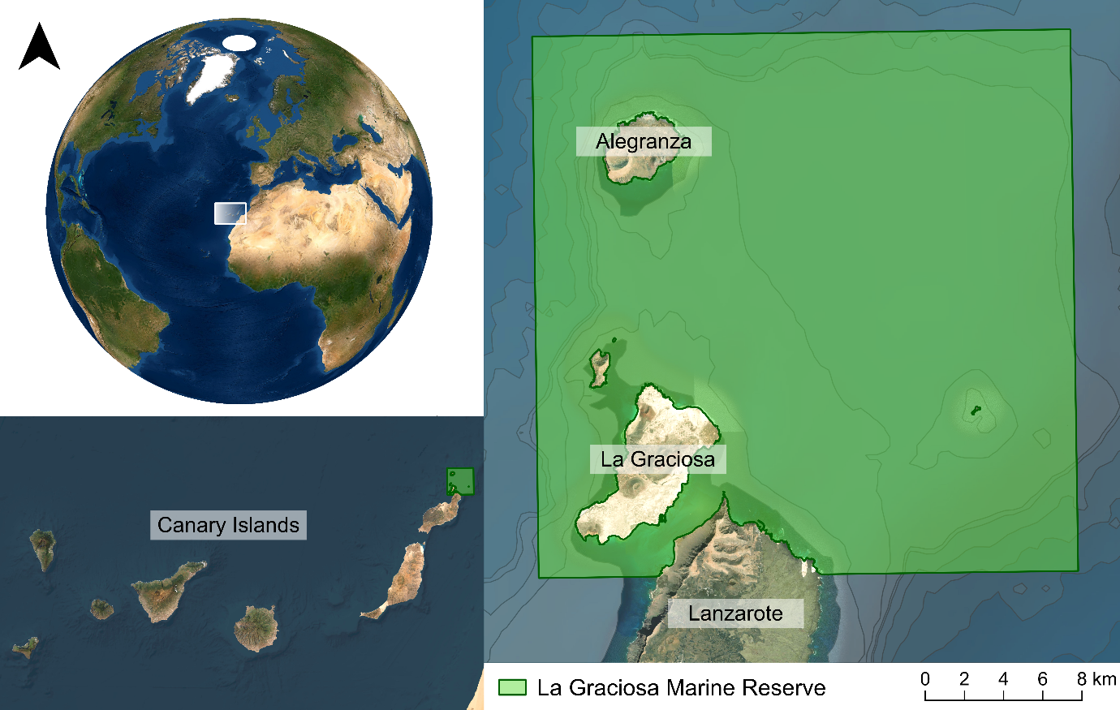
Figure 1. Map of the Canary Islands study area, with La Graciosa Marine Reserve extent shown in green.

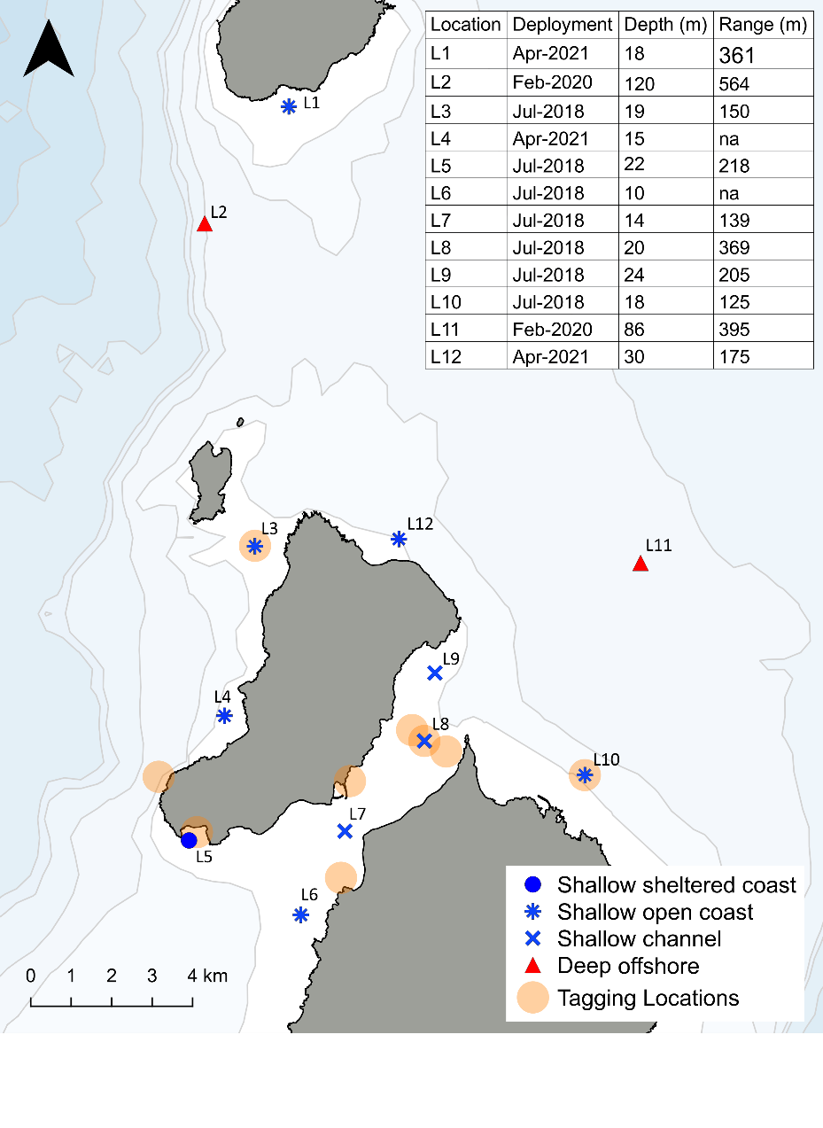
Figure 2. Map of the acoustic array in La Graciosa Marine Reserve, with each receiver labelled with its location name. Point colour and shape indicates the assigned habitat classification in each case: blue circle = shallow sheltered coast; blue star = shallow open coast; blue cross = shallow channel; red triangle = deep offshore. Initial deployment date, location depth and estimated detection range is shown in the table insert. In cases where more than one range test was carried out, a mean distance is provided. Tagging locations are indicated on the map by orange shading.
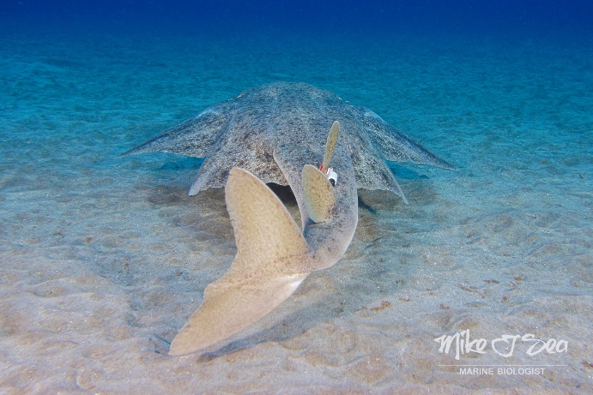
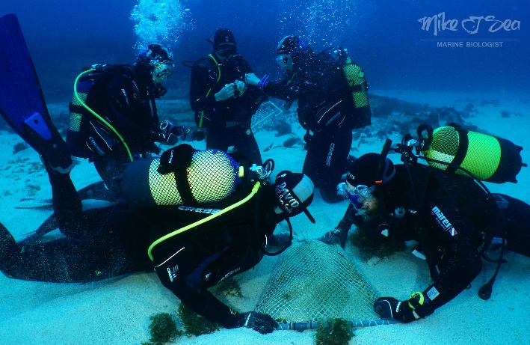
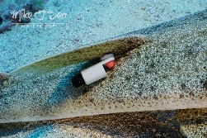
Figure 3. Images of (A) a shark being restrained during the tagging process, and (B) a shark with an acoustic tag attached to the first dorsal fin. Images by Michael J. Sealey.

A
B

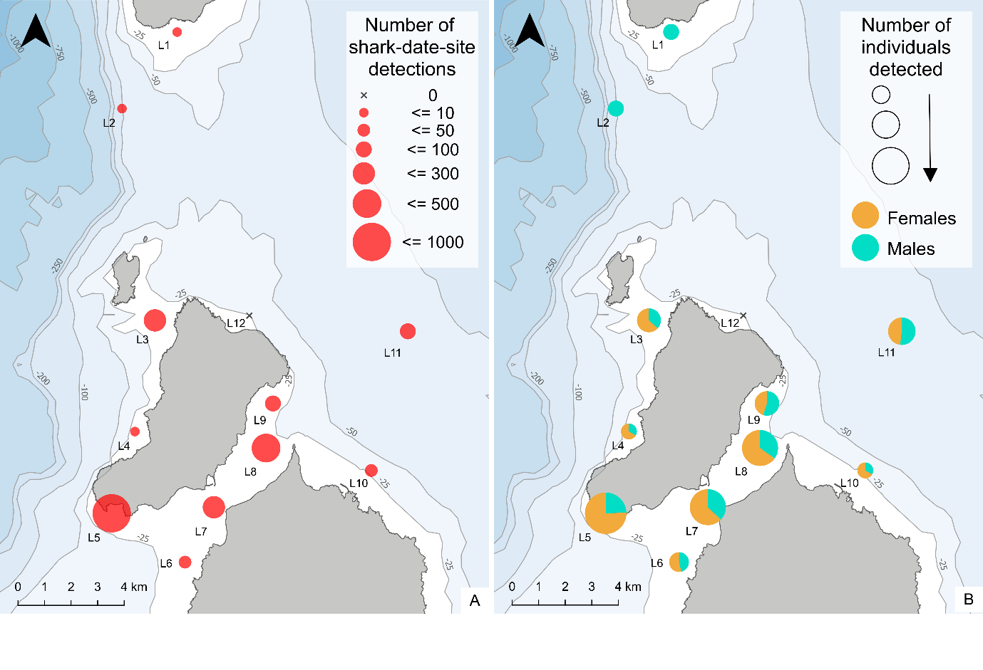
Figure 4. Mapped S. squatina presence across the acoustic array area: (A) Unique shark-date-site detections, summed for each location, indicated by point size; (B) Number of individuals indicated by point size (where greater point size indicates greater number of individuals) and male (blue) and female (orange) proportions at each location for the duration of the study.
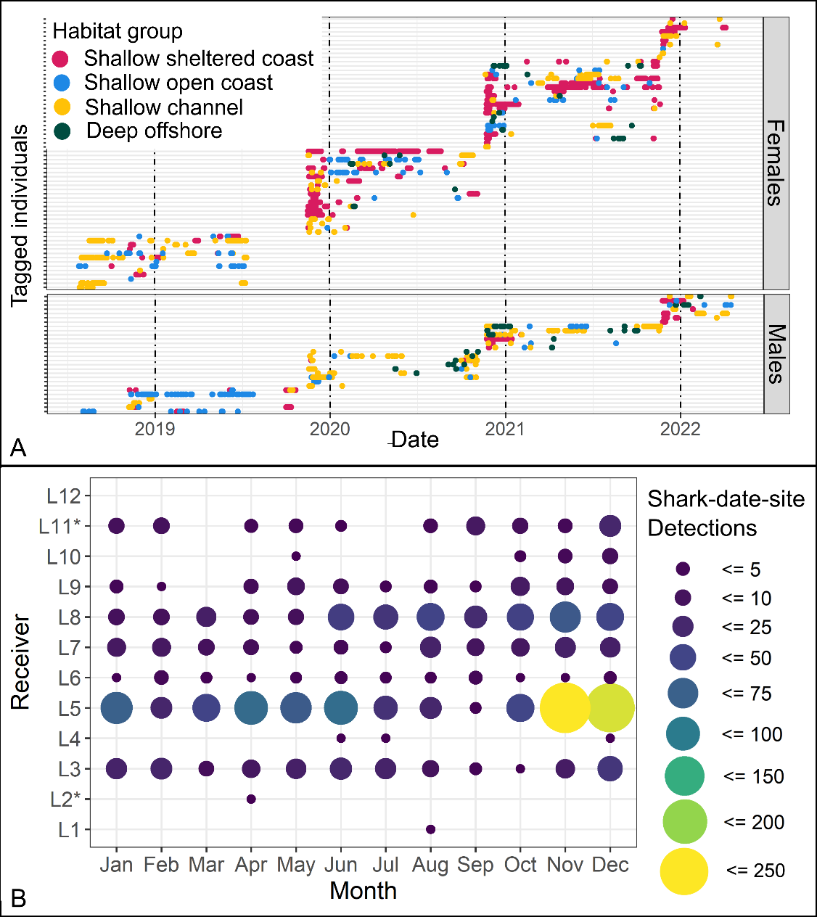
Figure 5. Spatio-temporal presence of S. squatina:(A) Detections over the study period for each tagged individual, with receiver habitat classification indicated by colour; (B) Shark-date-site detections by location and month of the year, , indicated by point size and colour. Deep receivers are indicated on y-axis (*). The greatest number of unique shark-date-site detections occurred in shallow sheltered coast habitat at L5 in November and December.

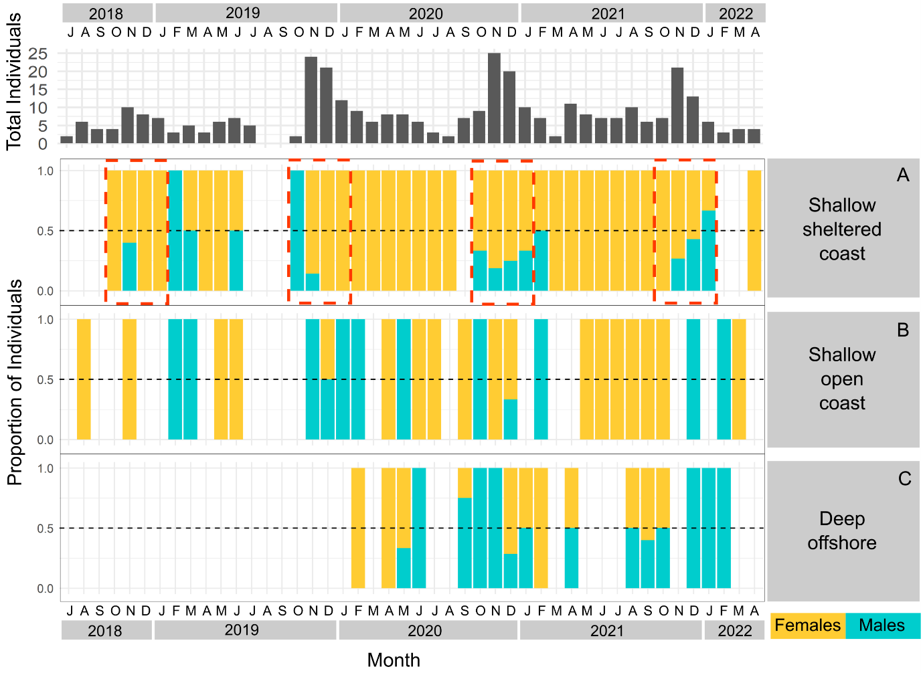
Figure 6. Spatiotemporal presence shown as monthly sex ratios by location over the full duration of the study, where bars indicate male (blue) and female (orange) proportions. Gaps in the plots therefore indicate absence (neither males nor females detected). (A) Sex ratios in shallow sheltered coast habitat (L5), with red boxes highlighting late autumn to winter months (October to January), (B) Sex ratios in shallow open coast habitat (averaged across L10, L6, L4), (C) Sex ratios in deep offshore habitat (L11). Note that deep offshore receiver L11 was not deployed until February 2020. The total number of individuals detected in the study area each month is also included above. Sex ratio figures for other locations are in S3.

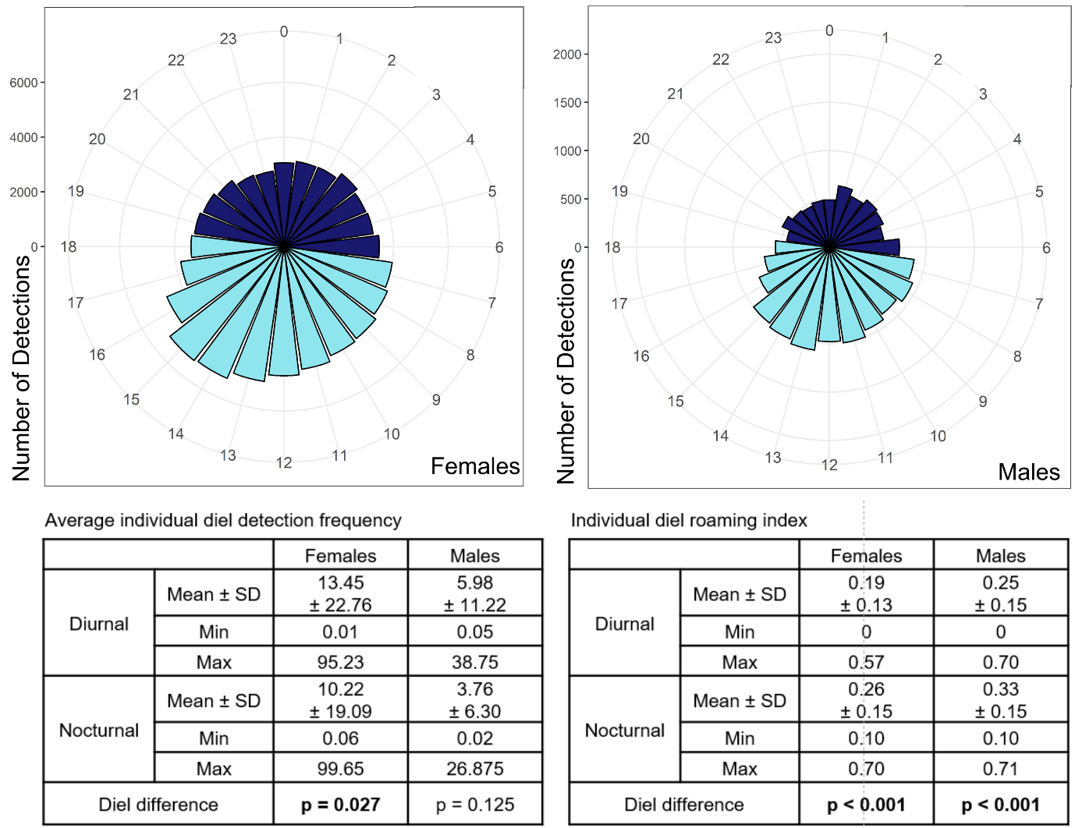
Figure 7. Diel detection counts for (A) females and (B) males. Each bar represents the total detection count for each hour during the study, with pale blue indicating diurnal detections and dark blue nocturnal detections. Diurnal and nocturnal summary statistics for average individual detection frequency and roaming index are shown in the table inserts. Statistical difference between diel periods is also indicated in each case.

