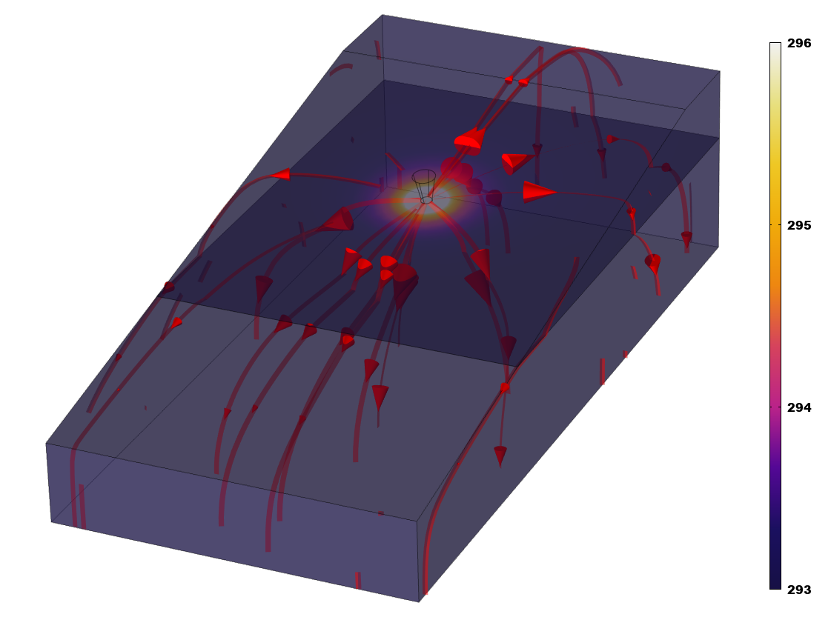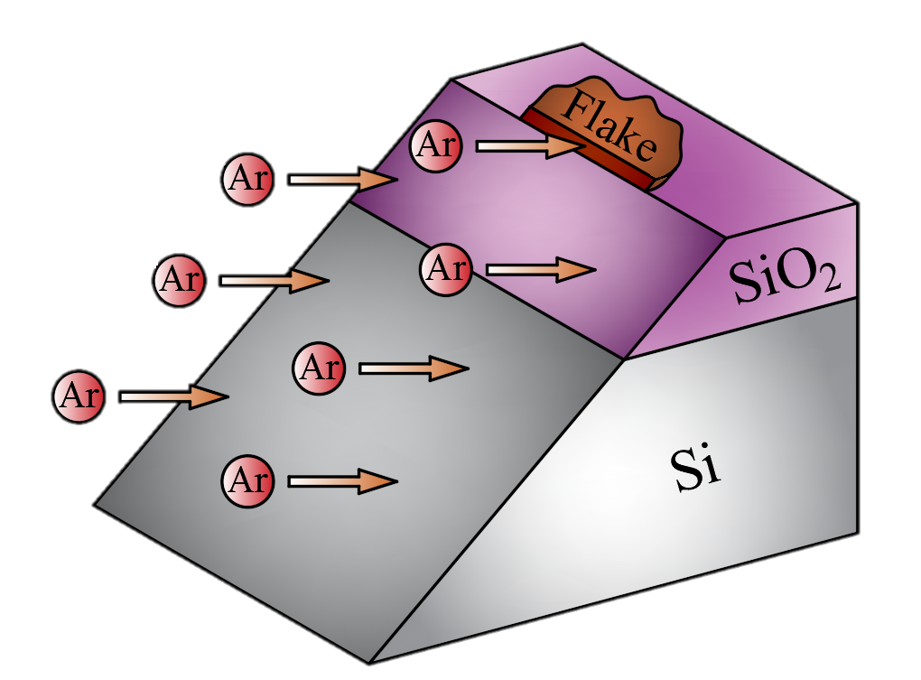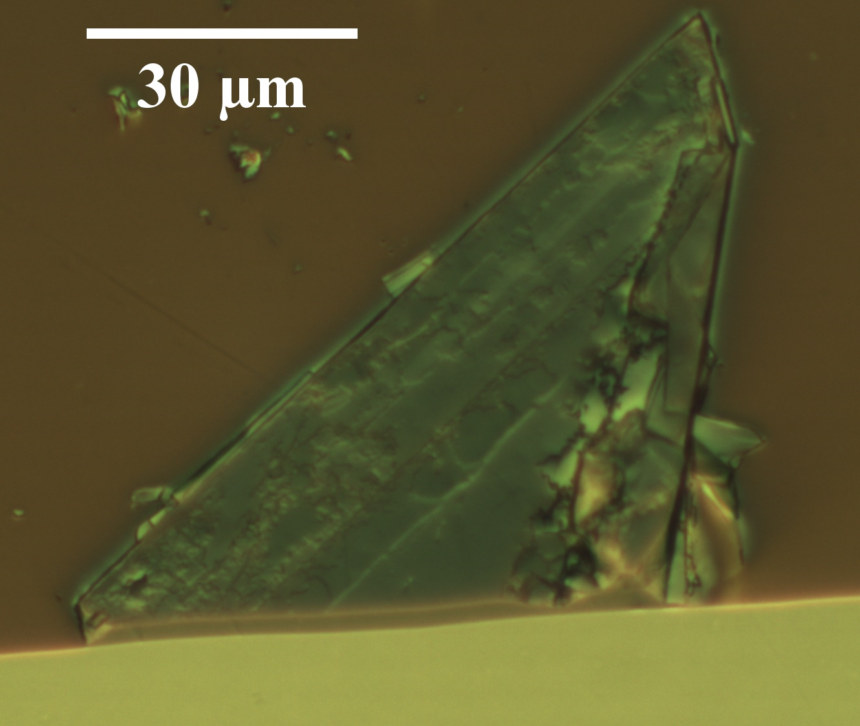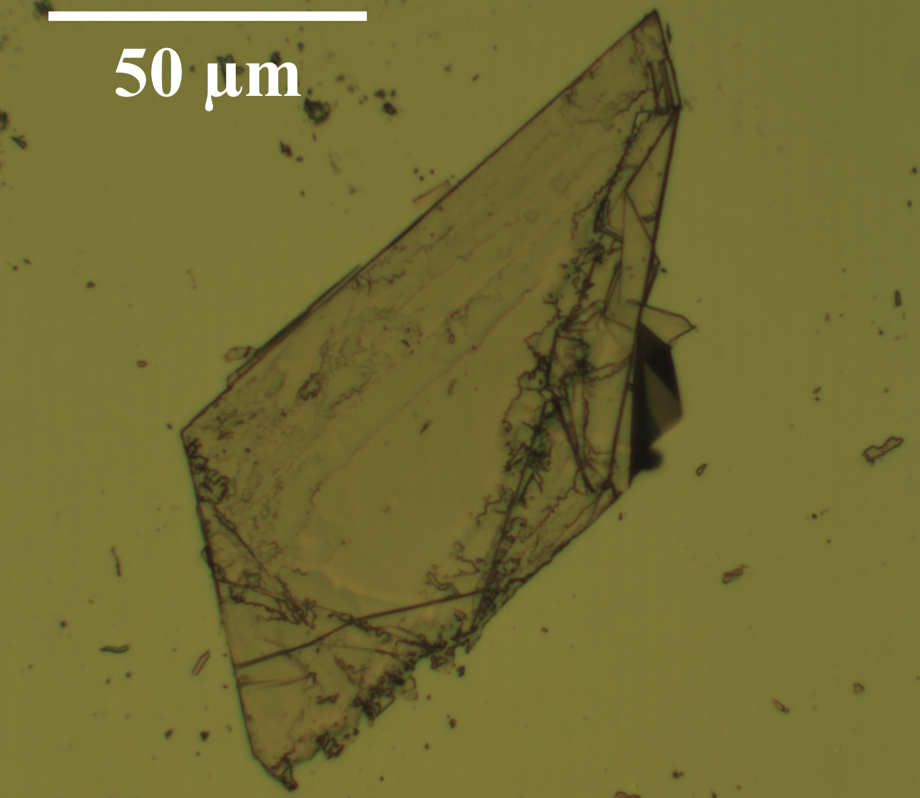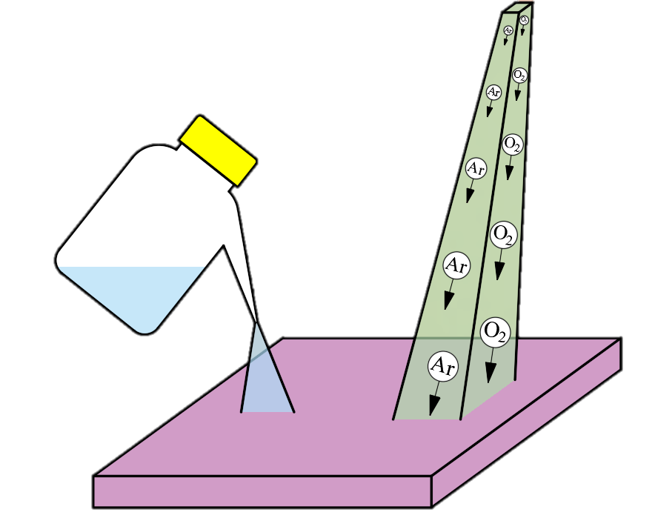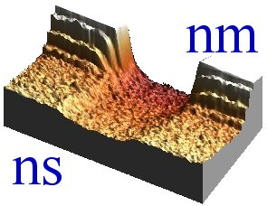000

**Acknowledgements:** Authors are grateful to Charalambos Evangeli, Yue Chen and Alex Robson for insightful discussion on the SThM and BEXP measurements. The support of Graphene Flagship Core 3 project, EPSRC EP/V00767X/1 HiWiN project, UKRI Nexgenna project and Paul Instrument Fund (c/o The Royal Society) is fully appreciated.

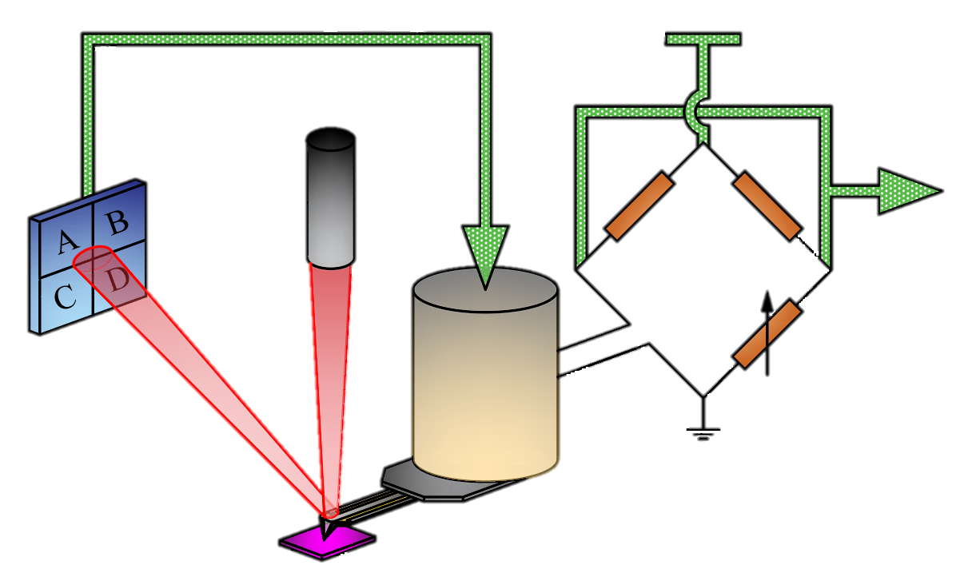

Vs

Photodetector diode

Sample

Topographic feedback

Laser

Thermal probe

Piezoelectric scanner

Wheatstone bridge

Variable resistance

Bridge potential

Vout

Characterization

Thermal transport is one of the key factors in defining the performance of thermoelectric (TE) materials, given that most of these cannot combine high power factor with low thermal conductivity[1]. Nevertheless, thermal transport in van der Waals (vdW) materials and their heterostructures could be tweaked, leaving an open platform for new TE applications[2]. In particular, indium selenide (InSe) shows high TE potential due to advantageous electrical and thermal properties, increasing the TE efficiency[3]. Here we quantify the thermal transport in γ-InSe nanolayers via x-section scanning thermal microscopy (xSThM), providing a key insight to its in-plane and cross-plane thermal conductivities as well as interfacial thermal resistance to the substrate[4,5].

Introduction

Summary

**Keywords:** Anisotropy, γ-InSe, nanoscale heat transport, wedge xSThM, thermal conductivity.

*1 Lancaster University, 2 National Physical Laboratory, 3 University of Nottingham, 4 Institute for Problems of Materials Science (NAS of Ukraine), 5Université Catholique de Louvain*

Sergio Gonzalez-Munoz1, Khushboo Agarwal1, Eli Castanon2, Zakhar Kudrynskyi3, Zakhar Kovalyuk4, Jean Spièce5, Olga Kazakova2, Amalia Patane3 and Oleg Kolosov1

**Quantitative Measurements of Anisotropic Thermal Transport in Gamma Indium Selenide via Cross-Sectional Scanning Thermal Microscopy**

**Conclusions:**

**·** Independently evaluate the γ-InSe and γ-InSe – substrate interfacial thermal resistance.

**·** Anisotropy in *k* of γ-InSe is reflected in the xSThM response *vs*. thickness and it is directly observed for the first time.

**·** Record lowest *k* in γ-InSe, beneficial for TE applications.

Anisotropic nature of γ-InSe thermal transport, fitting *Rx(t)* allows to quantify the thermal anisotropy (*kǁ/kꓕ*) and *rint*.

The next equation is an isotropic fitting model for heat spreading[5]. This can be transformed into anisotropic by changing $t→\overline{t}=t/{\sqrt{{k_{1,z}}/{k_{1,xy}}}}$ and $k_{1}=\sqrt{k_{1,xy}k_{1,z}}$.

The experimental data can be converted to thermal resistance with:

|  |  |  |
| --- | --- | --- |
|  | $$R_{s}=C_{cor}\frac{R_{p}V_{th}}{V_{nc}-V_{th}}-R_{c}$$ |  |

We present a novel cross-sectional scanning thermal microscopy (xSThM) approach to study anisotropic heat transport in nanoscale vdW materials (like γ-InSe) and thermal resistances of vdW – substrate interfaces. We use beam exit cross-sectional polishing (BEXP) of γ-InSe nanoflakes which shapes these into ultra-thin low angle wedges with atomic scale surface flatness, followed by the xSThM in high vacuum (HV) conditions. By mapping continuously varying sample thickness, we eliminate artefacts of through-the-air heat transport and SThM tip-surface interfacial thermal resistance[5], hence, quantifying the γ-InSe – substrate heat transport. By comparing experimental results with a theoretical model[5] and the finite element analysis (FEA) we can directly access the anisotropy of in-plane and cross-plane thermal conductance of the vdW material (*kǁ/kꓕ*) and the thermal resistance (*rint*) at the γ-InSe – substrate interface.

**References:**

**1.** Wu, J. *et al*. *Advanced Electronic Materials*. **vol. 4**. (2018).

**2.** Kim, H. G. *et al.* *Carbon*. **vol. 125**. 39-48. (2017).

**3.** Buckley, D. *et al.* *Advanced Functional Materials*. 2008967. (2021).

**4.** Zhang, Y. *et al.* *Advanced Functional Materials*. **vol. 30**. (2019).

**5.** Spièce, J. *et al.* *Nanoscale*. **vol.** **13**. (2021).

**3. BEXP:** Cross-sectional wedge cut + polishing of substrate’s edge and flake.

**2. Exfoliation:** vdW flakes deposited by dry exfoliation near to the substrate’s edge.

HV-SThM (see scheme on the right) measurements were performed with an NT-MDT Smena microscope under high vacuum conditions (≈ 10-6 mbar) and ambient temperature (≈ 296 K).

SThM incorporates a resistive heater receiving constant power via a DC-AC Wheatstone bridge. The bridge output voltage is proportional to the probe temperature, which changes due to variations of the probe-sample heat flow. By moving the probe across the sample surface, a quantitative map of the sample heat transport is obtained.

Results

Results

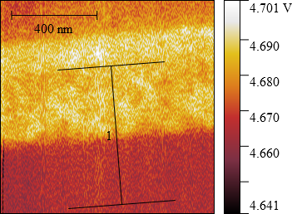

γ-InSe

Si

Si

γ-InSe



SiO2

Al

Thickness (*t*) and thermal signal (*Vth* - *left image*) maps of the wedge γ-InSe /Si and SiO2/Si interfaces are obtained. Profiles (*right graph*) are extracted from the images to provide the quantitative experimental data that are compared with the theoretical model.

Fabrication

**Samples:** *wedge γ-InSe flake on Si, wedge SiO2 on Si (calibration).* The fabrication procedure is depicted as follows:

**1. Substrate cleaning:** Solvent cleaning + O2 plasma on surface.

|  |  |  |
| --- | --- | --- |
| *rint* [Km2W-1] | *k1,xy* [Wm-1K-1] | *k1,z* [Wm-1K-1] |
| 9.6×10-11 | 2.16 ± 0.35 | 0.89 ± 0.09 |