Reductions in crop yields across China from elevated ozone

Yuanlin Wang^{1,2,*}; Oliver Wild²; Kirsti Ashworth²; Xueshun Chen¹; Qizhong Wu³; Yi Qi⁴; Zifa Wang^{1,5,6}

1 The State Key Laboratory of Atmospheric Boundary Layer Physics and Atmospheric Chemistry, Institute of Atmospheric Physics, Chinese Academy of Sciences, Beijing, 100029, China
2 Lancaster Environment Centre, Lancaster University, LA1 4YQ, United Kingdom
3 College of Global Change and Earth System Science, Beijing Normal University, Beijing, 100875, China
4 School of Architecture and Urban Planning, Nanjing University, Nanjing, 210093, China
5 Centre for Excellence in Urban Atmospheric Environment, Institute of Urban Environment, Chinese Academy of Sciences, Xiamen, 361021, China
6 College of Earth Sciences, University of Chinese Academy of Sciences, Beijing, 100049, China

*Corresponding author address:
Dr. Yuanlin Wang
LAPC, Institute of Atmospheric Physics (IAP)
Chinese Academy of Sciences (CAS)
Beijing 100029, China
E-mail: wangyuanlin13@mails.ucas.edu.cn
Abstract:
Exposure of crops to high concentrations of ozone can cause substantial reductions in yield that pose a serious threat to global food security. Here we provide comprehensive estimates of yield losses for key crops across China between 2014 and 2017 attributed to ozone using a number of new approaches. We use an air quality model at 5 km resolution and crop-specific dose-response functions developed for both concentration- and flux-based metrics. We bias correct modelled ozone concentrations and metrics using observations from more than 1000 locations. We find that on a 4-year average basis, production losses of key crops are 34-91 million metric tonnes (Mt/yr), dependent on the approach used, with highest losses in Henan province. At a national level, loss of winter wheat production derived using a China-specific dose-response function increased by 82% from 2014 to 2017, with large interannual variations in the North China Plain and in eastern China. Winter wheat losses estimated using flux-based functions, which require robust simulation of stomatal conductance and underlying vegetation physiology, are significantly lower, at 30 Mt/yr. We show that the definition of the growing season may have a greater impact on estimated losses than small biases in ozone surface concentrations. Although uncertainties remain, our findings demonstrate that increasing ozone concentrations have substantial adverse impacts on crop yields and threaten food security in China. It is important to control ozone concentrations to mitigate these negative impacts.
Key words: high resolution, air quality model, crop yield loss, M7/M12, AOT40, POD₃IAM, interannual variations

1 Introduction
With rapid urbanization and industrialization, air pollution has become a serious problem in China. In 2013 the Chinese government implemented a 5-year plan to control and reduce air pollutants. This plan focused on the reduction of fine particulate matter, PM_{2.5}, and its precursors such as sulfur dioxide (SO₂) and nitrogen oxides (NO_{x}), and it has achieved substantial benefits, with PM_{2.5} concentrations decreasing by 30‒40% in most parts of China between 2013 and 2017 (Zhai et al., 2019). However, as a secondary air pollutant, ozone is produced by oxidation of volatile organic compounds (VOCs) in the presence of NO_{x}, and reductions in NO_{x} emissions without corresponding reductions in VOCs emissions can result in increases in surface ozone concentrations (Liu et al., 1987; Sillman et al., 1990). Surface ozone in China is currently increasing (Han et al., 2020), and measurements suggest that it has now become the dominant air pollutant in many cities during summertime (CNEMC, 2016). In 2017 the 90th percentile of daily maximum 8-h average ozone concentration over the North China Plain, Yangtze River Delta and Pearl River Delta reached 92 ppb, 76 ppb and 77 ppb, respectively (Wang et al., 2020). These levels greatly exceed the WHO 8-h ozone standard of 100 μg/m³ (≈50 ppb).
High concentrations of ozone not only affect human health (US EPA 2006, 2013; Wang et al., 2020), but also pose a serious threat to ecosystems, including agricultural and horticultural crops and forests (Ashmore et al., 2005; Avnery et al., 2011a, 2011b). Long-term exposure to elevated levels of ozone affects the physiological processes in plants due to cellular oxidation damage, causing substantial reduction in crop yield and quality, and leading to adverse impacts on food security. Based on large-scale experimental studies of crop loss in the United States and Europe (Nussbaum et al., 1995; Fuhrer et al., 1997; Zheng et al., 1998), dose-response relationships between ozone concentrations and yield reduction have been produced for differing ozone “exposure” indices. The most common of these are M7 and M12 (mean 7-h and 12-h daytime ozone concentrations, predominantly used in North America), and AOT40 (accumulated hourly ozone concentration above 40 ppb, developed in Europe and also used in other regions) which have been derived for numerous major crops (Adams et al., 1989; Lesser et al., 1990; Mills et al., 2007). It should be noted that for chronic exposure, ozone damage occurs at relatively low concentrations; the threshold of 40 ppb, at which a 5% reduction is observed in wheat yields and which is used as the standard threshold in AOT40, for example, is below the WHO limit for human health effects (Mills et al., 2007).
Modelling studies using these empirically-derived relationships suggest that global wheat, rice, maize and soybean crop losses attributable to ozone pollution were 12-15%, 3-4%, 2-5% and 14-16%, respectively, in 2000 and mainly occurred in East and South Asia (Van Dingenen et al., 2009; Teixeia et al., 2011; Avnery et al., 2011; Mills et al., 2018). As a large and rapidly developing county, China’s food supply is critical to global food security (Wang et al., 2012). Although there is a lack of comparable large-scale assessments for China, the potential risk to food production of ozone exposure has been studied in both small-scale field trials and model simulations (Aunan et al., 2000; Wang and Mauzerall, 2004; Feng et al., 2003; Tong et al., 2011). Based on different indices, the relative yield losses for winter wheat, rice, and maize have been variously estimated to be 8.5-14%, 3.9-15% and 2.2-5.5%, respectively in 2014 (Lin et al., 2018). Given the observed increase in ozone concentrations, production losses are expected to increase substantially in China in the near future.
Concentration-based dose-response relationships are relatively easy to determine from field, controlled environment and open-top chamber experiments, and early studies adopted this approach. However, ozone damage to plants is dependent on the actual dose of ozone to plant cells and membranes, and this is determined by the flux through the stomata rather than by the atmospheric concentration of ozone (Fuhrer, 2000; Danielsson et al., 2003; Ashmore et al., 2005; Mills et al., 2011). Dose-response relationships based on stomatal flux have been shown to be more robust than concentration-based metrics (UNECE, 2017). This is to be expected, as flux-based metrics consider the vertical distribution of ozone within the crop canopy and also account for plant phenology and physiology, which are dependent on climate and meteorological conditions (Pleijel et al., 2004; Mills et al., 2018). For example, stomatal aperture is closely controlled by soil water availability and the dry, sunny conditions that favour high concentrations of ozone also result in stomatal closure to conserve water, reducing the ozone flux and the damage to stomata (Emberson et al., 2000). There is also clear evidence that the sensitivity of crops to cellular damage and changes in plant allocation of carbon caused by ozone uptake are strongly dependent on the stage of the growth cycle during which the dose is received (Heath and Taylor, 1997). These observations have led to the development of the Phytotoxic Ozone Dose (POD_{Y}), a flux-based metric that is defined as the accumulated stomatal flux of ozone above a critical threshold of Y (Mills et al., 2011). As further evidence has become available, this has been refined into POD_{Y}IAM (POD_{Y} for Integrated Assessment Modelling), which is based on vegetation type and is suitable for regional-scale and integrated assessment models (UNECE, 2017). The POD index is relatively well-established for estimating the relative yield loss for wheat, but this is not the case for other crops (Emberson, 2020), and in most instances the use of POD_{Y}IAM is more appropriate. As the critical stomatal flux is not known for different cultivars or crop species, the current best practice is to use POD₃IAM for all crops (UNECE, 2017), although there is evidence to support the use of a range of values between POD₆ (phytotoxic ozone dose above a threshold of 6 nmol m⁻² s⁻¹) and POD₁₂ (with a threshold of 12 nmol m⁻² s⁻¹) (Tang et al., 2013).
Using the POD₆ metric and a chemical transport model, Tang et al. (2013) estimated that wheat losses in China would be 19-23% in 2020. Air quality models are increasingly widely used to estimate crop yield loss due to their high temporal and spatial resolution and complete spatial coverage. However, most studies still ignore the systematic biases in model-derived ozone concentrations and metrics associated with uncertainties in meteorology and emissions, which may result in substantial differences in estimates of exposure and hence crop loss, particularly when using threshold metrics which are highly sensitive to extremes. To reduce the uncertainty in crop yield loss estimates, bias correction is often required to bring modelled ozone concentrations into better agreement with measurements (Lefohn et al., 1987).
In the current study, we estimate the crop yield reductions for major crops attributable to ambient ozone across China over the 2013-2017 period using a high-resolution air quality model, thorough bias correction, provincial-level crop production data, and a range of alternative exposure-response relationships. We explore how crop yield losses vary on different spatial scales, and then quantify the spatial and interannual variations in crop losses because of the changes in emissions and meteorological conditions. We then focus on winter wheat, the most extensively studied of the crops, and compare the differences in crop losses for winter wheat estimated using flux-based and concentration-based metrics and discuss the uncertainties in assessing ozone-induced crop yield reductions. This allows us to provide the first fully self-consistent assessment of different exposure-response methods, and to highlight the need to find more reliable exposure metrics or response functions in the future.
2. Methods and Data
2.1 Air quality model
In this study we use the Nested Air Quality Prediction Model System (NAQPMS) developed at the Institute of Atmospheric Physics, Chinese Academy of Sciences (Li et al., 2011; Wang et al., 2006) to generate hourly ozone concentrations and exposure metrics and to estimate crop yield losses. The model represents the emissions, chemistry, transport, diffusion, and deposition of atmospheric pollutants (Li et al., 2012). The model domain covers China and other parts of S and E Asia at a horizontal resolution of 5 km, a much higher resolution than used in previous studies that allows differences in the chemical environment of urban and rural regions to be represented better (Wang et al., 2020). A detailed description of this model configuration, meteorological fields, chemical initial and boundary conditions, and emissions can be found in Wang et al. (2018, 2020).
2.2 Estimation of the impacts on crop yield
2.2.1 Distribution of crop actual productions
We used distributions of wheat, rice, maize and soybean crops for China from the Global Agro-Ecological Zones dataset for the year 2000 (http://www.fao.org/nr/gaez/en/). These crop distribution maps were regridded from a resolution of 0.0833° to the 5 km resolution of the model. Province-specific crop production totals for 2013–2017 were taken from the China National Statistics Yearbook (https://data.stats.gov.cn) and used to normalize the year 2000 harvest distributions. Average crop production over the period 2013-2017 was then calculated for each grid cell to eliminate the impact of interannual variations in crop production on estimates of crop yield loss.
2.2.2 Metrics and dose-response functions
To assess crop yield losses and investigate the sensitivity of these estimates to current understanding of ozone impacts, we apply one flux-based metric (POD₃IAM) and two concentration-based metrics (AOT40 and M7/M12) along with their associated dose-response relationships. The AOT40 metric (with units of ppmh) is favored in European countries and has been demonstrated to be a reliable indicator of crop damage (UNECE, 2017). Here we apply two different AOT40-response relationships for each crop: one from Mills et al. (2007), which is based on 700 published studies on US and European crops, and has been used to estimate yield losses globally (Avnery et al., 2011a, 2011b; Tang et al., 2013), and the other from China-specific studies (Wang et al., 2012; Zhang et al., 2017) using open-top chambers with elevated O₃. For maize we apply the dose-response function from an Indian experiment (Singh et al., 2014) due to a lack of field studies in China. The M7/M12 metrics (in ppbv), which are favoured in the US, are included for comparison (Adams et al., 1989; Lesser et al., 1990). The definitions of these concentration-based metrics are shown below:
$M7/M12=\frac{1}{n}\sum_{i=1}^{n}{{[O_{3}]}_{i}}$ (1)
$AOT40=\sum_{i=1}^{n}{\left({\left[O_{3}\right]}_{i}-0.04\right), }$ for O₃ ≥ 0.04 ppm (2)
where ${[O_{3}]}_{i}$ is the hourly mean ozone concentration during daylight hours, which are assumed to be 08:00-19:59 for AOT40 and M12, and 09:00-15:59 for M7. n is the number of hours in the growing season for each crop, where the growing season is defined as the three months preceding the start of the harvest period (Van Dingenen et al., 2009). In this study, we obtain the growing season for each crop in China from the United States Department of Agriculture (USDA, 2008); these are given in Table S1.
In the current study we also use a stomatal ozone flux-response relationship for winter wheat, POD₃IAM (the accumulated phytotoxic ozone dose above a threshold of 3 nmol m⁻² sec⁻¹ during the growing season), to compare against M7 and AOT40. The calculation of POD₃IAM is shown below, based on the model of stomatal conductance ($g_{sto}$) proposed by Jarvis (1976, Eqn 3) and modified to incorporate ozone effects by Emberson et al (2000a, 2000b; Eqn 4):
$g_{sto}=g_{max}*\left[\min\left(f_{phen},f_{O_{3}}\right)\right]*f_{light}*max⁡\{f_{min},(f_{temp}*f_{VPD}*f_{SW})\}$ (3)
${POD}_{3}IAM=\sum_{i=1}^{n}{[\left({\left[O_{3}\right]}_{i}*g_{sto}-3\right)*(3600/{10}^{6})]}$ (4)
$g_{sto}$ is the instantaneous stomatal conductance of ozone ($mmolm^{-2}s^{-1}$); $g_{max}$ is the maximum stomatal conductance estimated from measurements under saturating light ($mmolm^{-2}s^{-1}$); and parameters $f_{phen}$, $f_{O_{3}}$, $f_{light}$, $f_{temp}$, $f_{VPD}$ and $f_{SW}$ are scaling factors in the range 0-1 that represent the impacts of phenology, ozone concentration, irradiance, temperature, atmospheric water vapour pressure deficit and soil moisture on stomatal conductance. $f_{min}$ is the ratio of minimum stomatal conductance during daylight hours to $g_{max}$. Values for the above parameters were obtained from UNECE (2017); meteorological factors are taken from the Weather Research Forecast model output used to drive the air quality simulations, and have been shown to be consistent with observations (Wang et al., 2020). As phenology, ozone concentration and soil moisture are not included in the parameterization of$g_{sto}$, $f_{phen}$, $f_{O_{3}}$ and $f_{SW}$ are set to 1 in the current study. In addition to this calculation of $g_{sto}$, we use the dry deposition scheme in the model (Zhang et al., 2001; Wesely et al., 1989) to estimate $g_{sto}$, and compare the two methods. The dose-response functions for M7, M12, AOT40 and POD₃IAM metrics for each crop are given in Table 1.
Table 1: Dose-response functions giving the relative yield (RY) for major crops from a range of studies, following Van Dingenen et al. (2009).

Crop | Dose-response function | Reference
Wheat | $RY=exp⁡[{-(M7/137)}^{2.34}]/exp⁡[{-(25/137)}^{2.34}]$ (winter) | Lesser et al. (1990)
 | $RY=exp⁡[{-(M7/186)}^{3.2}]/exp⁡[{-(25/186)}^{3.2}]$ (spring) | Adams et al. (1989)
 | $RY=-0.0161×AOT40$+0.99 | Mills et al. (2007)
 | $RY=-0.0228×AOT40$+1 | Wang et al. (2012)
 | $RY=-0.0064×{POD}_{3}IAM$+0.9756 | UNECE (2017)
Rice | $$RY=exp⁡[{-(M7/186)}^{3.2}]/exp⁡[{-(25/186)}^{3.2}]$$ | Adams et al. (1989)
 | $RY=-0.0039×AOT40$+0.94 | Mills et al. (2007)
 | $RY=-0.0095×AOT40$+1 | Wang et al. (2012)
Maize | $$RY=exp⁡[{-(M12/124)}^{2.83}]/exp⁡[{-(20/124)}^{2.83}]$$ | Lesser et al. (1990)
 | $RY=-0.0036×AOT40$+1.02 | Mills et al. (2007)
 | $RY=-0.0067×AOT40$+1.03 | Singh et al. (2014)
Soybean | $$RY=exp⁡[{-(M12/107)}^{1.58}]/exp⁡[{-(20/107)}^{1.58}]$$ | Lesser et al. (1990)
 | $RY=-0.0116×AOT40$+1.02 | Mills et al. (2007)
 | $RY=-0.012×AOT40$+1 | Zhang et al. (2017)
Note: RY is the relative yield as compared to a theoretical yield without ozone damage.
2.2.3 Assessment of crop yield loss
Following Avnery et al. (2011a, 2011b), we calculate the crop production loss (CPL) from the relative yield loss (RYL) and actual crop production (CP). RYL is defined as the crop yield loss compared to the theoretical yield without ozone damage. For each grid cell, RYL_{i} and CPL_{i} are estimated as follows:
${RYL}_{i}=1-{RY}_{i}$ (5)
${CPL}_{i}={RYL}_{i}/(1-{RYL}_{i})×{CP}_{i}$ (6)
We obtain provincial and national production losses by summing production losses over all grid cells within each province and then across China. Provincial and national relative yield losses are then calculated as the provincial and national production losses divided by the sum of production losses and crop productions at provincial and national levels.
2.3 Model bias correction for exposure metrics
Uncertainties in meteorology, emissions, and chemical mechanisms, along with the spatial resolution of chemical transport models, can lead to biases in simulated ozone concentration (Chen et al., 2014). These biases are accumulated in concentration metrics, particularly for the threshold-based AOT40 metric, and can lead to substantial errors. It is necessary to correct these biases in both ozone concentration and exposure metrics to obtain more accurate estimates of crop yield loss due to ozone exposure. Where measurements of ozone are available, modelled ozone concentrations are scaled to match the observed values. Where measurement data are unavailable, kriging is used to interpolate the scaling factor and then this is applied to the modelled concentrations. This approach accounts for the relative distance of each grid cell from nearby observation sites, and is therefore more appropriate than inverse distance weighting when observation sites are sparse. The National Crop Loss Assessment applies kriging to estimate M7 in the US (Lefohn et al., 1987). In this study, we apply kriging to the scaling factors between observations and simulations, allowing us to preserve modelled distributions and distinctions between urban and rural regions that is not possible by kriging the observations alone. This approach inherently accounts for the impacts of elevation, although we note that most crops are planted in eastern and northeastern China where the terrain is relatively flat.
We cannot use the same approach for AOT40 because it is an accumulated threshold-based metric. The relationship between ozone concentration and AOT40 is nonlinear, so we apply an iterative technique to scale the modelled ozone to generate an AOT40 that matches the observed AOT40. We then apply kriging to the resulting scaling factors and use these to derive AOT40 at each grid point. We also apply the bias-corrected hourly ozone concentration derived this way to calculate the flux-based metric POD₃IAM. Ozone measurements are available from far fewer sites in 2013 than in later years (Fig S2), as the observation network was being established, and we find a systematic bias in winter wheat yield loss using this reduced number of sites compared with the full set due to much poorer spatial coverage in key regions. Hence, we assess crop yield loss between 2014 and 2017 in this study.
3. Results
3.1 Distribution of concentration-based metrics
Fig 1 shows the spatial distribution of concentration-based metrics for each crop during their growing seasons from the model, averaged over the four-year period, along with observed values at 259 monitoring sites. At most locations, the model metrics are consistent with observations, and the distributions of M7/M12 and AOT40 are similar. Spatial distributions of concentration-based metrics for other crop species (spring wheat, early and late-crop rice and early maize in southern China) can be found in supplementary material (Fig S1); high exposure levels occur in the North China Plain, eastern and western China, but the concentrations vary depending on the growing season.
The North China Plain and eastern China are major crop production regions, but also experience high ozone concentrations. Here M7 ranges from 45 to 70 ppb and AOT40 varies from 10 ppmh to over 25 ppmh, much greater than national averages (40 ppb and 8 ppmh, respectively). High ozone exposure is expected to substantially reduce crop yields in these regions. In western China, ozone concentrations are relatively high with M7 ranging from 30 to 50 ppb, and AOT40 between 5 and 15 ppmh. Since the growing seasons for single-crop rice, maize and soybean extend into the period of peak summer ozone in China, the corresponding concentration-based metrics are higher than those for winter wheat. For example, AOT40 for winter wheat ranges from 5 to 18 ppmh (higher than the 2.2 ppmh “critical level” for a 5% reduction of yield; UNECE, 2017; Feng et al., 2019), while for other crops AOT40 varies from 5 to over 25 ppmh. We also compared our spatial distributions of AOT40 during the winter wheat and single-crop rice growing seasons with Feng et al (2019), who applied an inverse distance weighting method based on observations to modelled ozone. Exposure levels in the current study are slightly higher than those estimated by Feng et al. (2019), and this may be because observation sites are mostly in urban areas while planting occurs in rural areas, and the inverse distance weighting method used in the earlier study is less suitable in unmonitored areas.
Fig 1 Spatial distribution of four-year average crop production (left column, t/km²/yr) and bias-corrected concentration-based metrics M7/M12 (central column, ppb) and AOT40 (right column, ppmh) during the growing season for winter wheat, single-crop rice, maize and soybean (distributions for other crops are shown in Fig S1). Circles show the metrics based on observations at 259 monitoring sites over the same period.
3.2 Relative yield loss
Fig 2 shows the spatial distribution of losses estimated from the different concentration-based metrics and dose-response functions averaged over four years. Relative yield losses are determined from distributions of crop production and exposure metrics. At a national scale, losses for winter wheat and single-crop rice range from 6-28% and 2-11% respectively, across all exposure metrics. Estimates of relative yield losses for winter wheat and single-crop rice are larger when estimated from AOT40 than from M7, particularly when dose-response relationships from China-specific studies are applied. The highest losses of winter wheat occur in Henan and Shandong provinces, and this is consistent across all metrics. Field studies suggest that rice is more ozone-tolerant than wheat (Feng et al., 2019; Van Dingenen et al., 2009), and our estimated losses of single-crop rice are smaller than those of winter wheat, with greatest reductions in Shandong and Jiangsu. For maize and soybean losses are 3-7% and 8-20% at a national level, but estimates are larger using M12 than AOT40 due to differences in the dose-response functions. Higher losses for both maize and soybean occur in the North China Plain and eastern coastal areas, particular in Hebei and Shandong. Of particular concern is that the Northeast, the most important soybean production area in the country, experiences high losses. Fig S3 shows the spatial distribution of relative yield loss for other crops, with the highest ozone-induced losses seen for spring wheat, and the largest effects (10-50%) again occurring in Hebei, Shanxi and Liaoning provinces.

Fig 2 Spatial distribution of relative yield losses (RYL, in %) for four crops estimated from different concentration-based metrics and dose-response functions averaged over the 2014-2017 period.
3.3 Crop production loss
As shown in Table 2, national annual crop production losses for wheat range between 8.7 and 50 million metric tonnes (Mt/yr) depending on the concentration-based metric used. 98% of these are losses of winter wheat. National crop production losses are 4.0-22 Mt/yr for rice, of which single-crop rice accounts for 79% (3.1-17 Mt/yr), and are 8-18 Mt/yr for maize and 1-3 Mt/yr for soybean. For the same ozone concentrations, losses for all crops are greater when calculated using the AOT40-China response function than the AOT40-Euro function. Production losses are greater for wheat and rice, but smaller for maize and soybean when AOT40 is used than when M7/M12 is used. These results demonstrate that a better understanding and application of exposure-response functions are needed to evaluate crop yield loss reliably.
Table 2 Crop production losses derived from 4-year average concentration-based metrics and corresponding dose-response functions (million metric tonnes/yr)
Crop | M7/M12 | AOT40-Euro | AOT40-China
Winter wheat | 8.6 | 31 | 48
Spring wheat | 0.1 | 1.5 | 2.0
Wheat | 8.7 | 33 | 50
Single-crop rice | 3.1 | 16 | 17
Early double-crop rice | 0.3 | 2.8 | 1.8
Late double-crop rice | 0.6 | 3.2 | 2.2
Rice | 4.0 | 22 | 21
Maize | 18 | 8.0 | 18
Soybean | 3.2 | 1.2 | 1.6

The ten provinces with the highest estimated crop production losses for the major crops are shown in Fig 3, ranked by the mean of the losses derived from all three approaches used here. Winter wheat production loss is greatest in Henan (2-13 Mt/yr), followed by Shandong and Jiangsu. Ozone-induced single-crop rice production loss is highest in Jiangsu (1-4 Mt/yr), followed by Hubei and Heilongjiang. Highest losses of maize and soybean occur in Shandong (2-4 Mt/yr) and Heilongjiang (0-1 Mt/yr). It is worth noting that losses are much greater when M12 metrics are used for maize and soybean. The highest spring wheat production loss occurs in Inner Mongolia, and that of double rice in Hunan (Fig S4). The distribution of losses is related to both elevated ozone during the growing season, and to crop production intensity. Provinces such as Tibet with high relative yield loss do not necessarily have high crop production loss. In conclusion, the total production loss for all crops is greatest in Henan (5-16 Mt/yr), followed by Shandong (5-15 Mt/yr) and Jiangsu (2-10 Mt/yr).
Winter wheat | Single-crop rice
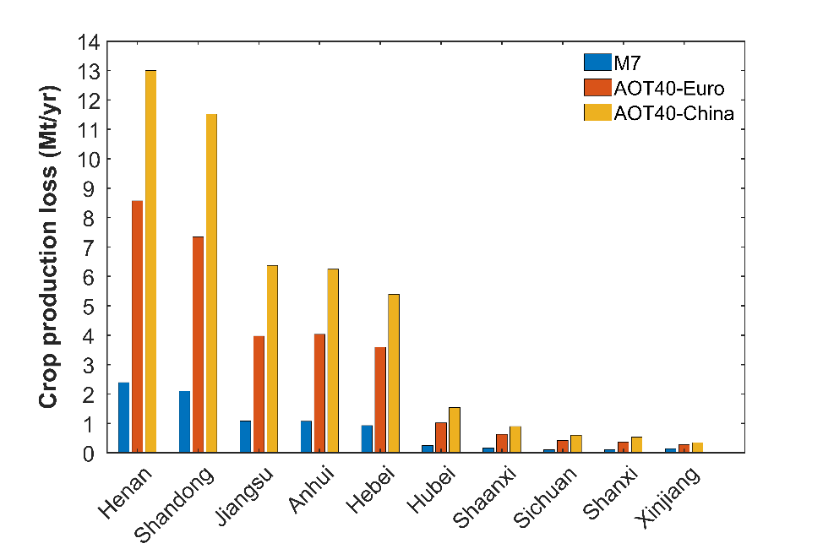 | 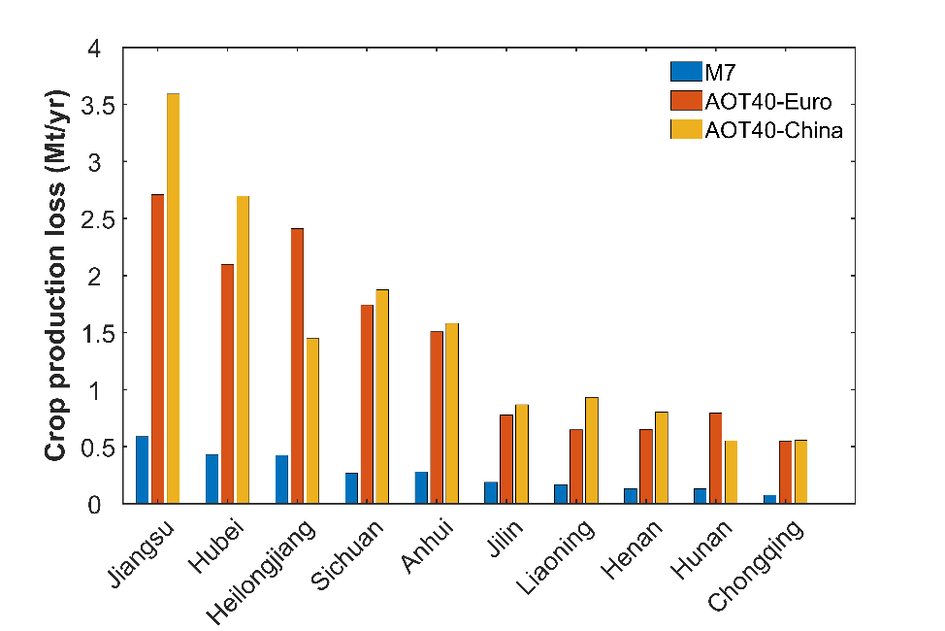
Maize | Soybean
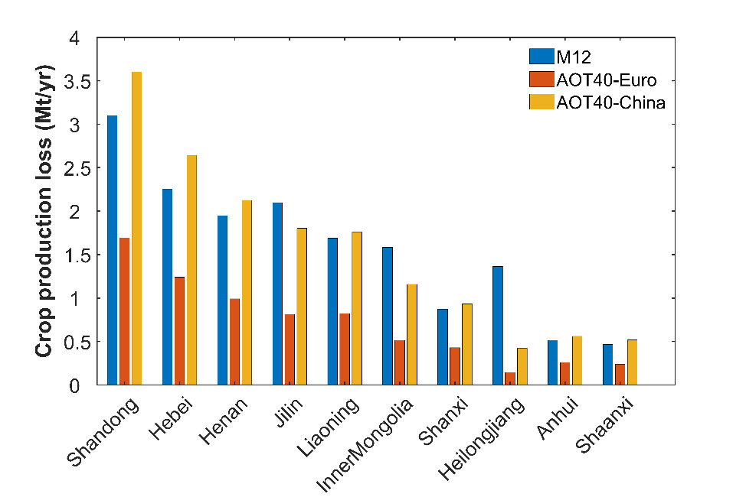 | 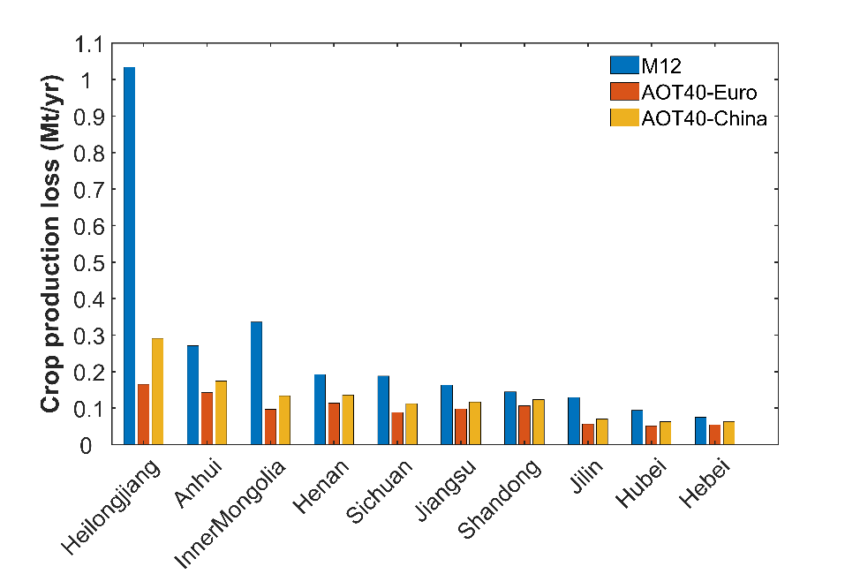
Fig 3 The ten provinces with the highest estimated crop production losses for the four major crops based on 4-year average ozone metrics for 2014-2017. Blue bars denote estimates derived from M7, and red and orange from AOT40 with dose-response functions taken from European and Chinese field trials, respectively.
3.4 Interannual variations in AOT40 and crop production losses
Since China implemented strict emissions control polices in 2013, NO_{x} concentrations have decreased and ozone concentrations are starting to rise. Therefore, we analyze interannual variations in concentration-based metrics and corresponding crop production losses from 2014 to 2017 at both national and regional levels. We take winter wheat as an example and investigate the production losses estimated from AOT40 with China-specific dose-response functions (see Fig 4). In 2017 the national average AOT40 is 10 ppmh and loss of winter wheat production is estimated at 73 Mt/yr. These are 45% and 82% higher than in 2014, respectively, with the non-linearity in effect due to the threshold nature of the AOT40 metric. Both AOT40 and winter wheat production losses show greater variation at a provincial level, particularly across the North China Plain, eastern and northwestern China, where AOT40 increases by between 17% and 85% in 2017, compared to 2014. The North China Plain and eastern China are major winter wheat production areas, and production losses increase by between 25% and 84% in 2017 compared with those in 2014 in these areas. Henan sees the largest winter wheat yield loss, and this is twice as large in 2017 as 2014. Meteorological conditions strongly influence ozone concentrations (Liu et al., 2019; Han et al., 2020), but the increases can also be partly attributed to increasing precursor emissions. Li et al. (2019) reported 1-2 ppb increases in ozone concentrations in eastern China due to changes in anthropogenic emissions during 2013 to 2017. Furthermore, AOT40 is very sensitive to increases in ozone concentration as it is an accumulated metric that only includes concentrations exceeding 40 ppb during the growing season. These changes contribute to the observed interannual variation in winter wheat crop losses, and are particularly clear at the provincial level.
Fig 4 Interannual variation in gridded AOT40 (ppmh) and attributed production losses (10⁴ t/yr) derived from AOT40 metrics and China-specific dose-response functions during the winter wheat growing season.
3.5 Winter wheat production losses using a flux-based metric
Studies have shown that crop production loss assessments may be more reliable with flux-based metrics than with concentration-based metrics (Pleijel et al., 2007; Mills et al., 2011; Feng et al., 2012). Fig 5 shows the spatial distributions of POD₃IAM and corresponding relative yield loss. High levels of POD₃IAM occur mainly in eastern and southern China; in areas along the Yangtze River and southern coast values exceed 35 mmol m⁻² (Fig 5: a). As POD₃IAM accounts for stomatal conductance, which is related to meteorological factors such as solar radiation, temperature and relative humidity, as well as ozone concentration, the spatial distribution of POD₃IAM differs markedly from that of M7 and AOT40. At a national level, the relative yield loss of winter wheat estimated from POD₃IAM is about 19%, higher than that from M7 (6%) but slightly lower than from AOT40 (20-28%). Relative yield losses are greater in southern and eastern coastal areas (20-30%), because the high temperature and relative humidity increase stomatal conductance and promote ozone uptake (Mills et al., 2018). However, in the dry climate of northern China stomatal uptake of ozone is lower, and relative yield losses are smaller (8-15%) in these areas (Fig 5: b). Based on POD₃IAM response functions, average national winter wheat production losses are 30 Mt/yr over the four years (Fig 5: c). These are again higher than those derived with M7 (9 Mt/yr) but slightly lower than with AOT40 (31-48 Mt/yr). Winter wheat production losses are largest in the main production areas, reaching 9 Mt/yr in Henan, 5.5/yr Mt in Shandong and 4.7 Mt/yr in Anhui, even though relative yield losses in these provinces are smaller than those in southern regions (Fig 5: d).

 | 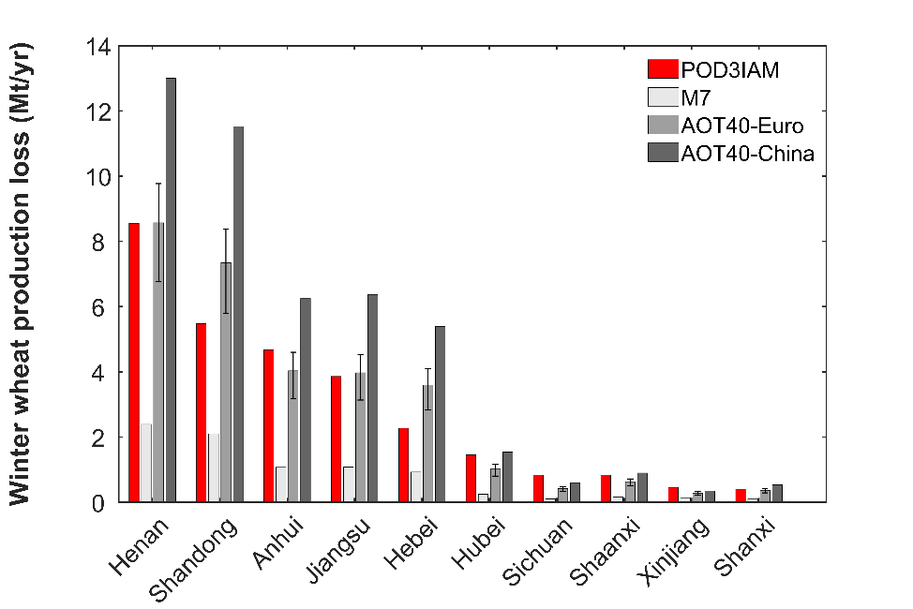
a | b
c | d
Fig 5 Estimates of winter wheat production losses based on POD₃IAM, showing distributions of (a) average POD₃IAM; (c) average relative yield loss; and (d) average production loss for the four years 2014-2017. Panel b shows the estimated production losses for the ten worst affected provinces, with error bars for AOT40-Euro representing 95% confidence intervals derived from Mills et al (2007).
4 Discussion
Using three different concentration-based approaches, our results suggest that average national crop yield losses for winter wheat, single-crop rice, maize and soybean from ozone pollution range between 5-37%, 2-11%, 3-8% and 7-21% respectively for 2014-2017 with corresponding production losses of 8.6-48 Mt, 3.1-17 Mt, 8-18 Mt and 1.2-3.2 Mt per year. Our estimates are strongly dependent on which of the metrics is used, but are broadly consistent with those of other modelling studies (Aunan et al., 2000; Van Dingenen et al., 2009; Avnery et al., 2011a, 2011b; Mills et al. 2018), although differences in model resolution, emissions, meteorology and study year lead to differences in ozone concentration, which affect relative yield losses. Most previous assessments have been based on coarse-resolution global models which are known to overestimate ozone concentrations over larger continental regions (Wild and Prather, 2006), and previous studies have shown that surface ozone concentrations can be 12-17% higher than those observed without model bias correction (Aunan et al., 2000; Avnery et al, 2011a). Some previous estimates have been based on measured ozone concentrations, e.g. Feng et al. (2019) interpolated AOT40 to a grid with a resolution of 0.05° applying an inverse weighting distance method to ozone observations from ~1500 station sites. However, with few monitoring sites in rural regions where crops are grown, the inverse weighting distance interpolation is less suitable than the kriging approach we have used here which preserves the urban-rural contrasts represented with the model. The relative yield loss of wheat estimated by Feng et al (2019) is 6%, lower than that of other assessments which range from 6.4-55% (Van Dingenen et al., 2009; Tang et al., 2013; Mills et al., 2018). We note that there may still be a bias associated with using ozone measurements made at a standard height of 2 m, as this is above the canopy level for many crops and thus ozone concentrations, and associated crop yield losses, may be overestimated.
The seasonality of ozone production and the timing of the growing season both affect concentration-based metrics, and therefore estimated crop production losses. Here we conduct four sensitivity tests to explore the influence of ozone concentration and growing season on estimated winter wheat production losses in 2015 (see Table 3). We focus on winter wheat, because it is the most studied and most certain of the dose-response functions across the range of metrics available compared with other crops.
Table 3 Sensitivity tests to investigate the importance of ozone concentration and growing season
Test | Ozone concentration | Growing season（date）
BASE | Bias-corrected NAQPMS | Mar 1 – May 31
S1 | Decreased O₃ by 1 ppb | Mar 1 – May 31
S2 | Increased O₃ by 1 ppb | Mar 1 – May 31
S3 | Bias-corrected NAQPMS | Feb 15 – May 15
S4 | Bias-corrected NAQPMS | Mar 15 – Jun 14
Fig 6 shows the national winter wheat production losses derived from these sensitivity tests. Systematic ozone increases or decreases of 1 ppb across the model domain lead to variations in winter wheat production losses of 6-9%. While this suggests that small model biases in ozone are likely to have a relatively small impact on estimated production losses, it also gives a useful indication of the increase in losses that may be associated with the recent 1-2 ppb increase in observed ozone across China. However, changes in growing season have a much greater impact. Shifting the growing season two weeks earlier decreases winter wheat production losses by about 26-30%, while delaying the growing season by two weeks leads to an increase in production losses of around 23-45%. This highlights the importance of using an appropriate growing season when assessing crop losses, but importantly also suggests that delaying the growing season increases the likely impacts of ozone damage, while adopting a policy of moving the season forward many mitigate the effects.
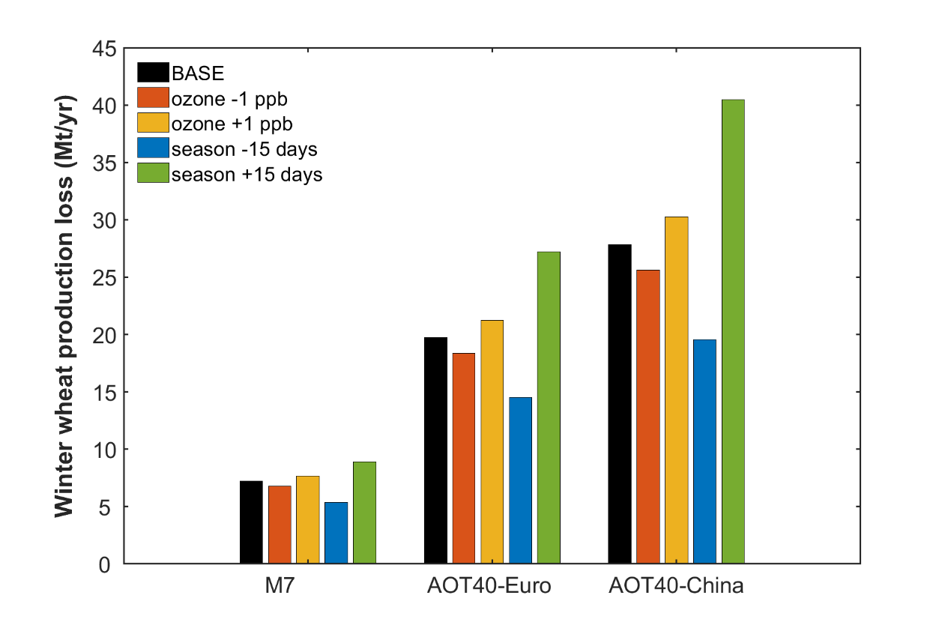
Fig 6 Chinese national winter wheat production losses in 2015 estimated using an AOT40 metric, along with the effects of changing ambient ozone concentrations by 1 ppb and shifting the growing season by 15 days.
In the current study we apply concentration-based and flux-based dose-response functions that have been derived from studies in different countries. Using the AOT40-response function established by Mills et al. (2007), we find that the relative yield loss for winter wheat in 2015 is 14% with 95% confidence limits giving a range 11-16%. These functions were derived from a meta-analysis of field trials and experiments conducted predominantly in Europe and the US. Applying the Lesser et al. (1990) response function, based on US field trials during the 1980s, suggests much more modest losses, only 6%. Such differences have been reported previously by Pleijel et al. (2019) who concluded that there are systematic biases between early US and later European AOT40-based response functions that may arise from differences in experimental conditions and methods, and/or differences in cultivar. In particular, it has been reported that modern cultivars of some crops appear to be increasingly sensitive to O₃ damage, possibly as the result of breeding for faster growth and biomass accumulation (e.g. Osborne et al., 2016). The evidence of differences between cultivars grown in different world regions consistently suggests that Asian cultivars are more sensitive (e.g. Emberson et al., 2009, Pleijel et al., 2019). It is therefore unsurprising that the yield loss we calculate with the China-specific response function is highest at 18%. We perform a simple t-test to determine if our results are significantly different when applying the Mills et al. (2007) and Wang et al., (2012) functions, and find that there is a significant difference at a 5% significance level (p-value = 0.02). This highlights the substantial uncertainty associated with functions derived for different cultivars and conditions, and underscores the need for more crop and region-specific experiments and trials to develop appropriate dose-response functions.
For the ozone flux-based metric POD₃IAM, we estimate${ g}_{sto}$ using the methodology recommended in UNECE (2017), resulting in projected relative yield and production losses for winter wheat of 19% and 30 Mt/yr. We then estimate losses using ${ g}_{sto}$ from the dry deposition scheme included in the NAQPMS model, which is based on a multiplicative approach accounting for air temperature and photosynthetically active radiation (Wesely et al., 1989). We find that winter wheat relative yield and production losses in 2015 derived directly from the model are 4.2% and 5.4 Mt/yr, respectively, much lower than those based on the UNECE (2017) method or on either of the concentration-based metrics. This discrepancy highlights weaknesses in the simple approach to stomatal conductance adopted in the Wesely scheme, and demonstrates that it is important that models include a better treatment of vegetation processes to estimate $g_{sto}$, e.g., through incorporation of plant canopy processes related to photosynthesis (Otu-Larbi et al., 2020). We conduct another t-test to verify if estimated winter wheat yield losses differ significantly when applying concentration-based and flux-based methods, and again find that the differences are significant at the 5% significance level (p-value = 0.04).
Flux-based metrics are still being refined and improved, and there are relatively few studies assessing crop yield and production loss. Tang et al (2013) derived POD₆ (Phytotoxic Ozone Dose above 6 nmol m⁻² sec⁻¹) from the WRF-Chem model at a spatial resolution of 40 km to estimate wheat production loss for the year 2020 in China, with relative yield and production losses of 23% and 30 Mt/yr, respectively. Losses of this magnitude are consistent with those in the current study (19%, 30 Mt/yr). Using ozone distributions from the EMEP regional model, Mills et al (2018) found high values of POD₃IAM in southern China, as we find in our study, but relative yield and production losses for winter wheat average 12% and 18 Mt/yr for 2010-2012, which are lower than those we estimate. This is most likely attributable to the fact that we do not account for soil moisture constraints on stomatal absorption of ozone, which are known to play a significant role in reducing ozone damage effects (Emberson et al., 2017; UNECE, 2017). However, we would also expect the wheat yield loss in 2014-2017 to be higher than that estimated by Mills et al (2018) for the earlier time period based on the observed increase in ozone concentration and actual wheat production in recent years.
5 Conclusion
We have applied concentration- and flux-based metrics and dose-response functions derived from field trials and experiments conducted primarily in Europe and the United States to estimate crop production losses in China. We find that annual production losses of winter wheat, single-rice, maize and soybean are 34-91 million metric tonnes (Mt/yr) on a 4-year average basis. The definition of the growing season may have a greater impact on estimated losses than small biases in ozone surface concentrations. Our results highlight large discrepancies between concentration- and flux-based estimates of ozone damage and between those derived from experiments conducted at different times, in different geographical regions and on different species and cultivars (Mills et al., 2007, 2011; UNECE, 2017; Pleijel et al., 2019; Emberson et al., 2020).
Flux-based metrics explicitly consider ozone deposition and absorption by stomata, and therefore more closely represent the fundamental physical and physiological processes that determine ozone damage to vegetation than concentration-based metrics. It is essential that future crop, Earth system and Integrated Assessment Models transition to this approach if they are to provide useful maps of areas of high vulnerability for vegetation productivity and food security. However, flux-based metrics are not easy to calculate as the need to estimate ${ g}_{sto}$ demands a relatively large number of species- (and even cultivar-) specific variables. As our findings show, there are still large uncertainties in estimates of yield reductions in winter wheat – one of the most studied crops – and losses of the other crops should be seen as rough estimates.
There is therefore a critical need for further open top chamber and Free Air Chemical Enrichment (FACE) experiments as well as data from large-scale field studies with which to gain understanding of the sensitivity of different crops and cultivars to ozone exposure (Zhu et al., 2014; Osborne et al., 2016; Pleijel et al., 2019; Emberson et al., 2020). These data will enable us to develop appropriate dose-response relationships and critical threshold values for the crop and region being studied (Paolotti et al., 2007; UNECE, 2017; Emberson et al., 2020). In spite of the uncertainties, we recommend that PODY is adopted in the interim as the standard metric for all ozone risk assessments.

Acknowledgements:
This work was supported by the Strategic Priority Research Program of Chinese Academy of Sciences (Grant No XDA19040202 No XDA19040203) and National Key Research and Development Project of China (Grant No 2018YFC0830802). KA is supported by the Royal Society of London (Grant No DH150070).

References:
Adams, Glyer, Johnson, et al. A reassessment of the economic effects of ozone on US agriculture [J]. Japca, 1989, 39(7), 960- 968. https://doi.org/10.1080/08940630.1989.10466583
Ashmore, M. R. Assessing the future global impacts of ozone on vegetation [J]. Plant, Cell & Environment, 2005, 28(8), 949-964. https://doi.org/10.1111/j.1365-3040.2005.01341.x
Aunan, K., Berntsen, T. K., Seip, H. M. Surface ozone in China and its possible impact on agricultural crop yields [J]. AMBIO: A journal of the human environment, 2000, 29(6), 294-301. https://doi.org/10.1579/0044-7447-29.6.294
Avnery, S., Mauzerall, D. L., Liu, J.et al. Global crop yield reductions due to surface ozone exposure: 1. Year 2000 crop production losses and economic damage [J]. Atmospheric Environment, 2011a, 45(13), 2284-2296. https://doi.org/10.1016/j.atmosenv.2010.11.045
Avnery, S., Mauzerall, D. L., Liu, J., et al. Global crop yield reductions due to surface ozone exposure: 2. Year 2030 potential crop production losses and economic damage under two scenarios of O3 pollution [J]. Atmospheric Environment, 2011b, 45(13), 2297-2309. https://doi.org/10.1016/j.atmosenv.2011.01.002
Chen, G., Li, J., Ying, Q., et al. Evaluation of observation-fused regional air quality model results for population air pollution exposure estimation [J]. Science of the total environment, 2014, 485, 563-574. https://doi.org/10.1016/j.scitotenv.2014.03.107
China National Statistics Yearbook, 2017. https://data.stats.gov.cn/ (last access: 24/8/2021)
CNEMC, Bulletin of China Ecological Environment, China National Environmental Monitoring Centre, 2016. http://www.cnemc.cn/ (last access: 24/8/2021)
Crutzen, P.J., 1988. Tropospheric ozone: An overview. In Tropospheric ozone (pp. 3-32). Springer, Dordrecht. https://doi.org/10.1007/978-94-009-2913-5_1
Danielsson, H., Karlsson, G.P., Karlsson, P.E. and Pleijel, H.H. Ozone uptake modelling and flux-response relationships—an assessment of ozone-induced yield loss in spring wheat [J]. Atmospheric Environment, 2003, 37(4), 475-485. https://doi.org/10.1016/s1352-2310(02)00924-x
Emberson, L.D., Ashmore, M.R., Cambridge, H.M., Simpson, D. and Tuovinen, J.P. Modelling stomatal ozone flux across Europe [J]. Environmental Pollution 2000a, 109, 403-413. https://doi.org/10.1016/s0269-7491(00)00043-9
Emberson, L.D., Wieser, G. and Ashmore, M.R. Modelling of stomatal conductance and ozone flux of Norway spruce: comparison with field data [J]. Environmental Pollution 2000b, 109, 393–402. https://doi.org/10.1016/s0269-7491(00)00042-7
Emberson LD, Ashmore MR, Cambridge HM, Simpson D, Tuovinen JP. Modelling stomatal ozone flux across Europe. Environ Pollut. 2000 Sep;109(3):403-13. doi: 10.1016/s0269-7491(00)00043-9. PMID: 15092873.
Emberson, L.D., Büker, P., Ashmore, M.R., Mills, G., Jackson, L.S., Agrawal, M., Atikuzzaman, M.D., Cinderby, S., Engardt, M., Jamir, C. and Kobayashi, K., A comparison of North American and Asian exposure–response data for ozone effects on crop yields. Atmospheric Environment, 2009. 43(12).1945-1953. https://doi.org/10.1016/j.atmosenv.2009.01.005
Emberson, L.D., Kitwiroon, N., Beevers, S., Büker, P. and Cinderby, S., Scorched Earth: how will changes in the strength of the vegetation sink to ozone deposition affect human health and ecosystems?. Atmospheric Chemistry and Physics, 2013.13(14),6741-6755. https://doi.org/10.5194/acp-13-6741-2013
Emberson, L., 2020. Effects of ozone on agriculture, forests and grasslands. Philosophical Transactions of the Royal Society A, 378(2183), p.20190327. doi: 10.1098/rsta.2019.0327.
Feng, Z. W., Jin, M. H., Zhang, F. Z., et al. Effects of ground-level ozone (O3) pollution on the yields of rice and winter wheat in the Yangtze River Delta [J]. Journal of Environmental Sciences, 2003, 15(3), 360-362. http://dx.doi.org/10.1016/j.envpol.2012.07.028
Feng, Z., Tang, H., Uddling, J., et al. A stomatal ozone flux–response relationship to assess ozone-induced yield loss of winter wheat in subtropical China [J]. Environmental pollution, 2012, 164, 16-23. https://doi.org/10.1016/j.envpol.2012.01.014
Feng, Z., De Marco, A., Anav, A., et al. Economic losses due to ozone impacts on human health, forest productivity and crop yield across China [J]. Environment international, 2019, 131, 104966. https://doi.org/10.1016/j.envint.2019.104966
Fuhrer, J., Skärby, L. and Ashmore, M.R. Critical levels for ozone effects on vegetation in Europe [J]. Environmental pollution, 1997, 97(1-2), 91-106. https://doi.org/10.1016/s0269-7491(97)00067-5
Fuhrer, J. Introduction to the special issue on ozone risk analysis for vegetation in Europe [J]. Environmental pollution (Barking, Essex: 1987), 2000, 109(3), 359. https://doi.org/10.1016/s0269-7491(00)00039-7
Global Agro-Ecological Zones, 2000. http://www.fao.org/nr/gaez/en/ (last access: 24/8/2021)
Han, H., Liu, J., Shu, L., et al. Local and synoptic meteorological influences on daily variability of summertime surface ozone in eastern China [J]. Atmospheric Chemistry and Physics, 2020, 20(1), 203-222. https://doi.org/10.5194/acp-20-203-2020
Heath, R.L. and Taylor, G.E., 1997. Physiological processes and plant responses to ozone exposure. In Forest decline and ozone (pp. 317-368). Springer, Berlin, Heidelberg. DOI: 10.1007/978-3-642-59233-1_10
Jarvis, P.G. The interpretation of the variations in leaf water potential and stomatal conductance found in canopies in the field, Philos [J]. Trans. R. Soc. Lond., B 1976, 273, 593-610. https://doi.org/10.1098/rstb.1976.0035
Lefohn, A.S., Knudsen, H.P., Logan, J.A., Simpson, J. and Bhumralkar, C. An evaluation of the kriging method to predict 7-h seasonal mean ozone concentrations for estimating crop losses [J]. JAPCA, 1987, 37(5), 595-602. https://doi.org/10.1080/08940630.1987.10466247
Lesser, V.M., Rawlings, J.O., Spruill, S.E. and Somerville, M.C. Ozone effects on agricultural crops: statistical methodologies and estimated dose-response relationships [J]. Crop Science, 1990, 30(1), 148-155. https://doi.org/10.2135/cropsci1990.0011183x003000010033x
Li, J., Wang, Z., Wang, X., Yamaji, K., et al. Impacts of aerosols on summertime tropospheric photolysis frequencies and photochemistry over Central Eastern China [J]. Atmospheric environment, 2011, 45(10), 1817-1829. https://doi.org/10.1016/j.atmosenv.2011.01.016
Li, J., Wang, Z., Zhuang, G., et al. Mixing of Asian mineral dust with anthropogenic pollutants over East Asia: a model case study of a super-duststorm in March 2010 [J]. Atmospheric Chemistry and Physics, 2012, 12(16), 7591-7607. https://doi.org/10.5194/acp-12-7591-2012
Li, K., Jacob, D.J., Liao, H et al. Anthropogenic drivers of 2013–2017 trends in summer surface ozone in China [J]. Proceedings of the National Academy of Sciences, 2019, 116(2), 422-427. https://doi.org/10.1073/pnas.1812168116
Lin, Y., Jiang, F., Zhao, J., et al. Impacts of O3 on premature mortality and crop yield loss across China [J]. Atmospheric Environment, 2018, 194, 41-47. https://doi.org/10.1016/j.atmosenv.2018.09.024
Liu, S.C., Trainer, M., Fehsenfeld, F.C., Parrish, D.D., Williams, E.J., Fahey, D.W., Hübler, G. and Murphy, P.C., 1987. Ozone production in the rural troposphere and the implications for regional and global ozone distributions. Journal of Geophysical Research: Atmospheres, 92(D4), pp.4191-4207. https://doi.org/10.1029/jd092id04p04191
Liu, J., Wang, L., Li, M et al. Quantifying the impact of synoptic circulation patterns on ozone variability in northern China from April to October 2013–2017 [J]. Atmospheric Chemistry and Physics, 2019, 19(23), 14477-14492. https://doi.org/10.5194/acp-19-14477-2019
Mills, G., Buse, A., Gimeno, B., et al. A synthesis of AOT40-based response functions and critical levels of ozone for agricultural and horticultural crops [J]. Atmospheric Environment, 2007, 41(12), 2630-2643. https://doi.org/10.1016/j.atmosenv.2006.11.016
Mills, G., Hayes, F., Simpson, D., et al. Evidence of widespread effects of ozone on crops and (semi‐) natural vegetation in Europe (1990–2006) in relation to AOT40‐and flux‐based risk maps [J]. Global Change Biology, 2011, 17(1), 592-613. https://doi.org/10.1111/j.1365-2486.2010.02217.x
Mills, G., Pleijel, H., Braun, S., Büker, P., Bermejo, V., Calvo, E., Danielsson, H., Emberson, L., Fernández, I.G., Grünhage, L. and Harmens, H. New stomatal flux-based critical levels for ozone effects on vegetation. Atmospheric Environment, 2011. 45(28).5064-5068. doi:10.1016/j.atmosenv.2011.06.009
Mills, G., Sharps, K., Simpson, D., et al. Ozone pollution will compromise efforts to increase global wheat production [J]. Global change biology, 2018, 24(8), 3560-3574. https://doi.org/10.1111/gcb.14157
Nussbaum, S., Geissmann, M., Fuhrer, J. Ozone exposure-response relationships for mixtures of perennial ryegrass and white clover depend on ozone exposure patterns [J]. Atmospheric Environment, 1995, 29(9), 989-995. https://doi.org/10.1016/1352-2310(94)00368-u
Osborne, S.A., Mills, G., Hayes, F., Ainsworth, E.A., Büker, P. and Emberson, L.. Has the sensitivity of soybean cultivars to ozone pollution increased with time? An analysis of published dose–response data. Global change biology, 2016, 22(9),3097-3111. https://doi.org/10.1111/gcb.13318
Otu‐Larbi, F., Conte, A., Fares, S., Wild, O. and Ashworth, K., 2020. Current and future impacts of drought and ozone stress on Northern Hemisphere forests. Global Change Biology, 26(11), pp.6218-6234. https://doi.org/10.1111/gcb.15339
Paoletti, E., Manning, W. J. Toward a biologically significant and usable standard for ozone that will also protect plants [J]. Environmental Pollution, 2007, 150(1), 85-95. https://doi.org/10.1016/j.envpol.2007.06.037
Pleijel, H., Danielsson, H., Ojanperä, K., et al. Relationships between ozone exposure and yield loss in European wheat and potato—a comparison of concentration-and flux-based exposure indices [J]. Atmospheric Environment, 2004, 38(15), 2259-2269. https://doi.org/10.1016/j.atmosenv.2003.09.076
Pleijel, H., Danielsson, H., Emberson, L., et al. Ozone risk assessment for agricultural crops in Europe: Further development of stomatal flux and flux–response relationships for European wheat and potato [J]. Atmospheric Environment, 2007, 41(14), 3022-3040. https://doi.org/10.1016/j.atmosenv.2006.12.002
Pleijel, H., Broberg, M.C. and Uddling, J., Ozone impact on wheat in Europe, Asia and North America–A comparison. Science of the Total Environment, 2019. 664,908-914. https://doi.org/10.1016/j.scitotenv.2019.02.089.
Sampedro, J., Waldhoff, S., Van de Ven, D.J., Pardo, G., Van Dingenen, R., Arto, I., Del Prado, A. and Sanz, M.J., 2020. Future impacts of ozone driven damages on agricultural systems. Atmospheric Environment, 117538. https://doi.org/10.1002/essoar.10501661.1
Sillman, S., Logan, J.A. and Wofsy, S.C., 1990. The sensitivity of ozone to nitrogen oxides and hydrocarbons in regional ozone episodes. Journal of Geophysical Research: Atmospheres, 95(D2), 1837-1851. https://doi.org/10.1029/jd095id02p01837
Singh, A.A., Agrawal, S.B., Shahi, J.P. and Agrawal, M. Assessment of growth and yield losses in two Zea mays L. cultivars (quality protein maize and nonquality protein maize) under projected levels of ozone [J]. Environmental Science and Pollution Research, 2014, 21(4), 2628-2641. https://doi.org/10.1007/s11356-013-2188-6
Tai, A.P., Martin, M.V. and Heald, C.L., 2014. Threat to future global food security from climate change and ozone air pollution. Nature Climate Change, 4(9), pp.817-821. https://doi.org/10.1038/nclimate2317
Tang, H., Takigawa, M., Liu, G., et al. A projection of ozone‐induced wheat production loss in China and India for the years 2000 and 2020 with exposure‐based and flux‐based approaches [J]. Global Change Biology, 2013, 19(9), 2739-2752. https://doi.org/10.1111/gcb.12252
Teixeira, E., Fischer, G., van Velthuizen, H., et al. Limited potential of crop management for mitigating surface ozone impacts on global food supply [J]. Atmospheric Environment, 2011, 45(15), 2569-2576. https://doi.org/10.1016/j.atmosenv.2011.02.002
Tong, L. O3 and CO2 fluxes monitoring and modeling of early rice in southern China and winter wheat in Northern China, Graduate University of Chinese Academy of Sciences(D), 2011.
UNECE. Chapter 3: Mapping Critical Levels for Vegetation. International Cooperative Programme on Effects of Air Pollution on Natural Vegetation and Crops. Bangor, UK, 2017. Retrieved from http://icpvegetation.ceh.ac.uk/ (last access: 24/8/2021).
USDA, United States Department of Agriculture. (2008). Major World Crop Areas and Climatic Profiles.
U.S. EPA. Air Quality Criteria For LEAD. U.S. Environmental Protection Agency, Washington, DC, EPA/600/R-05/144aF-bF, 2006.
U.S. EPA. Integrated Science Assessment for Ozone and Related Photochemical Oxidants. EPA/600/R-10/076F Office of Research and Development – National Centre for Environmental Assessment-RTP, 2013.
Van Dingenen, Dentener, Raes, et al. The global impact of ozone on agricultural crop yields under current and future air quality legislation. Atmospheric Environment, 2009, 43(3), 604-618. https://doi.org/10.1016/j.atmosenv.2008.10.033
Wang, X., Mauzerall, D. L. Characterizing distributions of surface ozone and its impact on grain production in China, Japan and South Korea: 1990 and 2020 [J]. Atmospheric Environment, 2004, 38(26), 4383-4402. https://doi.org/10.1016/j.atmosenv.2004.03.067
Wang, X., Zhang, Q., Zheng, F., et al. Effects of elevated O3 concentration on winter wheat and rice yields in the Yangtze River Delta, China [J]. Environmental Pollution, 2012, 171, 118-125. https://doi.org/10.1016/j.envpol.2012.07.028
Wang, Y., Chen, H., Wu, Q.,et al. Three-year, 5 km resolution China PM_{2.5} simulation: Model Performance evaluation. Atmospheric Research, 2018, 207, 1-13. https://doi.org/10.1016/j.atmosres.2018.02.016
Wang, Y., Wild, O., Chen, H., et al. Acute and chronic health impacts of PM2.5 in China and the influence of interannual meteorological variability [J]. Atmospheric Environment, 2020, 117397. https://doi.org/10.1016/j.atmosenv.2020.117397
Wang, Y., Wild, O., Chen, X., Wu, Q., Gao, M., Chen, H., Qi, Y. and Wang, Z., 2020. Health impacts of long-term ozone exposure in China over 2013–2017. Environment International, 144, 106030. https://doi.org/10.1016/j.envint.2020.106030
Wang, Z. F., Xie, F. Y., Wang, X. Q., An, J., Zhu, J. 2006. Development and application of nested air quality prediction modeling system. Chinese Journal of Atmospheric Sciences 30(5), 778. (Chinese). Doi:10.3878/j.issn.1006-9895.2006.05.07.
Wesely, L. Parameterization of surface resistances to gaseous dry deposition in regional-scale numerical models [J]. Atmospheric Environment (1967), 1989, 23(6), pp.1293-1304. https://doi.org/10.1016/j.atmosenv.2007.10.058
Wild, O. and Prather, M.J. Global tropospheric ozone modeling: Quantifying errors due to grid resolution [J]. Journal of Geophysical Research: Atmospheres, 2006, 111(D11). https://doi.org/10.1029/2005jd006605
Yao, F. F., Wang, X. K., Lu, F., et al Assessing the impact of ambient ozone on crop ecosystem: a case study in the Yangtze Delta, China [J]. Asian Journal of Ecotoxicology, 2008, 3(2), 189-195. https://doi.org/10.1016/j.envpol.2006.12.014
Zhai, S., Jacob, D.J., Wang, X., Shen, L., Li, K., Zhang, Y., Gui, K., Zhao, T. and Liao, H., 2019. Fine particulate matter (PM2. 5) trends in China, 2013–2018: separating contributions from anthropogenic emissions and meteorology. Atmospheric Chemistry & Physics, 19(16). https://doi.org/10.5194/acp-19-11031-2019
Zhang, L., Gong, S., Padro, J., et al. A size-segregated particle dry deposition scheme for an atmospheric aerosol module [J]. Atmospheric Environment, 2001, 35(3), 549-560. https://doi.org/10.1016/s1352-2310(00)00326-5
Zhang, W., Feng, Z., Wang, X., et al. Quantification of ozone exposure-and stomatal uptake-yield response relationships for soybean in Northeast China [J]. Science of The Total Environment, 2017, 599, 710-720. https://doi.org/10.1016/j.scitotenv.2017.04.231
Zheng, Y., Stevenson, K. J., Barrowcliffe, R., et al. Ozone levels in Chongqing: a potential threat to crop plants commonly grown in the region? [J]. Environmental Pollution, 1998, 99(3), 299-308. https://doi.org/10.1016/s0269-7491(98)00017-7
Zhu Z L, Sun X M, Yu G R, Wen X F., A review of research on ozone flux observation and stomatal uptake estimation over terrestrial ecosystems. Acta Ecologica Sinica, 2014, 34(21):6029-6038 (Chinese). DOI:10.5846/stxb201310172512

