Lancaster University
Doctoral Thesis
________________________________________________________
Bespoke Analysis of Soil in a High Uranium Background for Identification of Trace Plutonium in Decommissioning Applications
________________________________________________________
Submitted in accordance with the requirements of Lancaster University for the degree of Doctor of Philosophy

Christopher Mark Tighe, BSc
Department of Engineering
April 26th, 2019

Acknowledgements

Great thanks are due to various individuals and institutions that took part in my PhD throughout its completion and are as follows:
- Professor Malcolm Joyce for his careful and patient supervision of the project, offering pertinent advice and support countless times throughout the journey.
- Dr Jeremy Andrew for his valuable industrial insight and discussion, and Dounreay Site Restoration Ltd., for their financial support of the project.
- Staff at the Centre of Ion Beam Physics, ETH Zϋrich for their invaluable help and use of the AMS facility. Particular thanks are given to Dr Marcus Christl for his helpful discussions and Dr Maxi Castrillejo Iridoy for his supervision, support and friendship during long hours in the laboratory.
- Professor Claude Degueldre for his valuable input into discussion of radionuclide origins, based on decades of experience in the area, and his introduction to the staff at ETH Zϋrich.
- Staff at the Culham Centre for Fusion Energy for their guidance and support with gamma spectrometry and spectral analysis, in particular Dr Bethany Colling, Lee Packer, and Steve Bradnam.
- Dr Rashed Sarwar for instruction on the use of an FPGA board to count neutrons, and the associated PCB of his design.
- The Nuclear Science and Engineering research group at Lancaster for helpful discussions and support, in particular Helen Parker and Dr Ashley Jones.
- Dr Ioannis Tsitsimpelis and Dr Andrew West for their supportive pointers when MS Word made me feel like a philistine.
- Technical staff within the Lancaster University Engineering Department.
Further acknowledgements are made to the following individuals for carrying out certain measurements and offering help as follows:
- Dr. Marcus Christl of ETH Zϋrich for carrying out AMS measurements of the prepared samples.
- Dr. Maxi Castrillejo-Iridoy and Dr. Núria Casacuberta Arola of ETH Zϋrich for demonstrating the process of preparing samples for AMS measurement.
- Dr. Bethany Colling of CCFE for her guidance with carrying out gamma-ray measurements and analysis of the spectra with the ProSpect software.
- Ian Campbell for performing some repeats of the gamma-ray measurements at CCFE.
- Dr Vytas Astromskas for his keenness to offer feedback and corrections during the numerous practice presentations prior to conferences.
Finally, huge thanks are owed to my family and friends, without whom the PhD journey would not have happened.

Abstract

The development of fast neutron assay of low radioactivity samples collected from Dounreay decommissioning site is described, the development aims to identify a plutonium detection limit with neutrons. To inform the neutron measurements, a greater analysis of the chosen samples is presented.
Analyses used were fast neutron counting, gamma spectrometry and accelerator mass spectrometry. Analysis showed that fast neutron detection can distinguish samples at a radioactivity of approximately 1 Bq/g of ²⁴⁰Pu origin from samples at background levels of natural uranium radioactivity.
Further, AMS and gamma spectrometry has showed that the Dounreay samples are consistent with the global fallout averages for the main plutonium isotopes ²³⁹Pu, ²⁴⁰Pu, ²⁴¹Pu, and ²⁴²Pu. The ²⁴⁰Pu/²³⁹Pu ratio measured in this research is lower than average however for most Dounreay site samples, leading to a conclusion that this ²⁴⁰Pu/²³⁹Pu ratio is symptomatic of the Dounreay site hosting breeder reactors, which could boost the levels of ²³⁹Pu in comparison to ²⁴⁰Pu.
Declaration

I, Christopher Mark Tighe, hereby certify that this thesis has been written by myself and has not been submitted in any previous application for a higher degree. The work presented here was carried out at the University of Lancaster between October 2014 and March 2019.

Date Signature of candidate

I hereby certify that the candidate has fulfilled the conditions of the resolution and regulations appropriate for the degree of Doctor of Philosophy in the University of Lancaster and that the candidate is qualified to submit this thesis in application for that degree.

Date Signature of supervisor

List of Figures
Page No.
  - Topsoil uranium in England 13
  - The Dounreay Fast Reactor 17
  - The Dounreay shaft 18
  - Alpha Spectrometry 21
  - ²³⁸U decay chain 26

6 MFA PSD Plot 36
7 Parallel neutron detector arrays 37
8 Parallel background neutron measurements 38
9 Background neutron counts with alternating detectors 39
10 The 16-detector neutron counting array 41
11 16-detector array diagram 42
12 Neutron average per detector 43
13 The Broad Energy Germanium detector 47
14 Column chemistry 55
15 TANDY AMS system 56
16 ²³⁶U abundance 57

17 Neutron counts of background and sample 61
18 Background subtraction of sample neutron counts 61
19 Average neutron counts per detector 63
20 Average neutron counts per sample 64
21 Difference in neutrons detected over time (spiked sample) 66
22 Example gamma spectrum of DSRL1 68
23 Peaks of interest in DSRL1 spectrum 69
24 Peaks of interest in DSRL2 spectrum 70
25 ²⁴¹Am abundance 72
26 ²⁴¹Pu abundance 73
27 ²³⁹Pu abundance 77
28 ²⁴²Pu abundance 78
29 ²⁴⁰Pu abundance 78
30 ²⁴⁰Pu/²³⁹Pu ratios 79

31 Estimated neutron emission 84
32 Comparison Index 95
33 Literature ²⁴⁰Pu/²³⁹Pu ratios 103
34 Literature ²⁴¹Pu/²³⁹Pu ratios 106
35 Literature ²⁴²Pu/²³⁹Pu ratios 109
List of Tables
Page No.
1 Average neutron count per detector 82
2 Global average plutonium isotope ratios 101
3 ²⁴⁰Pu/²³⁹Pu ratios 102
4 ²⁴¹Pu/²³⁹Pu ratios 105
5 ²⁴²Pu/²³⁹Pu ratios 108

Contents
Page No.
Acknowledgements 2
Abstract 4
Declaration 5
List of figures 6
List of tables 7
Contents 8
- Introduction 10
  - Radioactivity in the Environment 12
  - Dounreay History 16
  - DSRL Objectives 19
  - Methods of Analysis 20
  - Neutron Measurements 23
  - Gamma-Ray Spectrometry 27
  - Accelerator Mass Spectrometry 28
  - Summary 29
- Experimental Methods 30
2.1. Samples 30
2.2. Neutron Methods 32
2.2.1. Neutron Detector Array Calibration 33
2.2.2. Parallel-Array Neutron Measurements 35
2.2.3. 16-Detector Neutron Array Measurement 40
2.3. Gamma-Ray Spectrometry 47
2.4. Accelerator Mass Spectrometry 53
2.4.1. Sample Preparation 53
- Results 59
3.1 . Neutron Results 61
3.1.1. Parallel Neutron Array 61
3.1.2. 16-Detector Neutron Array 63
3.1.3. Spiked Soil Sample Comparison 66
3.2. Gamma Spectra Results 68
3.3. Accelerator Mass Spectrometry Results 76
- Discussion 82
  - Neutron Detection 84
    - Parallel Detector Array Measurement 84
    - 16-Detector Array Measurement 85
    - Plutonium-240 Spike 91
    - Neutron Summary 88
  - Gamma-ray Spectrometry 93
  - Accelerator Mass Spectrometry 96
    - ²³⁹Pu 96
    - ²⁴⁰Pu 100
    - ²⁴²Pu 100
    - ²³⁶U 101
    - Isotopic Ratios 104
      - ²³⁶U/²³⁹Pu 105
      - ²⁴⁰Pu/²³⁹Pu 106
      - ²⁴¹Pu/²³⁹Pu 109
      - ²⁴²Pu/²³⁹Pu 112
      - ²⁴⁴Pu/²³⁹Pu 114
  - Summary 115
- Conclusions and Further Work 118
  - Conclusion 118
  - Further Work 120
Bibliography 121

- Technical Specifications 137
A.1 EJ-309 Detectors
A.2 Mixed Field Analysers
A.3 BEGe Detector

Chapter 1
- Introduction
Soil is a complicated matrix of various materials. It is host to many individual interconnected chemical processes dependent on the environment, elevation, water content, and so on.
For several decades, globally, soil has been subject to trace, ubiquitous deposition of anthropogenic nuclear materials including, and most importantly in this thesis, plutonium [1]. Anthropogenic deposits also arise in smaller localities, generally as a result of nuclear energy generation, accidents or the site of nuclear tests [2].
Deposits of radioactive material are subject to various reactions within the soil matrices that are still not fully understood. Such reactions affect transport through soil, sorption to soil media, and the formation of new compounds [3]. All of these influences complicate the identification, measurement and extraction of such material.
Dounreay Site Restoration Ltd. (DSRL), as the managing company of Dounreay - an end-stage decommissioning site that is host to these issues - are interested in the analysis of soils on site to identify plutonium level measurement limits. Levels of plutonium on site will then determine the actions taken, with regards to discerning what might have derived from site activities, to such a degree that the land fits the ‘End State’ as discussed in the Nuclear Decommissioning Authority Report: “Site End State Definition Process” [4].
This thesis describes a research project focussed on a bespoke method for analysing soils from Dounreay to identify plutonium at a specific activity level of 0.01 Bq/g.
The developed method must be efficient and cost-effective to improve upon methods already employed at the Dounreay decommissioning site. Fast neutron counting was chosen due to its recent advancements, particularly advances in the ability to process digital signals at an increased rate which now allows accurate, real-time neutron counting [see for example [5]. The real-time aspect of the counting method provides a great benefit to the research project’s methodology as it allows the analysis to be monitored continuously without ending measurements, potentially in-situ and for extended periods. The choice of fast neutron counting rather than thermal neutron counting stems from the greater penetration exhibited by fast neutrons compared to thermal neutrons. This greater penetration allows the analysis of much larger sample sizes than usually seen. Conventionally, when carrying out radiometric analysis of samples it is more desirable to analyse small sample masses to reduce the likelihood of attenuation within the sample, and therefore increase the probability of the radiation event making it to the detector for measurement, and is certainly the case when detecting thermal neutrons. Fast neutron detection is less inhibited by this principle, due to the low likelihood of these neutrons to be captured within the sample thanks to their greater kinetic energy. Due to the low efficiency of detection of fast neutrons, the methodology proposed would rely on longer counting times than those seen in thermal neutron detection to achieve significant statistics.
The following thesis documents results that present the potential for a new standard for the analysis of actinide content of Dounreay soils.

  - Radioactivity in the Environment
The largest challenge involved in this thesis is that concerned with distinguishing material associated with on-site activities from natural radioactive material and that of other anthropogenic origin. The challenge stems from the presence of ubiquitous anthropogenic material, generally originating from fallout, and the high natural uranium abundance in the area. This introductory chapter aims to discuss the differentiation between anthropogenic and naturogenic material, along with presenting some prior art of radionuclide detection methods including current industrial and research methods in use for such purposes; a brief history of the Dounreay site and the current pressing objectives of Dounreay Site Restoration Ltd. (DSRL) relating to this aspect of site closure.
All radioactive material found in nature can be characterized as naturogenic or anthropogenic. Some naturogenic material is primordial, i.e., it was formed with the Earth and is found, to a greater or lesser extent, throughout the Earth’s geology. This material has since changed in composition and distribution due to radioactive decay, but also in the production of heavier atoms in areas of high levels of nuclear material, dubbed natural nuclear reactors, where enough material was present in a location to undergo a sustained fission reaction. An example of such a reactor has been found in Gabon, Africa and thought to have been active two billion years ago, as described for example by Gauthier-Lafaye et al., (1996). Many other areas play host to higher than average abundances of radioactive material, albeit not close to the same levels, with concentration highs of approximately 4.2 mg kg⁻¹ of topsoil uranium in England as reported in “Geological Controls On Radon Potential In England” [7].
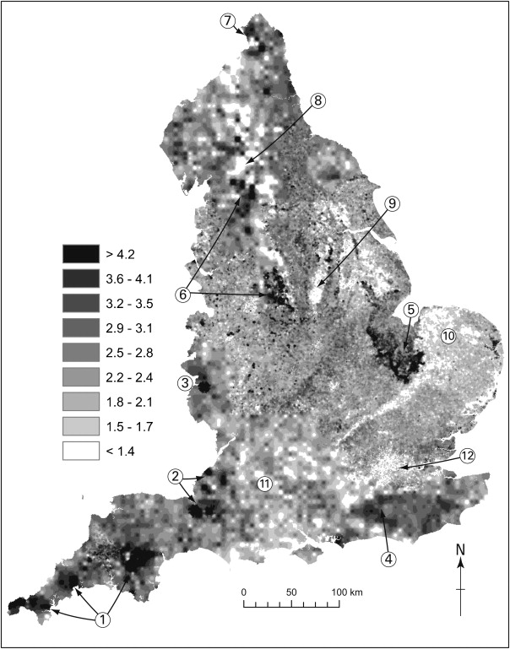
Figure 1 Topsoil uranium (mg/kg⁻¹) in England. Hotspots of uranium generally rest atop areas with a high abundance of granite [8]. The areas marked as “6” were chosen as the sites of comparison samples taken from England.
These areas of naturogenic radioactivity are influenced by geological conditions, generally associated with natural uranium and thorium with uranium comprising of a mixture of isotopes, of approximately 99% ²³⁸U, with less than 1% of ²³⁵U. The remaining uranium isotopes make up less than 0.5% of the abundance collectively [9].
Alongside natural uranium, ²³⁹Pu is also known to be found naturally, though typically one thousand times lower concentrations than the most abundant uranium isotopes. ²³⁹Pu is produced naturally by the decay of ²³⁹U, which itself is formed by the rare occurrence of a ²³⁸U isotope accepting a neutron. Both uranium and plutonium are generally found in their highest abundances in areas with underlying granite. Historically, these isotopes were the main contact people had with actinides until the pioneering work of Seaborg in the 1940s, discovery of the fission reaction and the spread of ubiquitous anthropogenic radioactive material that followed. Ubiquitous contamination began with local contamination, constrained to sites of radioactive materials processing and research, but with the advent of nuclear weapons, contamination rapidly spread globally via the transport of radionuclide particles in air and became known as fallout.
Most fallout originates from nuclear weapons tests carried out by the US, other Western powers and the former USSR. The US tests were carried out in areas of low population, mainly the Nevada desert (the Nevada Test Site) [10] and the Marshall Islands in the Pacific Ocean (Pacific Proving Grounds) [11]. The Soviet tests were mainly carried out in areas of Kazakhstan, namely Semipalatinsk, which was under USSR control at the time [2] [12] [13]. A total of 130 other Soviet tests were carried out in Novaya Zemlya, within the Arctic circle (Khalturin et al., 2005). British tests were carried out in Australia [15], while French tests were carried out in French-controlled Polynesia [16].
Each ground based nuclear bomb test (i.e. not subterranean) contributed to global fallout, regardless of the size of the explosion. While much of the radioactive material remained at the test sites, material was also carried into the atmosphere (largely in the northern hemisphere due to the majority of the bomb tests carried out here) to be deposited in the terrestrial and aquatic environment. It is estimated that a total of 10⁶ tonnes of radionuclides have been released from nuclear weapons tests [17]. Much of the deposits were of little consequence and have laid dormant in small enough concentrations to have little reported effect on human health day to day (Martin, 1982), or indeed have long-since decayed away.
The discovery of the potential continual heat output of sustained fission reactions has also been utilized for electrical power production. Nuclear energy became a further contributor to fallout over the next 60 years from reactor accidents such as Three-Mile Island, Windscale, Chernobyl and most recently Fukushima [18], and on a localized basis, the effluents from nuclear fuel manufacture and reprocessing.
With so much variation in the sources of nuclear material released into the environment, it poses further challenges for regulators and decommissioning projects to monitor and distinguish between what may have been left from fallout, and what was released from specific activities on nuclear sites.

1.2 Dounreay History
The challenge of distinguishing fallout from contamination derived from site activities becomes more of a challenge when the long history of contamination on the Dounreay site is considered.
First, the geology of the Dounreay site should be considered. Reports have shown [for example [19]] the geology to demonstrate such high abundances of uranium to be potentially economically viable for mining. With this comes a complication for the discrimination of site-borne contamination; i.e., how can a baseline for site-derived radioactivity be established against such high natural uranium background radioactivity?
Ousdale (Scotland), an area local to the site, reported approximately 850 ppm of uranium in soils [9]. Such an abundance of natural uranium would emit gamma rays in the low-energy range of 50-200 keV, as shown in L’Annunziata’s summary of gamma emissions [20], the same range that most plutonium gamma-ray emissions would be found and similarly in the context of thorium. Natural uranium also causes neutrons to be released through spontaneous fission of ²³⁵U, but at <1% abundance it is much lower than the potential releases from plutonium isotopes.
The reactors built on site included two fast reactors, the Dounreay Fast Reactor (Figure 2), the Prototype Fast Reactor and a Materials Test reactor.
Figure 2 The Dounreay Fast Reactor [21]
These were breeder reactors and so utilized breeder blankets of ²³⁸U to form ²³⁹Pu during the fission reaction. Such reactors produce ²⁴¹Pu as a waste product as the fission reaction is sustained, so if material was disposed from the waste lines it might be expected that the soil would exhibit higher than average levels of this isotope. Similarly, if any reactor material was dispersed, soil would exhibit higher-than-average ²³⁹Pu abundance. These considerations were kept in mind throughout the study.
Further to the local geology and the reactors that were on site is the knowledge of past waste management practices. Before modern practices were adopted, Dounreay constructed a shaft over 20 metres deep on the site to host all levels of waste including contaminated equipment and material.
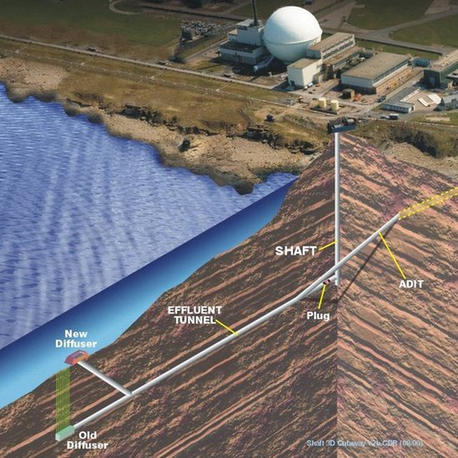
Figure 3 The Dounreay shaft. The shaft was designed to assist construction of the liquid effluent discharge tunnel and was subsequently licensed in 1958 for disposal of intermediate level radioactive waste long-term on the site [22]. Over time, the effluent tunnel began to leak into the sea, leading to a large scale clean- up project in the coastal waters. Since, the shaft has been identified as a decommissioning priority before the end state can be reached and clean-up is soon to begin.
Not everything disposed of was accounted for, which requires that the clean-up of the shaft is planned carefully. As the shaft is concrete lined and over 20 m deep(Figure 3), it is anticipated that it has had very little impact on the surface soil radioactivity and so will not be considered much further into this thesis, other than to state that the shaft has leaked radioactive material during an explosion driven by gas build-up [23]. This could present a potential method for radioactivity to be redeposited on land. Further, such methods of handling waste lends itself to the possibility of unreported, legacy contamination events on site.
Moving forward, the Dounreay site is nearing its end state of decommissioning. With this comes the demolition and removal of buildings, many of which have been in place since 1955. The issue this presents for soil monitoring is two-fold; firstly, demolition can lead to the movement of significant masses of ground material, which has the potential to bury any residual contamination deeper into the ground, making it less likely to be detected. Secondly, the removal of structures can present soils for analysis that have never come into contact with global fallout contamination from neighbouring facilities, let alone potential site contamination, which could influence the interpretation of assessments of contamination in an area, especially if the removal of said buildings has not been considered.

1.3 DSRL Objectives
As stated in Dounreay’s 2018 Socio Economic plan, the expected interim end date for the site will be reached between 2030 and 2033 [24].
The NDA define the ‘End State’ of a site as “...the physical condition of the site at the point at which the NDA has finished its business”. They also assert that “...a key point to note with this definition is that it does not necessarily require that all radiological material be removed from the site, since it is possible for the site to remain under long-term institutional control even after the NDA has finished its work” [4]. So, a baseline plutonium level needs to be determined and a system developed to measure that limit.
As mentioned, as part of the decommissioning process, most buildings involved in radiological handling will be removed which means that the majority of any residual contamination will reside in the soil matrix. Naturally, sampling all areas of soil on the site would require a huge amount of time, processing, and clearly, cost. For this reason, it is beneficial for DSRL to utilize as high throughput, high-efficiency, and low-cost system as possible.
1.4 Methods of Analysis
Currently, DSRL analyse soil samples using alpha-spectrometry. The use of alpha assay is valuable as the main source of radioactivity observed in actinides of interest is alpha decay, so the presence of alpha particles provides strong evidence for the presence of actinides. A downside of relying on alpha assay is that the particles are very interactive, making them unlikely to travel through samples to be detected, and therefore the method considers only superficial samples. The particles travel only a few centimetres through air - when in a dense sample, like soil, this distance is much reduced. Consequently, taking topsoil samples may not be representative of the contamination present - unless a greater diversity of samples is taken. This would be a drain on costs; both in terms of time spent carrying out the assay but also on materials and staff required to carry out the process. Alpha assay also takes a minimum of three weeks to complete, including excessive ‘man-hours’. Alpha spectrometry requires dissolution of soil samples before placement of the dissolved, dehydrated samples onto steel planchets for analysis, and when measuring gross alpha counts, only informs the analyst of how many alpha particles were counted and at what energy. It can provide more information but requires more time. While accurate, alpha spectrometry is an analysis method that is low throughput (shown in Figure 4), is not isotope specific, and requires a high amount of processing and therefore is not an optimal method for the analysis of large areas and volumes of soil. Further description of the alpha spectrometry method can be found in the review carried out by Vajda & Kim, 2010 of the alpha spectrometry methodology.
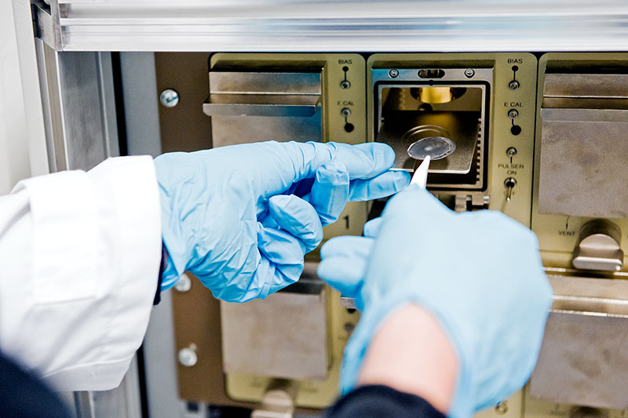
Figure 4 Alpha spectrometry. The sample disc can be seen being placed into the machine [physicsopenlab.org, useage: CC4.0, accessed 2019].
Other methods of radioactivity analysis include gamma-ray spectrometry, mass spectrometry, and neutron assay. As stated previously, the Dounreay area is highly abundant in natural uranium which affects the reliability of different methods. This natural uranium saturates some lines of the lower energy region of the gamma-ray spectrum where the majority of plutonium gamma-ray emissions are observed. The increase in background reduces the significance of plutonium peaks, making a general gamma-ray measurement method less suitable for use at Dounreay in isolation of other methods. Mass spectrometric methods are highly accurate and informative on the soil matrix composition [26] but have similar limitations to alpha-spectrometry in that they require excessive man-hours of preparation and encompass weeks to undertake from start to finish, as well as mainly providing measurements for entire isobars though some allow isotopic sensitivity with post-measurement analysis or sample separation. Further, the detail of analysis in mass spectrometry is likely much higher than required in a routine decommissioning scenario, where initial measurements aim to answer the simple binary question of: “is the sample of significantly higher activity than an average/threshold value?”. If the answer is yes, more analysis would be required, however it is more likely for the samples to be consistent with average activity and therefore a less detailed analysis method would be preferred to increase throughput, whilst also identifying ‘active’ samples. Neutron measurement could theoretically provide this analysis method and more.
The ideal goal of a ground remediation project is to leave the land and area in a comparable state to when the plant was first constructed. Of course, this is rarely a realistic expectation - especially when dealing with a long-serving site such as Dounreay that operated before stringent waste disposal guidelines were in place, and indeed, constructed before the majority of the global deposition (fallout). The Scottish Environmental Protection Agency’s (SEPA) policy regarding radioactive contaminated land [27] is a good example of such guidelines. Due to a historical lack of these policies, monitoring soils is pertinent, as soil is the most prevalent material of those left behind post decommissioning and allows quantification of various radioactive tracers that are deposited in the soil matrix.
The radionuclides found in the soil matrix are at an unknown depth, quantity, concentration and distribution, though specific areas of relatively high contamination have been identified on the Dounreay site (not relevant to this work). Due to these aforementioned unknowns, fast neutron detection is hypothetically an appropriate choice for a detection method - with complementary assays of samples of varied activity. Neutrons have low reactivity due to their lack of charge, making them highly penetrative, which increases the likelihood of their interaction with (and absorption by) a detector system rather than the soil matrix - both in-situ or otherwise for bulk soils assay.

1.5 Neutron Measurements
The use of fast-neutron detection of bulk soil samples is a novel technique for radioactive assay of plutonium, designed for time-efficient and convenient identification of the presence of radioactive soil contaminants. If paired with a comparative soil sample database, it could provide significant evidence of the relative level of neutron-emitting contamination at nuclear sites.
This study builds on developments made in the detection of neutrons in a mixed field, using Pulse Shape Discrimination (PSD) [28][5] carried out using Hybrid Instruments Mixed Field Analysers (MFAs) [29]. Organic liquid scintillation detectors are used in conjunction with this apparatus due to their ability to detect fast neutrons as well as thermal. Helium-3 detectors have been extensively used to measure both thermal and fast neutrons [30], but due to the expense of production of Helium-3 and the volatility of the material, there is a trend in the literature to move away from their use and explore other detection media with lower costs of manufacture [31].
The application of fast neutron detection to spot baseline levels of contamination within soil is a novel one, and could help forge an entirely new toolkit to be used by decommissioning organisations to highlight areas of higher-than-background radioactivity of neutron-emitting isotopes such as ²⁴⁰Pu. The development of such a neutron assay is described in this study. The study progresses from single detector experiments to a 16-detector array tested with varied masses of soil samples which were characterized by gamma-ray spectrometry at CCFE using their high-efficiency, high resolution Broad Energy Germanium detector, and the Tandy Accelerator Mass Spectrometer system at the Centre of Ion Beam Physics, ETH Zurich.
Neutron detection itself is not novel. It is commonly presented in modern research for multiplicity assay, typically using a californium-252 point-source [32], as well as other high emission sources [33], for safeguards applications exploiting the penetration of neutrons [34] [35] [36]. The measurement of neutrons released from low concentrations of plutonium contamination has often been considered too difficult due to the relative weakness of the source [37]. With recent evidence of passive, fast neutron detection of actinides, discovering the limit of detection of plutonium through fast neutron measurement is an exciting area of study. A prime example of recently published work in this field is H.M.O Parker et al.’s 2018 study on the “Passive, non-intrusive assay of depleted uranium” [38].
Within the project conditions, it is expected that the majority of neutrons emitted from the samples would be released as a product of either spontaneous fission of plutonium (particularly ²⁴⁰Pu) and primordial uranium isotopes, or of (α, n)-reactions in the sample media derived from some elements. Of the two, there is a high likelihood that (α, n)-reactions will cause the greater amount of neutron emission from the sample media. This is due to the long spontaneous fission half-lives of ubiquitous radionuclides, the short measurement time-frame, and the likelihood of extremely low concentrations of anthropogenic radionuclides - which would otherwise be high neutron emitters due to their high specific activities relative to primordial radionuclides. L’Annunziata (2012) also states that alpha particles at energies greater than 4 MeV cause (α, n)-reactions when colliding with low-Z material. Given that soil is made up almost exclusively of low-Z material, it is reasonable to assume that the majority of alpha emissions from isotopes of interest (Pu, Am, U) lead to an (α, n)-reaction following collision with a particle.
Thanks to Heathcote’s “Dounreay Site Description – Geology, Hydrology and Hydrogeology” [19], it is known that the DSRL samples originate from areas of relatively high uranium concentration, naturally it is expected that the samples will share this characteristic. The uranium decay chains contain a relatively high proportion of alpha emitters which, following the previous assumption, all would lead to (α, n)-reactions within the soil. Spontaneous fission is unlikely to be the cause of much of the samples’ neutron emission if they are of low plutonium concentration. Of the plutonium isotopes likely to be found in the soil; ²⁴⁰Pu is expected to emit the highest number of neutrons - with a spontaneous fission yield of 1020 neutrons per gram per second based on Ensslin’s “The Origin of Neutron Radiation” [39]. The neutron emission is expected to be even slightly higher when taking into account that the entire emission intensity of α-particles released by ²⁴⁰Pu is always greater than 4 MeV [20].
Feige et al.’s measurements of “Production Rates of Neutrons in Soils Due to Natural Radioactivity” [40] suggest relatively low levels of (α, n)-reactions within the soil, however. They predict (assuming 3ppm ²³⁸U and 11ppm ²³²Th and for alpha energies of 4.8-8.8 MeV) that 6.7±0.7 neutron/g/yr are released as a result of (α, n)-reactions in sand, and 13.5±1.3 neutron/g/yr in granite. They also assert that a further 1.4 neutron/g/yr are generated from the spontaneous fission of ²³⁸U and its daughter products, represented in Figure 5. Of course, these values are 50 years old, and so, whilst informative, the levels of actinides within soils may have changed since they took place. This means that the baseline levels of (α, n)-reactions in soils could very well be different.
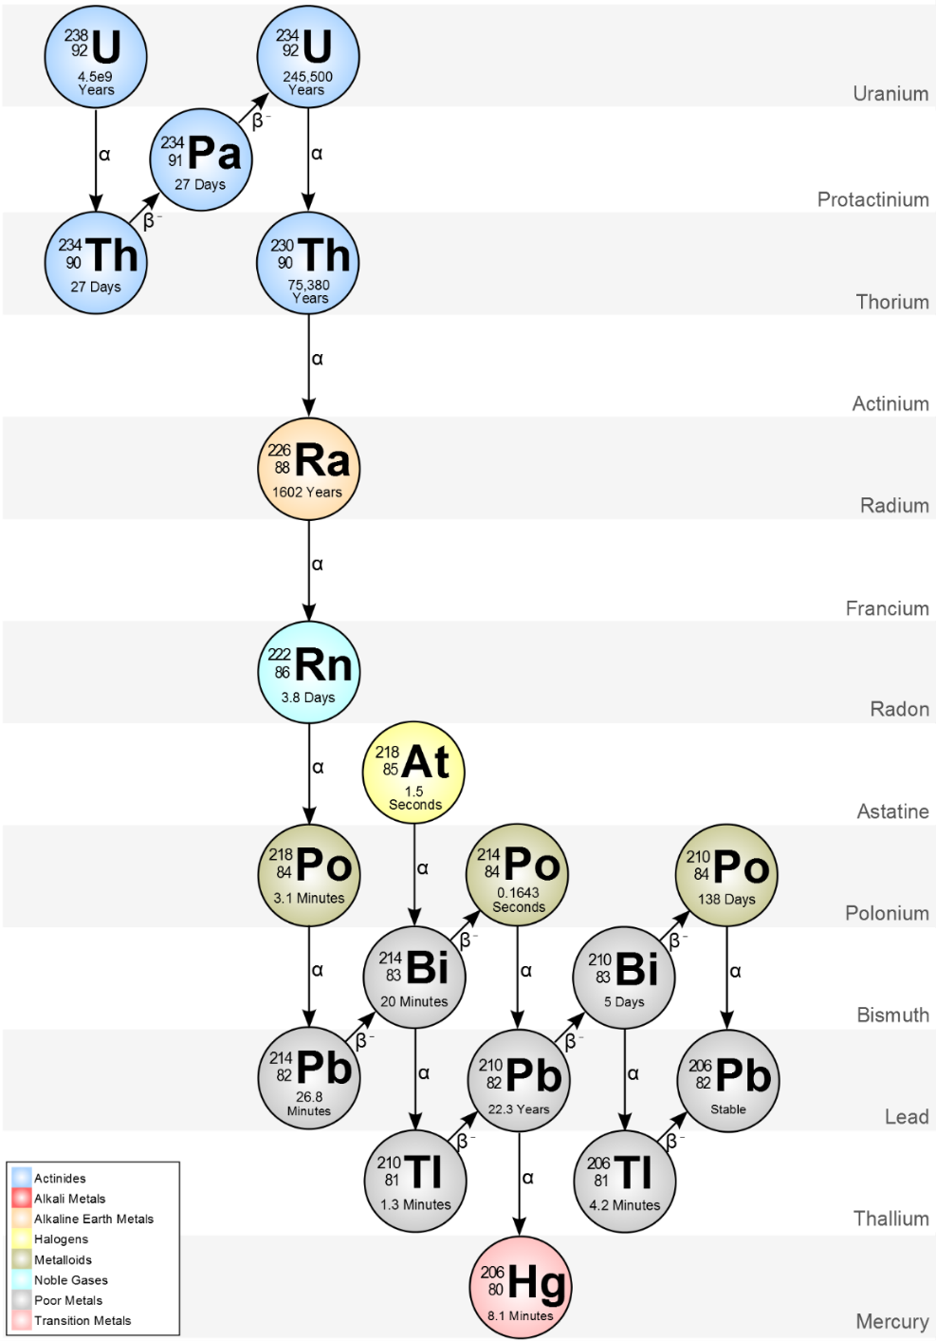
Figure 5 A visual representation of the ²³⁸U decay chain. As can be seen, the main decay mechanism of isotopes is alpha particle decay [Wikimedia Commons, usage: CC1.0, Accessed 2019].
Within the project was the opportunity to carry out measurements of the DSRLB2 soil sample spiked with a known amount of ²⁴⁰Pu. This experiment allows the calculation of an estimated neutron emission from the sample (and therein, ²⁴⁰Pu) per unit time to compare to the overall measured neutron emission. While the sample is only spiked with a single isotope, this experiment is very important for the project, as it provides understanding for what could be observed in terms of neutrons detected in a sample with activities of plutonium much higher than would normally expect to be deposited by fallout per gram of soil.
Heusser, reports a minimum combined thermal and fast neutron count of 7.3 cm⁻²s⁻¹ from the environment, including cosmic sources [41]. When considered in the context of this project geometry, it gives an anticipated neutron exposure in the experiment area of over 100 million neutrons over the course of a standard four-hour measurement. The background neutron count may be less when considering that a proportion of these neutrons will be reacting in the atmosphere and building before reaching the apparatus, and therefore will be below the 0.5 MeV detection threshold of the detectors. These conditions prompt the need for the application of corrections to the results to give a wider view of the neutron detection methods and evaluate the impact of neutron background on the assessment of soil samples.

1.6 Gamma Spectrometry
To support the development of the neutron measurement system, the gamma-ray spectra of the samples were measured to gain a greater understanding of the sample’s radioactive character. Observing the gamma-ray spectra highlights the most prolific gamma emitters within the samples, which is expected to show a high concentration of the uranium decay series daughters within the spectra, alongside peaks from various ubiquitous radionuclides such as potassium-40 and caesium-137. There is also still a chance that some plutonium peaks might be distinguishable in the spectra, which would help identify an estimate for expected neutron emission for that particular sample.
Consideration of T.E Sampson’s contribution to the PANDA manual [42] immediately prompts researchers to assess the low-energy regions of gamma spectra to attempt to identify any plutonium isotopes within the samples; Sampson reports 15 individual peaks from various plutonium isotopes (and ²⁴¹Am) in the energy range of 40-160 keV, when measuring ~500 grams of plutonium metal. It soon becomes clear however, that the gamma-ray spectra of background level actinides within soil are far removed from those found during gamma-ray emission measurements of nuclear fuel materials as published. Based on the Sampson report, plutonium gamma-ray lines at 148.6 keV and 152.7 keV from ²⁴¹Pu and ²³⁸Pu are expected respectively, however these are not sufficiently prominent to measure in soil samples. Instead, of the plutonium-related lines the ²⁴¹Am (59.5 keV) is the only line distinguishable from background, and as the direct daughter product of ²⁴¹Pu it can be used to generate an estimate for the plutonium content of the samples, albeit based on an estimate that the ²⁴¹Pu has been in existence. Further to americium, there is a line at 129 keV, a potential indicator of the presence of ²³⁹Pu, though this is largely derived from ²²⁸Ac, the daughter of ²³²Th.

1.7 Accelerator Mass Spectrometry
In addition to the gamma-ray spectrometry and neutron spectroscopy, the samples were measured with Accelerator Mass Spectrometry (AMS) which can quantify attogram per gram abundances of actinides (amongst other radionuclides).
The TANDY AMS system at ETH Zϋrich has proven a successful facility for the detection of actinides in sediments [43]. The technique was applied to soils from this project using similar techniques to break down the solid media as shown in Chamizo et al. [44].
AMS was invaluable in this study as its measurements provided high-resolution assessment of the plutonium isotopes within the samples. This was then translated into the expected neutron emission from the plutonium isotopes within the samples, when paired with spontaneous fission and α-emission rates to compare directly with the measured neutron emissions. Further to providing comparisons, knowledge of plutonium concentration within the samples allows additional speculation on the origin of said actinides which is helpful in decommissioning management practices and wider forensic possibilities.

1.8 Summary
Neutron detection can be used to identify the presence of fissile material, most notably ²⁴²Pu but also other decay products predominantly of the actinide decay chain. Gamma-ray spectrometry provides knowledge of gamma-ray emitters within each sample, confirming initial assumptions of the relatively high uranium character of the sample soils, while AMS gives the concentrations of ²³⁶U, ²³⁹Pu,²⁴⁰Pu,²⁴²Pu, and the 244-isobar including both ²⁴⁴Pu and ²⁴⁴Cm.
The results from each set of measurements are presented and discussed individually and in conjunction with one another to draw potential conclusions on the radioactive character of each sample, and ultimately draw conclusions of whether each set of measurements match. The conclusions are then presented and potential future work discussed, along with possible applications for the methods investigated in this research.
Chapter 2
- Experimental Methods
2.1 Samples
Ten soil samples were provided by Dounreay Site Restoration Ltd. to be analysed in this research. The ten soils were provided in one-litre, air-tight containers and labelled as DSRL1 through 10. These samples were approximately 1 kg mass when dried. Two samples from off-site at Dounreay (DSRLB1 and DSRLB2) were collected by DSRL staff near to the site and provided later in the project to serve as appropriate comparison samples from within the local area, these two samples had a mass of approximately 2 kg dried. The locations on-site were not disclosed and thus limits the extent of interpretation possible amongst the on-site samples.
Two further samples were collected from another part of the UK; Malham and Biggin, approximately 500 miles from the Dounreay site to provide other UK sample comparisons and noted in Figure 1. These samples weighed approximately 4 kg each dry. The Malham and Biggin samples were collected following extensive consideration of areas of known high natural radioactivity in the UK. A variety of sites were identified as useful, with Malham and Biggin being deemed the most appropriate, due to their relative locality to the researchers and their status as areas of high concentration of uranium in topsoil. The two sample sites were reported to have levels of uranium in excess of 4 milligrams per kilogram of soil (4 ppm), as shown in Scheib et al.’s “Geological Controls on Radon Potential in England and Wales” [7], in Figure 1.
The Malham and Biggin samples were collected by search sampling as described in A. Rahman’s “Decommissioning and Radioactive Waste Management” [45]. They describe search sampling as sampling with prior information of the location of ‘hot spots’ and a specific value of a parameter is being searched for, as is the case in this study, with a high natural radioactivity of soil being desired for comparison with indigenous activities at Dounreay.
The samples were processed very little during preparation. Each sample was dried and during the drying preparation it was visually confirmed that there was a low rock content within each sample. This was done by mechanically breaking apart larger clumps of soil to no more than approximately 1 cm in diameter, with the trowel used to manipulate the samples. This is important as a sample with significantly more rock may exhibit lower activities and could later present itself as an outlier. It was important to minimise systematic differences in the sample character.
To dry, each sample was spread over a steel tray to maximise surface area of each, then thermally dried in an oven for eight hours at 50 degrees Celsius. Following drying, the samples were immediately returned to their original containers and re-sealed to maintain dryness. Drying minimises the potential of neutron moderation (caused by water within the samples) which in this set of experiments would increase self-absorption of neutrons within the samples and further reduce neutron counts from the system as shown in Gorin et al’s contribution to Atomic Energy (2005) [46]. It was deemed appropriate to only dry the samples, leaving the soils in their natural matrices and thus accept the potential increased likelihood of an influence on neutron counts (albeit small) in terms of heterogeneity of radionuclides, which would be averaged out in later analyses. This was not a major worry during the design of the study, especially considering Sheppard et al’s (2008) comprehensive study on primordial radionuclides in Canadian background sites [47], where they found that even though there was a high amount of variation in soil characteristics, there was actually only a three-fold variation in radionuclide concentration across the seven soil types.
Late into the study, one more sample was provided by DSRL that included a plutonium-240 spike equating to ~1 Bq/g activity in the sample. This sample was originally the DSRLB2 sample, which was returned to DSRL. Some other samples in this sample set included a non-spiked DSRLB2 sample, and non-spiked DSRL7 samples following their characterisation by DSRL. No further processing was carried out on the samples within this set until specific measurements took place that are described hereafter. Following measurement, the sample masses at each measurement campaign were normalised to a consistent mass of 1 kg, unless stated otherwise.

2.2 Neutron Detection Methods
The neutron methods section describes experiments carried out at Lancaster University with varied detector configurations. Each of these experiments utilise Scionix EJ-309 liquid scintillation detectors with photomultiplier tubes (PMTs), as well as Hybrid Instruments mixed field analysers (MFAs) and other associated counting hardware made either from printed circuit boards (PCB) or Field Programmable Gate Arrays (FPGA) that have been constructed bespoke or programmed within the research group at Lancaster. The Hybrid Instruments MFAs are high-speed signal processors designed to differentiate between multiple neutron events within high neutron flux environments. In this work, they were used to measure single neutron events at low flux.
2.2.1 Neutron Detector Array Calibration
Every detector in the neutron array was calibrated using a ¹³⁷Cs point-source with the software provided with the MFA units [48]. The software has two modes in which the calibration needs to be carried out; MCA (multi-channel analyser) mode and PSD (pulse-shape discrimination) mode. The MCA mode is traditionally used to measure a spectrum of gamma energies, mapping count number against energy. Within this work, the MCA mode is only used to measure the ¹³⁷Cs point source, which causes a Compton edge to form from Compton scattering within the scintillation material. Compton scattering is caused when gamma rays interact with electrons in the atomic shells of the detector materials. This scattering in turn forms the Compton edge, which represents the full back-scatter of an interaction in the material. The Compton edge is used as a point of alignment across the detectors within the MCA spectra due to its assumed uniformity across each detector. Each detector’s voltage supply was adjusted within the software to align the Compton peak to a consistent point of the MCA spectra. Once the detectors are aligned via the Compton peak, the PSD mode was opened to set the optimum pulse-shape threshold at which neutron and gamma-ray pulses are distinguished from one another. PSD or pulse-shape discrimination is a process which identifies whether a scintillation pulse was generated by a gamma-ray or a neutron by measuring the differences in the shapes of the pulses (pictured in Figure 6). The neutron triggered scintillation pulses have a longer decay time than pulses triggered by the gamma-rays and this difference is measured as part of the PSD method. Detection starts with the point-source placed centrally in the array to give an example PSD scatter plot, then the PSD threshold is retrieved within the MFA software and adjusted by hand in the GUI (graphical user interface) to assign each detector a specific discrimination threshold that best fits the separation of the plumes in the data presented from the ¹³⁷Cs source. The PSD threshold can also be adjusted by channel number to make all detectors uniform in their threshold position, but the decision was made throughout all experiments presented to calibrate dependent on the PSD curves (plumes of gamma and neutron emissions), to consider the detector differences brought about by changes in geometry and uncontrollable differences within the instruments themselves. The same calibration methodology was carried out successfully in Parker et al.’s “Active fast neutron assay of uranium-235 enrichment in small samples of triuranium octoxide” (2016) [49].
It is important to set a consistent and accurate threshold between the two radiation plumes in the GUI as inaccuracy can lead to photon bleed-through. Bleed-through is a potential system-based contribution towards false sample counts measured in the detection system [50]. The system relies on pulse-shape discrimination (PSD) to distinguish between neutron and gamma radiation. Sometimes, dependent on the energy and pulse-shape of the events detected, one type of radiation can be mistaken as the other, this is known as bleed through. So, gamma emissions in any measurement could register in the system as neutrons. This is less likely assuring correct calibration, as there are only a small proportion of possible instances of bleed-through. These can be seen as individual points close to the threshold line during calibration far from the gamma (red) and neutron (blue) plumes where the majority of radiation events are recorded.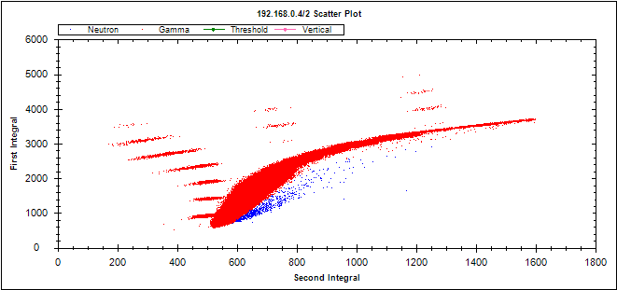
Figure 6 An example of a PSD plot following measurement with ¹³⁷Cs. The PSD threshold is the partition between red and blue points on the graph. Blue dots represent the neutron counts, while red the gamma. Points close to the threshold have the possibility to be bleed-through, though the threshold is set in a conservative manner to minimise this. Red lines seen horizontally across the screen were an issue with the machinery at the time, but did not affect the neutron measurements for this project, as only neutrons were measured, and all events on the gamma side of the threshold were discarded.
2.2.2 Parallel-array Neutron Measurements
The parallel-array measurement was comprised of two independent neutron arrays. Each array contained four vertically placed Scionix EJ-309 detectors attached to photo-multiplier tubes (PMTs) and one Hybrid Instruments MFA 4-channel unit. One array measured a sample’s neutron emission, while the other measured the background neutrons (no sample). The detectors of each of the two arrays were placed in a square arrangement, with the sample positioned centrally in the sample array and no sample or container in the background array, and the individual arrays set approximately 15 cm apart. A block of high-density polyethylene (HDPE), of dimensions 50 cm x 20 cm x 6 cm was placed between the two arrays to act as shielding and minimise scatter of events (cross-talk) between arrays.
The parallel array system described above was calibrated as described in section 2.2.1 and is pictured in Figure 7 below. The array was recalibrated every month to ensure a consistent detector response throughout the measurements, as well as whenever significant disturbances were made to the array, such as movement of detectors or power-outages.
Following measurement, the results were outputted from the MFAs into an Arduino-based circuit counter, which fed the data into a log file. The time-stamped data was processed from the log file in Python, giving neutron counts per four-hour period and the results are shown in Section 3.1.1.
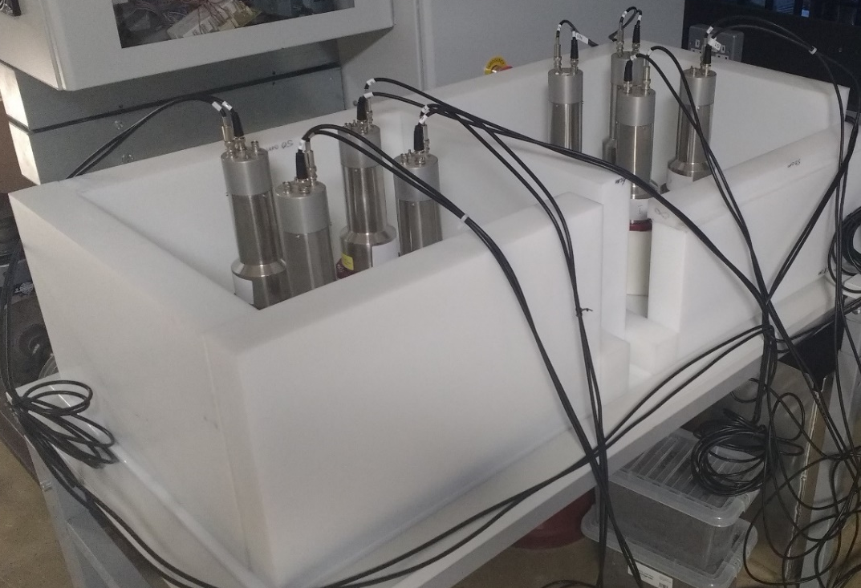
Figure 7 The parallel neutron detector arrays are pictured. Arrays are separated and surrounded by high-density polyethylene (HDPE). The arrays consist of four EJ-309 liquid scintillators with photo multiplier tubes and connected to two mixed field analysers that are not pictured. Detectors are set equidistant from a central point at which the samples are placed.
The separate arrays were analysed to check for differences in neutron measurements between each array under the same conditions. The comparisons between the two showed a significantly lower mean neutron count from the sample array than the background array, with values of 1024±65 and 1433±63 respectively derived from the data presented in Figure 8.

Figure 8 Background neutron measurements from the parallel detector arrays over 4-hour periods. There is an inconsistency between the array responses and the neutron background, though the measurements within the same arrays are consistent with one another. It should be noted that the measurements have had three omissions (3, 4, and 8) due to clear outliers thought to be due to electrical interference in the MFAs, creating an increase in neutron counts by two orders of magnitude, which if included, would have dwarfed the rest of the measurements.
Figure 9 shows a comparison of the detector response measured relative to each MFA, the detectors were alternated between the two MFAs (model numbers 4311 and 4314) to identify whether the neutron count differences were caused by the detectors or the MFAs primarily. The equipment was calibrated before each measurement and after every change in detector, and the response was measured as in the previous sections. When switching detectors between MFAs, the detectors remained in the same geometries and positions, but the cables were switched between the MFA units to identify the source of the neutron responses.

Figure 9 Background neutron counts measured over 24 hours, compared between detector and mixed field analysers (MFAs). The MFAs and detectors are differentiated by code, shown in the bottom right of the figure. MFA 4314 is shown in spotted red bars, while MFA 4311 is shown in the horizontal striped bars. On average, the neutron counts are higher in measurements with MFA 4311.
As shown in Figure 9, alternating the detectors against MFAs shows a general trend that MFA 4311 elicits a larger neutron count than MFA 4314 under the same conditions, with averages of 1097000 (±3000) and 960000 (±3000) neutrons detected respectively.
It is worth noting that the detection equipment was in relative proximity to the heating system for the room. While the building is set to be at a constant temperature throughout the day so the heating system does not change the local temperature enough to cause a spike in detector activity, this is a possibility in the case of a heating malfunction so has been noted in this section.
With the parallel array results in mind, a single, 16-detector array with four MFAs was proposed to increase detector efficiency in the neutron measurements. The parallel array method, while theoretically ideal, proved to harbour too many confounding variables for consistent comparisons to be carried out unless a normalisation was applied. The measurements could be confounded due to the inherent differences found between detectors from manufacture, such as slight changes in amount of scintillant liquid and differences in PMT performance [51]. Nonetheless, results of the comparison of neutrons against MFA unit suggest that the differences in response could also be due to the MFA units themselves after considering the building’s constant temperature and the lack of reported malfunction of said heating system. It is plausible to conclude that the immediate vicinity of the detectors (i.e. other machinery/heating) is not the cause of the neutron count difference as the array responses change significantly when the MFA unit changes. Therefore, it seems that the difference in detected neutrons comes from intrinsic differences within the machinery, combined with a low detector efficiency, due to the limited number of detectors used to measure each sample set.
The larger, single array of detectors offered the potential to normalise these confounding variables across measurements if consistent counts could be achieved. Further, the larger array would increase coverage of the samples, therefore reducing the loss of emitted neutrons and increasing absolute detection efficiency. The hypothetical benefit of such an array is that an increase in detection efficiency might allow greater differentiation between the total neutron emissions from each sample. Following the confirmation of consistent detector responses over multiple measurement iterations, it was planned that the single, large array of detectors would be used to compare multiple samples over different measurements, when also compared to background neutron measurement. Whilst this measurement method would not compare the background neutron level at the time of sample measurement, an average background value would yield a sufficient subtraction from each sample neutron count to provide comparisons across a sample set.

2.2.3 16-Detector array Neutron Measurement
The 16-detector neutron array measurement is a single array, made up of 16 Scionix EJ-309 liquid scintillators with PMTs configured into a 4x4x4x4 array surrounding the samples. The array is pictured in Figure 10 below and shown diagrammatically in Figure 11. Samples were placed centrally within the array, set upon a stack to try to ensure consistent measurements between the upper and lower detector layers.
The detectors are connected to four Hybrid Instruments Mixed Field Analysers (MFAs), which are connected via TTL port to a 16-channel circuit counter and processed via Field-Programmable Gate Array (FPGA) before file dump to a laptop computer running “PuTTY”, the data-processing freeware.
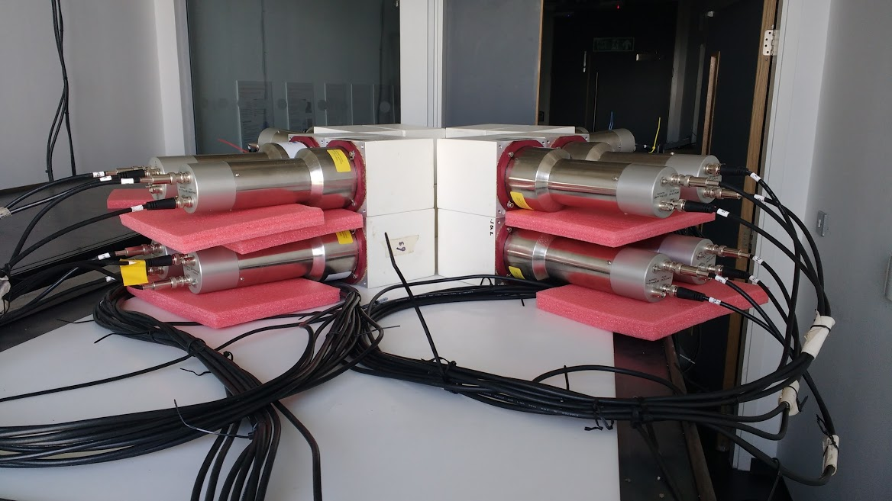
Figure 10 The final neutron array used within the project. The array consists of 16 Scionix EJ309 detectors with photo multiplier tubes, attached to four Hybrid Instruments mixed field analysers (MFAs) which are linked to laptop via Field Programmable Gate Array (FPGA) and pulse counting circuit. The detectors are aligned around a central point at which the samples are placed.
Figure 11 Diagram of the 16-detector neutron array with accompanying key. The cables, laptop, and signal counting circuit/FPGA are not included in the diagram. Approximate dimensions are shown in the diagram for the constituent parts of the array.
Passive, single fast neutron emissions were measured from 14 soil samples over four sets of four-hour measurements. Throughout the sample measurements, the neutron background was periodically measured to compare to, and ultimately providing a value for background subtraction. The average background was subtracted to account for the intrinsic variability in intensity of the background neutron radiation which is heavily influenced by weather and atmospheric pressure.
The 16-detector array was recalibrated based on the same protocol as the other neutron measurement arrays, however, whenever the detectors were disturbed, only those disturbed were recalibrated due to the added geometry complications.
Measurements taken from the 16-detector array were adjusted after identifying anomalous counts. The anomalies can be seen in Figure 12 below.

43
Figure 12 The total neutron count average over four, 4-hour periods per detector as a function of sample for a total of 16 different detectors within an array. Background measurements are shown as red bars, while each of the sample measurements are subsequent green-shaded bars. The figure clearly shows detector 12’s measurement of the ambient background as an outlier to the rest of the measurements, and hence it was omitted from further analysis. Overall the figure shows little variation in detector response, apart from detector 15.

Overall, the counts per detector in Figure 12 show consistency with one another (with slightly lower responses in detectors 7 and 9), providing confidence in the stability of the neutron counting apparatus. However, the variation in the neutron counts between some detectors is likely due to the combination of two different factors. Firstly, the neutron counts will be affected by unavoidable variation in the detector responses, caused by differences in orientation and in the liquid scintillant material. Secondly, the counts will be affected by the heterogeneity of the samples, which means that not all of the 16 detectors will be subjected to the same neutron flux of sample origin as one another. This is not unexpected, as soil is inherently heterogenous, and so it would be highly unlikely for the samples to exhibit homogenous characteristics. Grinding of the soil samples could provide an increase in homogeneity, but if the neutron detection method was to be adopted for industrial use, it would be much more time efficient for the samples to only be processed to the extent of complete drying. Further, if grinding large samples, specialist equipment would be essential but would not necessarily guarantee an increase in homogeneity of radionuclides within the soil. For this reason, it was considered most appropriate for the measurement methods to minimise sample preparation, therefore optimising the methodology for industrial conditions. This heterogeneity in the sample matrix is also accounted for when analysing the data to give the gross neutron counts per array for each sample per unit time, as well as the average neutron count per detector per unit time. However, we would not expect any variation of the order of what is seen to be due to heterogeneity.
The errors for each detector measurement were calculated by square-rooting each value as the detector measurements are Poisson distributed [52], which were then propagated with the formula:
$Error=\sqrt{a^{2}+b^{2}+c^{2}+...}$ Equation (1)
a, b, and c denote the error values of each repeat count value.
The background measurement of detector 12 (as seen in Figure 12 as a red line) was removed from the dataset following its identification as an anomaly. As it was a background measurement there is no chance of the orientation of the sample presenting a more active particle to detector 12 like there is in sample DSRL9 as shown in the figure for the same detector. This anomaly removal reduces the average count for the ambient background to 1019±8 and drops the mean neutron counts across all detectors to 1040±30. The error for background neutrons reduces from 16 to 8, but still shows no significant difference to average neutron counts when the anomaly is excluded.
The background was calculated by carrying out multiple neutron measurements in the array with no sample present, over various periods of differing weather conditions. Differing weather conditions can correspond to a difference in the atmospheric pressure, which is known to have a significant effect on the amount of cosmic neutron counts in background [53][54]. The mean of these measurements was used as the background subtraction value. Due to the multiple different background measurements it is possible that an example of high neutron background has been calculated, which could be contrary to the background conditions measured during a sample run, though this would likely be dampened by the average of many different measurements and so is not a likely to be a confounding variable.
Consideration of the array geometry is also important for this campaign of measurements. As the array only covered the horizontal plane of neutron emission, neutrons would not be detected if emitted along the vertical plane from the origin of the sample. For this reason, a correction for the sample coverage surface area was applied to the neutron count number, of 1.5, to account for the incomplete sample coverage, assuming two-thirds sample coverage at time of measurement. This correction was only applied to the summed ‘counts per array’ measurements, including the background.

2.3 Gamma-ray Spectrometry
The gamma-ray spectrometry measurements were carried out at the Culham Centre for Fusion Energy (CCFE) utilising their high-purity Broad Energy Germanium (BEGe) [55] gamma detector; an ultra-high efficiency detector in an ultra-low background housing of lead as shown in Figure 13.
The BEGe is a type of HPGe detector, with a germanium crystal that measures 91 mm in diameter and 31 mm in depth, designed to have exceptional energy resolution across a broad energy range (3 keV to 3 MeV). The detector is cooled by a liquid nitrogen coolant, the container can be seen in Figure 13. The data was processing and efficiency calibration was carried out in the Canberra LabSOCS software [56].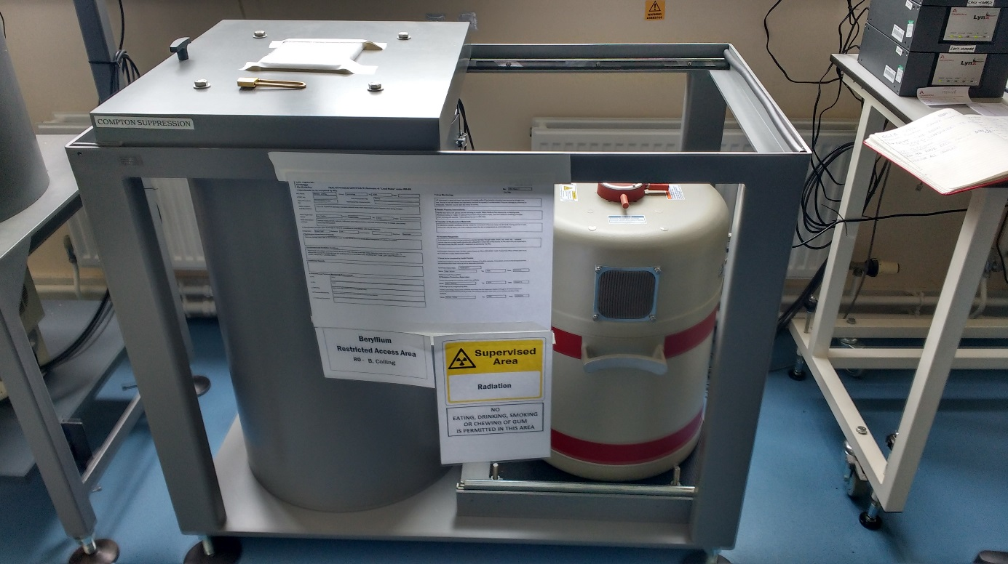
Figure 13 The Broad Energy Germanium detector used in this research at CCFE, and part of the ADRIANA toolkit which is part of the National Nuclear User Facility (NNUF.ac.uk). The lead housing is the container in the left of the image and hosts the germanium crystal, with the liquid nitrogen coolant in the dewar container to the right.
The BEGe detector was chosen over the SAGe (Small Anode Germanium) detector [57] - another high-purity germanium detector at CCFE – due to its high resolution at low energies of the gamma spectrum. Throughout the gamma spectrum, the BEGe has a slightly higher resolution than SAGe. It was thought that the greater resolution would provide more accurate measurements of plutonium gamma-ray emissions, including the americium-241 gamma line, allowing differentiation of peaks. The Mirion technologies SAGe detector application note [57] informed this decision.
The BEGe detector is calibrated in-house at CCFE with a mixed point source every fortnight. Details of this source are found in the appendices.
Sub-samples of each sample within the project were decanted into 100 ml containers, and during measurement were placed directly on the germanium crystal.
Each measurement in the BEGe detector was carried out over 24 hours, and the gamma emission spectrum of sub-samples of each soil sample was recorded. The sub-sample pot of each sample was filled to the same dimensions of 5 cm for consistency in the system, with similar soil compositions taken from each sample (for example, any clumped soil or vegetation was avoided), to maintain consistent density range. For each measurement, a geometry model of the 100 ml soil containers was loaded from a pre-set file on the ADRIANA lab database into the LabSOCS geometry composer, the density of soil was modified within the model to correspond with the mass of each sub-sample. Once the geometry was validated, an efficiency table was generated to calculate the absolute efficiency for a spread of arbitrary energies using a pre-made LabSOCS model of the BEGe detector and the soil container geometry specified earlier to calculate the intrinsic and geometric efficiencies respectively. Following this, an absolute efficiency calibration was carried out within the LabSOCS software so that each gamma-ray emission within each spectrum is validated.
Following efficiency calibration, a basic spectrum analysis was carried out within the Genie 2000 software, where the efficiency calibration file is supplied, and a nuclide library file is chosen to determine the presence of peaks within said nuclide library. The staff at CCFE suggested the chosen nuclide library as it is the standard nuclide library used by the radiometric analysis team at CCFE for analysis of radionuclide-contaminated materials and includes all plutonium isotopes and all of their common daughter products such as americium, thorium and uranium. The Curie MDA report mode was added to this, to state the minimum detectable activity of nuclides with peaks present in the spectra. The MDA reports validated the presence of ²⁴¹Am in some of the samples, and the complete lack of plutonium.
Geometry efficiency was calculated within the Genie software, with the efficiencies from energies 10 to 2000 published. At 60 keV where the ²⁴¹Am peak is observed, the efficiency calculated was 8.53x10⁻² (±8.53x10⁻³).
Spectra files were analysed in Lancaster in the Canberra software, ProSpect [58]. Here peaks were identified and compared to the literature gamma emission peaks, giving likely emitters for each peak. The peak counts were recorded to identify estimates for the abundance of nuclides within each sample.
Due to the close relationship between ²⁴¹Am and ²⁴¹Pu, with approximately 99.7% of ²⁴¹Pu decaying to ²⁴¹Am [20], it was possible to quantify the amount of ²⁴¹Pu currently in each sample using the estimated amounts of ²⁴¹Am via the 59.5 keV ²⁴¹Am photopeak and literature values of the decay rates and half-lives of both americium and ²⁴¹Pu isotopes. This is possible with use of the Bateman equation [59], which describes abundances and activities of radionuclides in a decay chain as a function of time, based on the decay rates and initial abundances of the isotopes within a given material [60].
The time component of the equation of approximately 35 years was provided by contacts at DSRL as an estimate for when ²⁴¹Pu may have been deposited - at the latest - on site (35 years prior to current date i.e. 1983). These assumptions are likely to over-estimate the quantity responsible, but when working with radioactive nuclides of unknown concentrations (like ²⁴¹Pu) in a decommissioning scenario, the precautionary principle [61] applies in the absence of better data rather than underestimate the radioactive presence within the soil on site.
The following is a step-by-step explanation of the analysis of the spectra gained from CCFE:
Sampling: To begin, a separate 100 ml pot was filled for each sample to a consistent and specific height (required for efficiency analysis) and weighed. The sample pots were placed in the BEGe detector for 24 hours to record the spectra of gamma-ray emissions from each sample.
Peak Identification: The spectra measured from each sample were analysed for emission peaks from any known gamma-ray emitters in the plutonium decay chain. Overall and unsurprisingly, the peaks observed were generally caused by daughter products of naturally-occurring uranium (lead, thorium etc.). Among some spectra however, an ²⁴¹Am peak was identified due to its characteristic 59.5 keV emission.
Americium-241: ²⁴¹Am is a decay product of ²⁴¹Pu, which is an activation product of the nuclear fuel process. The energy range surrounding the 59.5 keV peak (59-60 keV) was identified and the number of counts was collated in this range for each sample.
²⁴¹Am was chosen as the main focus in the spectra as it is the closest, visible, uncontaminated radionuclide to the plutonium decay series, and with literature values estimates for the overall number of plutonium atoms in each sample can be calculated to then get an estimate for the number of neutrons each sample was likely to emit. This neutron estimate allows corroboration of the neutron counts from the organic scintillator detector arrays.
Background Subtraction: When counts for ²⁴¹Am emission were measured for each sample, estimates were calculated for the background counts in each peak to subtract from the count number measured in the peak overall. This was an efficient way to assume the removal of background counts from the calculations.
Decay Rate: Next, the total number of ²⁴¹Am atoms that decayed over the 24 hours was determined using values from the ²⁴¹Am decay scheme [62]. This value was then converted to decays per second (Bq) and then Bq/g.
No. of Americium-241 Atoms per Sample: From the decay rate it is possible to calculate an estimate for the current number of ²⁴¹Am atoms per sample by dividing the decay rate by the ²⁴¹Am decay constant, which is derived from the rate of decay equation.
No. Plutonium-241 Atoms Originally: The current number of ²⁴¹Am atoms per sample can be used to calculate an estimate for the number of ²⁴¹Pu atoms originally in each sample. This is done using the Bateman equation [59]:
N₂(t) = N₀ ($\frac{λ_{1}}{λ_{2}-λ_{1}}$)($e^{-λ_{2}t}-e^{-λ_{1}t}$) Equation (2)
Where: N₂ = Number of americium-241 atoms
N₀ = Number of plutonium-241 atoms
λ₁ = Plutonium-241 decay constant
λ₂ = Americium-241 decay constant
t = Time (s)
Original Plutonium-241 Activity: From the original atoms of ²⁴¹Pu it is possible to quantify the mass of ²⁴¹Pu per gram and activity (Bq/g) per gram sample. This was done to try to identify the potential source of the ²⁴¹Pu later down the line. Knowing the level of activity of the ²⁴¹Pu can allow links to be made to known data of nuclear fuel burn-up at different times, and ranges of enrichment levels, at Dounreay.
Current Plutonium-241 Atoms and Activity: The estimated current number of ²⁴¹Pu atoms in the samples was calculated from the original estimated atoms of the isotope, then the activity per gram of samples and the mass of ²⁴¹Pu per gram of sample was calculated using the same methods as was used in the ²⁴¹Am calculations.

2.4 Accelerator Mass Spectrometry
2.4.1 Sample Preparation
Prior to any accelerator mass spectrometry measurements, the soil samples were ground with a pestle and mortar to maximise the surface area of the samples, increasing the potential for release of actinides from the soil matrix. Sub-samples of 5 g mass were transferred to Teflon beakers and spiked with 100 µl of ²³³U and 200 µl of ²⁴²Pu tracer solutions of known concentrations.
Leaching
1 ml of distilled water was added to moisten the soil samples before addition of 5 ml of HNO₃ and 1 ml of H₂O₂. The samples were placed on a hot plate at 50ºC and swilled periodically. This process was repeated 3-5 times until reactions ceased to take place. The samples were then centrifuged, and the supernatant was filtered via syringe back into a clean Teflon beaker. 5 ml of 8M HNO₃ was added to the centrifuge tube still containing the pellet and the step was repeated following cleaning of the syringe. Following the filtering of particulate, the samples were evaporated overnight to dryness at 110ºC. 10 ml of 8M HNO₃ was added to the evaporated beakers, followed by 0.2 ml of 3M NaNO₂ for valence adjustment of the actinides. The valence adjustment ensures that the actinides bind within the resin upon contact, rather than pass through. The solution was transferred to centrifuge tubes, and the beakers rinsed and transferred again to ensure complete transference of sample.
Sample Concentration and Conditioning
Once transferred to centrifuge tubes, 0.5 ml of Fe³⁺ (50 mg/ml) was added to the solution, followed by concentrated NH₄OH until an iron precipitate formed. Once the precipitate had formed, the solution was centrifuged, and the supernatant was carefully discarded (so as not to lose any precipitate). This was set aside until extraction columns had been preconditioned. Extraction columns for extraction chromatography are constructed with commercially available TEVA and UTEVA resins formulated to capture plutonium and uranium following preconditioning.
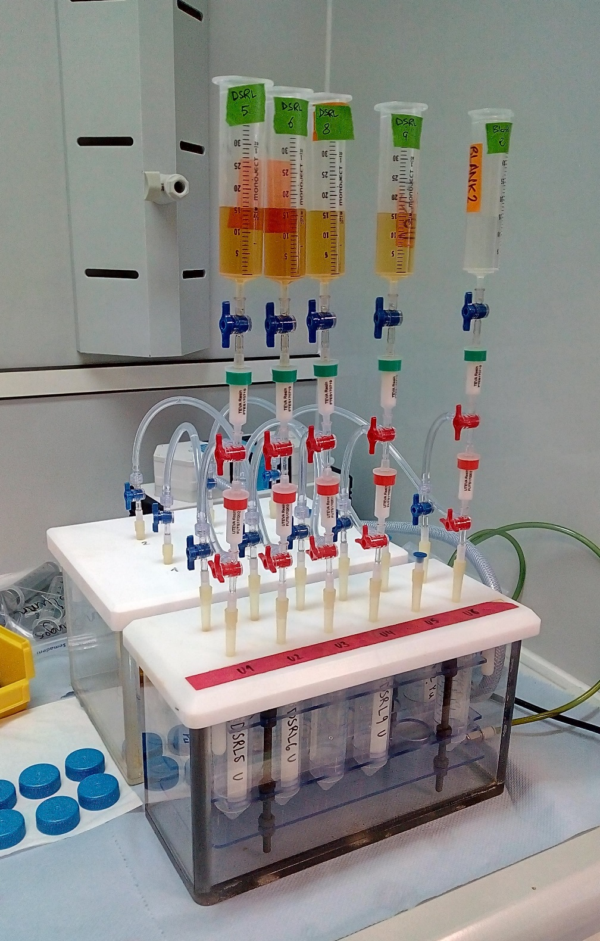
Figure 14 A picture taken of the column chromatography method in use at ETH Zϋrich for the AMS measurement preparation. Following dissolution, the samples were placed in the syringes in the image before being pulled via vacuum through the ion exchange resins and into the waste or sample containers as appropriate.
The columns are constructed with three-way valves leading to waste and sample pots, with the third option preventing flow through the columns. Solutions are drawn through the columns by vacuum, produced by a pump. The columns are preconditioned with HNO₃ before addition of the sample, to both activate the TEVA and UTEVA resins, and clear the columns of any contaminants. Following column conditioning, 15 ml of 8M HNO₃ was added to the centrifuge tubes to re-dissolve the iron precipitates and the contents were poured into the column syringes. This was repeated 3 times with 5 ml of 8M HNO₃ to ensure samples had been fully washed through the columns. Following column chromatography, the solutions were evaporated periodically from crucibles onto a hot plate at 80ºC until only dry particulate remained. The crucibles were placed in an oven and thermally activated at 700ºC overnight. The crucibles were left to cool, then individually, niobium was added to each one and mixed into the samples, before pouring into the target press. The samples are then pressed into titanium targets, sealed by compressed ball-bearings before being placed sequentially in the detector wheel for AMS analysis. A diagram of the accelerator mass spectrometer apparatus is shown in Figure 15 below.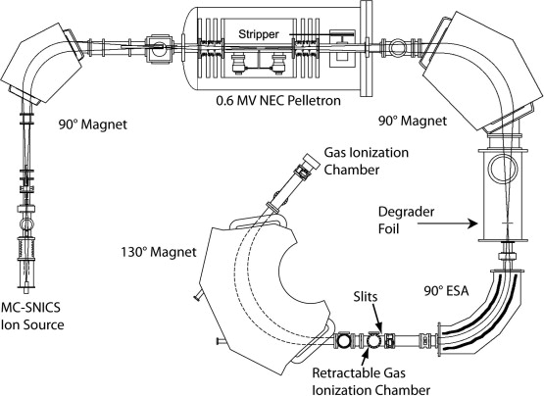
Figure 15 A diagrammatical representation of the TANDY AMS at ETH Zϋrich. The samples are processed clockwise around the system, with the titanium targets placed into the system after the MC-SNICS Ion Source [63].
Due to suspected errors in the ²³⁶U measurements, they are included in this section in Figure 16. The measurements have a high uncertainty, and display abundances much higher than that described in literature examples that would be expected to be an example of high global ²³⁶U levels from Bikini Atoll [44].

Figure 16 Abundances of ²³⁶U as measured with the AMS system at ETH Zϋrich. Further details are described in the Experimental Methods section. Solid black bars represent samples collected on-site at Dounreay, red striped bars represent samples collected off-site from the Dounreay locality, while the blue dotted bars represent samples collected by the author in English sites as named.
In Figure 16’s display of the ²³⁶U estimates, Malham shows a marked difference. In this measurement, Malham has negligible amounts of ²³⁶U while all other samples are in the range of 40,000 to 160,000 fg/g of sample, around a factor of a thousand higher than the measurement in Chamizo et al.’s study which was 88±1 fg/g. The measurements are discussed in Section 4, with the potential measurement issues specified.
Chapter 3
3. Results

This chapter presents the results of the experiments described in the Experimental Methods chapter. It is split into 4 sections.
Measurements were carried out to investigate the possibility of the assessment of trace quantities of plutonium in UK soils. The measurements included neutron counting, gamma-ray spectrometry, and accelerator mass spectrometry.
Section 3.1 covers the dual array measurements of the sample neutrons compared against the ambient background neutrons, then a comparison of the detectors and MFAs is presented, identifying any systematic differences of measurements due to issues with the equipment. Section 3.2 describes the results obtained from the neutron measurements made with the 16-detector array. Gamma-ray spectrometry results are presented in section 3.3. The peaks of interest are displayed and analysed to obtain estimates of absolute mass values of actinides to compare the samples with earlier datasets. Finally, section 3.4 presents the results achieved from AMS measurements of each sample carried out at ETH Zϋrich for comparison with the radiation measurement results.
Neutron-based measurements are presented here in two different iterations that reflect the development of the array configurations throughout this research. These developments enabled an increase in system detection efficiency, moving from two 4-detector arrays to a single 16-detector array, as well as some developments in the associated electronic counting equipment. The 16-detector array was used to measure project soil samples as collected from their sampling sites, and also a single sample spiked with a known amount of ²⁴⁰Pu for comparison.
Gamma-ray measurements were carried out for every soil sample and led to further analyses, post-measurement, combining experimental results and values from the literature to make further estimates, such as ²⁴¹Pu abundance, within the samples.
AMS results from a single campaign of measurements at ETH Zϋrich of all but two samples have been used to estimate ²³⁹Pu, ²⁴⁰Pu, ²⁴²Pu, and ²³⁶U abundances and the 244-mass isobar in the samples to compare with the other measurements.
3.1. Neutron Results
3.1.1. Parallel Neutron Array
Presented here are the results of measurements made to compare the difference in net neutrons detected in parallel arrays, measuring both background and samples. Parallel arrays consist of two independent neutron detector arrays identical in components and orientation. One array contains the sample to be measured while the other measures the neutron background. Both measurements are carried out over the same time period, so the background neutron counts can be subtracted from the sample neutron counts, theoretically presenting the neutron counts generated from the sample only.
These results are followed by a comparison of the intrinsic differences between the two different MFA and detector set-ups by exchanging the detectors between MFA units. Neutron counts of the background, measured by eight detectors and two MFAs are compared. The two measurements are carried out with the same equipment, but detectors were split into two groups of four and detectors were not exchanged throughout the measurements. The experimental methods for these measurements are described in section 3.4 of the Experimental Methods chapter.
These experiments began by measuring the sample and background neutrons in separate arrays over four-hour periods. This measurement period was chosen as it allowed multiple measurements daily whilst maintaining significant measurements. Hourly measurements were taken early into the project but the counts were consistently too low. The measurements were averaged and then the neutron contribution detected in the background array was subtracted from the neutron measurement made by the sample array. The measurements were carried out on samples DSRL7, 8, 9, and 10, and the results are shown in Figure 17 and Figure 18, for the mean and subtracted cases, respectively.
Figure 17 The neutron counts averaged over five, 4-hour measurements of both sample and background detector arrays. Sample array measurements are shown in black, while background measurements are shown in horizontal striped red. All samples but DSRL9 are within error of their ambient background neutron counts but there is a trend toward over response of the background assay relative to the sample.
Figure 18 Neutron counts compared across samples following ambient background subtraction from the sample counts. All samples are consistent with zero counts. The figure shows the Figure 17 values following background subtraction.

3.1.2 16-Detector Neutron Array Measurements
Presented here are the results from the measurement of neutrons emitted from most samples studied in the project, using the 16-detector array. The experimental methods for these measurements are described in section 2.2.3 of the Experimental Methods chapter. The neutron measurements of all samples are illustrated, averaged over four, 4-hour counting periods. The average neutron count per detector for each sample is presented, followed by the summed neutron count measured in the entire array per sample. The results in Figure 19 and Figure 20 are normalised to the mass of sample and have the background subtracted. Without subtracting background counts, the measurements may fail to identify any disproportionate neutron counts amongst a campaign of measurements that includes samples of inconsistent mass. Figure 19 and Figure 20 below illustrate this difference following efficiency corrections, normalisation to mass and background subtraction.

Figure 19 The background-subtracted neutron counts per four hours per detector measured per kilogram of sample in the 16-detector array. A mass correction to one kilogram was applied to the sample data, along with efficiency corrections and a notional detection efficiency of 1% to account for neutrons missed by the detectors to better reflect sample emission. On-site Dounreay samples are displayed as solid black bars, off-site Dounreay is depicted as a diagonal red striped bar, and other off-site samples are depicted as spotted blue bars.

Figure 20 This figure illustrates the differences between the sample and background counts. The neutron counts per four hours per detector array following subtraction of the average background, per kilogram of sample. A mass correction to one kilogram was applied to the sample data, along with efficiency corrections, accounting for two thirds coverage of the samples by the detectors and a notional detection efficiency of 1% to account for neutrons missed by the detectors to better reflect sample emission. On-site Dounreay samples are depicted by solid black bars, off-site Dounreay is displayed as diagonal red striped bars, and other off-site samples are depicted as spotted blue bars.

Calculating the background subtracted neutron counts shown in Figure 19 and Figure 20 is insightful as it gives direct estimates for the number of neutrons emitted from each sample.
In summary, there is some variation in neutron emission between the samples.
However the sample data show little variation from the mean neutron emissions and most samples are consistent with zero neutron counts following background subtraction.
When considering average counts per detector from Figure 19, DSRL4, 5, 9, 10 and DSRLB1 are significantly higher than zero counts following an average background subtraction, whereas all other samples are consistent with or lower than zero. Further, the summed counts per array share a similar trend, with only DSRL9 and 10 demonstrating counts significantly higher than zero after subtracting the background counts.
These figures will be explored in more detail in the discussion in Chapter 4 and compared to results gained from the other measurement methods, which are described in the next section.
3.1.3 Spiked Soil Sample Comparison
After identifying the minimal radioactivity of the previous samples, the need for a comparison sample became apparent. For this, DSRL provided a spike of ²⁴⁰Pu for the DSRLB2 sample which was split into two smaller samples. One sample remained unchanged, while one had a 45ng spike of ²⁴⁰Pu standard solution added, equivalent to 375.5 Bq for the entire sample, and by extension just over 1 Bq/g activity. The samples were measured following the same method as previous neutron measurements over six, four-hour increments which led to 24 hours total detection time. The 6 cumulative measurements allowed visualisation of the higher rate of neutron detection for the spiked sample than the unchanged sample. The results are given below, in Figure 21.
Figure 21 A graph to illustrate the difference in neutrons detected over time, in four-hour increments between a spiked and non-spiked soil sample. The blue points represent the spiked sample neutron counts, while the orange data show the sample without the spike. Each measurement was significantly different to one another, though the error bars are smaller than the data points at 1ơ. The count numbers were normalised per kilogram of soil.
As can be seen from Figure 21, there is a clear increased rate of neutron detection over the entire 24-hour period for the spiked sample. Each spiked measurement is significantly higher in neutron count than the unchanged sample, showing a clear difference in neutrons detected between the two.

3.2 Gamma Spectra Results
The following results were gained from High Purity Germanium detection of the project samples at CCFE, as described in the Experimental Methods chapter.
Example spectra from the measurements are displayed in Figure 22 to Figure 24, highlighting areas and peaks of interest in DSRL1 and DSRL2. The results following spectral analysis are also displayed, including transformation of the counts to absolute mass concentrations, and use of the Bateman equation to estimate the mass per gram of ²⁴¹Pu using estimates of the mass of ²⁴¹Am derived from these data.
The gamma spectra show clear evidence of ²⁴¹Am in most samples, evidenced by the 59.5 keV peak. Those samples where there was no clear isotope peak were processed in the same way, and so it must be remembered when considering the results, as while there was no discernible peak in some spectra, there may still be high counts in the same energy range due to higher background emissions within the sample.

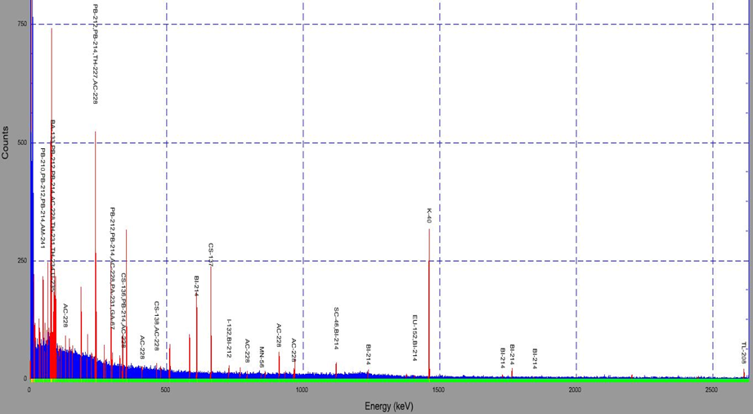
Counts
Energy (keV)
69
Figure 22 An example spectrum for DSRL1. The spectrum demonstrates the largest peaks are mainly due to the uranium decay chain isotopes of elements such as bismuth and lead, along with caesium-137 and potassium-40. The spectra shown is corrected for efficiency within LabSOCS.

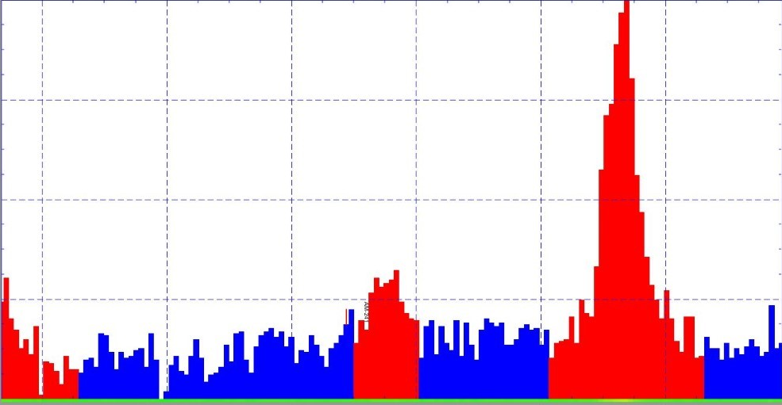
Energy (keV)
Counts
64
62
60
56
58
43
97
204
252
150
²⁴¹Am
²³⁴Th
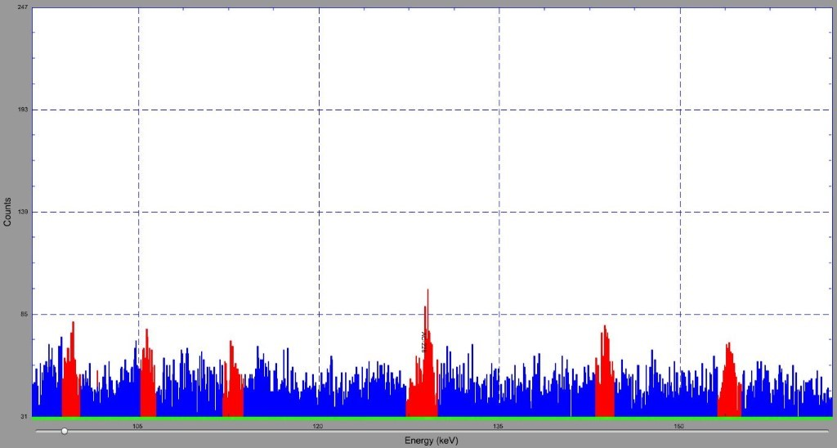
135
150
120
105
21
85
139
193
247
Energy (keV)
²³⁰Th
²²³Ra
²²⁸Ac
Unclear
Unclear
Unclear
Counts
Figure 23 Highlighted peaks of interest taken from DSRL1 spectrum of a 24-hour count. The top image shows the 60 keV ²⁴¹Am peak in the centre, a small peak but significant enough to identify. The bottom image highlights the 129 keV peak, corresponding to ²²⁸Ac of the thorium decay series and ²³⁹Pu. Both images show ‘Energy’ (keV) along the x-axis, with ‘Counts’ along the y-axis.
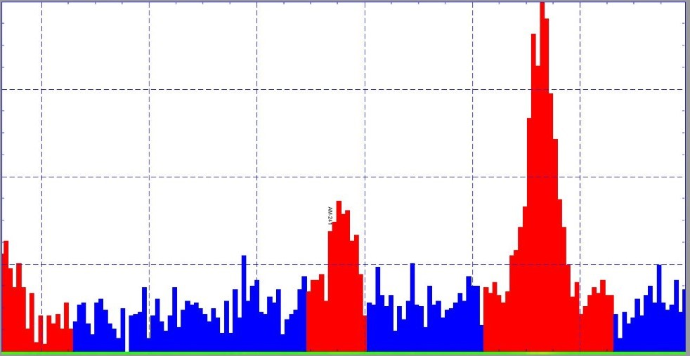
Counts
62
64
60
56
58
247
54
226
180
132
87
40
Energy (keV)
²⁴¹Am
²³⁴Th
120
193
139
Counts
85
31
150
135
Energy (keV)
105
²³⁰Th
Unclear
Unclear
Unclear
²²³Ra
²²⁸Ac
Figure 24 Highlighted peaks of interest taken from DSRL2 spectrum of a 24-hour count. The top image displays the 60 keV ²⁴¹Am peak in the centre of the image, showing significant counts. The bottom image highlights the 129 keV peak – again in the centre of the image, which corresponds to a combination of ²³⁹Pu and ²²⁸Ac, the latter of the thorium decay series. Both images show ‘Energy’ (keV) along the x-axis, with ‘Counts’ along the y-axis.

Ambient gamma activity, (measured without a sample in the detector well) was also measured to identify any gamma emissions not related to the samples, from for example, the detector materials and atmospheric radiation. The channel range at which the peaks of interest occurred were identified and the number of counts within these ranges were measured to subtract from the peaks identified within each sample.
Following time corrections and subtraction of the ambient spectrum from each sample spectrum, DSRL10 exhibited the highest counts in the 60 keV ²⁴¹Am peak at 1310±36, and DSRL7 the lowest at 101±10 gamma-rays detected (rounded to nearest integer).
As seen in the example in Figure 22 there are relatively high counts associated with ⁴⁰K, at 1460.6 keV which is common in soils, and ¹³⁷Cs which is expected within any soil sample due to fallout and deposition of radioactivity from reactor accidents, most likely originating from events such as the Chernobyl nuclear disaster.
There is also a significant amount of background radiation in the spectra. It is important to note this background is intrinsic to the soil matrix; as the ambient environmental gamma radiation is minimised by the lead shield that surrounds the germanium crystal of the detector. The ambient background counts amount to a maximum of around 20 counts in each channel at lower energy ranges up to around 500 keV emissions, and continue to reduce as the emission energies increase above 500 keV (not including the 511 keV annihilation peak.
Analysis of the two peak counts across all samples gives estimates of the mass concentrations for ²⁴¹Am, following background subtraction. These mass concentrations are compared in Figure 25 below.
Figure 25 ²⁴¹Am abundance (fg/g) calculated from the counts measured in the ²⁴¹Am 59.5 keV peak in the gamma-ray spectra measured using the BEGe detector at CCFE, as described in the Experimental Methods section. Black bars represent samples collected on-site at Dounreay, red bars represent samples collected off-site from the Dounreay locality, while the blue bars represent samples collected by the author in English sites as named. Averages are provided for each of the three sample sets.
The estimates for ²⁴¹Pu content in the soil are shown below in Figure 26, calculated as described in Section 2.3 of the Experimental Methods chapter.
Figure 26 ²⁴¹Pu abundance (fg/g) calculated from ²⁴¹Am abundances, ²⁴¹Pu half-life, rate of decay, and Bateman equation utilising a ‘t’ value of 35 years. As a result, the abundances are directly proportional to those of ²⁴¹Am. Black bars represent samples collected on-site at Dounreay, red bars represent samples collected off-site from the Dounreay locality, while the blue bars represent samples collected by the author at English sites as named.
The quantities in Figure 26 are proportional to those given in the ²⁴¹Am plot (Figure 25) but estimate values of ²⁴¹Pu are useful when trying to understand the origin of nuclear material found in the samples, even at low concentrations.
In summary, gamma detection with the BEGe system at CCFE has allowed identification of measurable amounts of ²⁴¹Am within most samples, at approximately fg/g levels, and estimates of the mass concentrations of ²⁴¹Pu using americium amounts and methods described in the literature [59][60], again specifying an approximate time since deposition (‘t’ value) of 35 years.
These amounts are compared in the discussion combined with both neutron counts presented previously, and AMS measurements which are presented in the next section of this chapter.
3.3 Accelerator Mass Spectrometry Measurements
Following the HPGe detection, the need for a complementary assessment of the plutonium isotopes in the soil was identified. The literature shows that accelerator mass spectrometric methods are amongst the most sensitive methods for quantifying picogram-and-below levels of radionuclides [64][65][26]. Accelerator Mass Spectrometry (AMS) is described in the Experimental Methods in section 3.8. The AMS measurements were carried out at ETH Zϋrich.
The results of the AMS measurements are presented in Figure 27 to Figure 29 as mass concentrations per gram of sample of ²³⁹Pu, ²⁴⁰Pu, ²⁴²Pu and ²³⁶U. As the ratio of plutonium-²⁴⁰Pu/²³⁹Pu is also an established marker for plutonium contamination, it is presented and compared to the global average value in Figure 30, including the average value calculated for the samples of the project.
Figure 27 displays a general consistency of ²³⁹Pu values across the samples, with the clearest differences from the average being significant in the samples DSRL3, DSRL8, and Malham and Biggin. DSRL3 demonstrates roughly double the average amount of ²³⁹Pu within every sample at 1001±30 fg/g, while DSRL8 shows roughly half at 289±9 fg/g. Interestingly, Malham and Biggin demonstrate much lower amounts of ²³⁹Pu than the rest of the samples at 341±10 fg/g and 428±13 fg/g respectively, but not to the same extent as DSRL8. There is a large range in the ²³⁹Pu mass across all samples, with the highest variation being within the DSRL samples. The average ²³⁹Pu mass concentration across all samples is 544±60 fg/g.
The ²⁴²Pu values shown in Figure 28 show a much lower range of values, but with the same samples showing maximum and minimum measurements as in Figure 27, to a high degree of significance, with DSRL3 at 4.1±0.2 fg/g and DSRL8 at 1.1±0.1 fg/g.
The same general trend continues in Figure 29 for the ²⁴⁰Pu concentrations, with the main point of note being the difference in Malham’s ranking in the figure. Malham contains ²⁴⁰Pu comparable to the average of all samples presented, while its ²³⁹Pu content is one of the lowest, though still consistent with the overall sample set average at 3-sigma.
Figure 30 compares all samples to the global average ²⁴⁰Pu /²³⁹Pu ratio of 0.176±0.014 [66] with the averages for each sample type in the figure legend.
Far-From-Site Avg: 384±16 fg/g
On-Site Avg: 571±52 fg/g
Off-Site: 620±18 fg/g
Figure 27 Abundances of ²³⁹Pu as measured with the AMS system at ETH Zϋrich. Further details are described in the Experimental Methods section. Solid black bars represent samples collected on-site at Dounreay, red striped bars represent samples collected off-site from the Dounreay locality, while the blue dotted bars represent samples collected by the author in English sites as named.
Off-Site: 2.1±0.3 fg/g
Far-From-Site Avg: 1.6±0.3 fg/g
On-Site Avg: 2.2±0.4 fg/g

Figure 28 Abundances of ²⁴²Pu as measured with the AMS system at ETH Zϋrich. Further details are described in the Experimental Methods section. Solid black bars represent samples collected on-site at Dounreay, red striped bars represent samples collected off-site from the Dounreay locality, while the blue dotted bars represent samples collected by the author in English sites as named. As ²⁴²Pu was added as the plutonium tracer for the AMS measurements, the amount of tracer added was taken into account during post-processing.

Far-From-Site Avg: 63±3 fg/g
Off-Site: 66±2 fg/g
On-Site Avg: 69±6 fg/g
Figure 29 Abundances of ²⁴⁰Pu as measured with the AMS system at ETH Zϋrich. Further details are described in the Experimental Methods section. Solid black bars represent samples collected on-site at Dounreay, red striped bars represent samples collected off-site from the Dounreay locality, while the blue dotted bars represent samples collected by the author in English sites as named.
0.13±0.01
0.18±0.01
Figure 30 Measured ²⁴⁰Pu/²³⁹Pu ratios across project samples using AMS. Black bars represent the samples on-site at Dounreay, the red striped bar is off-site at Dounreay. Blue dotted bars represent English samples collected by the author. Average ratios are also shown as horizontal lines in black and red. The black horizontal line represents the global average plutonium-240/239 ratio of 0.18±0.01 [66], while the red represents the project’s sample average of 0.13±0.01.
The average ratio across the on-site samples (black bars) is 0.123±0.011, the off-site average (one sample) is 0.106±0.003 (red striped bar) and the far-from-site average (blue dotted bars) is 0.167±0.007.
In summary, DSRL3 has the highest mass per gram of sample of all plutonium isotopes measured with the AMS system, while DSRL8 has the lowest.
Some ²⁴⁰Pu/²³⁹Pu ratios measured are significantly different to the global average ratio. Of those samples measured for the project, DSRL3, DSRLB1 and Malham are significantly different to the average ratio of the project samples, while all others were within error of the sample average. Malham was much higher than both the sample average ratio and the global average ratio. The AMS results did not include those of DSRL7 and DSRLB2 as in the other measurements as they were put aside to be spiked for further measurements prior to the AMS opportunity. Overall, the average sample ratio is uniformly lower than the global average, throughout.
Chapter 4
4. Discussion
This chapter focusses on the interpretation of the results recorded from each measurement approach, discussed in turn, followed by a combined discussion and summary of the main findings.
Overall, the results show that the soil samples taken from Dounreay are consistent with average global radionuclide abundances and lower than the plutonium ratios, which suggest the material’s origin is primarily fallout. AMS identified actinide levels within the samples to a high sensitivity and facilitated comparisons between project samples and global samples reported within the literature from varied sites around the northern and southern hemispheres.
Neutron measurement of a spiked off-site DSRL sample did identify significant differences between a sample spiked with 45 ng of ²⁴⁰Pu (equating to around 1 Bq/g) and a non-spiked sample. The neutron measurements of the original DSRL samples are consistent with the AMS findings as the AMS-derived ²⁴⁰Pu is shown to be much lower than the 45 ng spike, though the radionuclide abundance within the samples was too low to exhibit a significant enough neutron emission to distinguish between the project samples using only neutron emission. The significant differences shown in the ²³⁹Pu measurements between samples were not expressed in the neutron results, this is expected however as ²³⁹Pu is primarily an alpha emitter, with low neutron emission expected from the isotope when not in an active environment. If the differences between samples were seen in ²⁴⁰Pu instead of ²³⁹Pu, a variance in the neutron emission would be expected between the two samples.
Gamma measurements confirmed that the use of a high-resolution BEGe detector was not effective at identifying plutonium levels in the Dounreay samples of low plutonium character due to the presence of natural uranium and its subsequent decay products, though the ²⁴¹Am level can be measured through this method, and the ²⁴¹Pu estimated.
4.1. Neutron Detection
4.1.1 Parallel Detector Array Measurement
Parallel detector arrays offer a novel opportunity to directly compare the ambient neutron background counts with the sample array counts under the same conditions.
The results of the parallel array set-up showed no significant difference between the background and sample arrays, as the difference averages to zero, within errors. Indicating that either the soil matrix contains less activity than can be identified with the current 4-detector arrays, or that there is specifically very little neutron emitting material in the samples.
During investigation, the atmospheric background neutron counts measured by both detector arrays were compared and a deficit was found in the counts of the sample array, while the background array displayed consistently higher counts. The difference was likely caused by intrinsic variations in the detector material such as the volume or PMT multiplication effectiveness.
It is not possible to remove all the discrepancies in the array responses without calculating averages of the measurements, so it was deemed more beneficial to carry out the same calculations but with a single, higher efficiency array, and then compare the sample counts to background counts – with and without subtraction of an average measured neutron background.
4.1.2 16 – Detector Array Measurement
Following the comparison of parallel neutron detector arrays, a larger, higher-efficiency detector array was proposed to measure the differences in neutron emission between samples.
The background subtracted results in Figure 19 show that the neutron emission of most of the study samples is consistent with background. When considering the average neutron counts per detector, only five samples, DSRL4, 5, 9, 10 and DSRLB1 were consistently above background levels with DSRL10 demonstrating the highest, with an average neutron count of 9436±1065 following background subtraction. The remaining results that were significantly higher than background are shown in Table 1.
Sample | DSRL4 | DSRL5 | DSRL9 | DSRL10 | DSRLB1
Neutron count per detector /kg sample mass | 4260 ±915 | 5060 ±1198 | 8986 ±1208 | 9436 ±1065 | 2994 ±803
Table 1 Samples that have positive average neutron count per detector, following a correction for an assumed detection efficiency of 1% and the average background subtraction
Five of the fourteen samples are distinguishable from background when considering average neutron counts per detector, following background subtraction (shown in Table 1 Samples that have positive average neutron count per detector, following a correction for an assumed detection efficiency of 1% and the average background subtraction), and only two samples were significantly above background in the summed counts measurements in Figure 20. A correction was applied to the neutron counts to ascertain an estimate for the neutron emission from the samples. Without a correction, the neutron counts will be underrepresenting the reality emitted from the sample in the measurement period due to efficiency losses due to the array geometry.
It can be deduced from the results that the current neutron measurement technique alone is not sensitive enough to distinguish the emission of every sample from that of natural background, or that there is no measurable difference between ten of the samples and the natural background neutron emission.
It is possible that many of neutron counts measured in the detection period are of cosmic origin (as most samples are consistent with the background counts) as this is known to be significant, though Feige et al [40] estimate numbers much lower even per year, than what is seen over the course of a four hour measurement. With this difference to the literature in mind, it is also worth noting that it is possible that not all counts are genuine in each measurement. Various published reports allude to the potential for cross-talk between the detectors, which can contribute to up to 40% of counts. Cross-talk refers to the potential for a neutron to be detected multiple times in an array. This effect can increase as the distance between detectors decreases [67] [50]. Cross-talk is a significant factor to consider within the 16-detector array due to the close configuration of the detectors, as depicted in the Experimental Methods. This could mean that atmospheric neutrons are also being counted multiple times, further masking the sample counts, which suggests that a comparative measurement of the atmospheric background neutrons is important. This being said, Sarwar et al, while extremely relevant to the study due to their use of almost identical equipment, has a much higher neutron flux throughout their measurements due to the use of high neutron emission sources such as californium-252. In contrast, this project observes neutron flux around background levels so will see lower levels of neutron scatter and therefore lower levels of cross-talk.
Quantification of the actinide abundance within each sample using AMS allowed calculation of estimated neutron emission over the four-hour count times. This was based on the spontaneous fission and (α,n) emission rates for isotopes 239-242 of plutonium, as well as ²⁴¹Am and ²³⁶U, these theoretical neutron emissions are compared to the samples’ measured neutron emissions. The AMS-derived neutron emission is displayed below in Figure 31.
Figure 31 The figure above displays the estimated theoretical neutron emission over four hours from the isotopes that were measured by AMS within each sample, as well as the ²⁴¹Am and ²⁴¹Pu which were calculated via gamma spectrometry. The calculations are based on knowledge of the mass concentrations of ²³⁹Pu, ²⁴⁰Pu, ²⁴¹Pu, ²⁴²Pu, ²⁴¹Am, and ²³⁶U.
As can be seen from comparison of Figure 31 and Figure 20 of the Results chapter, there is a difference of four orders of magnitude between the measured and theoretical neutron emissions. Further, when we compare Figure 31 and Table 1, the trend shown in Table 1 with samples DSRL4, 5, 9, 10, and B1 is not mirrored in Figure 31 – the theoretical neutron emission based on AMS data.
These comparisons could suggest that there are more neutron emission events at play within the samples than first perceived in these theoretical calculations. One explanation could be that many of the neutrons are released from varied isotopes within the uranium decay chain during spontaneous fission or even induced fission events, rather than release from the plutonium isotopes considered. On the other hand, the AMS derived theoretical neutron emissions are of the same order of magnitude as the measured sample emissions before corrections were applied. This could mean that an over correction was applied to the measured neutron counts – though this is unlikely as it is known that the detectors have much less than 100% efficiency, and the samples were not fully covered by detectors in terms of solid angle. The most plausible explanation for the differences seen between the Table 1 data and Figure 31 data is that the levels of plutonium isotopes are totally masked by a combined neutron contribution of the uranium decay chain products, and atmospheric neutrons of cosmic origin. The levels of plutonium measured via AMS are almost certainly below the minimum detectable amount for neutron counting.
The differences between the samples’ neutron counts shown in Table 1 may also be explained by fluctuations in the cosmic neutron contribution, which, as mentioned previously is known to be highly variable and affected by meteorological phenomenon such as substantial cloud cover.
A potential solution that could be more valid for industrial users is the adoption of much larger sample sizes. Based on the previous statements in this section, one of the major limitations of the 16-detector array is the low geometric efficiency. For each of the 16 detectors, only one of the 5 active detector faces is exposed to the samples. A simple, but expensive solution would be the adoption of much larger sample sizes that would allow burial (of a sort) of the detectors within the samples during a measurement. This would have the benefit of increasing the geometric efficiency, whilst increasing the shielding (albeit little) of the detectors from cosmic neutrons. The adoption of this methodology could have benefitted this work, but was logistically difficult when considering the origin of the soil samples (Dounreay), with regards to access within the Dounreay site, or transport of such large volumes of soil such great distances.

4.1.3 ²⁴⁰Pu Spike
The neutron results for the ²⁴⁰Pu spiked samples showed a significant difference in neutron counts between the spiked and non-spiked sample at every 4-hour measurement point over a 24-hour measurement period.
While there were significant differences between spiked and non-spiked samples, the differences cannot be fully explained by this research nor by reference to the literature. Calculations for the neutron emission from the 45 ng ²⁴⁰Pu spike demonstrate a spontaneous fission neutron emission of 0.66 neutrons per sample over a 4-hour measurement. This calculation was based on a rate of release of 1020 g⁻¹s⁻¹ spontaneous fission neutrons for ²⁴⁰Pu [39]. With the minimum estimate for the neutron background reported by Heusser (1996)[41], discussed earlier, the theoretical difference between the samples due to ²⁴⁰Pu presented here could be completely hidden by the counting error of atmospheric background alone. Judging from these differences it can be concluded that there are mechanisms at play that have not been fully understood as part of this project. A possible explanation is that (α,n) reactions are one of the principal mechanisms in the neutron emission from ²⁴⁰Pu, not just the spontaneous fission. ²⁴⁰Pu has an emission intensity of almost 100% alpha particles, all of which are over 5 MeV in energy and in low-Z material (nitrogen, carbon etc.). These (α,n) neutrons are not taken into account by the spontaneous fission calculations used to estimate the ²⁴⁰Pu neutron emission, which could account for some of the difference in neutron emission between spiked and natural samples [40].
Cross-talk is again another potentially contributing systematic interference that can occur within this system. Whilst cross-talk could be a systemic interference, it is likely to affect both samples in the same way. This suggests it should not be a huge consideration when differentiating between two different samples, but it should be acknowledged that if one sample emits significantly more high-energy neutrons, there is a possibility that this could cause more cross-talk as the neutrons are likely to continue moving between detectors before they are fully moderated. This is again unlikely though in a sample of relatively low ²⁴⁰Pu abundance like ‘DSRLB2Spiked’ (when compared to most radioactive material).
An extra consideration for the experimental procedure is the adoption of high-density polyethylene (HDPE) as neutron shielding material, as has been used in previous measurement methods. The HDPE may reduce the cosmic neutron contribution (as previously mentioned) to the sample measurements. HDPE has been shown to moderate neutrons significantly at specific thicknesses [68]. This material was adopted in early experiments as a method to separate parallel arrays, and to act as a base for all experimental measurements. But the HPDE was adopted only as a base in the 16-detector measurement method due to limitations in the size of sheets that would cover the detector array, as well as the difficulty of removing the surface sheet when replacing samples for measurement. As the 16-detector array encompasses around 60cm² in area, the sheet would have to be at least this size to be effective, this would be difficult to move without disturbing the detector array.
Any physical disturbances would require a fresh calibration which, in this work, can take up to a week to configure, and time for the scintillant liquid to settle, as shown by work carried out by Dr. Vytautas Astromskas [51] in the Engineering department at Lancaster, utilising identical equipment. Such disturbances could lead to impractical increases in experimental set-up time and were therefore avoided.

4.1.4 Neutron Summary
Parallel detector arrays offer a novel opportunity to directly compare the ambient neutron background counts to the counts measured from the sample array. The comparisons between the two in this work show a lower neutron count from the sample arrays than the background arrays – with values of 1024±65 and 1433±63 respectively, and are statistically significant at three-sigma. That being said, when comparing the ambient background counts between both detector arrays there is a deficit in the counts of the array used for the samples, and a higher count in the array used for the background measurements.
The results of the dual array set-ups showed that the samples measured were within error of one another in terms of neutrons counted over 4-hour periods. They indicated that the soil matrix contains materials of a lower neutron emitting character than can be identified within the current 4-detector arrays due to a lack of detector efficiency, i.e. they are not sensitive enough.
Overall, the neutron assay methods identified differences between sample neutron emission, especially between the separately measured spiked and natural samples. However, it is acknowledged that the mechanics behind these differences are not fully understood. Indeed, cosmic background neutrons can fluctuate significantly day-to-day, potentially causing a significant difference to measurements in the 16-detector set-up. In an ideal situation there would be an identical, parallel array isolated from the sample array to provide a background subtraction for each individual measurement. Full HDPE shielding was not possible in the project at this time due to the significant difficulty in handling and placing such an amount of heavy material but will be put forward as a consideration for future work.
The adoption of a higher efficiency measurement geometry including greater masses of sample could also have benefitted the project, but due to logistical difficulties these were not plausible as alternatives over the short project timeline.
Judging from the presented work, neutron measurements can certainly distinguish between samples with an average activity of more than 1 Bq/g based on the ²⁴⁰Pu spiked data.
4.2 Gamma-ray Spectrometry
The gamma-ray spectrometry gave expected results overall; displaying many uranium decay products alongside other ubiquitous, environmental radionuclide emissions. One of only two obvious evidences of plutonium isotopes was that of the 129 keV gamma-ray emission that is indicative of both ²³⁹Pu and ²²⁸Ac. The other was the 59.5 keV gamma-ray emission from ²⁴¹Am. As was earlier anticipated, no other plutonium peaks were sufficiently free from contamination in the spectra, which is likely due to the high amount of uranium and thorium-derived background present within the samples, eclipsing the low concentrations of plutonium. The uranium decay chain has multiple decay products across these spectra, with many primordial gamma-ray emitters flooding the lower energy channels in counts such as ²³⁸U, ²¹⁰Pb and various thorium isotopes.
The high proportion of gamma-ray emitters of uranium origin effectively hide the emissions of plutonium origin that may otherwise be observed. The emission of 59.5 keV is reported widely in the prior art, which shows a wealth of information regarding its measurement within gamma-ray spectra [20][62]. In environmental samples, ²⁴¹Am is usually indicative of some form of nuclear contamination. It is produced when ²⁴¹Pu is formed as an activation product of neutron capture in the nuclear fuel cycle and in atmospheric weapon tests. The ²⁴¹Pu isotope decays to form ²⁴¹Am following beta emission. ²⁴¹Am can be hazardous to human health when ingested, due to its emission of high-energy alpha particles and as a daughter product of ²⁴¹Pu it is an important isotope to keep track of in decommissioning scenarios. As ²⁴¹Pu is also a common deposit from fallout, it means that ²⁴¹Am cannot be used directly as a pure tracer for the deposition of plutonium by the Dounreay site. Instead, the ²⁴¹Am can be used to gain an estimate for the original amount of ²⁴¹Pu deposited, when adopting an assumed age of contamination. This information can be used to inform the origin of the isotope based on the original activity or concentration and comparing it to nuclear events when such knowledge is available.
The Malham sample exhibited the highest abundance of ²⁴¹Am closely followed by that of DSRL10. Further, the average abundance of ²⁴¹Am far from site was higher than the DSRL average. The lower abundance of ²⁴¹Am on the Dounreay site suggests that the northern latitude may have experienced less ²⁴¹Pu fallout than areas further south such as Malham and Biggin, though the higher sample on-site could be located nearer a known effluent leak. It is plausible to assume that Malham demonstrates the highest ²⁴¹Am levels due to its higher elevation than other samples presented. DSRL samples are all taken from around sea level, while Malham was sampled in the Yorkshire dales Pennine moorland. This area is high, and relatively barren. These variables could create conditions for fallout event clouds to deposit greater amounts of material at such a location.
Another potential explanation for the differences in the ²⁴¹Am abundance between Malham and the other sample sites could be due to chelation (or lack thereof) of the ²⁴¹Am within soils by humic acids [69]. Humic acids are produced through the degradation of humic material (organic matter) [70]. While the Malham site was significantly more barren than the Biggin site, the difference in ²⁴¹Am abundance between the two would not be explained by a significantly lower level of humic acid chelation of ²⁴¹Am at the Malham site. The assumed lower levels of humic acid at Malham would suggest greater movement of ²⁴¹Am through groundwater movement, in that it is less tightly bound to the soils that were sampled, and therefore a lower abundance of ²⁴¹Am at the Malham site.
Methodologically, when retrospectively considering the use of either the BEGe or the SAGe detectors, the SAGe may have been a better choice due to the relatively inactive samples. The original decision was made to use the BEGe due to its greater resolution across the gamma spectrum and still remains a valid point. However, while the samples were generally quite inactive, it may have been more beneficial to use the SAGe detector due to the differences in geometry and the proximity of the samples to the detector crystals. The BEGe geometry meant that only a small fraction of each sample was adjacent to the detector crystal, and further, the sample size was limited to a 100 ml beaker. The SAGe however allowed the use of Marinelli beakers, which had a greater sample capacity of approximately 1.5 litres, and while the SAGe is a well-type detector, would mean that more of the soil in a sample would be adjacent to the detector crystal during detection. These factors would likely create an increase in sensitivity in the SAGe system great enough to exceed the benefits of the greater resolution found in the BEGe system.
In summary, when taking only the gamma-ray spectrometry measurements into account, it can be concluded that the ²⁴¹Am abundance is measurable but less significant than elsewhere in the UK. Americium levels are consistent with global fallout, and the differences between the Malham and Biggin sites are not fully understood at this time, though seem likely to be more significantly affected by geographical location and elevation than localised releases of radionuclides. Further, measurement of the samples using the SAGe high purity germanium detector may have provided higher measurements of ²⁴¹Am due to the potential increase in sensitivity when compared to the BEGe detector. Ultimately, no conclusions should be made on the ²³⁹Pu content within the samples based solely on the 129 keV gamma line due to the significant contamination by ²²⁸Ac, derived from ²³²Th.
4.3 Accelerator Mass Spectrometry
The use of AMS identified abundances of actinides of interest (²³⁹Pu, ²⁴⁰Pu, ²⁴²Pu, and ²³⁶U) in each sample which were converted to mass concentrations per gram of soil. This information further builds the picture of the anthropogenic content of the samples to verify (or otherwise) the gamma spectrometry and neutron emission measurements. ²³⁶U was found in picogram quantities per gram of sample, while all plutonium isotopes were found in a varying range of femtogram quantities per gram of sample, suggesting low plutonium contamination of each sample when compared to global abundances of these isotopes and suggesting fallout as the main mechanism for the contamination present. When compared to other published sample measurements of background levels of ²³⁹Pu and ²⁴⁰Pu, this project’s measurements are consistent with Quinto et al.’s [71] measured range of “~100 to 1000 fg/g” of ²³⁹Pu and “~10 to 100 fg/g” of ²⁴⁰Pu, as well as others [72].
4.3.1 ²³⁹Pu
All but two DSRL samples are consistent with one another in ²³⁹Pu abundance: DSRL3 and DSRL8 differ significantly from the sample trend. The average ²³⁹Pu abundance for the sample set is 544±60 fg/g (~1.35 Bq/kg). DSRL3 is almost double the average for the sample set at 1000±30 fg/g (~2.48 Bq/kg), while DSRL8 is just over half the average at 289±9 fg/g (~0.72 Bq/kg).
Malham and Biggin are significantly lower for ²³⁹Pu than most DSRL samples at abundances of 340±11 fg/g (~0.84 Bq/kg) and 428±13 fg/g (~1.06 Bq/kg), respectively.
At 620±19 fg/g (~1.54 Bq/kg), DSRLB1 (the off-site sample) has a slightly higher ²³⁹Pu abundance than most of the samples, but is within error of the average for the sample set.
It appears, from the data, that most of the samples are expressing fallout levels of ²³⁹Pu, with DSRL samples exhibiting slightly higher than Malham and Biggin, potentially boosted by dispersion from activities on site and the high natural uranium in the local geology facilitating neutron capture on ²³⁸U. DSRL3 may be sampled from an area close to an area of greater dispersion, or just an area prone to collection of material or preferential binding of plutonium [69], such as a low lying piece of land below a slope. Alternatively, the sample site could be near an area high in material that preferentially binds Pu. More information on the sample sites are needed for confirmation. DSRL8’s lower ²³⁹Pu abundance could simply be due to a sampling site on a higher area of land, exposed to a greater potential run-off, which would fit with the knowledge of the Malham sample site. DSRL8 could also have been sampled from the site of a previous building, which may have been removed during the decommissioning process. Coverage by a structure could have reduced the incident ²³⁹Pu deposition from either site activities, fallout, or both.
Malham and Biggin were sampled approximately 500 miles from Dounreay, so may have been subjected to slightly different levels of fallout. The differences between the two are also likely caused by the different elevations and environment at each site. The Biggin sample site was lower lying and more sheltered, while Malham was taken from a higher elevation, which was rockier due to the aforementioned underlying granite, and prone to more extreme conditions.
With an average estimated ²³⁹Pu mass per gram of the project soil samples at 544±60 fg/g (~1.34 Bq/kg), the average sample value is consistent with previously reported values of ²³⁹Pu stemming back to 1951, in Levine and Seaborg’s measurement of 550 fg/g (~1.36 Bq/kg) in Canadian pitchblende [72]. This correlation fits with the knowledge that the sample areas are all areas of high natural uranium. Other ²³⁹Pu masses reported in the literature range from a lower extreme of 6 fg/g (~0.01 Bq/kg) to 20 fg/g (~0.05 Bq/kg) in the southern hemisphere [73] to the maximum of 67±1 pg/g (~166 Bq/kg) [12] at Semipalatinsk test site, Kazakhstan. The low ²³⁹Pu masses reported in the Southern Hemisphere are thought to be due to significantly fewer weapons tests performed in this part of the world, while the high ²³⁹Pu mass of 67.1 pg/g was measured from soil collected from the Semipalatinsk-21 site in Kazakhstan - the primary testing venue for the Soviet Union’s nuclear weapons. These measurement ranges are more extreme than reported by Armstrong et al (2015) of 100 fg/g (~0.25 Bq/kg) to 5 pg/g (~12.40 Bq/kg), on the Savannah River Site from samples taken from worker’s boot scrapings over eleven years [74]. The average ²³⁹Pu mass concentrations presented in this research also fall comfortably within the range of world fallout levels of 7 fg/g (~0.02 Bq/kg) to 1.6 pg/g (~3.97 Bq/kg), presented by Harley in his 1980 review [75]. Other measurements carried out by Curtis et al (1999) [76] on soil samples taken from Cigar Lake and Koongarra in Australia support the standards with a range of 2 fg/g (~0.005 Bq/kg) to 6200 fg/g (~15.37 Bq/kg) of ²³⁹Pu.

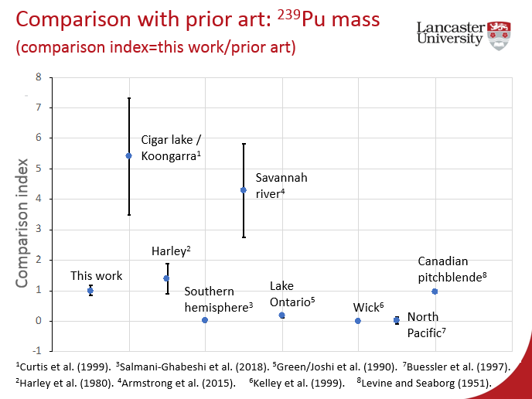
Figure 32 This figure provides a graphical comparison of this work to the prior art. As explained within the figure, the comparison index is a ratio of this work to the prior art [76][75][73][74][77][78][79][72]. The figure is a slide taken from the presentation of the work at Plutonium Futures, San Diego, 2018 [80]
Further, Kelley et al report ²³⁹Pu measurements of soil samples taken from Wick, Scotland, which measure at 1.29±0.02 pg/g (~3.20 Bq/kg) ²³⁹Pu abundance [78], more than double the average reported on the Dounreay site.
Lake Ontario sediments measured by Green et al demonstrate a lower range of ²³⁹Pu abundance at 2 fg/g (~0.005 Bq/kg) to 200 fg/g (~0.50 Bq/kg) [77]. The difference is expected as Green’s samples were Lake sediments, and so unlikely to have the same levels of fallout deposition as soil samples like those at Dounreay or the Savannah River Site.
Overall, the samples measured fit into the ranges of ²³⁹Pu abundance caused by nuclear fallout, as demonstrated by many examples from the literature.
4.3.2 ²⁴⁰Pu
The absolute mass of ²⁴⁰Pu in samples is not widely published as a less common isotope, and it is usually combined with the mass of ²³⁹Pu to give a ratio.
²⁴⁰Pu measurements demonstrate the same general trend to ²³⁹Pu measurements. Of the entire sample set, all but two (DSRL3 and DSRL8) are consistent with one another. As before, DSRL3 has the highest level with a ²⁴⁰Pu abundance of 93±3 fg/g (~0.83 Bq/kg), while DSRL8 has the lowest significantly at 37±1 fg/g (~0.33 Bq/kg). The average of all samples is 68±7 fg/g (~0.60 Bq/kg). The ²⁴⁰Pu abundance in the Biggin samples is also significantly lower than most of the samples at 58±2 fg/g (~0.52 Bq/kg).
Quinto et al [71] measured plutonium amounts in an ombrotrophic bog core using AMS and found plutonium concentrations “at femtogram (1x10⁻¹⁵) and attogram (1x10⁻¹⁸) levels”. Quinto et al.’s measurements are consistent with this work and suggests the ²⁴⁰Pu in the samples is of fallout origin. Few other conclusions can be made when considering the mass of ²⁴⁰Pu alone, so will be considered combined with other results later.
4.3.3 ²⁴²Pu
Little variation is shown in ²⁴²Pu abundance across the project samples and a similar trend is again shown as for the lighter isotopes. All DSRL samples are consistent with one another except DSRL3 and DSRL8, which are significantly higher and lower than the sample set average, respectively. The overall sample average sits at 2.1±0.6 fg/g (~3.04x10⁻⁴ Bq/kg) of ²⁴²Pu, while ²⁴²Pu abundance in DSRL3 is 4.1±0.2 fg/g (~5.96 x10⁻⁴ Bq/kg) and 1.10±0.06 fg/g (~1.60 x10⁻⁴ Bq/kg) in DSRL8. Malham and Biggin both demonstrate ²⁴²Pu abundances of 1.6±0.2 fg/g (~2.33 x10⁻⁴ Bq/kg).
²⁴²Pu is an anthropogenic isotope generally created within nuclear reactors. The origin of ²⁴²Pu suggests that Malham and Biggin have been subject to lower fallout from high neutron flux origins, likely from weapons tests, when compared to the Dounreay samples, unless the Dounreay area has had consistent contamination events at similar levels of ²⁴²Pu abundance. The former is unlikely as the DSRLB1 (offsite) sample demonstrates similar levels to those on-site. It is possible that the increased ²⁴²Pu at Dounreay relative to the samples far-from-site (Malham and Biggin) could be due in part to the Soviet weapons tests at Novaya Zemlya in the arctic circle. The levels of influence are currently unclear, though some literature shows that the area surrounding Novaya Zemlya exhibits higher levels of plutonium abundance, and as the distance from the site increases, the levels of plutonium decrease [81]. This is not directly related to airborne contamination, which would be the main method of contamination if Dounreay were impacted by these tests, as the measurements were carried out on sea ice samples. They do however paint a similar picture in terms of the possibility of contamination by Novaya Zemlya tests, and the confirmation that the emissions from that site are measurable, even though most of the tests were subterranean.
Comparison of soils measured from the Semipalatinsk test site in Kazakhstan [12] demonstrate higher levels of ²⁴²Pu, in the range 4.0±0.3 (~5.82 x10⁻⁴ Bq/kg) to 5.4±0.4 fg/g (~7.85 x10⁻⁴) compare to the average of 2.1 fg/g (~3.05 x10⁻⁴ Bq/kg) over the entire project sample set. The Semipalatinsk samples are expected to be higher in ²⁴²Pu abundance than Dounreay samples as nuclear weapons tests create a high neutron flux, increasing the proportion of higher-mass plutonium isotopes formed. Like ²⁴⁰Pu, ²⁴²Pu abundance alone can provide significant information that contamination is present, but cannot conclusively inform the origin of the material further than a significantly high abundance of ²⁴²Pu suggests weapons origin, but conclusions of origin are possible when ²⁴²Pu association with ²³⁹Pu is considered as a ratio.
4.3.4 ²³⁶U
The sample abundance of ²³⁶U does not exhibit a specific trend, with some variation between samples. DSRL6 demonstrates the highest levels of ²³⁶U at 143±27 pg/g (~0.333 Bq/kg) while DSRL8 demonstrates the lowest yet again, at 40±10 pg/g (~9.32x10⁻² Bq/kg).
Chamizo et al measured the ²³⁶U abundance in IAEA standard samples with the 1 MV AMS system at the Centro Nacional De Acceledores (Seville, Spain)[82]. The samples were made up of sediment and soils and were consistent in ²³⁶U abundance to the Dounreay samples, which averaged 84±53 pg/g (~0.196 Bq/kg) due to the high error margins.
The highest measurement Chamizo made of ²³⁶U abundance was from the IAEA-410 soil sample, from Bikini Atoll of 225±8 (x 10⁶ atoms/g). When converted to mass (using the ²³⁶U atomic mass and Avogadro’s constant) this translates to an absolute mass value of 88±1 fg/g (~2.05x10⁻⁴ Bq/kg) – three orders of magnitude lower than the Dounreay average. The IAEA sample from Bikini Atoll has of course been influenced by the detonation of 23 nuclear devices by the United States and so is expected to be higher than the UK samples.
This is an interesting result as it suggests that there could be a source of anthropogenic contamination originating from the Dounreay site, greater than that seen from a thermonuclear test site. This however does not consider the comparatively high levels of both the off-site ‘DSRLB1’ and ‘Biggin’ samples. It is possible for some historical contamination on-site to potentially have been carried off-site (i.e. DSRL -> DSRLB1), but improbable for the same contamination to migrate ~500 miles to the Biggin sample site.
The report published by Salmani-Ghabeshi et al (2018) demonstrates similar values to those published by Chamizo et al with their lowest values of approximately 0.7 fg/g (~1.63x10⁻⁶ Bq/kg), ranging to their highest taken from Bikini Atoll, of approximately 135 fg/g (~3.15x10⁻⁴ Bq/kg)[73].
It is important to reiterate that the ²³⁶U values in this study are approximate estimates due to potential sampling errors highlighted by the staff at ETH Zϋrich, hence the high uncertainties, but they still allow some informed comparison between samples from this project and those of the others.
Overall the results confirm high levels of ²³⁶U in the project samples. This is possible in the samples as all are collected from areas of high natural uranium abundance, relative to the average in the UK, though there is a high chance that mistakes made within the methodology concerning the AMS preparation impacted the results. This is particularly highlighted with the comparison to Bikini Atoll samples. Due to the uncertainties in the ²³⁶U measurements it is not prudent to use these data to make any conclusions and it would be recommended to carry out repeat measurements for certainty.
4.3.5 Isotopic Ratios
Calculation of the ratios between the abundances of plutonium isotopes can provide more detailed information on the origin of nuclear materials. The ratios of plutonium isotopes can act as fingerprints to help identify the origin of nuclear material at a sample site.
The relationship between actinide isotope abundances is typically expressed as a ratio, and these ratios have been calculated over many different analyses to provide global average values, including materials from anthropogenic and primordial sources. The global fallout ratio values are important to consider as they represent ubiquitous anthropogenic contamination and therefore without this any material discovered on a site could be identified as site contamination without proper consideration of the wider picture. This is important for sites such as Dounreay, as the acknowledgement of ubiquitous contamination means these sites can identify justifiable amounts of isotopes of fallout origin, as long as they are within error of the global fallout ratio value.
The global averages of some plutonium isotopic ratios are displayed in Table 2 below. The isotopic ratios of project samples will be explored in light of these global averages in turn, followed by a combined discussion and conclusion.

Isotope Ratio | Global Average [Source]
²³⁶U/²³⁹Pu | 0.23 ±0.02 [83] - Fallout
²⁴⁰Pu/²³⁹Pu | 0.176 ±0.1 [66]
²⁴¹Pu/²³⁹Pu | 0.00139 ±0.00007 [64] - Fallout
²⁴²Pu/²³⁹Pu | 0.0041 ±0.0006 [12]
Table 2 The main global average plutonium isotopic ratios that relate to this work. The values denoted by “Fallout” relate to the fact that the sample areas could have had no possible other contribution than global fallout as mentioned by the authors.
4.3.5.1 ²³⁶U/²³⁹Pu
Srncik et al discuss the limited data on the ²³⁶U/²³⁹Pu ratio in the literature [84], which also applies to this discussion. As mentioned in Table 2, Sakaguchi et al. report a ratio value for fallout of 0.23±0.02 [83]. The samples measured from the Dounreay site expressed much higher ratios than this with an average of 134±16. The ²³⁶U abundances within the samples were extremely high, along with uncharacteristically high errors for the methods used, which caused concerns of possible contamination of the samples. Due to the limited time to access the apparatus a second measurement was not possible, and so the ²³⁶U/²³⁹Pu ratio will be considered no further in this discussion.

4.3.5.2 ²⁴⁰Pu/²³⁹Pu
Krey et al reported a global average ²⁴⁰Pu/²³⁹Pu ratio of 0.176±0.014 [66]. The average ²⁴⁰Pu/²³⁹Pu ratios of this project’s samples are displayed in Table 3 below.
Area | ²⁴⁰Pu/²³⁹Pu ratio
On-site | 0.125 ±0.004
Off-site | 0.106 ±0.003
Away from site | 0.167 ±0.007
Table 3 The ²⁴⁰Pu/²³⁹Pu ratios of the different samples in this study, differentiated by sampling site.
As shown, both sample sets from Dounreay, on-site and off-site show a ratio of ²⁴⁰Pu/²³⁹Pu significantly lower than that of the global average, while the sample average collected ‘away from site’ in Derbyshire and Yorkshire is consistent with the global value. The values are displayed in Figure 33.

Figure 33 ²⁴⁰Pu/²³⁹Pu ratios compared between multiple global sites of differing radioactive material origin, including the three sample areas from the project [64][85][86][87][88][89]. Samples; “Away”, “Offsite”, “Onsite”, and “Our Average” are all sample measurements produced as part of this project and are outlined in black for clarity. All samples presented were soil samples, other than the ‘Sellafield’ sample, which is Irish Sea sediment contaminated by Sellafield waste emissions.
Judging from Figure 33, it is likely that the plutonium content within the ‘away from site’ samples originates from ubiquitous fallout plutonium, with slight changes to the global values caused by the increased elevation and geography of the sample area. The Dounreay sample averages are not consistent with other published measurements of samples from the UK. Samples from Irish Sea sediment (originating from Sellafield site) measured by Steier et al [64] are significantly higher than both Dounreay samples and the global average, suggesting typically higher ²⁴⁰Pu (as was expected) or lower ²³⁹Pu concentrations (which is more likely). This trend continues with measurements carried out of soil with material originating from the “Ivy Mike” weapons tests [85]. They measured a ²⁴⁰Pu/²³⁹Pu ratio of 0.363. Further measurements were made of Chernobyl debris [86], giving a ratio range of 0.186 - 0.348. The significant difference between the previous two measurements and the Dounreay samples gives confidence that the material detected in the Dounreay samples is unlikely to originate from a single significant event like that of a weapons test or plant failure, though, as Srncik states [87], a low isotopic ratio (like that seen in the DSRL samples) is associated to low burn-up material, which is characteristic of plutonium produced specifically to be high in ²³⁹Pu.
Consideration of the history of the Dounreay nuclear site leads to a likely conclusion of the production of material with high percentage composition of ²³⁹Pu. This conclusion fits the reported data well, considering the origins of Dounreay research in the use of breeder reactors and the ²⁴⁰Pu/²³⁹Pu value that is significantly lower than the average global value. Other reported soil measurements reflect these conditions, to a greater magnitude, like the Mayak and Semipalatinsk-21 sites in Kazahkstan, at ratios of 0.028 and 0.044 respectively, whose ratios have been skewed much more than the Dounreay value due to higher releases of material at low ²⁴⁰Pu/²³⁹Pu ratio. The Novaya Zemlya site soil also expresses similar ratios at 0.04, with areas closer to the site in the sea being measured in the range of 0.13 – 0.19 [81]. Therefore, of the miniscule amount dispersed hypothetically at Dounreay, the ²⁴⁰Pu/²³⁹Pu ratio does appear to offer evidence of it being breeding material.

4.3.5.3 ²⁴¹Pu/²³⁹Pu
The average ²⁴¹Pu/²³⁹Pu ratios of this project’s samples are presented in Table 4 below. The ²⁴¹Pu values in this work are based on calculated values originating from ²⁴¹Am counts measured with the BEGe gamma spectrometer at CCFE.
Area | ²⁴¹Pu/²³⁹Pu ratio
On-site | (1.7±1) x10⁻³
Off-site | (9.4 ±0.5) x10⁻⁴
Away from site | (2.9 ±0.1) x10⁻³
Table 4 The ²⁴¹Pu/²³⁹Pu ratios of the different samples in this study, by sampling site.
In the 2013 report on “AMS of the minor Plutonium Isotopes” [64], Steier et al. assume a Salzburg soil sample as an example for the global fallout ratio of ²⁴¹Pu/²³⁹Pu. The sample was collected in [88]. Their value of ubiquitous ²⁴¹Pu/²³⁹Pu fallout is: [(1.39±0.07)x10⁻³]. The sample ratios are displayed in Figure 34, compared against some notable examples from the literature of varying origins.

Figure 34 ²⁴¹Pu/²³⁹Pu ratios compared between multiple sites, including the three sample types from the project [64][86][87][88][89]. Samples; “Away”, “Offsite”, “Onsite”, and “Our Average” are all sample measurements produced as part of this project and are outlined in black for clarity. All samples presented were soil samples, other than the ‘Sellafield’ sample, which is Irish Sea sediment presumed contaminated by Sellafield waste emissions.
As can be seen from Figure 34, Sellafield values are the highest by a significant margin, which fits with Day & Cross’s Nature report in 1981, stating the 200 Ci y⁻¹ releases of waste ²⁴¹Pu into the Irish Sea [90], where the sample was collected from the sediment. Similarly, Garigliano drainage shows a higher ratio (though not significantly higher than all DSRL samples) which fits the same trend of ²⁴¹Pu waste release and the narrative, as it was sampled from Garigliano nuclear power plant drainage [64][91], the uncertainty on this measurement is proportionally high however, so it remains consistent with most of the other measurements.
The overall project sample average and on-site ratio values are consistent with global fallout ²⁴¹Pu/²³⁹Pu ratios, which suggests minimal to no significant contamination solely from a Dounreay site release of ²⁴¹Pu. If this were the case, the ratio could be significantly higher.
The ‘away from site’ average shows one of the highest ²⁴¹Pu/²³⁹Pu ratios when compared to the global sample examples. This difference reflects a higher ²⁴¹Pu abundance in the two ‘away’ samples alongside a lower ²³⁹Pu abundance. The increased ²⁴¹Pu could be due to the sample sites’ higher elevation, making the site more susceptible to fallout deposition than the Dounreay area, which rests at sea level. Further, Dounreay is ~500 miles further north than the ‘Away’ samples which could also have allowed increased deposition of ²⁴¹Pu at Malham and Biggin compared to Dounreay. Based on these observations, it could be argued that ‘Away’ samples received higher deposits of Chernobyl origin than others in the sample set, or that there may have been increased levels of ²³⁹Pu in the Dounreay area which has driven the ratio down when compared to the ‘Away’ samples.

4.3.5.4 ²⁴²Pu/²³⁹Pu
The ²⁴²Pu/²³⁹Pu ratios demonstrate consistent levels in all samples. They are presented in Table 5 below.
Area | ²⁴²Pu/²³⁹Pu ratio
On-site | (4±2) x10⁻³
Off-site | (3.4±0.5) x10⁻⁴
Away from site | (4.1±0.4) x10⁻³
Table 5 The ²⁴²Pu/²³⁹Pu ratios of the different sample groups in this study, measured using AMS at ETH Zϋrich and differentiated by sampling site.
The values displayed in Table 5 were measured with AMS. They are compared against other samples including the global average ²⁴²Pu/²³⁹Pu ratio in Figure 35 below.

Figure 35 ²⁴²Pu/²³⁹Pu ratios compared between multiple sites, including the three sample types from this project [64][85][86][87][88][12]. Samples; “Away”, “Offsite”, “Onsite”, and “Our Average” are all sample measurements produced as part of this project and are outlined in black for clarity. All samples presented were soil samples, other than the ‘Sellafield’ sample, which is Irish Sea sediment contaminated by Sellafield waste emissions.
As can be seen from Figure 35, all of the project samples are consistent with the global average ²⁴²Pu/²³⁹Pu ratio. The Klofta (Norway) sample is also in good agreement with the project samples. Glomfjord (Norway) and Sellafield are well above the project ratios, which suggest high ²⁴²Pu abundances and/or low ²³⁹Pu in the project samples. As Sellafield released plant waste into the Irish Sea, this sample’s high ratio is likely due to a low ²³⁹Pu contribution and higher ²⁴²Pu abundance. The Semipalatinsk test site shows the lowest ²⁴²Pu/²³⁹Pu ratio, likely due to the relatively large amount of ²³⁹Pu emitted during the Russian nuclear bomb tests at the Kazakh site.
The samples from the Dounreay site exhibit very similar ratio values to that of Salzburg and Klofta, areas of low radioactivity, while showing huge differences to samples that are indicative of significant radioactive events.
4.3.5.5 ²⁴⁴Pu/²³⁹Pu
Ordinarily, ²⁴⁴Pu would provide evidence for whether the material is of high yield weapons test origin or not as it is a long-lived radionuclide (half-life 80.8 million years) that is only created from a high neutron flux environment, i.e. high-yield weapons tests. ²³⁹Pu forms ²⁴⁴Pu by acquiring neutrons in quick succession. This reaction does not often occur in sustained fission reactions as the lower neutron flux allows time for many of the ²⁴¹Pu atoms to decay to ²⁴¹Am and then ²³⁷Np.
This project’s values for the ²⁴⁴Pu/²³⁹Pu ratio are not specific to ²⁴⁴Pu, only the measurements for the full ²⁴⁴Pu isobar were taken from the AMS due to various constraints. Therefore, the ²⁴⁴Pu values measured from AMS comprise the mass of ²⁴⁴Pu and ²⁴⁴Cm. Comparisons can still be made between the project samples and the literature, although the reader must be mindful that the actual ²⁴⁴Pu/²³⁹Pu ratio for the project samples will be lower than that presented for this reason.
Even with a larger than representative ²⁴⁴Pu/²³⁹Pu ratio, the project sample is within the range of two values presented by Steier et al of Salzburg soil and Irish Sea debris (affected by Sellafield emission)[64]. The combined ²⁴⁴Pu isobar values from this project present at (1.6±0.7) x10⁻⁵, while Salzburg soil (used as an estimate for global fallout only) demonstrates a higher ratio at (5.7±1) x10⁻⁵ and Irish Sea debris is <3.5 x10⁻⁶.
While a conclusion based only on this data set would be tenuous at best, it does confirm that the DSRL samples are within a reasonable range of ²⁴⁴Pu abundance, which suggests that the samples have not been subjected to contamination greater than that of fallout.
4.4 Summary
Overall comparison between the gamma spectra and AMS results validates the lack of visible plutonium peaks within the gamma spectra. The plutonium abundance reported by the AMS reveals levels too low to display significant peaks in the soil at such a high uranium abundance, due to the uranium decay chain gamma background.
Comparisons between the gamma-ray spectra and the neutron detection results show correlating results as both sets of measurements displayed very low levels of sample radioactivity. The gamma results demonstrated this through the presence of an ²⁴¹Am peak – the only peak originating from a plutonium decay chain amongst spectra inundated with uranium and thorium decay emissions, consistent throughout the samples. This ²⁴¹Am peak measurement is supported by Figure 34, where the on-site samples show comparable ratios to the Salzburg site sample, which is considered the standard for global average. The fact that the ‘Away’ (Malham and Biggin) samples show a significantly higher average ratio than the Salzburg sample also shows good agreement between the gamma-ray and AMS measurements, as the ‘Away’ samples demonstrated higher ²⁴¹Am abundance within the sample sets.
The low abundances of actinides reported by the AMS measurements confirm the low neutron counts measured from the samples in the 16-detector array. However, the low neutron counts did not allow confirmation of the array’s ability to identify high levels of plutonium in soil samples. This ability was confirmed by the spiked soil samples. The 45 ng ²⁴⁰Pu spike is equivalent to approximately 1 Bq/g of activity in the 313 g soil sample, which has shown to demonstrate a significantly higher neutron emission than the un-spiked sample.
From the research presented, it is reasonable to conclude that there has been no noticeable, plutonium-related contamination in the DSRL soil samples, other than that consistent with that reported globally.
The samples are consistent with global averages for fallout in both ²⁴¹Pu/²³⁹Pu and ²⁴²Pu/²³⁹Pu ratios, though they differ slightly from global ²⁴⁰Pu/²³⁹Pu average ratios.
Overall, the sample averages are consistent with global fallout. When separated to different sample types, the ‘Away’ samples remain consistent with the global fallout average [66] while all samples collected around Dounreay, both on and off site are significantly lower than the average for fallout. If only the on-site samples were significantly lower than the fallout average while off-site remained consistent, it would have led to a conclusion of on-site contamination. However, both sample types display significantly lower ratios than the global averages, which means that this result is unlikely to be the cause of Dounreay site activities. The results are more likely symptomatic of the previously reported high uranium abundance of the local geology, where the abundant ²³⁸U accepts neutrons and convert to ²³⁹Pu through natural acceptance of neutrons, and also the historical presence of breeder reactors.
Distinguishing between two low mass samples by measuring neutrons has been shown to be possible, however it is likely that a lower mass of material could be discerned in a larger sample size for a longer counting period. Further, an increase in the number of detectors and detector coverage of the samples (currently at approximately two thirds coverage) could further increase the array sensitivity. The measurements in this study were subject to time, space, and material limitations that would be less of a barrier in applications outside of research. In the same vein, repeat measurements of the gamma and AMS techniques would have provided greater confidence in the results, but due to time and cost constraints only one campaign of measurements for each technique were analysed.
Chapter 5
5. Conclusions and Further Work
5.1 Conclusions
Following are the conclusions made following consideration and discussion of the results, followed by potential future applications for the work and further research that could be undertaken to continue development of the techniques presented.
This project has demonstrated the use of varied analysis methods to identify plutonium content within Dounreay soil samples. The project developed a neutron detector array made up of liquid scintillators that could not distinguish between samples of background level radioactivity but did identify differences between a sample spiked with 45 ng of ²⁴⁰Pu, and the same sample pre-spike. There are still areas of analysis that must be undertaken to identify the limit of spike at which two such samples could be distinguished, and the mechanisms involved in the production and detection of fast neutrons.
The project also confirmed that the use of gamma detection in a high natural uranium background does not have the required resolution to isolate plutonium peaks. The analysis method did however provide valuable data on the ²⁴¹Am content of samples, which were visible in most spectra, which enabled estimation of ²⁴¹Pu abundance.
Accelerator Mass Spectrometry identified that the Dounreay samples contain plutonium abundances consistent overall with global averages for fallout. The ²⁴⁰Pu/²³⁹Pu ratio of DSRL samples was not consistent however with the global averages for fallout. The ratio was lower than the average, which could suggest low levels of ²⁴⁰Pu on site, or, more likely, high ²³⁹Pu. It is known that the Dounreay site was host to two fast breeder reactors, the Dounreay fast reactor and the Prototype fast reactor which utilised and produced fuel high in ²³⁹Pu. Further, it is known on-site that the site has had multiple contamination events local to specific areas. With these considerations, it is reasonable to conclude that the site soil has seen contamination by material proportionally high in ²³⁹Pu.

5.2 Further Work
Through the project, areas of further work have been identified to increase understanding of this diverse field of research.
The most common area for further work to compliment this study must be analyses to increase the UK database of nuclides within soils, particularly an attempt to identify areas with the lowest radioactivity in soil. An increased database would allow more appropriate comparisons for decommissioning sites and regulators to consider.
Further to an increase in sampled sites would be a study to aim to quantify the effect that the immediate environment has on the abundance of actinides. Many studies have been carried out on vertical soil profiles, showing the decrease of actinides as depth increases. However, there are gaps in the literature in how actinides behave on surfaces with a high gradient. For example, would mechanical deposition of actinides via water displacement occur before the movement of actinides through the vertical soil profile, and to what extent?
In terms of neutron measurements, clearly there is a gap in the research for the identification of the detection limit of plutonium. To tackle this, a simple experiment could be carried out with incrementally increasing levels of ²⁴⁰Pu within spiked soil samples as carried out in this project. The neutron emission could be measured and the point at which the spiked samples are distinguishable from un-spiked samples could be identified. Unfortunately, the difficulty with carrying out such studies is not the analysis but rather the procurement of material with consistent levels of neutron emission.

Bibliography
[1] M. Koide, J. J. Griffin, and E. D. Goldberg, “Records of plutonium fallout in marine and terrestrial samples,” J. Geophys. Res., vol. 80, no. 30, pp. 4153–4162, Oct. 1975, doi: 10.1029/JC080i030p04153.
[2] M. Gastberger et al., “Plutonium in soil from Dolon near the Semipalatinsk nuclear test site,”  by Oldenbourg Wissenschaftsverlag, 2001.
[3] D. Marčiulionienė et al., “137Cs and plutonium isotopes accumulation/retention in bottom sediments and soil in Lithuania: A case study of the activity concentration of anthropogenic radionuclides and their provenance before the start of operation of the Belarusian Nuclear Power Plant (NPP),” J. Environ. Radioact., vol. 178–179, pp. 253–264, Nov. 2017, doi: 10.1016/J.JENVRAD.2017.07.024.
[4] Nuclear Decommissioning Authority, “Site End State Definition Process,” 2006.
[5] A. Lavietes et al., “Liquid scintillator-based neutron detector development,” in 2012 IEEE Nuclear Science Symposium and Medical Imaging Conference Record (NSS/MIC), 2012, pp. 230–244, doi: 10.1109/NSSMIC.2012.6551100.
[6] F. Gauthier-Lafaye, I. P. Holliger, and P.-L. Blanc, “Natural fission reactors in the Franceville basin, Gabon: A review of the conditions and results of a &quot;critical event&quot; in a geologic system,” 1996.
[7] C. Scheib, J. D. Appleton, J. C. H. Miles, and E. Hodgkinson, “Geological controls on radon potential in England,” Proc. Geol. Assoc., vol. 124, no. 6, pp. 910–928, 2013, doi: 10.1016/j.pgeola.2013.03.004.
[8] C. Scheib, J. D. Appleton, J. C. H. Miles, and E. Hodgkinson, “Geological controls on radon potential in England,” Proc. Geol. Assoc., vol. 124, no. 6, pp. 910–928, Dec. 2013, doi: 10.1016/j.pgeola.2013.03.004.
[9] British Geological Survey, “Mineral Profile: Uranium,” no. March, 2010.
[10] L. E. Peterson and R. L. Miller, “Association between radioactive fallout from 1951–1962 US nuclear tests at the Nevada Test Site and cancer mortality in midwestern US populations,” Russ. J. Ecol., vol. 39, no. 7, pp. 495–509, Dec. 2008, doi: 10.1134/S1067413608070060.
[11] Y. Muramatsu, T. Hamilton, S. Uchida, K. Tagami, S. Yoshida, and W. Robison, “Measurement of 240Pu/239Pu isotopic ratios in soils from the Marshall Islands using ICP-MS,” 2001.
[12] T. M. Beasley et al., “Isotopic Pu, U, and Np Signatures in Soils from Semipalatinsk-21, Kazakh Republic and the Southern Urals, Russia,” 1998.
[13] A. Markabayeva et al., “Increased prevalence of essential hypertension in areas previously exposed to fallout due to nuclear weapons testing at the Semipalatinsk Test Site, Kazakhstan,” Environ. Res., vol. 167, pp. 129–135, Nov. 2018, doi: 10.1016/j.envres.2018.07.016.
[14] V. I. KHALTURIN, T. G. RAUTIAN, P. G. RICHARDS, and W. S. LEITH, “A Review of Nuclear Testing by the Soviet Union at Novaya Zemlya, 1955–1990,” Sci. Glob. Secur., vol. 13, no. 1–2, pp. 1–42, Jan. 2005, doi: 10.1080/08929880590961862.
[15] S. G. Tims, M. B. Froehlich, L. K. Fifield, A. Wallner, and M. De Cesare, “236U and 239,240Pu ratios from soils around an Australian nuclear weapons test site,” J. Environ. Radioact., vol. 151, pp. 563–567, Jan. 2016, doi: 10.1016/J.JENVRAD.2015.06.020.
[16] I. Pitrou, “Nuclear Tests in French Polynesia,” Asia Pacific J. Public Heal., vol. 27, no. 2, pp. 232–233, Mar. 2015, doi: 10.1177/1010539514548761.
[17] Brian Martin, “The global health effects of nuclear war,” 1982. [Online]. Available: https://www.uow.edu.au/~bmartin/pubs/82cab/. [Accessed: 26-Jan-2019].
[18] S. Schneider et al., “Plutonium release from Fukushima Daiichi fosters the need for more detailed investigations,” Sci. Rep., vol. 3, no. 1, p. 2988, Dec. 2013, doi: 10.1038/srep02988.
[19] J. Heathcote, “Dounreay Site Description - Geology, Hydrology and Hydrogeology,” 2012.
[20] M. F. L’Annunziata, Handbook of radioactivity analysis. Elsevier Science, 2012.
[21] UK Government, “Dounreay,” Gov.uk, 2020. [Online]. Available: https://www.gov.uk/government/organisations/dounreay.
[22] M. S. Tate, “Environmental Safety Case - DSRL,” 2006.
[23] J. N. Hutchinson, D. L. Millar, and N. H. Trewin, “Coast erosion at a nuclear waste shaft, Dounreay, Scotland,” Q. J. Eng. Geol. Hydrogeol., vol. 34, no. 3, pp. 245–268, Aug. 2001, doi: 10.1144/qjegh.34.3.245.
[24] D. A. Cavendish and D. Partnership, “Dounreay Socio Economic Plan,” 2018.
[25] N. Vajda and C.-K. Kim, “Determination of Pu isotopes by alpha spectrometry: a review of analytical methodology,” J. Radioanal. Nucl. Chem., vol. 283, no. 1, pp. 203–223, Jan. 2010, doi: 10.1007/s10967-009-0342-x.
[26] L. K. Fifield, “Accelerator mass spectrometry of the actinides,” Quat. Geochronol., vol. 3, pp. 276–290, 2008, doi: 10.1016/j.quageo.2007.10.003.
[27] Scottish Environmental Protection Agency, “ENVIRONMENTAL PROTECTION The Radioactive Contaminated Land ( Scotland ) Regulations 2007,” vol. 1995, no. 179, 2007.
[28] B. D’Mellow, M. D. Aspinall, R. O. Mackin, M. J. Joyce, and A. J. Peyton, “Digital discrimination of neutrons and ??-rays in liquid scintillators using pulse gradient analysis,” Nucl. Instruments Methods Phys. Res. Sect. A Accel. Spectrometers, Detect. Assoc. Equip., vol. 578, no. 1, pp. 191–197, 2007, doi: 10.1016/j.nima.2007.04.174.
[29] M. J. Joyce, K. A. A. Gamage, M. D. Aspinall, F. D. Cave, and A. Lavietes, “A 4-channel multiplex analyzer for real-time, parallel processing of fast scintillators,” IEEE Nucl. Sci. Symp. Conf. Rec., pp. 134–138, 2012, doi: 10.1109/NSSMIC.2012.6551077.
[30] I. Tsutomu, M. Takehiko, and S. Keisho, “Measurement of Fast Neutron Spectrum with Helium-3 Proportional Counter,” J. Nucl. Sci. Technol., vol. 8, no. 4, pp. 192–194, 1971, doi: 10.1080/18811248.1971.9735315.
[31] A. J. Hurd and R. T. Kouzes, “Why new neutron detector materials must replace helium-3,” J. Appl. Genet., vol. 129, no. 10, Oct. 2014, doi: 10.1140/epjp/i2014-14236-6.
[32] R. C. Martin, J. B. Knauer, and P. A. Balo, “Production, distribution and applications of californium-252 neutron sources,” 2000.
[33] N. Holden and M. Zucker, “A reevaluation of the average prompt neutron emission multiplicity (nubar) values from fission of uranium and transuranium nuclides.” 1984.
[34] M. J. Joyce, K. A. A. Gamage, M. D. Aspinall, F. D. Cave, and A. Lavietes, “Real-time, fast neutron coincidence assay of plutonium with a 4-channel multiplexed analyzer and organic scintillators,” IEEE Trans. Nucl. Sci., vol. 61, no. 3, pp. 1340–1348, 2014, doi: 10.1109/TNS.2014.2313574.
[35] J. L. Dolan et al., “Active-interrogation measurements of fast neutrons from induced fission in low-enriched uranium,” 2014, doi: 10.1016/j.nima.2013.11.052.
[36] R. Chandra, G. Davatz, U. Gendotti, and A. Howard, “Fast neutron detection in homeland security applications,” in IEEE Nuclear Science Symposuim & Medical Imaging Conference, 2010, pp. 508–511, doi: 10.1109/NSSMIC.2010.5873813.
[37] A. Zimbal, D. Degering, M. Reginatto, H. Schuhmacher, B. Wiegel, and K. Zuber, “Low-level measuring techniques for neutrons: High accuracy neutron source strength determination and fluence rate measurement at an underground laboratory,” vol. 1549, p. 77, 2013, doi: 10.1063/1.4818078.
[38] H. M. O. Parker, J. S. Beaumont, and M. J. Joyce, “Passive, non-intrusive assay of depleted uranium,” J. Hazard. Mater., vol. 364, pp. 293–299, Feb. 2019, doi: 10.1016/j.jhazmat.2018.08.018.
[39] N. Ensslin, “The Origin of Neutron Radiation,” Passiv. Nondestruct. Assay Nucl. Mater., pp. 337–356, 1991.
[40] Y. Feige, B. G. Oltman, and J. Kastner, “Production rates of neutrons in soils due to natural radioactivity,” J. Geophys. Res., vol. 73, no. 10, pp. 3135–3142, May 1968, doi: 10.1029/JB073i010p03135.
[41] G. Heusser, “Low-Radioactivity Background Techniques,” Annu. Rev. Nucl. Part. Sci., vol. 45, no. 1, pp. 543–590, Dec. 1995, doi: 10.1146/annurev.ns.45.120195.002551.
[42] S. Reilly, D., Ensslin, N., Smith, H. Jr., Kreiner, “Passive Nondestructive Assay of Nuclear Materials,” 1991.
[43] H.-A. Synal and L. Wacker, “AMS measurement technique after 30years: Possibilities and limitations of low energy systems,” Nucl. Instruments Methods Phys. Res. Sect. B Beam Interact. with Mater. Atoms, vol. 268, no. 7–8, pp. 701–707, Apr. 2010, doi: 10.1016/j.nimb.2009.10.009.
[44] E. Chamizo, M. López-Lora, M. Villa, N. Casacuberta, J. M. López-Gutiérrez, and M. K. Pham, “Analysis of 236U and plutonium isotopes, 239,240Pu, on the 1 MV AMS system at the Centro Nacional de Aceleradores, as a potential tool in oceanography,” Nucl. Instruments Methods Phys. Res. Sect. B Beam Interact. with Mater. Atoms, vol. 361, pp. 535–540, Oct. 2015, doi: 10.1016/J.NIMB.2015.02.066.
[45] A. Rahman, Decommissioning and Radioactive Waste Management, Illustrate. Whittles publishing, 2008.
[46] N. V. Gorin et al., “Calibration Experiment on the Detection of Fissioning Material in Soil by Means of Neutron Detection,” At. Energy, vol. 99, no. 3, pp. 670–675, Sep. 2005, doi: 10.1007/s10512-005-0264-9.
[47] S. C. Sheppard, M. I. Sheppard, M. Ilin, J. Tait, and B. Sanipelli, “Primordial radionuclides in Canadian background sites: secular equilibrium and isotopic differences,” J. Environ. Radioact., vol. 99, no. 6, pp. 933–946, Jun. 2008, doi: 10.1016/j.jenvrad.2007.11.018.
[48] M. D. Aspinall et al., “Real-Time Capabilities of a Digital Analyzer for Mixed-Field Assay Using Scintillation Detectors,” IEEE Trans. Nucl. Sci., vol. 64, no. 3, pp. 945–950, Mar. 2017, doi: 10.1109/TNS.2017.2654512.
[49] Helen M.O. Parker et al., “Active fast neutron singles assay of 235U enrichment in small samples of triuranium octoxide,” Prog. Nucl. energy, vol. 93, pp. 59–66, 2016.
[50] R. Sarwar et al., “An event-triggered coincidence algorithm for fast-neutron multiplicity assay corrected for cross-talk and photon breakthrough,” Nucl. Inst. Methods Phys. Res. A, vol. 903, pp. 152–161, 2018, doi: 10.1016/j.nima.2018.06.056.
[51] V. Astromskas, M. J. Joyce, and M. Aspinall, “Investigation of instabilities of photomultiplier tubes for multi-element detector systems,” J. Instrum., vol. 13, no. 10, pp. P10008–P10008, Oct. 2018, doi: 10.1088/1748-0221/13/10/P10008.
[52] Frank A. Haight, Handbook of the Poisson Distribution. Wiley, 1967.
[53] R. R. S. De Mendonça, J.-P. Raulin, E. Echer, V. S. Makhmutov, and G. Fernandez, “Analysis of atmospheric pressure and temperature effects on cosmic ray measurements,” J. Geophys. Res. Sp. Phys., vol. 118, no. 4, pp. 1403–1409, Apr. 2013, doi: 10.1029/2012JA018026.
[54] I. . Artamonova, D. M. Volobuev, and N. G. Makarenko, “Analysis of lower atmosphere pressure field response for short-time cosmic ray variations by Multifield Comparison Measure method,” J. Phys. Conf. Ser., vol. 675, no. 3, p. 032030, Feb. 2016, doi: 10.1088/1742-6596/675/3/032030.
[55] Canberra, Broad Energy Germanium Detectors (BEGe). 2013.
[56] Mirion Technologies, “Model S574 LabSOCS calibration software,” 2017.
[57] Canberra, Small Anode Germanium (SAGe) Well Detector Features. 2016.
[58] Mirion Technologies, “Prospect Gamma Spectroscopy Software Features,” 2013.
[59] Harry Bateman, “The solution of a system of differential equations occurring in the theory of radioactive transformations,” Proc. Cambridge Philos. Soc. Math. Phys. Sci., vol. 11, pp. 423–427, 1910.
[60] J. Cetnar, “General solution of Bateman equations for nuclear transmutations,” Ann. Nucl. Energy, vol. 33, no. 7, pp. 640–645, May 2006, doi: 10.1016/j.anucene.2006.02.004.
[61] J. Lemons, “Erring with high‐level nuclear waste disposal: a case study of the precautionary principle,” Int. J. Environ. Stud., vol. 58, no. 5, pp. 549–583, Aug. 2001, doi: 10.1080/00207230108711351.
[62] T. E. Sampson, “Plutonium isotopic composition by gamma-ray spectroscopy: a review,” Los Alamos, NM, Sep. 1986.
[63] H.-A. S. A.M. Muller, M. Christl, J. Lachner, M. Suter, “Competitive 10Be measurements below 1 MeV with the upgraded ETH–TANDY AMS facility,” Nucl. Instruments Methods Phys. Res. Sect. B Beam Interact. with Mater. Atoms, vol. 268, no. 17–18, pp. 2801–2807, Sep. 2010, doi: 10.1016/J.NIMB.2010.05.104.
[64] P. Steier et al., “AMS of the Minor Plutonium Isotopes,” Nucl. Instruments Methods Phys. Res. Sect. B Beam Interact. with Mater. Atoms, vol. 294, no. 2–2, pp. 160–164, Jan. 2013, doi: 10.1016/j.nimb.2012.06.017.
[65] H.-A. Synal, “Developments in accelerator mass spectrometry,” Int. J. Mass Spectrom., vol. 349–350, pp. 192–202, Sep. 2013, doi: 10.1016/J.IJMS.2013.05.008.
[66] P. W. Krey, E. P. Hardy, and W. K. Benson, “Mass Isotopic Composition of Global Fall-Out Plutonium in Soil,” in Symposium on transuranium nuclides in the environment, 1976, pp. 671–677.
[67] B. Simony et al., “Cross-Talk Characterization in Passive Neutron Coincidence Counting of Radioactive Waste Drums With Plastic Scintillators,” IEEE Trans. Nucl. Sci., vol. 63, no. 3, pp. 1513–1519, Jun. 2016, doi: 10.1109/TNS.2016.2542290.
[68] M. M. Abdel-Aziz, S. E. Gwaily, A. S. Makarious, and A. El-Sayed Abdo, “Ethylene-propylene diene rubber/low density polyethylene/boron carbide composites as neutron shields,” Polym. Degrad. Stab., vol. 50, no. 2, pp. 235–240, Jan. 1995, doi: 10.1016/0141-3910(95)00177-8.
[69] Francis R. Livens & Diane L. Singleton, “Plutonium and americium in soil organic matter,” J. Environ. Radioact., vol. 13, no. 4, pp. 323–339, Jan. 1991, doi: 10.1016/0265-931X(91)90005-Z.
[70] M. M. Kononova and I. V. Alexandrova, “Formation of humic acids during plant residue humification and their nature,” Geoderma, vol. 9, no. 3, pp. 157–164, Jul. 1973, doi: 10.1016/0016-7061(73)90056-6.
[71] F. Quinto, E. Hrnecek, M. Krachler, W. Shotyk, P. Steier, and S. R. Winkler, “Determination of 239Pu, 240Pu, 241Pu and 242Pu at femtogram and attogram levels – evidence for the migration of fallout plutonium in an ombrotrophic peat bog profile,” Environ. Sci. Process. Impacts, vol. 15, no. 4, p. 839, 2013, doi: 10.1039/c3em30910j.
[72] C. A. Levine, G. T. Seaborg Vol, B. A. Charles Levine, and G. T. Seaborg, “The Occurrence of Plutonium in Nature,” J. Am. Chem. Soc., vol. 7, no. 73, pp. 3278–3283, 1951, doi: 10.1021/ja01151a085.
[73] S. Salmani-Ghabeshi, E. Chamizo, M. Christl, C. Miró, E. Pinilla-Gil, and F. Cereceda-Balic, “Presence of 236 U and 239,240 Pu in soils from Southern Hemisphere,” J. Environ. Radioact., vol. 192, pp. 478–484, 2018, doi: 10.1016/j.jenvrad.2018.08.003.
[74] C. R. Armstrong, P. R. Nuessle, H. A. Brant, G. Hall, J. E. Halverson, and J. R. Cadieux, “Plutonium Isotopes in the Terrestrial Environment at the Savannah River Site, USA: A Long-Term Study,” Environ. Sci. Technol., vol. 49, no. 3, pp. 1286–1293, 2015, doi: 10.1021/es504147d.
[75] J. H. Harley, “Plutonium in the environment - A review.,” J. Radiat. Res., vol. 21, no. 1, pp. 83–104, Mar. 1980, doi: 10.1269/jrr.21.83.
[76] D. Curtis, J. Fabryka-Martin, P. Dixon, and J. Cramer, “Nature’s uncommon elements: Plutonium and technetium,” 1999.
[77] L. W. Green, F. C. Miller, J. A. Sparling, and S. R. Joshi, “Determination of plutonium 240/239 ratios in Lake Ontario sediments,” J. Am. Soc. Mass Spectrom., vol. 2, no. 3, pp. 240–244, May 1991, doi: 10.1016/1044-0305(91)80050-H.
[78] J. M. Kelley, L. A. Bond, and T. M. Beasley, “Global distribution of Pu isotopes and 237 Np,” 1999.
[79] K. O. Buesseler, “The isotopic signature of fallout plutonium in the North Pacific,” J. Environ. Radioact., vol. 36, no. 1, pp. 69–83, Jan. 1997, doi: 10.1016/S0265-931X(96)00071-9.
[80] M. J. Joyce et al., “Searching for Zero Plutonium in the Far North of Scotland,” in Actinides Research Quarterly, 2019, pp. 27–30.
[81] W. P. Masque., J.K. Cochran., D. Hebbeln., D.J. Hirschberg., D. Dethleff., A., “The Role of Sea Ice in the Fate of Contaminants in the Arctic Ocean: Plutonium Atom Ratios in the Fram Strait,” Environ. Sci. Technol., vol. 37, no. 21, pp. 4848–4854, 2003, doi: 10.1021/es034176n.
[82] E. Chamizo, M. Christl, and L. K. Fifield, “Measurement of 236 U on the 1 MV AMS system at the Centro Nacional de Aceleradores (CNA),” 2015, doi: 10.1016/j.nimb.2015.05.008.
[83] A. Sakaguchi et al., “First results on 236 U levels in global fallout,” Sci. Total Environ., vol. 407, pp. 4238–4242, 2009, doi: 10.1016/j.scitotenv.2009.01.058.
[84] M. Srncik, S. G. Tims, M. De Cesare, and L. K. Fifield, “First measurements of 236 U concentrations and 236 U/ 239 Pu isotopic ratios in a Southern Hemisphere soil far from nuclear test or reactor sites,” J. Environ. Radioact., vol. 132, pp. 108–114, 2014, doi: 10.1016/j.jenvrad.2014.02.022.
[85] H. Diamond et al., “Heavy Isotope Abundances in Mike Thermonuclear Device,” Phys. Rev., vol. 119, no. 6, 1960.
[86] M. E. Ketterer, K. M. Hafer, and J. W. Mietelski, “Resolving Chernobyl vs. global fallout contributions in soils from Poland using Plutonium atom ratios measured by inductively coupled plasma mass spectrometry,” J. Environ. Radioact., vol. 73, pp. 183–201, 2004, doi: 10.1016/j.jenvrad.2003.09.001.
[87] M. Srncik, E. Hrnecek, P. Steier, and G. Wallner, “Determination of U, Pu and Am isotopes in Irish Sea sediment by a combination of AMS and radiometric methods,” J. Environ. Radioact., vol. 102, no. 4, pp. 331–335, 2011, doi: 10.1016/j.jenvrad.2011.01.004.
[88] M. Srncik, E. Hrnecek, P. Steier, A. Wallner, G. Wallner, and P. Bossew, “Vertical distribution of 238Pu, 239(40)Pu, 241Am, 90Sr and 137Cs in Austrian soil profiles,” Radiochim. Acta, vol. 96, no. 9–11, pp. 733–738, Jan. 2008, doi: 10.1524/ract.2008.1559.
[89] T. M. Beasley, L. A. Ball, J. E. Andrews, and J. E. Halverson, “Hanford-derived plutonium in columbia river sediments.,” Science, vol. 214, no. 4523, pp. 913–5, Nov. 1981, doi: 10.1126/science.214.4523.913.
[90] J. P. Day and J. E. Cross, “241Am from the decay of 241Pu in the Irish Sea,” Nature, vol. 292, no. 5818, pp. 43–45, Jul. 1981, doi: 10.1038/292043a0.
[91] M. De Cesare et al., “Actinides AMS at CIRCE and 236U and Pu measurements of structural and environmental samples from in and around a mothballed nuclear power plant,” Nucl. Instruments Methods Phys. Res. Sect. B Beam Interact. with Mater. Atoms, vol. 294, pp. 152–159, Jan. 2013, doi: 10.1016/j.nimb.2012.05.020.

Appendix
Technical Specifications
A.1 EJ-309 Detectors
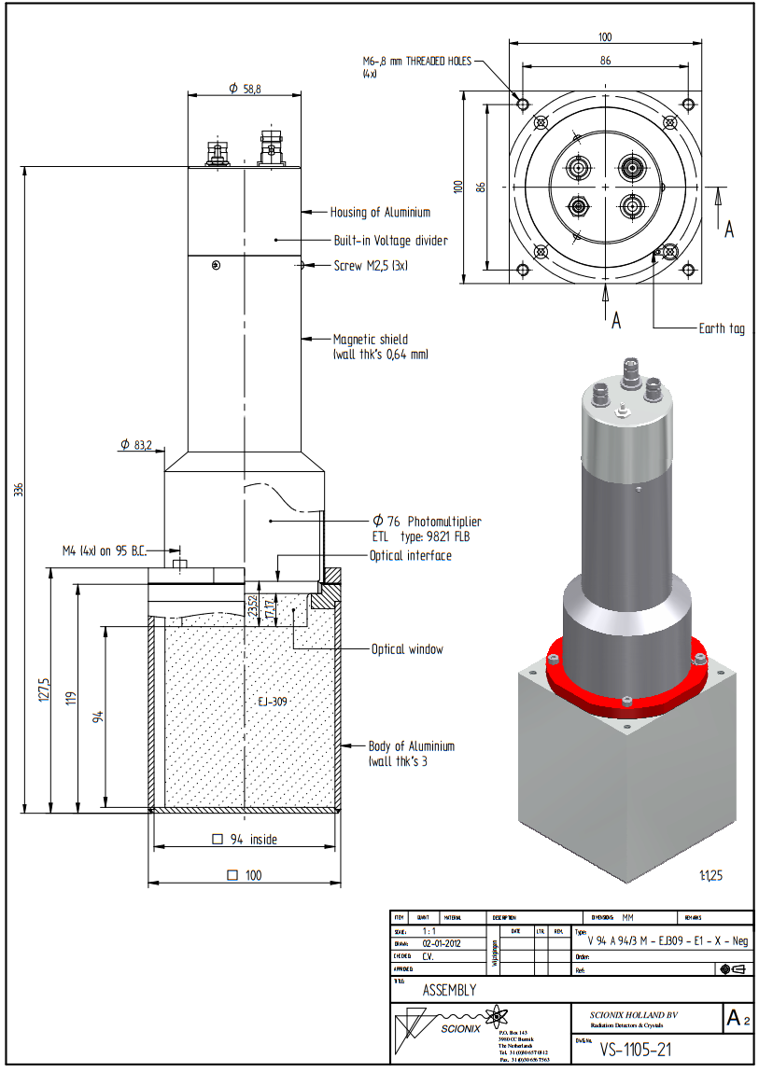

A.2 Hybrid Instruments Mixed Field Analysers
Specifications

System
Input voltage 28 V to 40 V DC, 80 W
Dimensions 35 cm x 26 cm x 11 cm
Mass 4.8 kg
Temperature range Operating: 0°C to 50°C

High voltage
Channels 4
High voltage max. -2000 V DC
Output voltage control PC software based graphical user interface
Regulation 0.001% for 0% to 100% load change
Stability 50 ppm/Hr, 200 ppm/8Hr
Temperature coef. 50 ppm/°C
Current limit 120% of maximum output current, 2 mA
Protection Short circuit and arc protected

Digitiser
Channels 4
Full scale range 20 mVpp to 600 mVpp user configurable Variable Gain Amplifier (VGA)
Impedance 50 Ohm
Resolution 12 bit bipolar
Sampling rate 500 MS/s
Acquisition window 148 ns
ADC clock On-board PLL using internal oscillator
Communication interface Ethernet (<5 kpps), TTL (3.3 Mpps), serial (debugging)
Onboard memory 32 Mbit EEPROM
Input protection Over limit diode protected

Digital TTL output
Impedance 50 Ohm
Current limit 20 mA
Switching time <1 ns
Idle state 3.8 V, high
Active state 0 V, low
Pulse width 50 ns
Max. PSD throughput 3.3 Mpps/channel
Input-to-output jitter <6 ns

A.3 BEGe Detector

Gamma Reference Source
Nuclide | Gamma-ray energy [MeVl | Activity | Emission rate  Is-Il
Americium-241  Cadmium-109  Cobalt-57  Cerium-139 Mercury-203  Tin-113  Strontium-85  Caesium-137 Yttrium-88  Cobalt-60  Cobalt-60  Yttrium-88 | 0.060  0.088  0.122  0.166  0.279  0.392  0.514  0.662  0.898  1.333  1.836 | 3.42E03  1.59E04  5.79E02  7.25E02  1.40E03  2.58E03  2.88E03  2.77E03  5.11E03  3.36E03  3.36E03  5.11E03 | 1.23E03  5.82E02  4.96E02  5.79E02  1.14E03  1.68E03  2.83E03  2.36E03  4.80E03  3.36E03  3.36E03  5.07E03

