Resonant cavity enhanced photodiodes on GaSb for the mid-wave infrared
A. P. Craig,^{1*} F. Al-Saymari,¹ M. Jain,² A. Bainbridge¹, G. R. Savich,³ T. Golding,^{2,3}
A. Krier,¹G. W. Wicks,^{3,4} and A.R Marshall¹
¹Physics Department, Lancaster University, Lancaster, LA1 4YB, UK.
²Amethyst Research Ltd., Kelvin Campus, West of Scotland Science Park, Glasgow G20 0SP, UK.
³Amethyst Research, Inc., 123 Case Circle, Ardmore, Oklahoma 73401, USA.
⁴The Institute of Optics, University of Rochester, Rochester, New York 14627, USA.

Abstract
We report the design, growth, processing and characterization of resonant cavity enhanced photodiodes for the mid-wave infrared at ~3.72µm on GaSb. Using AlAsSb/GaSb mirrors, AlAsSb barrier and spacer layers and a thin 96 nm InAsSb absorber, we observed dark current and detectivity behavior superior to common InAsSb nBn detectors in the literature, with peak specific detectivity values of $8×{10}^{10}$ and $1×{10}^{10} cm{Hz}^{1/2}W^{-1}$ measured at 250 K and 300 K, respectively. In the same temperature range, the linewidth of the detector response was <44 nm and the quality factor ~ 80. Peak quantum efficiency was > 60% where the enhancement due to the resonant cavity was ~ 20x. We estimate that the devices can operate close to, or slightly above, the BLIP limit imposed on broadband detectors for a 300 K scene.

*Corresponding author: a.craig1@lancaster.ac.uk
Infrared photodiodes operating in the mid-wave infrared (MWIR) have been subject to much develop-ment in recent years [1-5]. In particular, nBn detectors,[6] as well as bulk InAs, InSb and InAsSb, are now commercially available [7-8]. More intricate designs such as quantum well and cascade detectors are also being improved [9, 10]. The spectroscopic sensing of toxic or pollutant gasses is a primary application of MWIR detectors: CH4, CO2 and CO are well known examples, with absorption features around 3.3 μm, 4.3 μm and 4.6 μm, respectively. [11] However, given that many chemical agents, pollutants, or biological markers, have “fingerprint” IR absorption signatures, the detection of these substances is a further application. Warfare agents such as VX or Sarin are salient examples, known to exhibit signatures between 9 – 10 μm. [12] Spectroscopy-based detection is usually achieved using tunable lasers paired with broadband sensors. From the literature, resonant cavity enhanced (RCE) photodiodes can offer high spectral discrimination and reduced dark currents and noise compared with conventional photodiodes. [13-15] The principle of operation is the placement of a thin absorber layer within an optical cavity typically comprised of distributed Bragg reflector (DBR) mirrors. The dark currents and noise are reduced with the absorber thickness, whilst the mirrors select and enhance sensitivity in a narrow spectral band. From theory, the dark currents due to Auger and trap-related processes scale with the absorber volume, and both can be reduced by as much as two orders of magnitude compared with a conventional photodiode whilst maintaining strong quantum efficiency. RCE photodetectors were first practically realized in the 1980s and 1990s using GaAs/AlGaAs DBR mirrors, which are a mature technology due to VCSEL development. Several authors have reported InAs-based devices grown mismatched on GaAs, sensitive at ~3.1 µm.[16] Others have used InGaAs/ GaAs quantum wells. [17] InP-based devices have further been demonstrated with an InGaAs absorber, sensitive at 1.55 μm and grown lattice matched. [18] Further works have used PbTe films and Ge/As2S3 mirrors on Si. [19] For this work, III-Sb RCE photodiodes were envisaged as ideal candidates for use in detection systems targeting a wide range of substances, due to their extended detection wavelength, high spectral selectivity, and low dark currents and noise. An RCE photodiode design was conceived and grown on GaSb. The choice of a GaSb substrate allows for an extension of the operating wavelength. For the present work, 96 nm of InAs0.91 Sb0.09 allowed for sensitivity at ~3.72 μm and proof of concept. However, in principle, similar designs can be extended to the long-wave infrared by using quantum confined III-Sb absorbers such as InAsSb/InAs superlattices or quantum wells. The principal challenge in transitioning to a GaSb substrate is the realization of AlAsSb/GaSb DBR mirrors.
All growth was performed by III-V molecular beam epitaxy (MBE) using a Veeco GENXplor solid source reactor. SUMO cells were used for Al, Ga and In, whilst valved cracker cells provided As2 and Sb2 fluxes. GaSb wafers under-went oxide desorption at 530 C before cooling to 505 C for epitaxy. The epilayer structure is shown in Figure 1. The AlAs0.08Sb0.92 layers (hereafter “AlAsSb”) and GaSb layers were grown at 505 C and the InAs0.91Sb0.09 layers were grown at 450 C. V-III growth rate ratios of >2 and deposition rates of ≤ 1ML/s were used throughout. A compensation doping scheme was applied to the 211 nm AlAsSb layers, as optimized through a series of calibration growths with varying Ga2Te3 cell temperatures. X-ray diffraction (XRD) scans were obtained using a Bede QC200 diffractometer, which showed strain < 500 ppm for each layer. For each wafer, common processing steps were used for standard photolithography and wet-chemical etching. After removing the top mirror, mesas were defined using just 30 nm of n-InAsSb to designate the active device area. This narrow gap layer acts as a contact layer not contributing to absorption, since it is both thin and posit-ioned at the node of the optical field. The AlAsSb upper cavity spacer layer, chosen to consist of a wide gap material not contributing to dark current, or absorption at the resonant wavelength, was left unetched – effectively using a shallow-etch or “nBn style” processing scheme. The effect of this is to suppress surface and defect related dark currents. [20] The 96 nm absorber was sited within the optical cavity to closely coincide with the antinode (maximum) of the optical field, as shown on the right-hand side of Figure 1. In addition to the RCE photodiode, reference devices were grown
Sample | InAsSb Absorber thickness | Mirrors
RCE photodiode | 96 nm | Yes
RCE photodiode reference | 96 nm | No
nBn reference | 2 μm | No
Table 1: List of samples grown

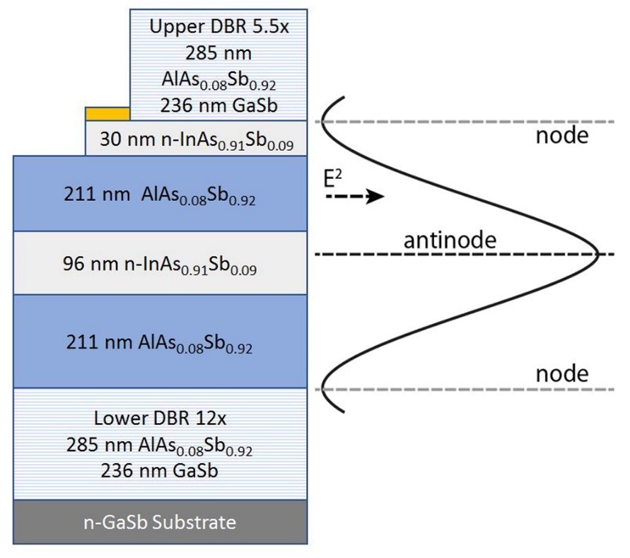
Figure 1: RCE photodiode epilayer structure. Right hand side: optical field intensity.
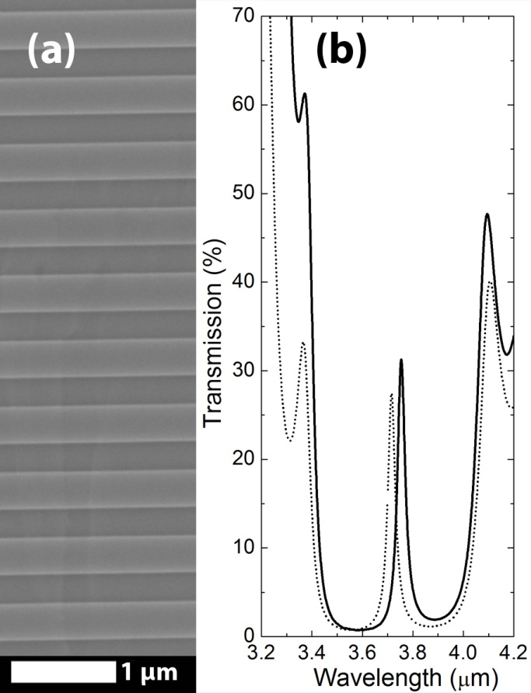
Figure 2(a) SEM micrograph showing the RCE photodiode lower mirror. (b) RCE photodiode experimental transmission at 300 K (solid line) showing the resonant peak at 3.72 µm, and a modeled curve (dotted line) with good agreement.
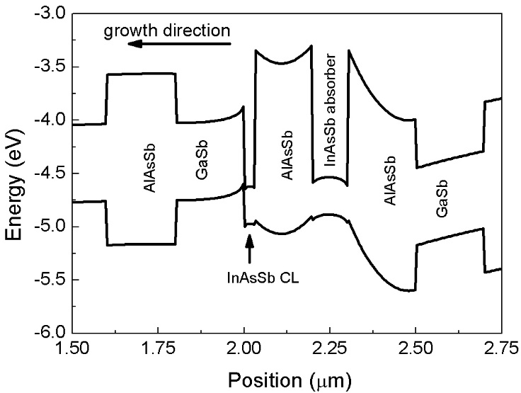
Figure 3: RCE photodiode band diagram, showing the AlAsSb/GaSb mirrors, the 96 nm InAsSb absorber, AlAsSb spacer layers and the InAsSb contact layer (CL).
and fabricated using the same epilayer structure, but without the DBR mirrors. The RCE photodiode reference was grown with the same absorber thickness (96 nm) as the RCE photodiode and the nBn reference was grown with a 2 μm-thickness absorber. All samples are summarized in Table 1. All me-tallizations were made using Ti/Au. Current-voltage (IV) measurements were made using a Keithley 2450 Sourcemeter and a Lakeshore TTPX low temperature probe station, equipped with a removable radiation shield. Spectral response was measured as a function of temperature using an Oxford Instr-uments OptistatDN-V cryostat, and a Bruker Vertex 70 FTIR, calibrated using an HgCdTe detector.
To obtain a high quality factor the DBR mirrors must have good interface morphology and periodi-city; a scanning electron micrograph and transmission data are shown in Figure 2. Modeling of the RCE photodiode wafer transmission was performed using a transmission line model and an absorption coefficient of α=4000 cm⁻¹ for InAsSb, and by assuming α=0 elsewhere. Confirming the accuracy of the cavity thickness prior to fabrication, Figure 2(b) further shows both experimental and modelled transmission scans with peak response at ~3.72 μm. The cavity is designed to share the properties of an nBn detector, i.e. diffusion current-limited leakage scaling with the absorber volume. The RCE photodiode band structure is shown in Figure 3[21] showing that, as for an nBn detector, the AlAsSb

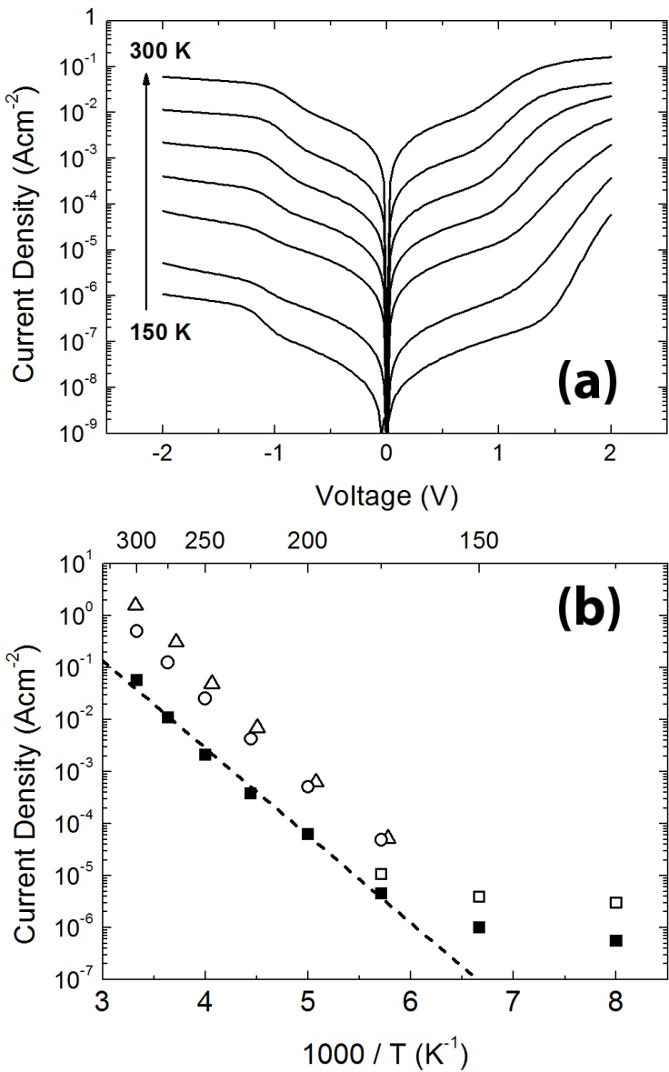
Figure 4(a) Cold-shielded dark current measurements for the RCE photodiode at 25 K increments between 150 and 300 K. (b) Arrhenius plot showing the RCE photodiode dark current (∎), the current with 300 K background flux (□) and data for nBn detectors (with 2 μm thickness absorbers) from this work (○) and reproduced from [5] (∆) with the permission of AIP Publishing. The dotted line shown an activation energy fit giving Ea = 0.33 eV.
layer above the absorber blocks majority carriers, suppressing dark current but allowing photogen-erated holes to flow. In the simulation, the compensation doping is included so that the overall carrier concentration is n-type at a level of $4×{10}^{16} cm^{-3}$.
The RCE photodiode dark current density has a temperature dependence shown in Figure 4(a). The dark current was found to have an area scaling behavior, with a weak perimeter contribution attributed
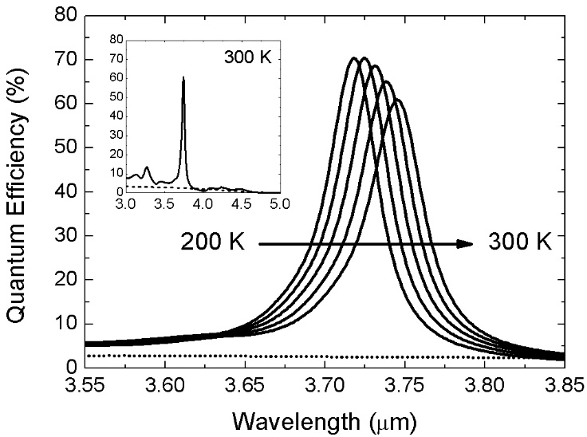
Figure 5: Solid lines show the RCE photodiode spectral response at 25 K increments between 200 - 300 K at -1.9 V applied bias. Dotted line shows the RCE photodiode reference response at 300 K. The inset shows the same data on a reduced scale.
simply to a diffusion length effect around the mesa perimeter. In Figure 4(b) an Arrhenius plot for the RCE photodiode was fitted with an activation energy of 0.33 eV which is close to the absorber bandgap (~0.35 eV) indicating that the devices are diffusion current limited. At temperatures between 200 – 300 K the mean dark current reduction is by a factor of ~11 compared with the nBn reference and by a factor of ~26 and compared with ref [5] (both use a 2 μm-thickness absorber). The bias conditions were -0.5 V for the nBn reference and -0.25 V for ref [5] for which the quantum efficiency was 30-35% in each case. In theory the absorber thickness can be reduced further, leading to additional reductions in the dark currents – we estimate that a 20 nm absorber (dark current scaling by 50-100x) is achievable.
In theory, RCE photodiodes are not subject to the same BLIP limit as conventional photodiodes since off resonance radiation is not enhanced – in other words resonant cavity devices will detect only a small fraction of the background radiation. Accordingly, there is also data shown in Figure 4(b) where the RCE photodiode was exposed to 300 K background radiation by removing the radiation shield from the cryogenic probe station. In this condition, the detector field of view is 54° and the scene temperature (in other words the glass and stainless-steel body of the probe station) is 300 K. The BLIP temperature is found to be ~170 K, with the data merging with the dark current above ~200 K.
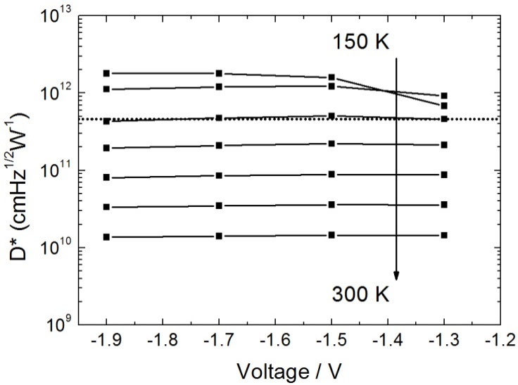
Figure 6: Peak specfic detetivity for the RCE photodiode near ~3.72 µm, between 150 and 300 K in 25 K increments. The dotted line indicates the BLIP condition for a comparable broadband detector due to a 300 K scene under the same conditions.
The RCE photodiode maintains quantum efficiency (QE) for a thinned absorber. Figure 5 shows spectral QE between 200 and 300 K, in 25 K increments. Peak values between 60 - 70% indicate an enhancement factor of >20 due to the resonance. Exposed InAsSb absorber area around the etched mirror contributes to residual sensitivity away from the resonant wavelength. However, this can be eliminated, if desired, by design of mask-set and processing. In Figure 5, this has been subtracted from the data for the RCE photodiode.
The temperature dependence of the resonant wavelength depends on the cavity width and the refra-ctive index. Between 200 and 300 K, the effects of thermal expansion upon the cavity were calculated to account for a ~0.04% change in thickness only [22]. This is not enough to account for the shift in the resonance position, which varies between ~3.72 and ~3.76 μm over the same temperature range (~1%). Therefore, temperature shifts in the refractive indices for the cavity layers are believed to be the dominant effect varying the resonant wavelength. However, these are not well documented in the literature at present. The width of the resonance peak is < 44 nm at all temperatures, falling from ~44 nm at 300 K to ~40 nm at 200 K with a quality factor of ~80. From theory, the width varies with the number of periods in the DBR mirrors. Modelling shows that the width of the resonance can be reduced further in principle, albeit the cavity thickness defines the center wavelength and this is difficult to control with ever-increasing precision during growth.
For the RCE photodiode, peak specific detectivity (D*) was calculated from the unshielded dark curr-ent density and the photoresponse in the shot and Johnson noise limited regime. The optimum oper-ating voltage was found to be between -1.5 and -1.9 V. The response was found to be almost flat in this bias range, after rising rapidly between -1.1 and -1.3 V, an effect attributed to bending of the valence band in the 211 nm AlAsSb spacer layers. This is in turn attributed to the compensation doping in the AlAsSb layers, which was introduced to ensure flat bands in the thin absorber. D* was found to exceed that measured for common InAsSb broadband nBn detectors in the literature for similar temperatures [e.g. 5] and is illustrated between 200 – 300 K in Figure 6. Peak values of 8$×{10}^{10} cm{Hz}^{1/2}W^{-1}$ were achieved for 250K, a temperature noted to be compatible with common thermoelectric coolers (TECs). Room temperature operation is also amenable, the detectivity was ~ $1×{10}^{10} cmHz^{1/2}W^{-1}$ at 300 K. A radiometric calculation of the background photon flux was carri-ed out to determine the expected photocurrent due to radiation originating from the body of the probe station. The emissivity of stainless steel and glass were taken as 0.1 and 0.9 [23] and the detector field of view was measured to be 54°. Under these conditions, the background photocurrent density for a comparable broadband photoconductor with 35% quantum efficiency between 2 – 4 μm (as is the case approximately for an InAsSb nBn, e.g. ref [5]) was calculated to be $1.5×{10}^{-5} Acm^{-2}$. The BLIP limit is then ~$5×{10}^{11} cmHz^{1/2}W^{-1}$. This figure is exceeded by our devices at temperatures below 200 K.
In summary, resonant cavity photodiodes were demonstrated at ~3.72 µm on GaSb using AlAsSb/ GaSb mirrors and an InAsSb absorber. Dark currents lower than, and quantum efficiency higher than, for conventional nBn detectors and a spectral width of < 44 nm were demonstrated. The specific detectivity at 300 K was found to exceed 10¹⁰ cmHz^{1/2}W⁻¹. By considering the background photo-current for a 300 K scene, it was shown that RCE photodiodes can exceed the fundamental BLIP limit of a broadband photodetector.
The authors would like to thank UK MOD and DSTL for funding under grant DSTLX:1000116341 and the EPSRC for the PhD studentship of A. Bainbridge under grant ref. EP/R513076/1.
[references]
[1] Rogalski, A. Infrared Detectors (2nd ed.) (Boca Raton, FL, CRC Press, 2011).
[2] “Antimonide-based Infrared Detectors: A New Perspective” A. Rogalski, M. Kopytko and P. Martyniuk, (SPIE Press 2018).
[3] A. P. Craig, M. D. Thompson, Z.-B. Tian, S. Krishna, A. Krier and A. R. J. Marshall Semicond. Sci. Technol. 30 (2015) 105011
[4] J. B. Rodriguez, E. Plis, G. Bishop, Y. D. Sharma, H. Kim, L. R. Dawson, and S. Krishnaa Appl. Phys. Lett. 91, 043514 (2007)
[5] A. Soibel, C. J. Hill, S. A. Keo, L. Hoglund, R. Rosenberg, R. Kowalczyk, A. Khoshakhlagh, A. Fisher, D. Z.-Y. Ting, and S. D. Gunapala, Appl. Phys. Lett. 105 023512 (2014).
[6] P. C. Klipstein, Y. Gross, D. Aronov, M. ben Ezra, E. Berkowicz, Y. Cohen, R. Fraenkel, A. Glozman, S. Grossman, O. Klin, I. Lukomsky, T. Marlowitz, L. Shkedy, I. Shtrichman, N. Snapi, A. Tuito, M. Yassen and E. Weiss in Proc. SPIE 8704, Infrared Technology and Applications XXXIX, 87041S (2013).
[7] “PV-2TE Series 2 – 12 μm IR Photovoltaic Detectors Thermoelectrically Cooled”, VIGO System S.A. (2015).
[8] “Indium Antimonide detectors”, Teledyne Judson Technologies (March 2003).
[9] S. D. Gunapala, S. V. Bandara, J. K. Liu, C. J. Hill, S. B. Rafol, J. M. Mumolo, J. T. Trinh, M. Z. Tidrow and P. D. LeVan, Semicond. Sci. Technol. 20, 473 (2005).
[10] Z.-B. Tian, T. Schuler-Sandy, and S. Krishna, Appl. Phys. Lett. 103, 083501 (2013).
[11] A. Krier, M. Yin, V. Smirnov, P. Batty, P. J. Carrington, V. Solovev, and V. Sherstnev, Phys. Stat. Sol. (a) 205, No. 1 (2008).
[12] A. J. Mott, P. Rez, Spectrochimica Acta Part A 91 (2012) p. 256– 260.
[13] K. Kishino, M. Selim Unlu, J.-I. Chyi, J. Reed, L. Arsenault, and H. Morkoq, IEEE J. Quantum Electron. VOL. 21, NO. 8, (1991)
[14] M. Selim Unlu, J. Appl. Phys., Vol. 78, No. 2, 15 July (1995).
[15] T.A. O’Loughlin, G.R. Savich, D.E. Sidor, B.R. Marozas, T.D. Golding, K.D. Jamison, L. Fredin, B. Fowler, W. Priyantha, and G.W. Wicks, J. Vac. Sci. and Technol B 35, 02B111(2017).
[16] A. M. Green, D. G. Gevaux, C. Roberts, P. N. Stavrinou and C. C. Phillips, Semicond. Sci. Technol. 18 964 (2003).
[17] F. Y. Huang, A. Salvador, X. Gui, N. Teraguchi and H. Morkoc, Appl. Phys. Lett. 63, 141 (1993).
[18] A. G. Dentai, R. Kuchibhotla, J. C. Campbell, C. Tsai, C. Lei, Electron Lett. Vol. 27 No. 23 (1991).
[19] J. Wang, J. Hu, P. Becla, A. M. Agarwal, L. C. Kimerling, Vol. 18, No. 12 / Opt. Express 12890 (2010).
[20] S. Maimon and G. W. Wicks (2006) Appl. Phys. Lett. 89 151109.
[21] D. W. Winston, “Physical Simulation of Optoelectronic Semiconductor Devices” Thesis (PH.D.)--UNIVERSITY OF COLORADO AT BOULDER, 1996.Source: Dissertation Abstracts International, Volume: 57-04, Section: B, page: 2779.
[22] I. Vurgaftman, J. R. Meyer, and L. R. Ram-Mohan, J. Appl. Phys., Vol. 89, 11 (2001).
[23] S.I. Woods, T.M. Jung, D.R. Sears, J. Yu, Cryogenics 60 p 44–48 (2014).

