Further details of individual tasks

Theodora Alexopoulou
University of Cambridge

Marije Michel
Lancaster University

Akira Murakami
University of Cambridge

Detmar Meurers
University of Tübingen

Further details of individual tasks

Narrative Tasks: Movie Plot (6.1) and Memorable Experience (7.4)
The first task is a narrative from level 6, shown in Figure 1. It asks learners to continue the story of a movie plot so to help a friend improve her story. This task is set in an informal environment as it is meant to help a friend. The student is required to come up with a story based on creativity. Yet as the first part of the movie plot is given, the story needs to continue making reference to the same characters and scenes for a coherent narrative.
In terms of grammar, the unit leading up to this task focuses linguistically on adjectives to describe a movie (fascinating, spectacular) and adverbs (first, then, suddenly, incredibly) to support telling a movie plot (in one of the preceding tasks learners are asked to help a friend improve a summary of a movie plot by filling in gaps with adverbs like suddenly, unfortunately etc.). The learners are presented with the first part of the plot which could serve as a model for the free writing task. The first part of the plot is written in present tense using mostly main clauses, co-ordination or simple sub-ordination with because or when.
Throughout the unit, learners have seen and could listen to several examples of movie plots. They can read a chat interaction between two friends who discuss a movie and they do several fill-in-the-gaps activities where they have to provide adjectives and adverbs. Before this final task, they have another attempt at telling a movie plot where they are encouraged to use a model provided.
Our second narrative task (Figures 2 and 3) comes from level 7. It provides students with an email of their friend Tim who tells about a remarkable experience during a holiday trip and at the end asks: “Has anything like that ever happened to you?” (Figure 2). Learners then click on the white tab to remove the email and reach the writing screen (Figure 3), where they are asked to reply to that email by telling about a memorable event they experienced themselves. The email of their friend is written mainly using past tense (apart from the opening and closing formula of the email) and provides ample examples of temporal connectives. Reflecting the higher teaching level (7) this time, the example also shows instances of indirect speech, use of modal verbs (In hindsight, we should) and a variety of punctuation ( -, ; “ ! ?). The email sets the task in an informal context and the student has to tell a personal experience from memory. The unit leading up to this task focuses on personal experiences and leisure activities. Exercises deal with the use of adjectives (e.g., exciting, bizarre) and tense in narratives (simple past versus past continuous).
Descriptive Tasks: Meal Complaint (6.7) and Holiday Complaint (7.7)
Turning to the descriptive tasks, at level 6 (Figure 4) learners are requested to leave a note in the guest book of a restaurant where they just had a disgusting meal. The task provides guidelines on what to comment on (e.g., starter, main course and dessert) and states that a description of the food and drinks and their taste is required. The unit leading up to this task is about going to a restaurant. The linguistic focus lies on adjectives describing flavors and tastes as well as on polite requests and complaints, i.e., students listen to and see several models of restaurant complaints. Throughout the unit they also have to write several short reviews of how food tasted. The task is set within a semi-formal setting, i.e., a complaints book of a restaurant, typically a hand-written note.
Our second descriptive task comes from level 7 (Figure 5). It asks students to help a friend to write a letter of complaint about a holiday. The friend was on a holiday cruise but the experience was completely different from what was announced in the leaflet. The leaflet, which is shown next to the writing screen, talks in flowery language about the beauty of the holiday destination and the luxury accommodation at a low cost. Learners then listen to their friend telling about the contrasting experience. They are asked to take notes and use that information and the leaflet when writing the letter of complaint. The preceding unit targets positive versus negative adjectives (un-/friendly, im-/polite) and students’ attention is drawn to the difference between formal versus informal complaints. Given that this is an official letter of complaint, the task is set in a formal context.
Professional Tasks: CV (6.4) and Job Advert (7.3)
Finally, two tasks have been chosen that do not represent a specific task type but they both are situated within the same formal professional environment (finding a job) requiring students to produce text that typically follows a very narrow genre-specific language use and lay out. Both tasks ask students to act within this formal professional context and the units preceding the tasks introduce learners to this formal language use.
Task 6.4 (Figure 6) asks students to write a resume as an answer to a job advertisement. Learners are required to follow the genre-specific convention of a resume, i.e., bullet-pointed summary of work experience, education and skills. Typically, no full sentences (no subjects, nonfinite verb forms) are used while the language is characterized by compound nouns and adjectives (e.g., excellent computer skills).
The unit introducing this task shows examples of job advertisements, letters of invitation/acceptance to a job interview and resumes. The language focus lies on formal English within the professional context as e.g., in a resume.
The final task comes from level 7 (Figure 7) and seems to be a complementary task to 6.4. This time, L2 users are required to write a job advertisement based on provided specifics for that job (e.g., company name, location, duties, educational requirements). So, in 7.7 all the information is given as is the most important lexis but the learner needs to write full sentences that fit within the specific genre of a job advertisement using appropriate language and layout.
The unit that leads up to this task provides several examples of job advertisements while the language focus lies on the pronunciation (stress pattern) of 3- and 4-syllabic adjectives.

Figures
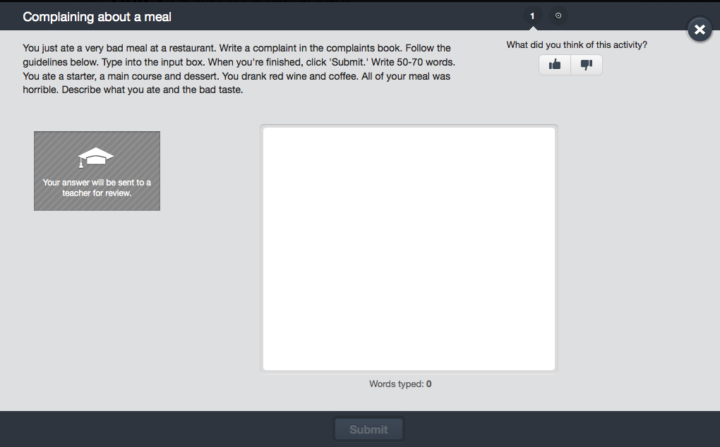
Figure 1. Englishtown Task 6.7: Complaining about a meal
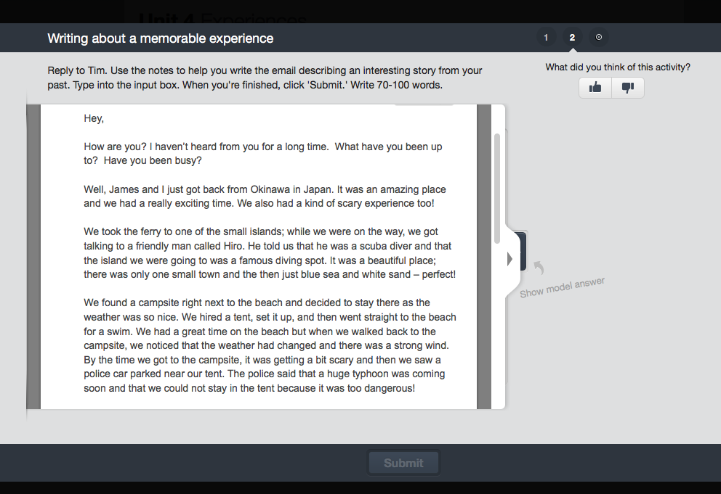
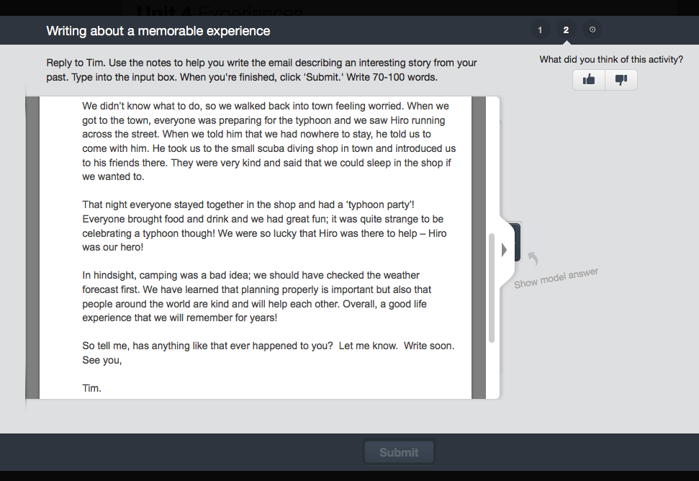
Figure 2. Englishtown Task 7.4: Writing about a memorable experience (I).

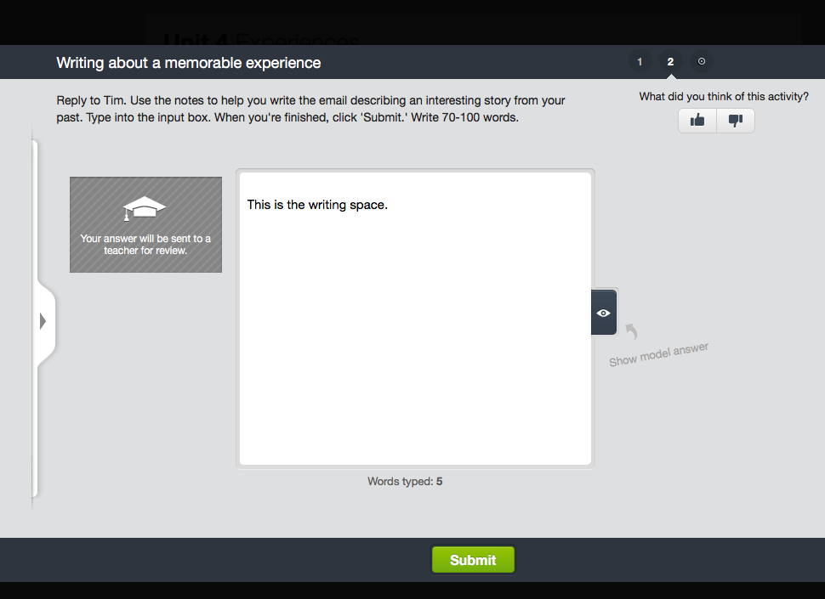
Figure 3. Englishtown Task 7.4: Writing about a memorable experience (II).

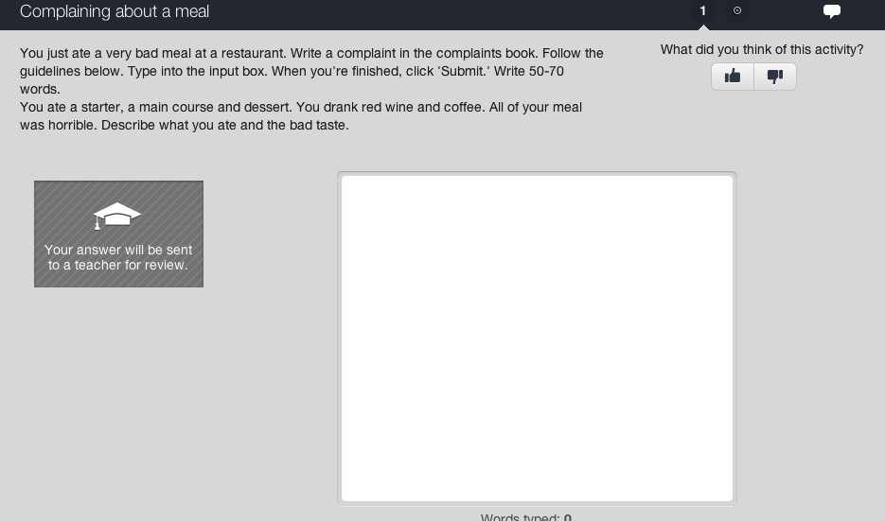
Figure 4. Englishtown Task 6.7: Complaining about a meal

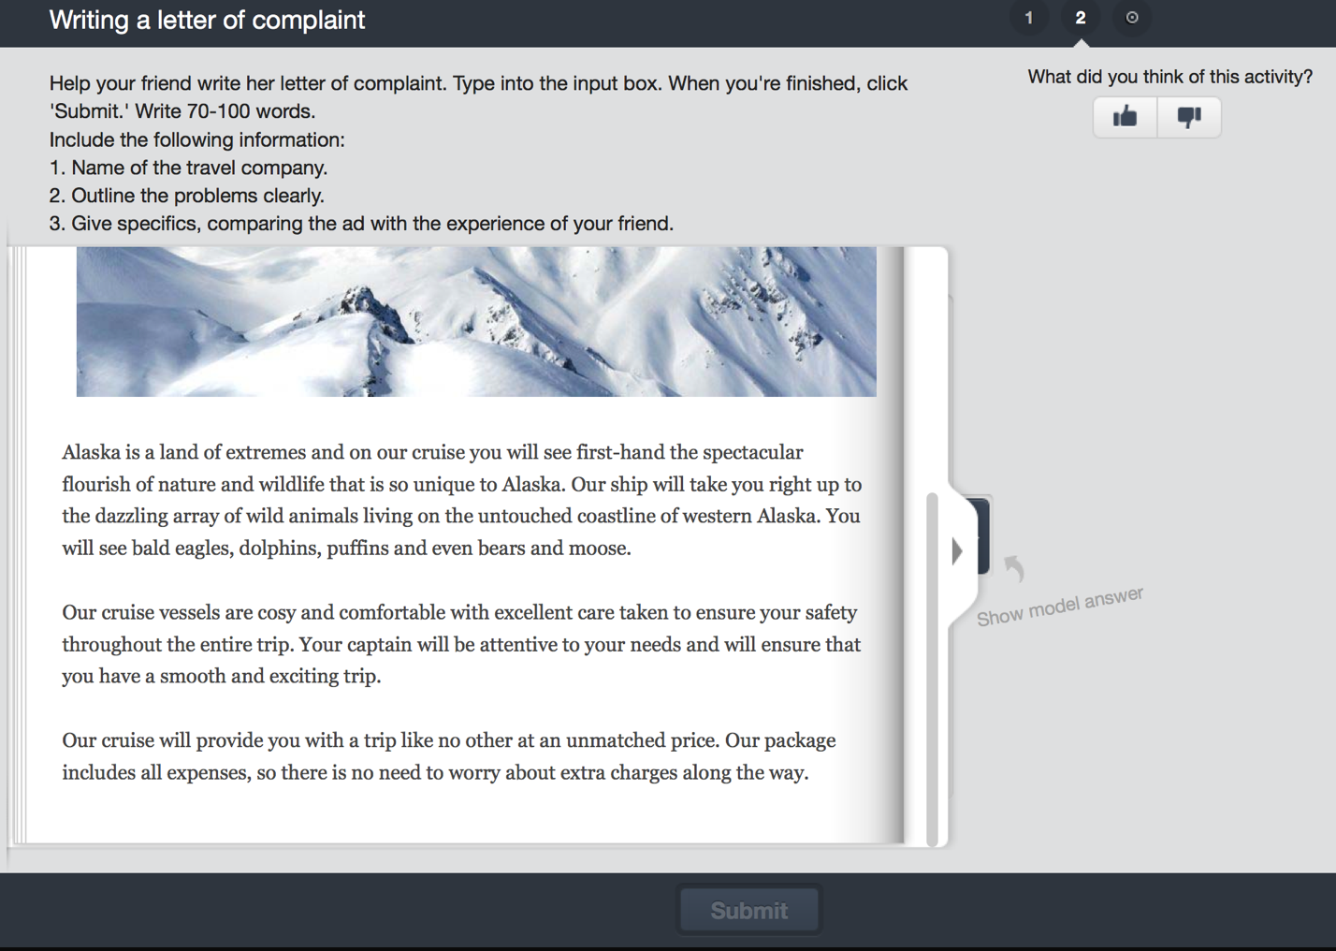
Figure 5. Englishtown Task 7.7: Writing a letter of complaint

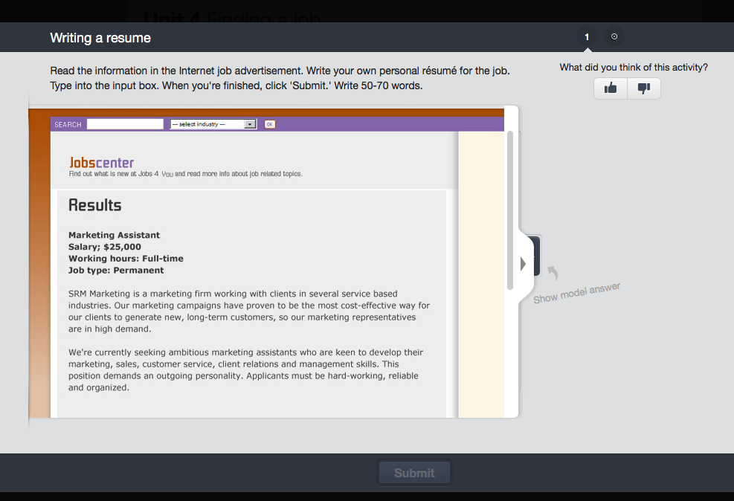
Figure 6. Englishtown Task 6.4: Writing a resume

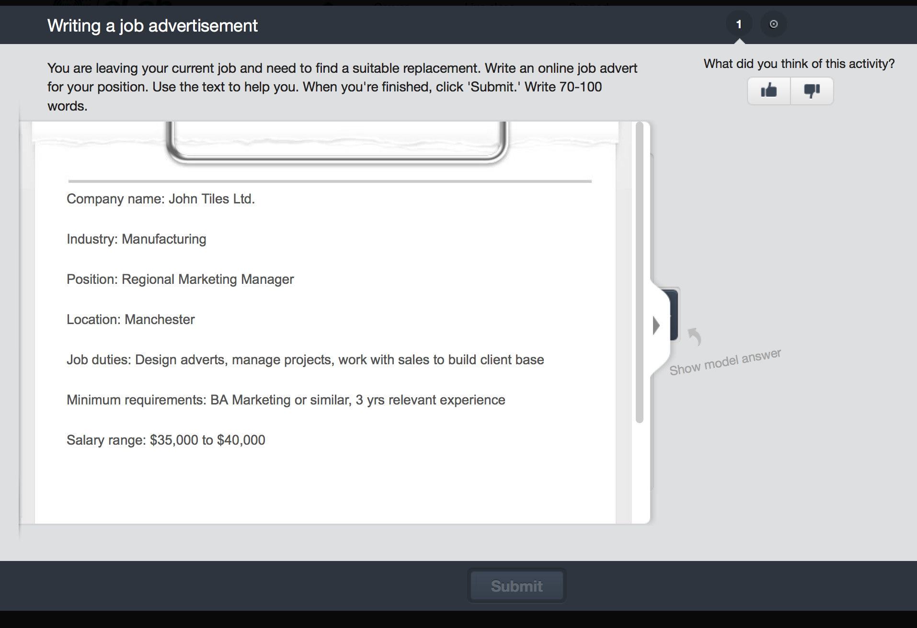
Figure 7. Englishtown Task 7.3: Writing a job advertisement

