A Surrealist Inspired Mobile Multiplayer Game: Fact or Fish?

Abstract

Copyright is held by the author/owner(s).

FNG2006, June 26–28, 2006, Preston, England.
ACM 1-xxxxxxxxxxxxxxxxxx.
Will Bamford
Informatics
Infolab21
Lancaster University
Lancaster, LA1 4WA, UK
w.bamford@lancaster.ac.uk

Paul Coulton
Informatics
Infolab21
Lancaster University
Lancaster, LA1 4WA, UK
p.coulton@lancaster.ac.uk

Reuben Edwards
Informatics
Infolab21
Lancaster University
Lancaster, LA1 4WA, UK
r.edwards@lancaster.ac.uk

With mobile phone ownership now saturated in many countries, mobile operators are looking to data services to increase their average revenue per user and one service seen as a key to their success is that of mobile games. Single player games, which currently dominate the market, do little to increase data traffic once downloaded. Therefore, focus is increasingly turning to multiplayer games that use the network. However, to date, game designers have struggled to create successful mobile multiplayer games because their current designs are based on the experiences gained from the PC and console world and often fail to accommodate both the difficulties of the mobile environment and the differing demographic of the mobile gamer. In this paper we explore game design that will address both of these criteria and take our inspiration from a technique used by Surrealists to create accidental poetry in the 1920s.

Keywords
mobile, multiplayer, game design, gamer demographics, surrealism, exquisite corpse

ACM Classification Keywords
J. Computer Applications, J.7 Computers in Other Systems-Consumer.

Introduction
There is little doubt that with global mobile subscriptions having reached 2 billion users [5] the mobile phone has become the most pervasive consumer device. Mobile games are seen as an important service for many of these consumers by both the network operators and the games industry. Operators are currently trying to drive up the Average Revenue Per User (ARPU) by encouraging greater use of data services and games are seen as a means to achieve this. The games industry also sees this as an enormous opportunity for increasing sales and customer base, indeed, mobile games already represent 14% of $43 billion total world gaming revenue [6] and many current predictions would suggest that the mobile platform will become the dominant force in games. However, the mobile games market is currently dominated by single player or quasi Peer to Peer (P2P) games (using short range communications such as Bluetooth) which do little to increase data traffic. Whilst there are some successful massively multiplayer games which do generate data traffic on the internet, the nature of mobile users and their environment means that new design approaches need to be considered. Additionally, these mobile games have been dominated by the so-called ‘casual’ titles [2] which attract a particular user demographic that the games industry has often failed to adequately engage.
If we first examine the mobile environment, there are a number of issues to be addressed to ensure a successful design such as:
- The network latency can be as high as a few seconds in mobile, which is too long for the majority of fast action multiplayer games.
- Users dropping out of games due to either accidental loss of connectivity (such as loss of signal while going through a tunnel) or deliberate disconnection to perform another task (such as answering a call).
- Mobile application usage tends to be spontaneous rather than planned and is often used to fill spare moments resulting in short game sessions.
- Extremely variable capabilities of individual users’ phones (e.g. screen resolution and key layout) and software platform.

In relation to the demographic of mobile users playing games, Glu Mobile’s 2005 UK survey showed that the classic image of the PC or console gamer as an 18-35 year old male is incorrect for mobile. The main demographic is much more varied as 16% of all phone users regularly play games on their phone, although this rises to 29% in the 16-24 age group, and just as many women as men play games on their mobile phones. In terms of ethnicity, where gamers have traditionally been predominantly white, a report from 2005 by NPD group on US mobile gamers indicate that they are twice as likely to be African-American, Hispanic or Asian. Although the demographic of mobile gamers is different to that of console gamers, they are often simply divided into the two traditional broad categories used by the games industry, that of casual gamer and hardcore gamer [4]. Whilst many in the console games industry have fairly well established techniques for targeting the hardcore gamer, the casual gamer has proved more elusive and success stories in this area, such as ‘The Sims’ by EA Games, have often proved surprising. In fact there is growing criticism, both inside and outside the games industry, that the very large budgets now required to produce a game result in creativity being stifled with too few risks taken in relation to the game play design.
Before we consider mobile gamers specifically, it is worthwhile considering the popular profiles of hardcore and casual gamers [4], as they are undoubtedly influencing industry expectations about the mobile gamer.
Hardcore Gamers:
- Purchase and play many games;
- Enjoy longer play sessions and regularly play games for long periods;
- Are excited by the challenge presented in the game;
- Will tolerate high levels of functionality in the user interface and often enjoy mastering the complexity;
- Often play games as a lifestyle preference or priority.

Casual Gamers:
- Buy fewer games, buy popular games, or play games recommended to them;
- Enjoy shorter play sessions – play in short bursts;
- Prefer having fun, or immersing themselves in an atmospheric experience;
- Generally require a simple user interface (e.g. puzzle games);
- Consider game playing as another time-passing entertainment like TV or films.

It is often assumed within the games industry that casual gamers form the majority of mobile gamers [3]. We believe this is an over simplification, as the nature of the mobile environment is a major contributor to the formation of gaming habits. There is a strong argument that the game industry must establish new definitions specifically for mobile. In an interview for the Game Daily Biz in February 2006, Jason Ford, General Manager for Sprint Entertainment, defined two specific types of hardcore mobile gamer:
- “First there are the ‘cardcore’ mobile gamers. These are people who play casual games in a hardcore fashion. The type that might spend hours and hours trying to get a Bejeweled high score but don’t own a gaming console.”
- “Second is the ‘hard-offs’. These are your more typical hardcore gamers, who are playing off their normal platform. They’re the type more likely to check out the mobile version of a hit console title, because they know and like the brand.”

Additionally at the 2006 CES panel discussion ‘Future of Mobile Games‘, IDG’s CEO, Dan Orum, stated:

"We're seeing an emergence of the 'social gamer’, they're like the typical 'hardcore gamer', but with social lives."
Whilst these definitions form part of the profile of mobile gamers, it further highlights that the industry perceive the player demographic for mobile from its experience of the PC and console market and it is still fixated with the hardcore gamer. In our research to better understand the likely demographic for a MMMG we studied some of the work from International Hobo on producing better game design [1]. Although this work was developed in relation to console gaming and internet multiplayer games, we felt that it highlights some generic gamer personality traits that could be utilized for mobile. They produced a classification for both hardcore and casual gamers based on clusters from the personality types of the Myers-Briggs Dichotomies, which is used to classify individuals’ personalities. They called these types:
- “The Conqueror is actively interested in winning and ‘beating the game’. In single-player games, completing the game generally counts as winning, while in multiplayer the goal is to beat the other players – either way, winning is the most important factor to these players.”
- “The Manager is generally looking for a strategic or tactical challenge. They are interested in the mastery of the game – that is, the process oriented challenge of learning how to play well. Winning is to some extent meaningless to the Manager-type player if they have not earned it.”
- “The Wanderer is a player in search of a fun experience. They won’t play a game they aren’t enjoying, and will in fact stop playing the moment it ceases to be fun.”
- “The Participants are the largest group in the population. Very little is known about them except that they are often very story-oriented and will generally only play games as a social experience. They wish to participate either in the story the game is offering, or participate with other players in some emotional context.”

International Hobo’s research study indicates that the majority of game players actually fall into the class of wanderer. However, more generic Myers-Briggs based research would indicate that the majority of the rest of the population are generally considered participants and International Hobo admitted this group was underrepresented in their study. Therefore, we have not restricted our design simply to the hardcore or casual gamer, but rather wanderers and participants that we feel are likely to be most representative of the average phone user.
Using this as the initial inspiration for the project presented in this paper, we have explored a simple to use and easily understood game that:
- can be played is short bursts;
- avoids repetitiveness and has a strong element of fun;
- is story orientated;
- has a simple user interface and can be played across a wide range of mobile phones;
- provides a social experience.

The outcome is a novel multiplayer mobile game called ‘thetxtbk’, based on the surrealist technique of ‘Exquisite Corpses’ and the old Victorian parlour game of ‘Consequences’. The game builds to produce a massively multi-authored book.

Game Design and Implementation
Exquisite Corpse is a word game developed by surrealists in 1920s Paris as a means of ‘discovering’ accidental poetry. It has its roots in the parlour game of Consequences which was designed to be played by five to nine players after dinner by Victorian ladies and gentlemen. The surrealist version is generally played by four or more people who all have a pencil and paper. To start, each player writes an adjective, then folds the paper to hide this word and then passes their paper to the next player. The process continues until the sequence of adjective, noun, adverb, verb, adjective, noun has been completed. The sentences are then read out by the players. One of the results from the first playing of the game was “Le cadavre exquis boira le vin nouveau” (The exquisite corpse will drink the new wine) which is how the technique obtained its name (www.exquisitecorpse.com).
In this project we build on the game premises previously outlined and have adapted them to produce a mobile game called ‘thetxtbk’, which is based around the standard SMS message length of 160 characters. Each player takes a turn writing a contribution to the book based upon only the last 160 characters entered. There are a number of reasons for basing the system of an SMS message:
- Firstly, although the system is based on Wireless Application Protocol (WAP), and the length of the message is entirely a design choice, we felt WAP still has a very negative image with consumers due to the disastrous launch on GSM. SMS messaging, however, is incredibly popular and well understood, with over 85 million text messages sent everyday in the UK alone (www.textit.com);
- Secondly, allowing a short message, rather than an individual word, allows for greater creativity, increased sense of individual game play and avoids the need to control the type of word at each stage;
- Thirdly, SMS messaging is often used to support social groupings and creating a community relationship is often seen as an important aspect to the success of multiplayer games.

The system developed to support the game consists of a central server database written in MySQL, which holds both the entries in the book and names of the contributing authors. To distribute the game we have utilized an SMS message which contains both an invitation to contribute to the book and the link to the WAP site as shown in figure 1.
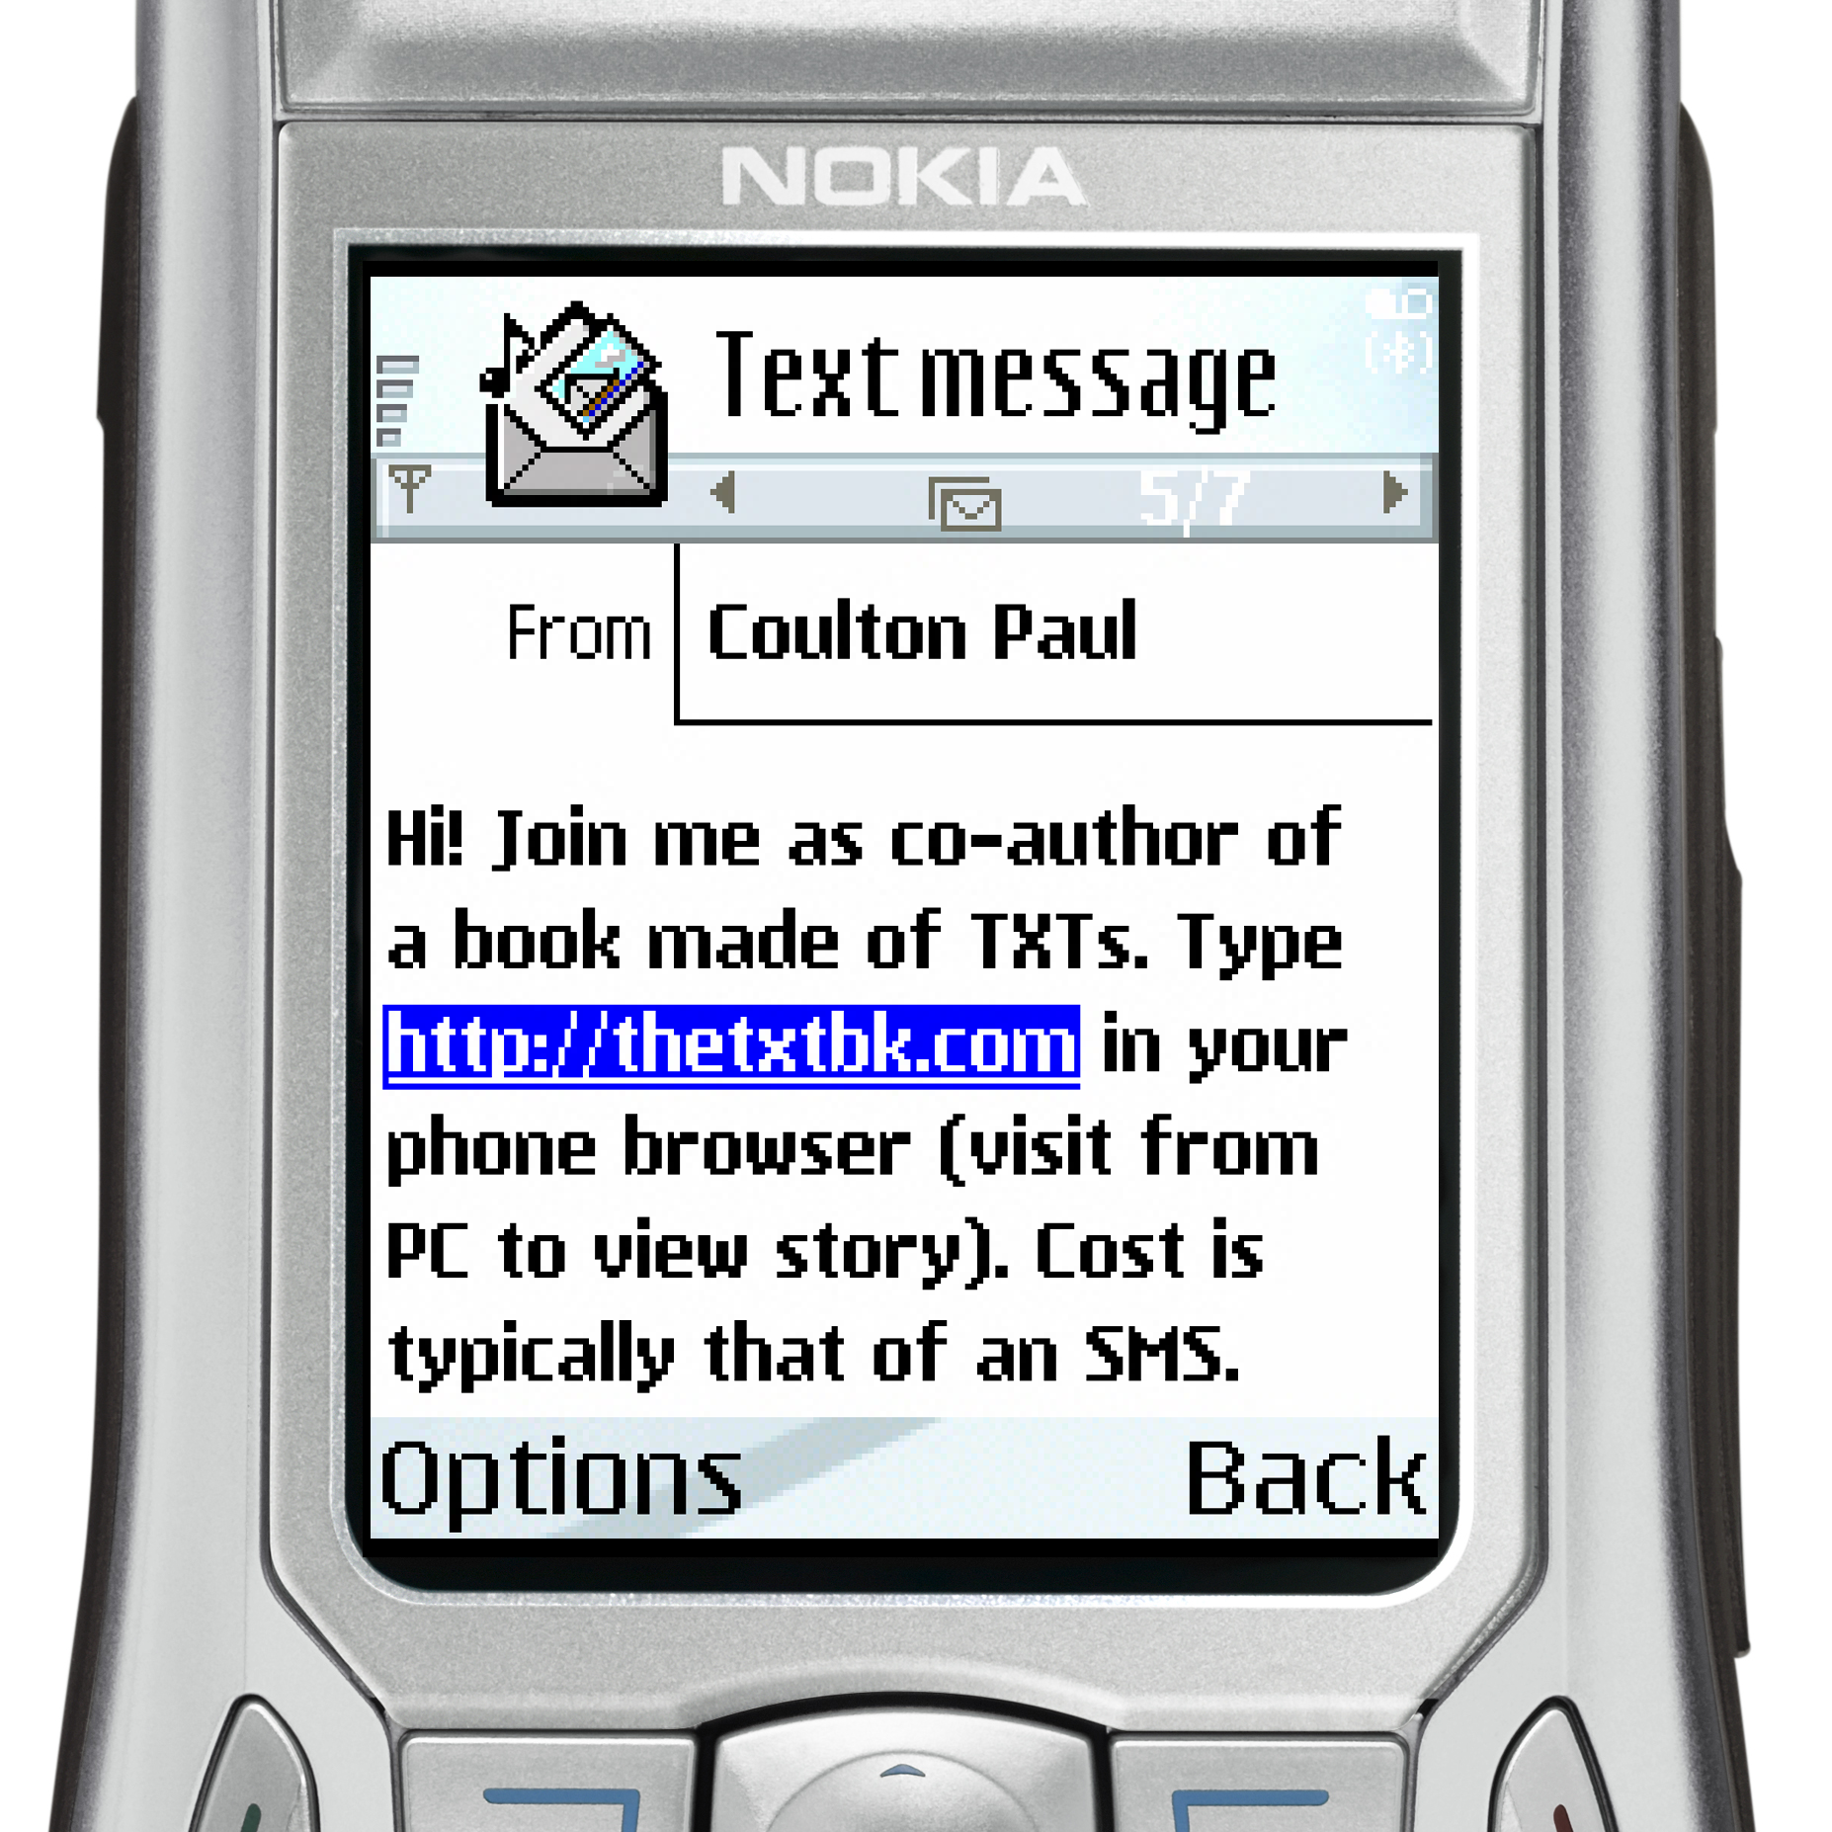
figure 1. SMS invitation to contribute to thetxtbk.
The majority of new phones allow links to be opened directly from within the message itself, whilst on older models the URL link can be entered into phone’s micro browser. If an SMS message is received from the known number of a friend, it is more likely to be opened and acted upon. Therefore, we encourage contributors to personally forward the invitation SMS to their friends.

Once the player uses the link, the system detects that they are accessing the site from a phone and provides access through a series of WAP pages as shown in figure 2.


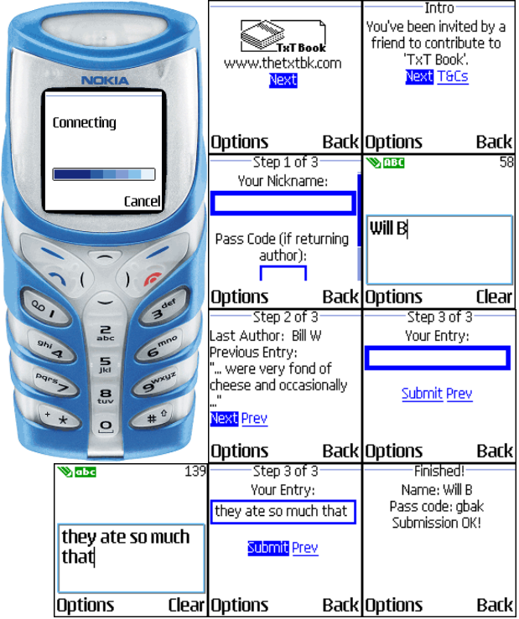
figure 2. Entering a book submission on a mobile phone.
The process is very simple. Firstly, the prospective author enters their Nickname (and pass code if they are a returning author). They are then shown the last entry to the book from which their own entry should follow. Finally, they make their own entry. Once they have submitted their entry they are given a pass code to enable them to make future entries under the same author name. They are also encouraged to forward on the SMS invitation message to their friends. We have added other elements to the game to increase both the sense of community and a competitive element for hardcore gamers. In particular, the website offers both the ability to make an entry and also gives larger snippets of the book to allow people to identify with the larger community of authors. There is also a list of contributing players and the number of entries they have made. We felt this was analogous to the high score tables which are often used to address the competitive desire of hardcore gamers and encourage greater levels of participation in games. Although we have provided for entry via the web and have indicated in figure 1 that awareness of the game can also be spread via email, we have not actively encouraged this as our main focus is in mobile entry and mobile distribution.

Game Evolution
Whilst the book, which is at the heart of this game, is still evolving, and the purpose of this paper is predominantly to document its inspiration and subsequent design, it has already provided some interesting insights into the way the players engage with the game. In this section we shall explore such interaction and the obvious place to start, as with all books, is the beginning. For our opening we decided to play homage to the Philip K Dick classic, ‘Do Androids Dream of Electric Sheep?’, by altering the opening line of the novel’s hero Rick Deckard (who is listed as an author) to be in the first person past participle;
"A merry little surge of electricity piped by automatic alarm from the mood organ beside the bed awakened me.
It is interesting to note that this first line is complete, which is something that turned out to be unusual in subsequent entries. The second entry, as shown, is indicative of the main feature that dominates the style of entries in that the current author leaves the line open ended for the next author to follow. This would indicate that the players have a sense of community and that they are interested in developing the story - both attributes of the participants.
I felt exhausted from the strange dreams that plagued my sleep. Who was eating my cheese, I wondered? Did I have mice? Or was there another reason I was a few crumbs short. It occurred to me that my obsession with cheese had to stop, before I began to hallucinate with desire
The two passages that follow illustrate another common practice amongst the players, where the current author follows the story of the previous author but tries to create a humorous twist in the plot that often sends it off in a completely new direction. This would indicate it’s a fun experience which is desirable from the expectation of the wanderers. Further, we can also see in the second of the two passages that the story is now progressing in the second person past participle. This switching generally occurs after the inclusion of a fairly random (even by the standards of this book) entry which does occur every so often.
a deep fried guinea pig that I had once enjoyed whilst trekking through deepest darkest Peru in search of a lost tribe who were reported to engage in acts so mundane, that they remained undiscovered for centuries - I didn't find them. However, I did meet another tribe who engaged in acts so terrible that

, the Cornish comedian, was not so lucky. The oncoming implement smashed into his chest, impaling him to a near by bench that marked the spot of the first alien landing in Lancaster. The day they abducted Phil went down in history for the longest ever probing session. Eventually the aliens became despondent when he pointed out their futile business model. They started data harvesting
Further, the second and third entries of the second passage were from two known members of our research group and we were able to identify an obvious in joke between them. This highlights the potential for social experience, which is another desirable trait for participants.
Authors tended to use a first person narrative. One of the key reasons for this is that it is almost impossible to maintain characters; omission of the character name from a single entry results in the following author having no knowledge of them and they simply disappear. This is illustrated in the case of Dr Forbes in the passage below.
they'd even been shunned by their neighbours, a group of satanic cannibals with a penchant for random, drawn-out torture. So I turned to Dr Forbes and asked if we should exterminate them using our latest "death-ray" technology. Dr Forbes suggested an easier method of neutralizing our adversaries, involving the organs of small tree frog, ear wax, and a large roll of gaffer tape. The result was
Interestingly this was not the last appearance of Dr Forbes and regular contributors who had come across him in the past often tried to resurrect him, although this is generally a short lived experience.
the elusive Dr Forbes who seems to appear and disappear like a veritable will o’ the wisp. We were particularly suprised to see him here as he had vowed to sto ck tomato soup only on Saturdays and today was a Tuesday. 'Hey Forbsey', I whispered, 'Got any of your special, out the back?'. Forbes smiled and gestured toward the trap door leading to his cellar. "They're down there mate. Careful though, one of them nearly bit my arm off the other day". I began to walk toward the hatch when
There are a many other statistics and patterns developing for this game although they are beyond the scope of this paper and will be presented in a future publication.

Conclusions
In this paper we have attempted to create a profile of the requirements that a game would need to fulfill in order that it would be attractive to the majority of mobile gamers. To this end we drew inspiration from surrealist poets of the 1920’s to create a simple socially orientated story based game that can be played in short bursts and is capable of handling problems of latency and drop outs. Although the game developed for this research project may lie outside any current definitions of game genres, and indeed many inside the games industry are likely to argue against it even being considered a game, we believe that there is substantial evidence of game experience and indeed it has many attributes that could be compared to the highly successful ‘WarioWare’ by Nintendo, already popular with the casual gamer in terms of its ever changing short term game play.
Whilst we would not consider to have produced a definitive description of the attributes of the mobile gamer or indeed the magic formula for a successful mobile game, we have shown that there is a tremendous opportunity for developers to step outside the current gaming genres and create new, and uniquely mobile, game experiences.

Acknowledgements
The authors would like to thank Nokia for their provision of software and hardware used in the implementation of this project.

Example citations
- Bateman, C., and Boon, R. 21st Century Game Design, Charles River Media, Massachusetts USA, 2005.
- BBC News. ‘Simple games’ rule mobile charts. http://news.bbc.co.uk/go/pr/fr/-/1/hi/technology/4461239.stm. April 2005.
- Kashi, N. Targeting the Casual Gamer in the Wireless World. IGDA Online Games Quarterly, The Demographic, Volume 1 Issue 2, Spring 2005.
- Laramee, D.F. Secrets of the Game Business. Charles River Media Inc, Massachusetts, USA, 2005.
- Nokia. The Mobile Device Market. http://www.nokia.com/nokia/0,,73210,00.htm, August, 2005.
- Palmer, Mobile phone makers eye booming games market. http://news.ft.com, August, 2005.

For the purposes of this paper alternate entries are indicated by a switch to/from italics.

