Creativity in everyday literacy practices: the contribution of an ethnographic approach

Abstract
In this article, we explore creativity in everyday literacies. We argue that much creativity can be found in the seemingly mundane and repetitive acts of text production and text use that are part of everyday life and work. Such creativity, however, can only be identified if we look beyond the texts themselves and examine the practices of making and engaging with texts. Once we leave aside conventional text-based notions of creativity, which focus on aesthetic features of language, we can understand creativity as a ‘popular’ and ‘ubiquitous’ event. To support our argument, we give examples from two different contexts: research on literacy in a parish community in the North-West of England and a study of literacy in relation to community-based tourism in Namibia.

1. Literacy and creativity

Literacy studies has long challenged previously dominant notions of literacy as a decontextualised skill (Street 1984, Barton 2006). Studies of literacy practices in context have shown clearly that people produce, use and generally interact with texts in different ways in different social contexts. These practices are patterned by social structures, institutions and power relationships. They are purposeful and part of people’s broader social goals. They are shaped by the cultural practices within which they are situated, locally and historically. And such practices hold intrinsic meanings for the people involved, which vary according to the personal, social and cultural context (Barton and Hamilton 2000, Papen 2005).

To date, much of the focus of work in literacy studies has been on researching such practices in different contexts, describing the range of activities and meanings involved and relating the local literacy practices to the broader social context, challenging ‘autonomous’ notions of literacy (see for example Street 1993, 2001, Barton and Hamilton 2000). Creativity is not a concept which has so far enjoyed a great deal of focus in this work. Now that the socially situated nature of literacy practices has been established, it is of value to explore in more depth what this means for various aspects of our understandings of text in people’s lives.

This article explores creativity in everyday literacy practices. We have already explained that literacy practices are socially situated, and need to be understood in relation to their social contexts. However, this does not imply that they are socially determined. There is a great deal of creativity in the way people respond to the potentials and limitations of different social contexts, to produce and interact with written texts. As we have argued previously (Papen and Tusting 2006), by exploring practices involved in text production we can see that there is creativity even in seemingly routine or mundane literacy practices. We will give examples of this creativity from our own research, and explain how this can be understood in relation to the social practices and the social and cultural context in which the literacy-related activities are situated.

2. Understandings of creativity

There are many ways of being creative with written language. Only some of these, however, tend to be identified as important or legitimate forms of creativity. Banaji and Burn (2007: 62) suggest that the notion of ‘creativity’ is ‘constructed as a series of rhetorical claims’, and identify several rhetorics of creativity associated with different philosophical or political traditions. The first, ‘Creative Genius’, argues that creativity is a ‘special’ quality, associated with highly educated and talented individuals, and elite artistic and cultural products. This notion remains implicitly the dominant one in much of the discourse around creativity. It is close to what Craft (2001) calls ‘high’ creativity: the creation of something remarkable, new and original, unlike anything which has been made before. Such a creative product changes our perspective on the world. This position is challenged by the rhetoric which Banaji and Burn term ‘Democratic Creativity’, which shares the position that creativity is associated with artfulness, but highlights the existence of similar ‘creative’ aesthetic features in popular cultural products and patterns of cultural consumption.

Much research into creativity in language shares the focus on aesthetics of both ‘Creative Genius’ and ‘Democratic Creativity’. Academic studies of creativity often focus on aspects of language use which foreground Jakobson’s ‘poetic’ function (Jakobson 1960); that is, language which draws attention to its own form, through features such as parallelisms, repetition, rhyme and other sorts of ‘word play’ (Cook 2000, Carter 2004, and see Maybin and Swann forthcoming). This conceptualisation of creativity in relation to aesthetic and poetic features of language tends to lead to a position where texts can be categorised as being ‘more’ or ‘less’ creative.

Our position, and, we argue, the position implied by the theoretical stance of seeing literacy as social practices, is encapsulated by the rhetoric Banaji and Burn label ‘Ubiquitous Creativity’. This suggests that creativity is inherent and essential in people’s everyday lives. This is also the view taken by Pahl (2007). Using children’s texts as examples, she shows that a focus on literacy events and literacy practices - the units of analysis drawn on by the New Literacy Studies – allows us to draw out the creativity inherent in texts produced by children in a Foundation classroom. In this paper, we take a similar approach. Looking at how people produce and use texts, we identify the creativity inherent in seemingly mundane forms of written communication, even where the texts themselves might show little evidence of the language features normally associated with ‘artfulness’. Rather than exploring language features and categorising texts in terms of their relative creativity, we will argue that text production practices are intrinsically creative. Furthermore, we argue that it is necessary to study text production and text use in their local settings to understand how these creative processes are shaped by the potentials and limitations of different social contexts. We illustrate this argument using examples taken from ethnographic literacy research.

Our understanding of creativity draws on Kress’ work on writing and multimodality (Kress 2003). Creativity, he suggests, has to do with the writer’s selection and combination of various means and modes to make meanings. Sign-making, he argues, is always producing a new sign, even in the case of one that is made in response to and as an interpretation of a sign that already exists. From this perspective, creativity does not necessarily have to refer to making something startlingly original, apt, witty or playful, but simply, where language is concerned, can mean the human capacity for making meaning in a given situation where no meaning or communication existed before. Creativity is seen not as the privilege of the particularly gifted, but as a common occurrence.

Kress focuses his attention on the text itself (thinking of text here in a broad, multimodal sense). Our concern is only partly with texts. We complement Kress by looking at creativity not only in relation to the creative elements which can be identified in texts. Instead, we examine texts in conjunction with the everyday literacy practices through which people in a range of different settings produce and interact with texts. We draw out the creativity inherent in these practices.

3. Studying literacy and creativity: ethnographic methods

If, as we have suggested above, creativity can be found in everyday acts of producing and using texts, we need to find ways of studying these activities that allow us to draw out their creative aspects. Crucially, this requires methods which go beyond examining texts as such (for example discourse analysis or literary criticism). Instead, we need an approach that allows the researcher to understand the social activities involving the use and production of texts. We need to find out about people’s intentions in dealing with and producing texts. And we need to gain a thorough understanding of the broader social, cultural and economic context within which the acts of text making and text use take place. Only then can the creativity inherent in what people do with texts become visible.

Ethnographic methods – detailed observations of and participation in social practices over time – allow us to study literacy practices in this way. The aim of an ethnography of literacy practices is to systematically record and describe any literacy-related activities as well as the social practices they are part of. In a further step, these descriptions have to be analysed in order to identify their patterns and the relationships between them (see Barton and Hamilton 1998, Tusting and Barton 2005). This requires the ethnographer not only to observe and participate, but also to talk to the people involved in literacy events. Interviews – usually unstructured or semi-structured – aim to gauge people’s intentions and attitudes, their understanding of the situation in question and their own views in relation to what they are doing.

In the following sections, we will demonstrate how this ethnographic approach to studying literacy practices reveals the creativity inherent in these practices. It enables us to describe in detail the process of creative combination of meaning-making strategies described above, showing how people draw on the semiotic resources available to them and combine them in creative ways to fulfil the demands of particular situations. We will show this process in relation to literacy practices from two very different contexts: people publishing a weekly church bulletin in a Catholic parish in the North-West of England, researched by Tusting, and people producing advertising texts in Namibia, researched by Papen. Neither of these studies originally focused primarily on creativity, but re-examination of the data from this perspective draws out the creativity inherent in both. These examples will demonstrate how the creativity inherent in people’s everyday literacy practices is socially shaped: how it involves adaptation to social and institutional constraints, how it is drawn out and bounded by the potentials and limitations of different contexts, and how new and hybrid discourses call forth creativity in literacy practices.

4. Recurrent creativity: the production of a weekly parish bulletin

Our first example comes from research carried out in a Catholic parish, which explored the roles of written texts in the construction of community identity (Tusting 2000a, b). Data was collected through eighteen months’ participant-observation in parish life. One key text in the parish was the weekly bulletin, which contained news and information about that week’s events. The bulletin consisted of a piece of A4 paper, printed on both sides and folded into a four-page booklet (see Figure 1, below). It was given out to each person attending Mass at any of the churches in the parish. A sample copy of each bulletin was collected each week over 10 months.

Figure 1: A sample parish bulletin

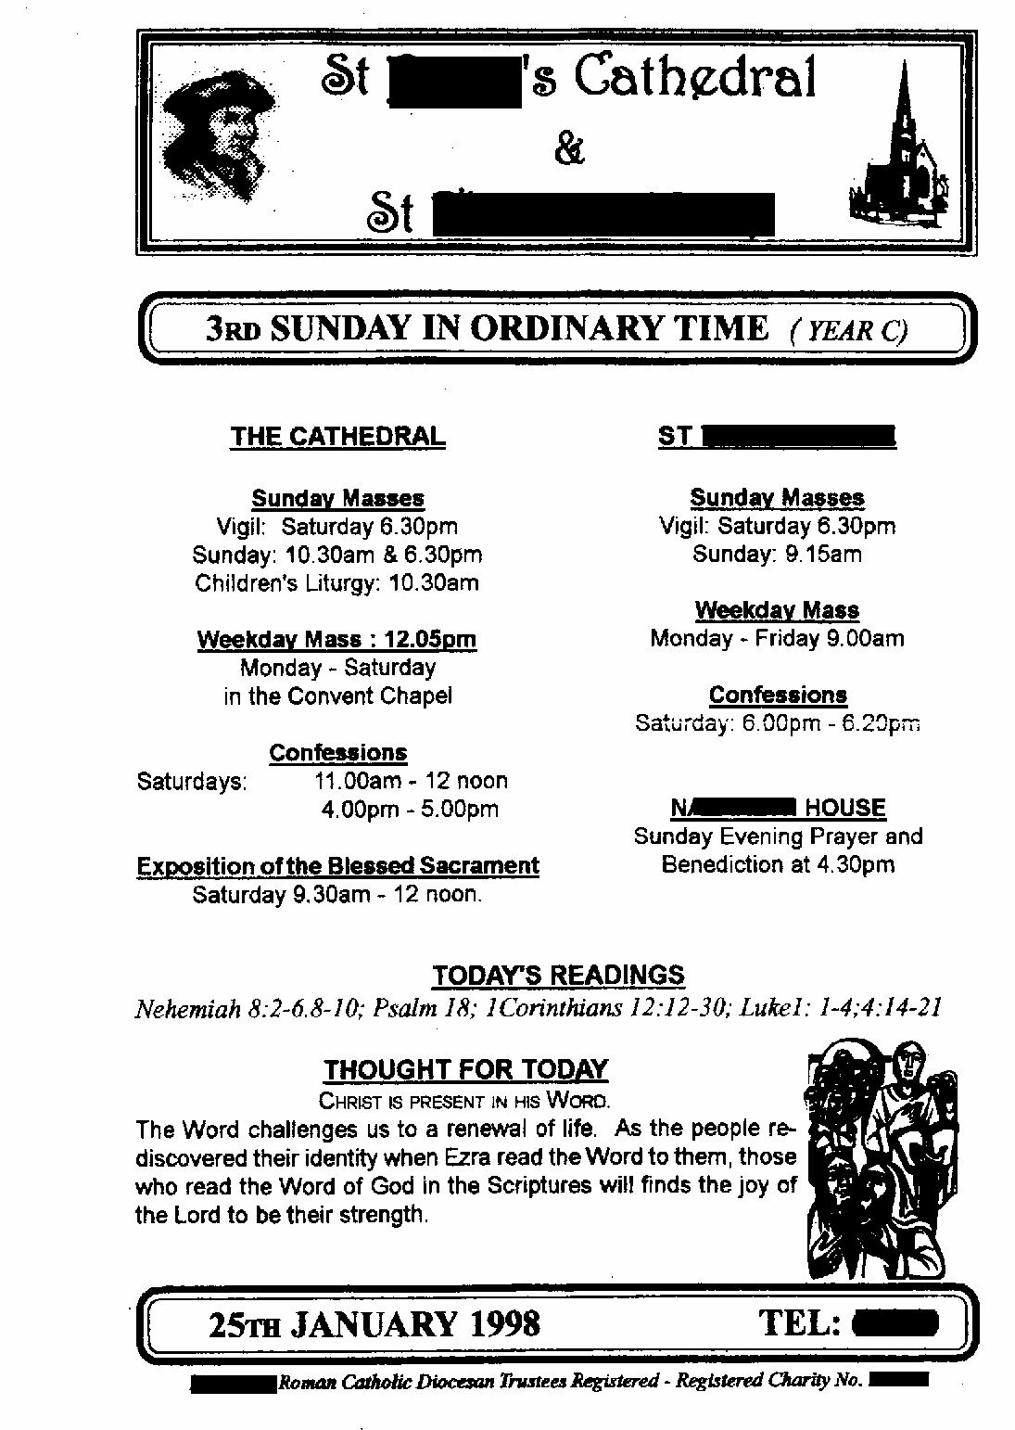

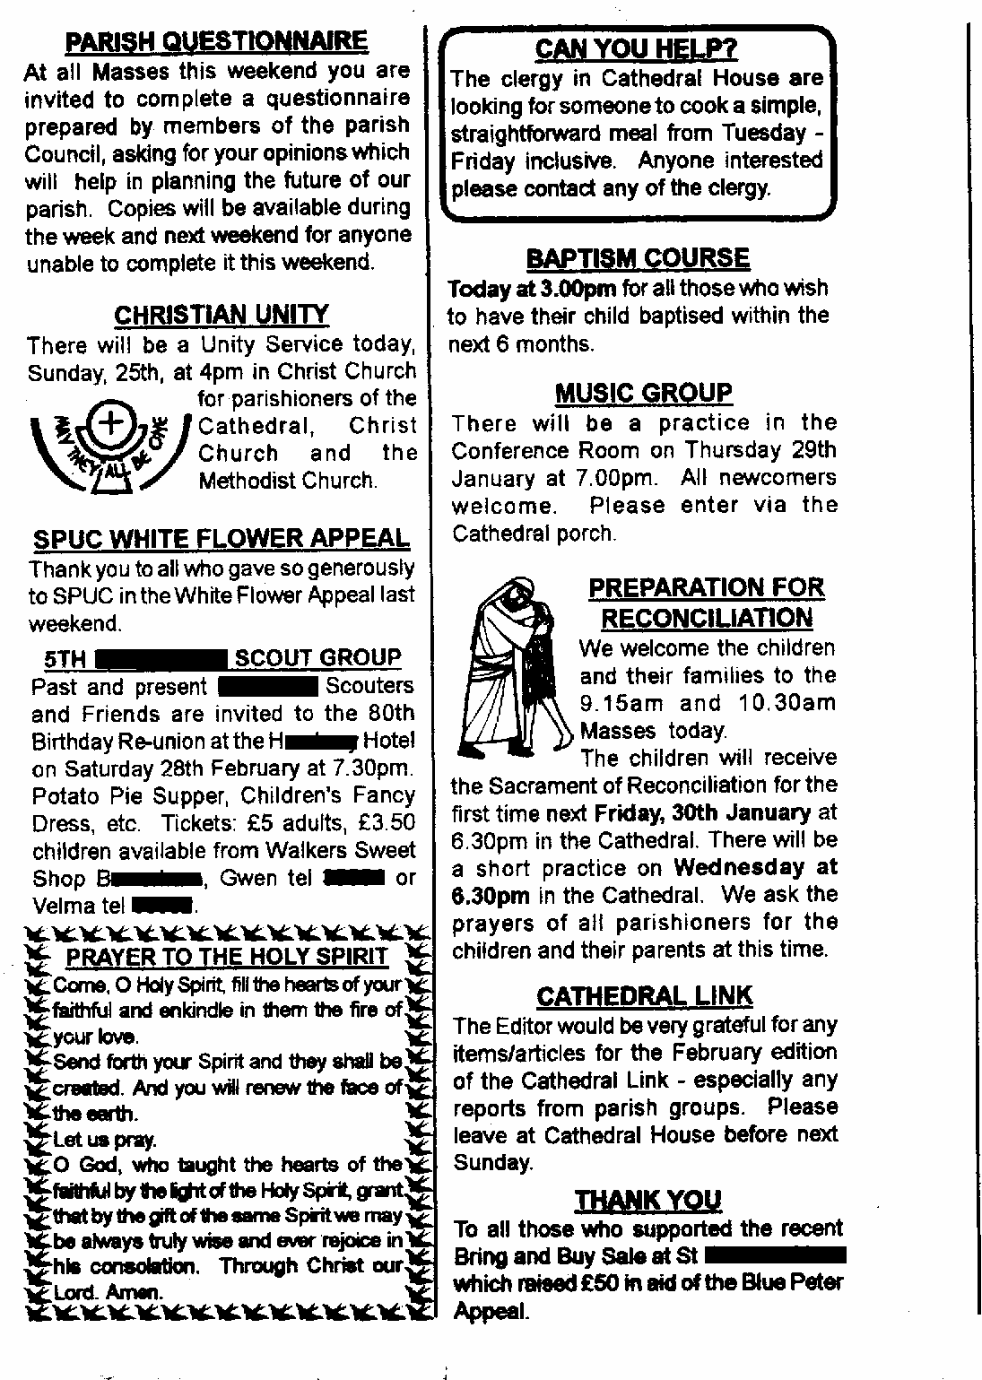
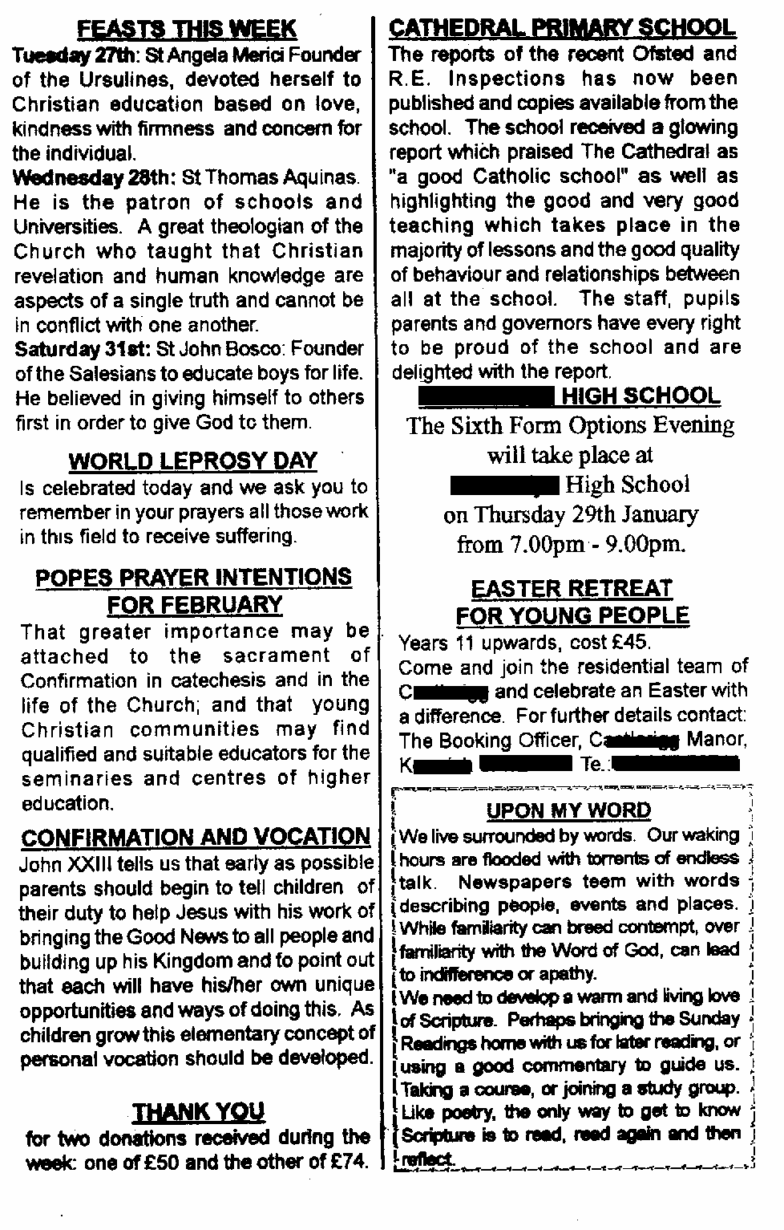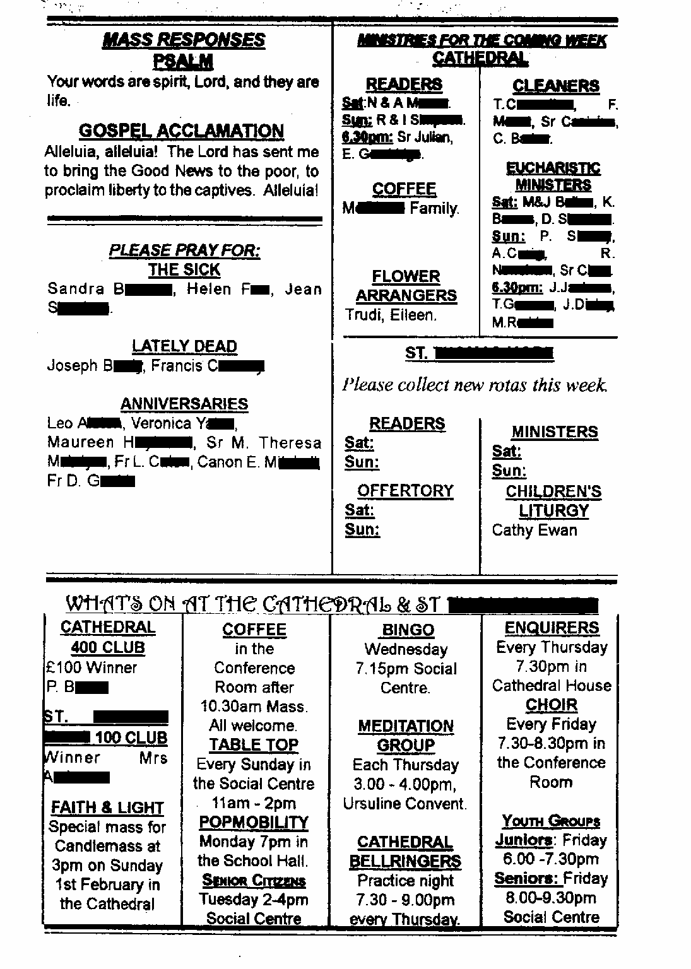The example in Figure 1 shows the general form of the bulletin. It was made up of a number of distinct sections, each demarcated by a short title. The overall structure and format was similar in each issue. The content is diverse, covering in a single sheet a wide variety of topics relating to several domains of experience: spiritual, administrative and bureaucratic. Interpersonally, the bulletin serves various functions: providing information, inviting attendance, requesting actions, thanking and questioning. Different audiences are addressed: some sections address the parish as a whole, but most are for particular groups, such as those who wish to have their child baptised, young people, parents of children attending parish schools, or people who supported various events, with some of the prayers directly addressing God or the Holy Spirit. Discrete sections occupy distinct spaces with few links constructing coherence between them, different fonts and graphics are used, and there is little linguistic cohesion between the different sections.

A rhetoric of creativity focusing on unusual or artful aesthetic features might dismiss the parish bulletin as a mundane administrative piece. However, analysis of the practices by means of which it was produced shows the creativity involved as the bulletin producer engaged in a complex process of selection and combination to meet a wide range of demands in the production of this heterogeneous text.

Each week, the bulletin was produced on a Thursday morning by the parish secretary, who was interviewed in detail regarding this process. She also worked in the church office part-time doing administrative work, as well as being involved in much of parish life, and was therefore one of the few people who was aware of most of what was going on, in a very active church community with many different groups and activities.

The information drawn on to produce the bulletin came from very many different sources. Parish groups left notes and messages at varying levels of detail in the ‘bulletin box’ in the parish office. The parish diary listed forthcoming events and activities. Information about the Church’s year came from a book called the Ordo, sent from Westminster to the clergy each year, or from a monthly magazine for bulletin producers. The ‘thought for the day’ material, stories and inspirational sections were taken from the Missal (Mass book) or from magazines. Requests for prayers came from various sources: knowledge about recent funerals in the parish or requests for a Mass for someone who had recently died, or whose anniversary it was; priests’ anniversaries from the Ordo; ‘the sick’ from the priest’s visiting list. The parish secretary had to fit all of this information into the bulletin in a digest form short enough to fit everything in, yet long enough to include all relevant information.

This process began when the parish priest sat down with the bulletin box and the parish diary, and dictated text in his own words. The secretary would then sit down at the computer and open up the previous week’s bulletin in Microsoft Publisher. Elements which would run another week were kept in, and then the information from the priest’s dictation was entered, adapted to written form as necessary.

Each week, decisions had to be made about what to include and what to leave out, based on various criteria. Interpersonal criteria were key. Information coming directly from one of the priests would go in automatically; information from parishioners was considered in relation to its urgency. General information from a non-parish source, such as background material on a saint’s day, might be pushed out if space was tight. The key question deciding whether or not information would be included was whether there was some form of link with the parish. For example, reunions at Catholic schools in the area which parishioners might have attended were occasionally advertised, as a way of making links to people’s history. The domain of the elements concerned also played a role in the selection criteria. The bulletin producer felt the ‘Thought for the Day’ and similar sections were particularly important, describing them as ‘a form of adult religious education’, designed to contribute to people’s spiritual development. She therefore prioritised the inclusion of some elements of this kind each week, to balance out the more administrative functions.

In addition to balancing these selection criteria, the secretary considered each bulletin in relation to its position in a series over time. Announcements of events would be included several weeks or months early as ‘warnings’, for busy people who needed advance notice. They would run for two or three weeks, in case people missed an issue, and would then be taken out, to be put in again for a few weeks before the event took place. Pictures (generated by computer clip-art packages) were included not only for aesthetic reasons, ‘to break up the text’, but also for functional reasons, to link together over time sections which recurred every week, such as reminders of the sessions of the sacramental preparation courses which continued throughout the year. Cohesive links were thereby produced between different issues of the bulletin.

This description of the complexity of practices involved in the production of the bulletin demonstrates the creativity evident within what might appear a routinised production of similar texts week after week. Analysis of these practices highlights the range of creative responses to the particular exigencies of producing each issue, managing multiple resources and constraints. The parish secretary engaged in an ongoing process of selection from the information resources available to her, carefully crafting them into a form appropriate to the social and institutional constraints within which she was working, balancing interpersonal, temporal, institutional and stylistic factors. This involved a complex process of bringing together contributions from a wide variety of different sources, weighing up multiple considerations to choose what to include and to work out the best way of presenting the information. She collaborated with a range of actors in its production, drawing a myriad of different voices together in a single text that represented the multi-stranded ‘voice of the parish’. Multiple and hybrid discourses – spiritual, bureaucratic, and administrative – were balanced in fulfilling the bulletin’s many functions. This example underlines the creativity inherent in the production of a non-literary form. It can be seen as an example of ‘ubiquitous creativity’, showing the range of creative practices inherent in the routine production of what at first sight might be thought of as a repetitive, highly structured text, produced by someone not traditionally positioned as a creative artist.

5. Creativity and constraint: ‘advertising literacy’ in Namibia

The next examples come from a larger ethnographic study of literacy practices in Namibia carried out in 1999 and 2000. The aim of this study was to explore the uses and meanings of literacy (i.e. reading and writing) in people’s everyday life and work. Fieldwork was carried out over a period of 10 months. The study used ethnographic methods, including participant observation, repeated informal conversations with informants and semi-structured interviews. Discourse analysis and visual analysis were drawn on as complementary tools, to explore the texts people produced and used as part of their daily lives.

At the time of the research, Namibia was in the middle of a process of rapid cultural, political and economic change. The end of South African rule and the abolition of apartheid in 1990 opened the country to foreign tourists and investors. Tourism was growing at a rapid pace and the country was gradually gaining a reputation as a place worth visiting. This provided new social opportunities for many Namibians. The growth of tourism, a trend that has carried on in more recent years, is particularly important for the majority of the black and coloured Namibians who - despite efforts by the government and support from foreign donors - experience high levels of unemployment and a low standard of living. In 1999 and 2000, when Papen conducted her research, local or ‘community-based’ tourism had seen a major boost, allowing small-scale enterprises, owned by black Namibians, to enter the tourism market.

Despite these developments, competition was fierce, and anybody trying to make money from tourism needed to be as inventive as they could when advertising their services. Advertising, in whatever form, is a playing field of creativity. In Namibia, where many producers cannot rely on high technologies and a wealth of materials, plain writing and perhaps some paint and drawing are often the only means of communication advertisers can afford. Many are also advertising in English, a language which few people have been formally taught. In what follows, we will show the creativity that emerges from these social and economic conditions.

Face-to-Face Tours: Experiencing Katutura face-to-face

The first example comes from research in Katutura, the former black township of Windhoek, the capital of Namibia (Papen 2007). There is a lot going on in Katutura, despite economic hardship and a general lack of resources. People build houses and shacks, they set up new businesses, formed local associations and met in bars (shebeens) or on the local markets. Business in Katutura is mostly small-scale and family-run. Women produce and sell goods, often as a secondary means to increase the family budget. Men offer their services as car mechanics or builders.

In the township, competition for tourist money is particularly high. Those working in the sector have to compete with the many companies that are located in Windhoek’s city centre, much closer to the hotels and guest houses where the majority of the tourists stay. People have little money to invest into advertising; nor do they have formal training in marketing and promotion. But this doesn’t mean they don’t advertise their goods. They have to. In such a context, creativity can be found in the choice and combination of material people can get hold of and the opportunities they draw on to achieve what they desired to do.

In the summer 2000, when Papen was in Namibia, she herself became such a resource to be drawn. As part of her research, she worked closely with a group of tour guides who showed visitors around the township, its historical sites and contemporary life. Katutura Face-to-Face Tours was set up in 1999 by a group of young school leavers. The guides were supported by a local umbrella organisation for community-based tourism enterprises (CBTEs) and they were in possession of an advertising flyer, which they had produced with the help of a friend who was a journalist

At the time of this research, they wished to update their flyer and to create additional promotional material. They wanted a flyer with photographs of tourist being shown around the township. But they did not have the expertise or the means to produce such a document. They approached Papen to help them. Together they went around Katutura, staging photographs showing a European woman talking to locals and listening to a guide explaining the history of the township’s cemetery. They then asked her to draft a text for their new flyer. The guides used these photos for a handmade board that they put together for a marketing stall at a large city fair.

This example demonstrates creativity in relation to the practices of making texts, by identifying materials, drawing on ‘experts’ and exploiting any means available in an environment scarce of resources and opportunities. It also demonstrates democratic creativity that occurs in unexpected places. Furthermore, Papen’s example shows creativity emerging from collaboration, rather than being the product of an individual creative mind. It was the tour guides’ idea to produce the photographs and they chose the places where the images were to be shot. But Papen and the group together decided what precise images to take. They also discussed the ideas for the flyer together, even if they then left it to Papen to produce the actual text .

Khowarib campsite

The next example comes from Damaraland, the former homeland of the Damara people and nowadays an administrative region located in the eastern-central parts of Namibia. The Khowarib Camp (see Figure 2) is owned and run by a group of people from the Khowarib community, a small settlement in Damaraland. The campsite is situated close to the main road leading from Windhoek towards the north-west of the country. In theory, this makes Khowarib an ideal stopping point for anybody on their long and arduous way towards the Kaokoveld, one of Namibia’s tourist attractions. But places like this suffer from the structural inequalities which characterise the Namibian tourism sector. Despite many measures to support community-based local (black) enterprises, the sector was and still is dominated by white and foreign-owned tourism companies. The majority of the tourists coming to Namibia prefer to stay in lodges owned by white Namibians or foreigners. Relatively few venture onto community-run campsites.

Places like Khowarib, which was founded by a local community with no prior experience in tourism, lack the resources for a professional marketing strategy which might help them attract more visitors to their site. But this does not mean that they fail to advertise their product or lack creativity in doing so. Figure 3 shows the signboard the owners of the Khowarib camp put up next to the road.

Figure 2: Khowarib campsite

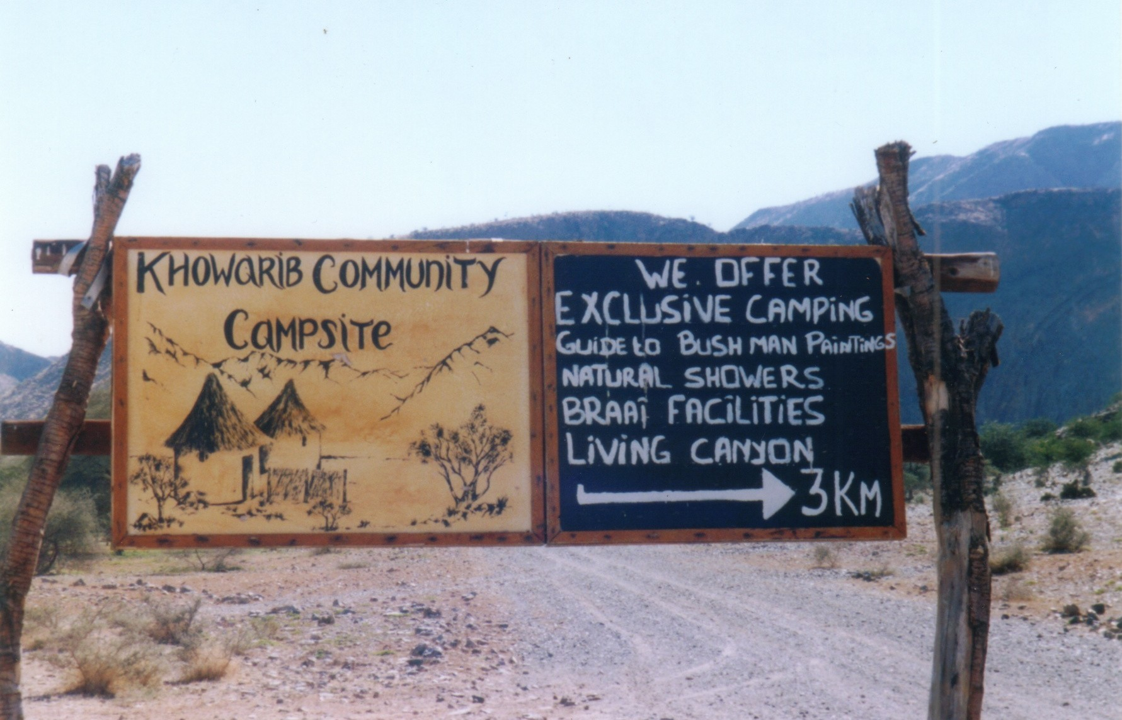

The people of Kwowarib told Papen that the making of the signboard had been a collaborative process, involving the Khowarib community and a business advisor from the same organisation that also supported Face-to-Face Tours. Like the township guides, the people running the Khowarib campsites were newcomers to the tourism business and they, as many other community-based tourism enterprises, had only limited resources to draw on.

Looking closely at the images and accompanying text, we can see the ‘design work’ (Gee 2000: 185) that went into its making. This is semiotic work and its goal is to create images (representations, both verbal and visual) of the advertised product that respond to the ‘tourist gaze’ (Urry 2002): their wishes and preferences, needs, desires and dreams. Khowarib’s signboard does a very good job at responding to the typical European or North-American tourists’ dreams. Most tourists on their way to the wilderness of the Kaokoveld come to the country because of their interest in its natural environment. They would be likely to have a keen interest in local culture and to be happy to support the local economy. But as thrilled as they would be to know that the campsite was largely built of natural materials, they would also be relieved to discover that the site provides the modern luxury of running water.

Its text is complemented by a drawing. The stereotypical representation of African huts continues with the same themes and metaphors set out in the writing. Jewitt and Oyama (2001) have pointed out that hand-drawn and photographic images are assessed by their viewers in different ways. The latter are judged by their reality value, the former appeal through their assumed authenticity. The images of the huts respond to the tourists’ search for an ‘authentic’ African experience. The creativity of the signboard lies in the combination of textual and visual elements, a form of multimodality that was achieved without any high-tech equipment, cleverly exploiting the tourists’ wishes and needs. The camp workers had drawn on their existing resources – their ability to draw – to construct a text which appeals to tourists by virtue of its hand-drawn quality.

Creativity and literacy in Namibia: Conclusion

The signs presented above are examples of creative texts which were produced by people with little formal education and prior experience in marketing and design. Nevertheless, the texts produced are examples of the kind of everyday creativity that can be identified and appreciated by taking an ethnographic approach. In order to fully appreciate what is creative about these texts, we need to understand the ethnographic context out of which they were born. People in Namibia (and elsewhere) who experience rapid and drastic social and economic change need to adapt quickly to new linguistic contexts. Creativity is inherent in the exploration of often scarce available resources, and it involves the combination of new and old practices and text or image types. The writers of the Khowarib sign appropriated new discourses (of tourism) and relied on ‘old’ skills (drawing) to produce a creative sign. The tour guides appropriated the expertise and willingness to help of a foreign researcher who happened to be in the area to produce texts in new discourses of tourism that they were learning to draw on. In both cases, creativity was collaborative and democratic, drawing on the resources and abilities of different people with different backgrounds and experience.

6. Conclusion

In this paper, we have looked at creativity in everyday, mundane contexts, and under conditions that are not usually seen as being conducive to creativity. Our examples emphasize that once you look beyond the texts themselves, and examine the practices involved in producing and using them, the creativity that emerges from the opportunities and constraints inherent in different social, institutional and economic contexts becomes clear. Analysis of the production practices of a parish bulletin showed the parish secretary skilfully and creatively negotiating a range of criteria and constraints of different kinds in producing, selecting and arranging the texts that became the parish newsletter. Examination of tourist advertising texts in Namibia has highlighted the creativity inherent in their production. What people like the owners of the Khowarib camp and the tour guides did makes creative use of the resources available in the context they lived in, despite their economic marginalization and the limited experience with tourism and advertising.

Production of texts is never just a process of copying and repetition. It always entails adaptation and change, as can be seen in the mix of genres and idioms, the combination of old and new which the writers in our examples used. This is what Levi-Strauss (1972) has described as bricolage: the bricoleur is someone who makes use of means (linguistic and material, in these examples) that are already there, but which have not necessarily been conceived for the purposes the bricoleur has in mind (see also Derrida 1978, Robins 1996). Creativity lies in the bricoleurs’ ability to capture or imagine the potential of the things they find in their environment. The parish secretary, the guides from Face-to-Face Tours and the owners of the Khowarib camp are all bricoleurs.

Furthermore, these examples demonstrate the collaborative nature of creativity, showing that text making more often than not relies on creative combination of contributions from more than one person. This idea is rarely highlighted in discussions of ‘conventional’, artistic creativity. It is however a common theme in more recent research on digital literacies (see for example Knobel and Lanksheer 2006, 2007, Merchant 2001, 2005). Researchers who have looked at new forms of electronic reading and writing emphasize that creativity on the internet is often the result of a collaborative product. Our examples show that creativity and collaboration are also common features of more mundane and less technologically-sophisticated forms of text-making.

More generally, the three examples we have presented are proof that creative intellectual and semiotic work is part and parcel of people’s everyday activities of communication and sense making, even where the texts they produce and use are not characterised by the sorts of language features that foreground the poetic function. An ethnographic approach, which focuses on what people actually do with texts, how they use and produce texts in particular social and cultural contexts, brings to bear a perspective which complements other, more text-based approaches to understanding linguistic creativity. By seeing creativity in relation to its social context, we can understand and value creativity in people’s literacy practices as an ubiquitous characteristic of communication.

References

Banaji, S. and Burn, A. (2007) Creativity through a rhetorical lens: implications for schooling, literacy and media education. Literacy, vol 41, no 2, pp 62-70.

Barton, David (2006) Literacy: An Introduction to the Ecology of Written Language, Blackwell Publishing Ltd, Oxford, 2nd edition.

Barton, David and Hamilton, Mary (1998) Local Literacies: Reading and Writing in One Community, Routledge, London and New York.

Barton, David and Hamilton, Mary (2000) ‘Literacy practices’ in Barton, Hamilton, Ivanic, ed, Situated Literacies, Routledge, London and New York, pp 7-15.

Carter, Ron (2004) Language and Creativity: The Art of Common Talk, Routledge, London and New York.

Cook, Guy (2000) Language Play, Language Learning, Oxford, Oxford University Press.

Craft, Anne (2001) An Analysis of Research and Literature on Creativity in Education, Qualifications and Curriculum Authority, London, retrieved 12 June 2007 from http://www.ncaction.org.uk/creativity/creativity_report.pdf.

Derrida, Jacques (1978) ‘Structure, sign and play in the discourse of the human sciences’ in his Writing and Difference (278-294), trans. A.Bass, Routledge, London, retrieved 12 June 2007 from http://www.hydra.umn.edu/derrida/sign-play.html.

Gee, James Paul (2000) The New Literacy Studies: from ‘socially situated’ to the work of the social, in Barton, David, Hamilton, Mary and Ivanic, Roz, ed, Situated Literacies, Routledge, London and New York, pp 180-197.

Jewitt, Carey and Oyama, Rumiko (2001) Visual meaning: a social semiotic approach, in Van Leeuwen, Theo and Jewitt, Carey, ed, Handbook of Visual Analysis, Sage, London, pp 134-157.

Lankshear, Colin and Knobel, Michelle (2006) New Literacies: Everyday Practices & Classroom Learning, Open University Press, Buckingham.

Lankshear, Colin and Knobel, Michel, ed, (2007) A New Literacy Studies Sampler, Peter Lang. New York.

Levi-Strauss, Colin (1972) The Savage Mind, Weidenfeld and Nicolsen, London, translated from French.

Kress, Gunther (2003) Literacy in the New Media Age, Routledge: London and New York.

Maybin, Janet and Swann, Joan (2007) Language and Creativity in Social Context,
Special issue of Applied Linguistics, vol 28, n 4

Merchant, Guy (2001) Teenagers in cyberspace – an investigation of language use and language change in internet chatrooms Journal of Research in Reading, vol 24, no 3, pp 293-306.

Merchant, Guy (2005) Digikids: cool dudes and the new writing, E-learning, vol 2, no 1, pp 50-60.

Pahl, Kate (2007) Creativity in events and practices: a lens for understanding children’s multimodal texts, Literacy, vol 41, no 2, pp 86-92.

Papen, Uta (2005) Adult Literacy as Social Practice: More than Skills, Routledge, London and New York.

Papen, U. (2007) Literacy and Globalisation: Reading and Writing in Times of Social and Cultural Change, Routledge, London and New York.

Papen, Uta and Tusting, Karin (2006) Everyday literacies: collaboration, context and creativity, in Swann, Joan and Maybin, Janet, ed, The Art of English: Everyday Creativity, Palgrave Macmillan Basingstoke, pp 312-350.

Robins, Steven (1996) Cultural brokers and bricoleurs of modern and traditional literacies: land struggles in Namaqualand’s coloured reserves, in Prinsloo, Mastin and Breier, Mignonne, ed, The Social Uses of Literacy, John Benjamins, Amsterdam, pp 123-141.

Street, B.V. (1984) Literacy in Theory and Practice, Cambridge University Press, Cambridge.

Street, B. V. (1993) Cross-Cultural Approaches to Literacy, Cambridge University Press, Cambridge.

Street, B. V. (2001) Introduction, in his, ed, Literacy and Development, Routledge, London, pp 21-27.

Tusting, Karin (2000a) Written Intertextuality and the Construction of Catholic Identity in a Parish Community: An Ethnographic Study. PhD thesis, Lancaster University.

Tusting, Karin (2000b) The new literacy studies and time: an exploration, in Barton, D., Hamilton, M. and Ivanic, R., ed, Situated Literacies: Reading and Writing in Context. London and New York: Routledge, pp 35-54.

Tusting, Karin and Barton, David (2005) Community-based local literacies research, in Beach, R., Green, J., Kamil, M. and Shanahan, T., ed, Multidisciplinary Perspectives on Literacy Research. Cresskill, NJ: Hampton Press Inc, pp 243-263.

Urry, John (2002) The Tourist Gaze: Leisure and Travel in Contemporary Societies, Sage, London, 2nd edition.

Acknowledgements

Karin Tusting would like to express her appreciation to those many members of the parish who assisted with her research, and in particular to the parish secretary at the time, who was unfailingly supportive of the project and gave up her own time to assist in producing this analysis. Her research was supported by the Economic and Social Research Council. Uta Papen would like to thank the members of the community-based tourism enterprises who shared her experiences with her. Her research was supported by a King’s College London Association (KCLA) research studentship and the University of London’s Central Research Fund. She is grateful to both institutions for their support. We would both like to thank David Barton, Joan Swann and Janet Maybin for comments on an earlier draft of this paper.

We use the terms black, coloured and white without racist intention. Black or black people refers to people of indigenous African origin. Whites are people of European descent, although many of them were born in Africa. Coloured refers to people of mixed ancestry.
The intention had been that Papen would discuss her draft text with the group and then revise it following their feedback. However, in the end the idea never went beyond the first draft, because the local NGO supporting the guides prepared a new brochure including pages on all the CBTEs associated with them. There was no need and no financial support for an additional, separate flyer.

